**Cleveland Urban Area Metropolitan Planning Organization Travel Demand Model**



**Base Year Model Development and**

**Calibration Report**

Prepared for Cleveland TN MPO

FINAL DRAFT

February 2, 2021

1. Introduction / History of Cleveland Model 4

2. Model Review 5

3. Network and Socioeconomic Data Development 6

3.1. Introduction 6

3.2. *Study Area / Planning Area Boundary Considerations* 6

3.3. *Zone System Definition* 6

3.4. *External Stations* 6

3.5. *Land Use Data* 6

3.6. *Highway Network Development* 8

3.7. *Traffic Counts* 12

3.8. *Network Link Capacity* 13

4. Trip Generation 13

4.1. Introduction 13

4.2. Model Form 13

4.3. Model Application 14

4.4. Model Results 15

5. Trip Distribution 17

5.1. Introduction 17

5.2. Model Form 17

5.3. Model Application 18

5.4. Model Results 18

6. Mode Split 20

6.1. Introduction 20

6.2. Mode Split Factors 20

7. Commercial Vehicles 21

7.1. CV Generation 21

7.2. CV Distribution 22

8. External Trips 22

8.1. Introduction 22

8.2. Through Trip Table 22

8.3. IE/EI Trip Generation 24

9. Time of Day 25

9.1. Introduction 25

9.2. Model Form and Application 25

9.3. Vehicle Occupancy Factors 26

10. Trip Assignment 27

10.1. Introduction 27

10.2. Highway Assignment 27

10.3. Model Results 28

11. Future Year Model Development 33

11.1. Introduction 33

11.2. Land Use Data 33

11.3. Highway Network 34

11.4. Externals 34

# Introduction / History of Cleveland Model

WSP was tasked with updating the Cleveland MPO Travel Demand Model. The goals of this model update work include (a) to develop 2018 base year model and calibrate/validate it to 2018 count data, (b) to develop future 2045 scenario, and (c) to update model development and calibration report. The list below gives an overview of the historical changes to the Cleveland MPO Model.

It should be noted that the previous version of Cleveland MPO Travel Demand Model Development and Calibration report[1] was used as a starting point for this document. One of the objectives in this work is to calibrate and validate the 2018 base year model in accordance to TDOT minimum travel demand model calibration and validation guidelines[2].

* In 2004 the City of Cleveland and portions of Bradley County were officially designated as a Metropolitan Planning Organization (MPO) as a result of the 2000 United States Census. With this designation came the responsibility of developing and maintaining a regional TDM capable of assisting the MPO in accurately assessing current and future transportation travel demands within the MPO area. Using an older QRS II model as a base, a TransCAD TDM was developed with a base year of 2000.
* 2005: The model was updated to a base year of 2003 which included updated forecasts along I-75 in the future year model.
* 2010: As part of the MPO’s 2035 Regional Transportation Plan (RTP), the 2003 base TransCAD Model was updated to a base year of 2008.
* 2015/2016: As part of the MPO’s 2040 Regional Transportation Plan (RTP), the 2008 base TransCAD Model was updated to a base year of 2013, the most recent year for which traffic counts were available when model development began. Improvements were made to the user interface, including the addition of model reporting for all steps of the model. The new 2016 model also includes a time-of-day component, more detailed breakout of employment types compared to the 2008 model, and an expanded set of network attributes.
* 2020/2021: The model was updated to TransCAD 8 platform. A more recent 2018 base year scenario was developed, calibrated and validated to 2018 traffic counts. 2045 future year scenario was also developed. External model procedures were updated to produce through trip tables for 2018 base and 2045 future year scenarios. Model documentation was also updated.

# Model Review

Consistent with TDOT standards, the model was developed using the TransCAD 8 build 22360 travel demand forecasting software. The MPO TDM can be executed by running a GISDK macro.

The MPO TDM follows the traditional four-step planning process. However, the focus of the model is on the highway network; thus, the mode of transit is not included in the model and the mode choice step is excluded. The structure of the model is illustrated by the flow chart diagram shown in Figure 1.

Figure 1: Cleveland Model Structure

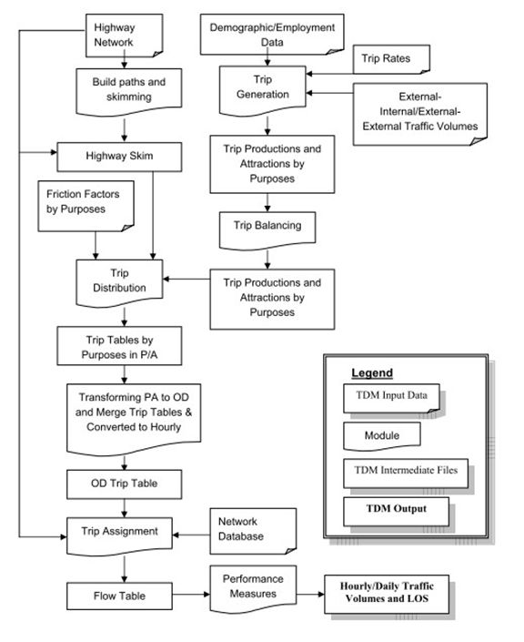

# Network and Socioeconomic Data Development

## Introduction

The spatial representation of the transportation system is one of the most important aspects of travel demand modeling. The transportation system elements include the basic roadway system in the study area along with their key attributes as well as a system of traffic analysis zones.

## *Study Area / Planning Area Boundary Considerations*

One of the first steps in the development of a travel forecasting model is the determination of the geographic area of analysis, or study area. The model boundary didn’t change from the previous model development work. The Cleveland model includes the entirety of Bradley County and a portion of McMinn County.

## *Zone System Definition*

Traffic Analysis Zones (TAZs) are geographic areas dividing the transportation study area into homogeneous areas of land use, land activity, and aggregate travel demand. TAZs are geographic polygons representing areas of trip production and attraction activity within the study area. The previous version of Cleveland TN MPO model had 144 internal zones. In 2019[3], WSP edited TAZ boundaries so they are consistent with census block groups and tracts. This revised TAZ layer was used in the current model update. It should be noted that the current TAZ layer has 138 internal zones. Six small zones from the previous version of TAZ layer were removed as part of TAZ boundary edits performed in 20193.

## *External Stations*

External zones, commonly referred to as external stations, are similar to traffic analysis zones in that they represent travel activity. For external zones, this travel activity has an origin and / or destination outside of the study area. Unlike TAZs, they are not represented by a geographic polygon and demographic data but are represented as a node in the highway network with an associated traffic count. The Cleveland model has twenty-three external stations.

## *Land Use Data*

Land use at the TAZ level is a primary input to the modeling process. Table 1 lists the land use and demographic variables used for the Cleveland model.

Table 1: Land Use and Demographic Data Variables

|  |  |  |
| --- | --- | --- |
| Variable | Description | Data Input (I) or Model Generated (M) |
| Households | Households as defined by census 'occupied dwelling units' | I |
| HHPopulation | Population living in households | I |
| GQPopulation | Population living in group quarters | I |
| Vehicles | Number of vehicles | I |
| Students | K-12 student enrollment data | I |
| Industry | Industrial employment | I |
| Retail | Retail employment | I |
| HwyRet | High-traffic retail employment | I |
| Service | Service sector employment | I |
| Office | Office employemnt | I |
| TotEmp | Total employment | I |
| CV*IND | Commercial Vehicles: autos (1), pickups (2) or trucks (3) at an industrial site (IND), retail site (RET), high retail site (HWY), service site (SER), or office site (OFF) | M |
| CV*RET | M |
| CV*HWY | M |
| CV*SER | M |
| CV*OFF | M |
| hhp*a# | Household by size and auto ownership where * = 1, 2, 3, 4, or 5; and # = 0, 1, 2, or 3 | M |

Cleveland MPO staff primarily put together Land use data for the 2018 base year model development with some assistance from WSP. Table 2 shows households, population and employment data summary used in the 2018 base year model development.

Table 2: Base Year (2018) Model Socioeconomic Data Summary

|  |  |
| --- | --- |
| Variable | Total |
| Households | 44,220 |
| Household Population | 114,948 |
| Group Quarter Population | 3,780 |
| Vehicles | 85,365 |
| Students | 19,565 |
| Employment by Type |  |
| Industry | 20,802 |
| Retail | 6,711 |
| High Traffic Retail | 4,748 |
| Service | 15,556 |
| Office | 11,441 |
| Total Employment | 59,258 |

## *Highway Network Development*

Representation of transportation infrastructure in the form of a computerized network is mechanically implemented within TransCAD using a GIS data layer. The highway network serves several purposes in the analysis of transportation systems. First, it is an inventory of the existing road system of interest represented in a GIS data layer, serving as a catalogue of facilities. Basic information such as length of roadway, roadway configurations and cross-section, capacity, and volume can be stored in the highway network GIS database. Second, the network is used in demand analysis to estimate the highway impedance between TAZs in the region. The third major use of the network is in estimating auto travel volumes and their associated impacts.

Each link in the GIS network database has several attributes associated with it. The coded roadway attributes defined for the Cleveland model are described in Table 3. Facility type values are described in more detail in Table 4.

Table 3: Roadway Link Attributes

|  |  |
| --- | --- |
| Attribute | Description |
| ID | Link ID |
| Length | Length in miles |
| DIR | Link directionality |
| Posted Speed | Posted speed in mph |
| Facility Type | Facility Type. See Table 3 for attribute value description |
| Divided_CD | Divided facility definition (0=Un Divided, 1=Divided) |
| AB/BA Lanes | Number of lanes in AB/BA direction |
| Terrain_CD | 3: Rolling/Standard, 4: Mountainous/Challenging, 5: Flat/Ideal |
| AB/BA_CAPPHPL | Capacity per hour per lane in AB/BA direction. See Table 6 |
| AB/BA_AMCAP | AM peak period capacity in AB/BA direction. Similarly, for other time periods |
| AB/BA Initial Time | Initial link travel time calculated from posted speed. See Table 4 |
| Alpha | Parameter used in the Volume Delay Function See Table 5 |
| AB/BA Count | 2018 count by AB/BA direction |
| DailyCount | 2018 daily count |

Table 4: Description of Facility Type Values

|  |  |  |
| --- | --- | --- |
| Value | FACTYPE_CDD | Definition |
| Freeway | 1 | Roads with uninterrupted flow and fully restricted access including interstate facilities, freeways, and expressways. |
| Multi-lane Highway | 2 | Partial access control two-way facility. No traffic signals or with traffic signals spaced at least 2 miles apart. Directional traffic is divided or with a continuous turn lane. |
| Two-lane Highway | 3 | Rural, undivided, two-way highways. Intercity or commuting route serving longer trips in rural areas. |
| Urban Arterial I | 4 | Principal arterials of high speed design. |
| Urban Arterial II | 5 | Most suburban designs, and intermediate designs for principal arterials. |
| Urban Arterial III | 6 | Generally urban design for principal arterials, intermediate design for minors. |
| Urban Arterial IV | 7 | Minor arterials of intermediate or urban design. |
| Collector | 8 | Urban suburban locations with lower speeds than arterials. Can be rural roadways with low free-flow speed or frequent interruptions. |
| Local Road | 9 | Low speed collectors coded to provide connectivity. |
| Diamond Ramp | 10 |  |
| Loop Ramp | 11 |  |
| Centroid Connector | 12 |  |

The previous version of 2013 year highway network was used as a starting point to develop 2018 highway network. The current TAZ layer 138 zones – 6 fewer zones compared to previous version. The highway network was edited so it’s consistent with the zone layer by removing the six centroids and their connections. WSP was given the list of completed projects from 2014-2020 Transportation Improvement Plan (TIP) were reviewed to update the highway network. The project “construction of interchange on US-64/74 between I-75 Exit 20 & SR-2/US-11” was coded in the highway network.

A review of centroid connectors was performed on the highway network as some of the Cleveland model zones are large. Centroid connectors were reconfigured at several locations. Figure 2 shows centroid connector updates for zone number 99 and 101 located southeast of Cleveland. For zone 99, one of the centroid connectors (red color links) connects to Route 60 Dalton Pike crossing the zone 101 boundary. The blue color links shows revised version of centroid connectors near zone 99 centroid location. Zone 101 centroid location was moved to North to represent the realistic centroid location and its connectors. A more detailed review was done during the base year model calibration and validation looking at link level model volumes and counts. The final version of base year network includes all network updates.

Figure 2: Centroid Connector Updates South East of Cleveland

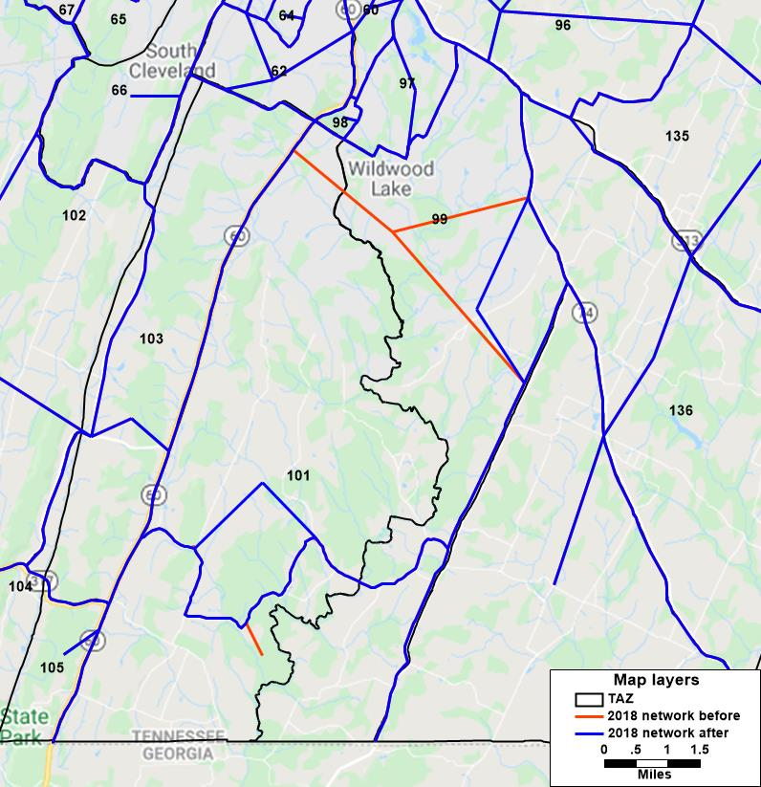

A facility is determined to be divided if it generally operates as if there is no opposing traffic that would affect operational capacity. Facilities with a median and center turn lane are considered divided as are all ramps. Roadways with a 3-lane or 5-lane cross section where the center lane is a continuous left turn lane (CLTL) are treated as a divided highway.

The free-flow speed and initial travel time is calculated based on the posted speed, facility type, and terrain. Free-flow is the speed at which a vehicle would travel if there were no other vehicles on the road. This calculation is done with a lookup table, which is shown in Table 5. The speed adjustment column is the miles per hour added to the posted speed.

Table 5: Initial Link Travel Time Calculation Lookup

|  |  |  |
| --- | --- | --- |
| Facility Type | Terrain | Speed Adjustment |
| Freeway | Flat/Ideal | 5 |
| Freeway | Rolling/Standard | 5 |
| Freeway | Mountainous/Challenging | 2 |
| Multi-lane Highway | Flat/Ideal | 3 |
| Multi-lane Highway | Rolling/Standard | 3 |
| Multi-lane Highway | Mountainous/Challenging | 1 |
| Two-lane Highway | Flat/Ideal | 3 |
| Two-lane Highway | Rolling/Standard | 3 |
| Two-lane Highway | Mountainous/Challenging | -2 |
| Urban Arterial I | Flat/Ideal | -1 |
| Urban Arterial I | Rolling/Standard | -1 |
| Urban Arterial I | Mountainous/Challenging | -3 |
| Urban Arterial II | Flat/Ideal | -2 |
| Urban Arterial II | Rolling/Standard | -2 |
| Urban Arterial II | Mountainous/Challenging | -4 |
| Urban Arterial III | Flat/Ideal | -3 |
| Urban Arterial III | Rolling/Standard | -3 |
| Urban Arterial III | Mountainous/Challenging | -5 |
| Urban Arterial IV | Flat/Ideal | -3 |
| Urban Arterial IV | Rolling/Standard | -3 |
| Urban Arterial IV | Mountainous/Challenging | -5 |
| Collector | Flat/Ideal | -5 |
| Collector | Rolling/Standard | -5 |
| Collector | Mountainous/Challenging | -7 |
| Local Road | Flat/Ideal | -5 |
| Local Road | Rolling/Standard | -5 |
| Local Road | Mountainous/Challenging | -7 |
| Diamond Ramp | Flat/Ideal | 0 |
| Diamond Ramp | Rolling/Standard | 0 |
| Diamond Ramp | Mountainous/Challenging | 0 |
| Loop Ramp | Flat/Ideal | 0 |
| Loop Ramp | Rolling/Standard | 0 |
| Loop Ramp | Mountainous/Challenging | 0 |
| Centroid Connector | Flat/Ideal | 0 |
| Centroid Connector | Rolling/Standard | 0 |
| Centroid Connector | Mountainous/Challenging | 0 |

The application of a facility type specific volume delay function (VDF) during highway assignment requires that the function parameters be coded as a data attribute in the highway line layer. The VDF parameter controls the level of speed sensitivity to changes in congestion. The VDF parameter is coded in the attribute table based on the value in field Facility Type. Any links that are not coded with a valid Facility Type will not be coded with the essential parameter value. Table 6 shows the Alpha parameter lookup table values for the Cleveland model.

Table 6: Alpha Values for Conical Delay Function

|  |  |
| --- | --- |
| Facility Type | Alpha |
| Freeway | 10 |
| Multi-Lane Highway | 8 |
| Two-lane Highway | 6 |
| Urban Arterial I | 6 |
| Urban Arterial II | 6 |
| Urban Arterial III | 6 |
| Urban Arterial IV | 6 |
| Collector | 2 |
| Local Road | 2 |
| Diamond Ramp | 8 |
| Loop Ramp | 8 |
| Freeway to Freeway Ramp | 8 |
| Centroid Connector | NA |

## *Traffic Counts*

The following two traffic count data sources were used in developing the 2018 count data for the Cleveland MPO model. The base year model highway network was updated with 2018 count data used in the final validation of the model.

* TrfcHist.shp: TDOT ESRI shapefile containing the history data for traffic counting stations across the State of Tennessee
* ETRIMS traffic count link shape file for Bradley and McMinn counties

## *Network Link Capacity*

The specification of highway network capacity in a travel demand model relates the supply characteristics of the urban roadway system to the network representation used by travel demand models and application software. An accurate portrayal of highway system supply is very important as it is related to the highway travel demand through a feedback or equilibration process resulting in a well understood and accepted model of individual route choice behavior. For the Cleveland model, a capacity lookup table is used to assign per hour per lane capacity values to each roadway link using a combination of facility type, posted speed, terrain, and whether the facility is divided or undivided. An example is shown below in Table 7.

Table 7: Capacity Lookup Table - Example

|  |  |  |  |  |
| --- | --- | --- | --- | --- |
| FACTYPE_CD | SPEED | TERRAIN_CD | DIVIDED_CD | Capacity (Hourly/Lane) |
| 1 | 55 | 5 | 1 | 1750 |
| 1 | 55 | 3 | 1 | 1650 |
| 1 | 55 | 4 | 1 | 1550 |
| 2 | 65 | 5 | 1 | 1550 |
| 2 | 65 | 3 | 1 | 1475 |
| 2 | 65 | 4 | 1 | 1400 |
| 2 | 55 | 5 | 0 | 1400 |
| 2 | 55 | 3 | 0 | 1325 |
| 2 | 55 | 4 | 0 | 1250 |

# Trip Generation

## Introduction

Trip generation is step one in the traditional 4-step model approach. A trip generation model estimates the number of trip-ends generated for each zone in the model. Only trips with both ends in the modeled area are counted. A separate external model is used to account for trips external to and through the modeled area. The number of trips estimated is based on socioeconomic characteristics such as the number of persons, households, autos, and the employment for each zone. This estimate is based on an average weekday trips. A trip rate is applied to these socioeconomic values to calculate trip ends by trip purpose.

## Model Form

The model form for trip productions is a cross-classification model. The cross-classification model uses a simple trip rate per household, but classifies the households according to discrete characteristics. The Cleveland model uses a 2-variable cross-classification model of household size and auto ownership. Household size varies from 1 to 5+ persons (5 categories), while auto ownership varies from 0 to 3+ autos (4 categories). This model provides a trip rate for 20 separate household types. The trip rates (by purpose) are applied to the number of households in each household type, by zone. A cross-classification model does not assume a linear relationship between the classification variables and trips, and is therefore able to reflect the non-linear nature of trip production behavior.

The trip attraction model is a regression model using a linear equation to estimate trip attractions based on employment by employment type for each zone.

## Model Application

The trip generation cross-classification model was applied for five internal trip purposes: Home-Based Work (HBW), Home-Based Other (HBO), Home-Based School (HBSCH), Non-Home-Based Work (NHBW), and Non-Home-Based Other (NHBO). Minor adjustments were made to previous version of trip production rates, so the percent of trips by purpose fall within the TDOT recommendations. The final trip production rates based on the final validation are shown in Table 8. The final trip attraction rates based on the final validation are shown in Table 9.

Table 8: Person Trip Production Rates by Purpose

|  |  |  |  |  |  |  |
| --- | --- | --- | --- | --- | --- | --- |
| persons | autos | R_hbw | R_hbo | R_nhbw | R_nhbo | R_hbsch |
| 1 Person HH | 0 Auto HH | 0.318 | 1.515 | 0.081 | 0.582 | 0.006 |
| 1 Person HH | 1 Auto HH | 1.114 | 1.986 | 0.479 | 0.921 | 0.020 |
| 1 Person HH | 2 Auto HH | 1.114 | 1.986 | 0.553 | 0.921 | 0.020 |
| 1 Person HH | 3+ Auto HH | 1.114 | 1.986 | 0.553 | 0.921 | 0.020 |
| 2 Person HH | 0 Auto HH | 0.873 | 2.350 | 0.135 | 0.851 | 0.167 |
| 2 Person HH | 1 Auto HH | 1.149 | 3.578 | 0.479 | 1.451 | 0.167 |
| 2 Person HH | 2 Auto HH | 2.209 | 3.578 | 0.727 | 1.451 | 0.051 |
| 2 Person HH | 3+ Auto HH | 2.209 | 3.578 | 0.850 | 1.451 | 0.026 |
| 3 Person HH | 0 Auto HH | 1.393 | 2.444 | 0.252 | 0.851 | 0.647 |
| 3 Person HH | 1 Auto HH | 1.545 | 4.598 | 0.737 | 1.841 | 0.647 |
| 3 Person HH | 2 Auto HH | 2.362 | 4.598 | 1.092 | 1.841 | 0.451 |
| 3 Person HH | 3+ Auto HH | 3.171 | 4.598 | 1.169 | 1.841 | 0.451 |
| 4 Person HH | 0 Auto HH | 1.393 | 2.444 | 0.252 | 0.851 | 1.031 |
| 4 Person HH | 1 Auto HH | 2.064 | 5.547 | 0.737 | 1.913 | 1.031 |
| 4 Person HH | 2 Auto HH | 2.362 | 6.585 | 1.092 | 2.672 | 1.031 |
| 4 Person HH | 3+ Auto HH | 3.171 | 6.585 | 1.169 | 2.672 | 1.158 |
| 5 Person HH | 0 Auto HH | 1.393 | 4.482 | 0.252 | 0.851 | 1.638 |
| 5 Person HH | 1 Auto HH | 2.064 | 5.547 | 0.737 | 1.913 | 1.638 |
| 5 Person HH | 2 Auto HH | 2.362 | 8.495 | 1.092 | 3.234 | 1.638 |
| 5 Person HH | 3+ Auto HH | 3.171 | 8.495 | 1.169 | 3.234 | 1.638 |

Table 9: Person Trip Attraction Rates by Purpose

|  |  |  |  |  |  |
| --- | --- | --- | --- | --- | --- |
| purpose | HBW | HBO | HBSCH | NHBW | NHBO |
| TOTEMP | 1.470 | 0.000 | 0.000 | 0.000 | 0.000 |
| INDUSTRY | 0.000 | 0.600 | 0.000 | 0.360 | 0.200 |
| RETAIL | 0.000 | 6.020 | 0.000 | 1.670 | 2.900 |
| HWYRETAIL | 0.000 | 6.020 | 0.000 | 1.670 | 2.900 |
| SERVICE | 0.000 | 0.500 | 0.000 | 0.290 | 0.115 |
| OFFICE | 0.000 | 0.340 | 0.000 | 0.230 | 0.102 |
| HOUSEHOLDS | 0.000 | 1.960 | 0.000 | 0.000 | 0.720 |
| STUDENTS | 0.000 | 0.000 | 0.940 | 0.000 | 0.000 |

Trips made within the study area by non-residents are called non-home-based non-resident trips (NHB-NR). These trips were estimated as a percentage of External-Internal (EI) trips. The typical assumption is that non-residents will make NHB trips at a similar rate as residents of the region. The following parameters and assumptions were made in the estimation of these trips:

* + The proportion of Internal/External (IX) trips categorized as Internal-External (IE) trips was 0.90
  + The factor applied to the EI trips to get the number of NHBW-NR trips was 11% and the factor applied to the EI trips to get the number of NHBO-NR trips was 21%

The EI trips were estimated using the following formula:

EI = (IXP – (IX-ATTRhh * 0.90))

Where: IXP = External station productions

IX-ATTRhh = External station attractions for households only

NHBW-NR trips were estimated by multiplying 0.11 times the EI trips and NHBO-NR trips were estimated by multiplying 0.21 times the EI trips. The resulting trips were proportionally allocated to each zone for the NHBW and NHBO trip purposes respectively.

## Model Results

This section summarizes the model results for the final application of the trip generation model. The Center for Transportation Research at University of Tennessee developed guidelines2 for traditional 3 or 4 step models for reasonableness check. The TDOT recommends model developers to follow these minimum travel demand model guidelines during the model calibration and validation. WSP used guidelines in this document as a reference during the Cleveland area MPO 2018 base year model development, calibration and validation.

The regional level trip making patterns are shown in the Table 10. The model shows 8.8 trips per household, 3.4 trips per person and 1.5 work trips per employee. All three numbers are within the ranges recommended in the TDOT guidelines.

Table 10: Internal Trip Generation Statistics – Regional Level

|  |  |  |
| --- | --- | --- |
| Type | Number | TDOT |
| Trips per Person | 3.4 | 3.3 to 4 |
| Trips per HH (or DU) | 8.8 | 8 to 10 |
| HBW trips per Employee | 1.5 | 1.2 to 1.55 |

Table 11 is a tabulation of the internal trip generation statistics including the number of productions and attractions by trip purpose and the normalization, or production to attraction ratio (P/A ratio). The normalization factor for the P/A ratio should ideally be between 0.9 and 1.1. This factor is within an acceptable range for all trip purposes in the Cleveland model. The other statistic summarized in this table is the percent of trips by trip purpose. The typical ranges for trips by trip purpose as recommended in the TDOT guidelines are displayed in Table 11 along with the model estimated percentages. All percentages are within the recommended range.

Table 11: Internal Trip Generation Statistics by Purpose

|  |  |  |  |  |  |
| --- | --- | --- | --- | --- | --- |
| Trip Purpose | Productions | Attractions | P/A | Percent | TDOT |
| HBW | 86,953 | 87,109 | 1.00 | 22 | 12 to 24 |
| HBO | 180,038 | 179,803 | 1.00 | 46 | 33 to 60 |
| HBSCH | 18,265 | 18,391 | 0.99 | 5 | 5 to 8 |
| NHBW | 33,801 | 33,767 | 1.00 | 27 | 20 to 33 |
| NHBO | 72,276 | 72,193 | 1.00 |
| Total | 391,333 | 391,263 | 1.00 | 100 |  |

Non-home-based nonresident trips are shown in the Table 12.

Table 12: Non-Resident Non-Home-Based Trips

|  |  |
| --- | --- |
| NHBW-NR | 5,389 |
| NHBO-NR | 10,055 |

# Trip Distribution

## Introduction

The trip distribution model pairs or connects estimated productions and attractions by TAZ to each other. The resulting output is a trip table or matrix of trips from every zone to every other zone for each of the trip purposes specified in the model. In addition to productions and attractions by zone, the trip distribution model uses a generalized cost value for the distribution of trips. As noted in a previous section, the advantage of this approach is that distance is considered as part of the perceived cost of travel.

## Model Form

The trip distribution model structure applied for the Cleveland model is the standard gravity model. In general, the “gravity” model suggests that the number of trips from one TAZ to another is proportional to attractions at the attraction TAZ and inversely proportional to the travel impedance between the two TAZs.

The general formulation of the model can be described as follows:

$$T_{ij}= P_{i}* \frac{A_{j}*F_{ij}* K_{ij}}{\sum_{k=1}^{zones}{\left(A_{k}*F_{ik}* K_{ik}\right)}}$$

Where

$$T_{ij}=Number of trips from zone i to j$$

$$P_{i}=Number of trip productions in zone i$$

$$A_{j}=Number of trip attractions in j$$

$$F_{ij}=The friction factor associated with the travel impedence from zone i to j$$

$$K_{ij}=The socioeconomic or physically related factor for all movements between zone i and j$$

In general, proper model specification attempts to avoid the use of K-Factors as the validity of these factors may be questionable when applied in a future year. K-Factors should only be considered when an underlying physical or geographic barrier can be associated with the error in estimation (e.g., river crossing) or when a distinct socioeconomic or land use characteristic introduces the error (e.g., mismatch between worker and job features). K-Factors were not needed for the Cleveland model.

The friction factors for the trip distribution model are estimated using the gamma function. The final gamma coefficients for the Cleveland model are shown in Table 13.

Table 13: Gamma Coefficients

|  |  |  |  |
| --- | --- | --- | --- |
| **Trip Purpose** | **a** | **b** | **c** |
| HBW | 93.27 | 0.395 | 0.060 |
| HBO | 811.02 | 0.250 | 0.076 |
| HBSCH | 354.08 | 0.100 | 0.070 |
| NHBW | 470.39 | 0.510 | 0.055 |
| NHBO | 2,983.10 | 0.510 | 0.065 |

## Model Application

The trip distribution model was applied using the balanced productions and attractions, the zone to zone impedance measures, and the gamma coefficients listed in Table 13 for five internal trip purposes: Home-Based Work (HBW), Home-Based Other (HBO), Home-Based School (HBSCH), Non-Home-Based Work (NHBW), and Non-Home- Based Other (NHBO).

Generalized cost values were used in the gravity model application. Auto operating cost and average wage rate values were used in the generalized cost calculations. These parameters were updated in the current model work to a value of 14 cents per mile as auto operating cost, and $12.62 per hour as average wage rate. The average wage rate was calculated from the per capita income of $26,248 for 12 months in 2018 dollars – Census data facts for Bradley county Tennessee.

## Model Results

Intrazonal trip summary after calibration is shown in Table 14 for all purposes. Intrazonal shares are within the range of TDOD recommendation for all purposes.

Table 14: Intrazonal Trips

|  |  |  |  |  |
| --- | --- | --- | --- | --- |
| Trip Purpose | Total Trips | Intrazonal Trips | Intrazonal % | TDOT Intrazonal % |
| HBW | 86,953 | 2,700 | 3.1 | 1 to 4 |
| HBO | 180,038 | 18,624 | 10.3 | 3 to 10 |
| HBSCH | 18,391 | 2,404 | 13.1 | 10 to 12 |
| NHBW | 39,191 | 3,510 | 9.0 | 5 to 9 |
| NHBO | 82,331 | 7,615 | 9.3 | 5 to 9 |

The results from the final application of the trip distribution model are shown in Table 15. Average trip length values follow a logical trend with the HBW trip purpose having the longest travel time, and within TDOT guidelines.

Table 15: Trip Distribution Results - Averages

|  |  |  |  |  |
| --- | --- | --- | --- | --- |
| Trip Purpose | Generalized Cost | Distance (miles) | Travel Time (min) | TDOT Travel Time (min) |
| HBW | 20.6 | 6.2 | 12.3 | 12 to 35 |
| HBO | 24.4 | 5.0 | 11.0 | 8 to 20 |
| HBSCH | 26.9 | 5.5 | 12.3 | 7 to 16 |
| NHBW | 14.6 | 3.8 | 7.9 | 6 to 19 |
| NHBO | 18.1 | 4.6 | 9.9 | 6 to 19 |

The trip length distributions by trip purpose resulting from the final application of the trip distribution are shown in Figure 3. The trip length frequency distributions are logical.

Figure 3: Travel Time Distribution for Internal Trip Purposes

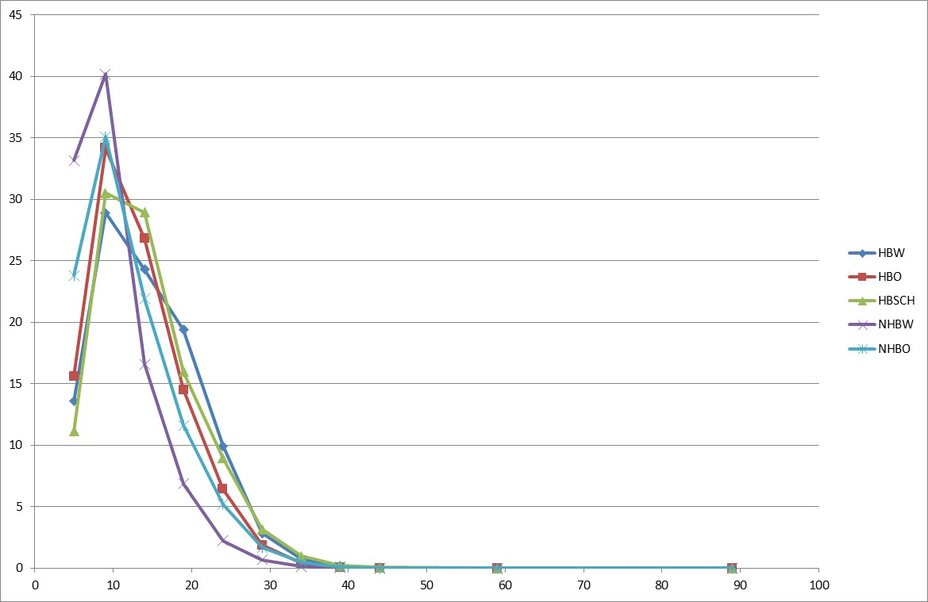

# Mode Split

## Introduction

The Cleveland trip generation model estimates person trips. Before these trips can be assigned to the highway network, factors must be applied to convert the person trips to auto trips. This conversion is accomplished through the application of mode split factors.

## Mode Split Factors

A simple mode split approach involves applying mode share factors to the person trip tables for the internal trip purposes (HBW, HBO, HBSCH, NHBW, and NHBO) in order to convert the person trips to auto person trips. The conversion from person trips to person auto trips uses uniform mode share values by trip purpose. Mode split values were asserted based on previous experience with travel surveys from similar sized communities. These values are summarized in Table 16.

Table 16: Applied Mode Shares

|  |  |  |
| --- | --- | --- |
| Purpose | Auto | Non-Auto |
| HBW | 94.6% | 5.4% |
| HBO | 93.7% | 6.3% |
| HBSCH | 93.7% | 6.3% |
| NHBW | 94.6% | 5.4% |
| NHBO | 95.2% | 4.8% |

Auto and non-auto trips purpose are shown in Table 17.

Table 17: Auto and Non-Auto Trips by Purpose

|  |  |  |  |
| --- | --- | --- | --- |
| Purpose | Auto | Non-Auto | Total |
| HBW | 82,258 | 4,696 | 86,954 |
| HBO | 168,696 | 11,343 | 180,039 |
| HBSCH | 17,232 | 1,159 | 18,391 |
| NHBW | 37,074 | 2,117 | 39,191 |
| NHBO | 78,379 | 3,952 | 82,331 |
| Total | 383,639 | 23,267 | 406,906 |

# Commercial Vehicles

## CV Generation

The Commercial Vehicle (CV) trip generation model uses a regression model for both trip productions and trip attractions. Trip productions and attractions are based on employment by employment type. The final trip production and attraction rates for the Cleveland model are shown in Table 18and Table 19.

Table 18: CV Trip Production Rates

|  |  |  |  |  |  |  |
| --- | --- | --- | --- | --- | --- | --- |
|  | Employment Type | |  |  |  |  |
| CV Type | Industry | Retail | High Traffic Retail | Service | Office | Households |
| CV1 (Auto/Vans) | 11.762 | 14.316 | 14.316 | 17.562 | 17.562 | 0.151 |
| CV2 (Pickups) | 23.863 | 34.648 | 34.648 | 24.725 | 24.725 | 0.390 |
| CV3 (Trucks) | 26.902 | 32.807 | 32.807 | 30.811 | 30.811 | 0.040 |

Table 19: CV Trip Attraction Rates

|  |  |  |  |  |  |  |
| --- | --- | --- | --- | --- | --- | --- |
|  | Employment Type | |  |  |  |  |
| Type | Industry | Retail | High Traffic Retail | Service | Office | Households |
| CV1 (Auto/Vans) | 0.120 | 0.199 | 0.150 | 0.060 | 0.072 | 0.011 |
| CV2 (Pickups) | 0.169 | 0.226 | 0.186 | 0.141 | 0.073 | 0.006 |
| CV3 (Trucks) | 0.519 | 0.463 | 0.346 | 0.145 | 0.159 | 0.025 |

The production and attraction models were applied for three commercial vehicle trip purposes: autos/vans (CV1), pickups (CV2), and trucks (CV3) and the final validation results are summarized in Table 20.

Table 20: CV Trip Generation Results

|  |  |  |  |
| --- | --- | --- | --- |
| Trip Purpose | Productions | Attractions | P/A |
| CV1 (Auto/Vans) | 6,803 | 6,787 | 1.00 |
| CV2 (Pickups) | 9,202 | 9,209 | 1.00 |
| CV3 (Trucks) | 20,707 | 20,726 | 1.00 |
| Total | 36,712 | 36,722 | 1.00 |

## CV Distribution

The trip distribution model for the commercial vehicle trip purpose started with the NHB trip purpose generalized cost value for the impedance measure, but these values were modified during model calibration. The final gamma coefficients for the Cleveland model are shown in Table 21.

Table 21: CV Gamma Coefficients

|  |  |  |  |
| --- | --- | --- | --- |
| Trip Purpose | a | b | c |
| CV1 (Auto/Vans) | 2,983.1 | 1.3076 | 0.0782 |
| CV2 (Pickups) | 2,983.1 | 1.3076 | 0.0782 |
| CV3 (Trucks) | 2,983.1 | 1.0461 | 0.0782 |

The trip distribution procedure was applied using the balanced productions and attractions from the trip generation step, the zone to zone impedance measures, and the gamma coefficients. The results from the model are shown in Table 22.

Table 22: CV Trip Distribution Results

|  |  |  |  |  |
| --- | --- | --- | --- | --- |
| Trip Purpose | Generalized Cost | Travel Time (min) | Distance (miles) | Intrazonal % |
| CV1 (Auto/Vans) | 11.48 | 6.45 | 2.84 | 19.9 |
| CV2 (Pickups) | 11.33 | 3.37 | 2.80 | 20.1 |
| CV3 (Trucks) | 12.51 | 7.00 | 3.11 | 17.8 |

# External Trips

## Introduction

External travel can be defined as through traffic, external-internal travel, and internal- external travel. Through traffic is defined as having both trip ends external to the study area. External-internal or internal-external travel is defined as having one trip end external to the study area.

## Through Trip Table

The through trip table for the Cleveland model was synthesized using a synthetic estimation procedure developed by Dr. David Modlin and documented in Transportation Research Record 842. The external traffic count data and roadway functional classification were provided by TDOT. The value for percent trucks was assumed based on the traffic volume and the functional classification. The station data inputs for the synthetic process are summarized in Table 23. The internal-external trip productions are also shown in this table.

Table 23: External Station Input Data for Through Trip Table

|  |  |  |  |  |  |
| --- | --- | --- | --- | --- | --- |
| Station ID | Route | Functional Classification | AADT (2018) | % EE | IE/EI Productions |
| 1001 | I 75 | Interstate | 41,776 | 85.0 | 6,266 |
| 1002 | SR 2 / US 11 | Principal Arterial | 4,310 | 17.9 | 3,539 |
| 1003 | CR 700 | Minor Collector | 1,195 | 5.3 | 1,131 |
| 1004 | CR 750 | Minor Collector | 1,789 | 15.0 | 1,521 |
| 1005 | CR 660 | Minor Collector | 666 | 8.7 | 608 |
| 1006 | SR 163 / Etowah Rd | Minor Collector | 3,030 | 13.8 | 2,612 |
| 1007 | Athens Rd | Minor Collector | 659 | 9.0 | 600 |
| 1008 | Upper River Rd | Minor Collector | 761 | 5.7 | 718 |
| 1009 | Bakers Bridge Rd | Minor Collector | 859 | 6.0 | 808 |
| 1010 | SR 33 / Benton Pike | Local | 2,110 | 9.2 | 1,916 |
| 1011 | SR 40 / Waterlevel | Principal Arterial | 19,645 | 45.0 | 10,805 |
| 1012 | SR 313 / Ladd Springs | Local | 940 | 3.2 | 910 |
| 1013 | Spring Place Road | Major Collector | 1,693 | 45.0 | 931 |
| 1014 | Keith Valley Road | Local | 421 | 4.0 | 404 |
| 1015 | SR 60 / Dalton Pike | Minor Arterial | 4,528 | 30.0 | 3,170 |
| 1016 | SR 317 / Weatherly Switch | Minor Collector | 1,031 | 3.4 | 996 |
| 1017 | US 11 / SR 2 / S Lee Hwy | Minor Arterial | 6,411 | 18.9 | 5,199 |
| 1018 | I 75 | Interstate | 61,997 | 60.0 | 24,799 |
| 1019 | SR 312 | Local | 2,968 | 15.9 | 2,497 |
| 1020 | SR 60 / Georgetown Pike | Principal Arterial | 7,100 | 22.2 | 5,525 |
| 1021 | SR 306 / Lower River Rd | Major Collector | 2,960 | 9.9 | 2,666 |
| 1022 | CR 20 | Minor Collector | 607 | 3.8 | 584 |
| 1023 | CR 57 | Minor Collector | 163 | 7.6 | 151 |
|  | Total |  | 167,619 |  | 78,356 |

Study area population and route continuity are both required inputs to the synthetic process. The study area population was input as 114,948 to develop base year through trip table. The route continuity is shown in Table 24.

Table 24: Route Continuity

|  |  |
| --- | --- |
| From Station | To Station |
| 1001 | 1018 |
| 1018 | 1001 |

## IE/EI Trip Generation

The simplifying assumption for the Cleveland model is that all IE/EI productions are made at the external stations. Trip attractions are based on employment type and total households in a zone. Including the households in the attraction equation recognizes that, even with the simplifying assumption of all productions at the external stations, some external trips are a result of trips produced by households in the region, not just employment attractions made by households outside of the region. The trip attraction rates for the external station trips are shown in Table 25.

Table 25: IE/EI Trip Attraction Rates

|  |  |  |  |  |  |  |
| --- | --- | --- | --- | --- | --- | --- |
| Purpose | Households | Industry | Retail | Highway Retail | Service | Office |
| IE/EI | 0.764 | 0.788 | 1.135 | 0.649 | 0.649 | 0.649 |

The final application of the external station trip generation model yields the results summarized in Table 26. The normalization factor for the P/A ratio is within range as expected given the reasonableness checks and model adjustments performed for the through trip analysis.

Table 26: IE/EI Trip Generation Statistics

|  |  |  |  |
| --- | --- | --- | --- |
| Purpose | Productions | Attractions | Normalization Factor (P/A ratio) |
| IE/EI | 78,356 | 78,395 | 1.00 |

The trip distribution model for the external station trip purpose uses a generalized cost value for the impedance measure and the gamma function for the friction factors. The final gamma coefficients for the external trip model are documented in Table 27.

Table 27: IE/EI Gamma Coefficients

|  |  |  |  |
| --- | --- | --- | --- |
| Purpose | a | b | c |
| IE/EI | 2983.1 | 4.184 | 0.156 |

The trip distribution procedure was iteratively applied using the balanced productions and attractions, the zone to zone impedance measures, and gamma coefficients. The final results are shown in Table 28.

Table 28: IE/EI Trip Distribution Results

|  |  |  |  |  |
| --- | --- | --- | --- | --- |
| Purpose | Generalized Cost | Travel Time | Distance | Intrazonal % |
| IE/EI | 32.02 | 13.75 | 10.3 | 0 |

# Time of Day

## Introduction

The need to participate in various activities in most, if not all, study areas varies throughout the day and as such the travel (traffic) required for participating in these activities varies throughout the day. Time-of-day factors and peak/off-peak traffic assignments are recommended for any urban area that has or will require design, capacity and level of service guidance from the planning process, regardless of its size. Daily traffic assignments cannot reflect the effect of volume delay on route choice and therefore cannot be used to forecast congested conditions or the effects of increases in highway capacity on traffic congestion.

## Model Form and Application

The conversion of daily trips to trips by time of day is accomplished by applying departure and return factors by trip purpose for each hour of the day. The different departure and return factors by trip purpose capture the different peaking characteristics for the different trip purposes as well as the fact that the departures and returns by time of day vary by trip purpose. The use of departure and return factors by time of day also converts the trip tables from production/attraction (P/A) format to origin/destination (O/D) format. The only trip purpose where this is not necessary is through trips (EE) as these trips are already in O/D format. Table 29 summarizes the departure and return factors for the internal trip purposes by time of day. These factors were derived from work performed for the North Carolina Department of Transportation on the development of a combined household travel survey database representing travel survey results from several communities across North Carolina. The commercial vehicle trip purposes and the IE/EI trip purposes use the factors for the NHBO trip purpose. The percent flow factors for the EE trips are also provided in this table.

Table 29: Time of Day Factors

|  |  |  |  |  |  |  |  |  |  |  |  |
| --- | --- | --- | --- | --- | --- | --- | --- | --- | --- | --- | --- |
|  | HBW | | HBSCH | | HBO | | NHBW | | NHBO | | EE |
| Hour | Dep | Ret | Dep | Ret | Dep | Ret | Dep | Ret | Dep | Ret | %Flow |
| 0 | 0 | 0.05 | 0 | 0 | 0 | 0.02 | 0 | 0 | 0 | 0 | 0.02 |
| 1 | 0.05 | 0.59 | 0 | 0.17 | 0.04 | 0.33 | 0 | 0 | 0.04 | 0.04 | 0.29 |
| 2 | 0 | 0.20 | 0 | 0 | 0 | 0.03 | 0.02 | 0 | 0.02 | 0.02 | 0.07 |
| 3 | 0.15 | 0.04 | 0 | 0 | 0.03 | 0.03 | 0 | 0.03 | 0.02 | 0.02 | 0.08 |
| 4 | 0.32 | 0.03 | 0 | 0 | 0.07 | 0.04 | 0 | 0.06 | 0.02 | 0.02 | 0.13 |
| 5 | 1.82 | 0 | 0 | 0 | 0.32 | 0.04 | 0 | 0.49 | 0.07 | 0.07 | 0.63 |
| 6 | 6.54 | 0.08 | 0.88 | 0 | 1.00 | 0.11 | 0.14 | 2.01 | 0.12 | 0.12 | 2.23 |
| 7 | 15.46 | 0.12 | 18.55 | 0 | 3.57 | 0.68 | 0.29 | 7.25 | 1.10 | 1.10 | 7.20 |
| 8 | 11.94 | 0.26 | 20.29 | 0 | 4.70 | 1.78 | 0.89 | 11.42 | 2.88 | 2.88 | 8.77 |
| 9 | 4.24 | 0.18 | 3.92 | 0.34 | 4.31 | 1.68 | 1.73 | 4.21 | 2.61 | 2.61 | 5.31 |
| 10 | 1.62 | 0.28 | 0.90 | 0.41 | 3.56 | 1.57 | 2.31 | 1.82 | 3.43 | 3.43 | 4.61 |
| 11 | 0.55 | 0.47 | 0.42 | 0.28 | 3.40 | 2.66 | 3.17 | 2.19 | 4.40 | 4.40 | 5.42 |
| 12 | 0.85 | 1.59 | 0.49 | 1.80 | 2.71 | 3.08 | 7.78 | 3.94 | 4.70 | 4.70 | 6.72 |
| 13 | 1.33 | 1.26 | 0.35 | 2.36 | 2.59 | 2.83 | 4.76 | 7.42 | 4.82 | 4.82 | 6.66 |
| 14 | 1.17 | 1.52 | 0.52 | 4.48 | 3.00 | 2.87 | 3.29 | 4.52 | 4.56 | 4.56 | 6.23 |
| 15 | 0.91 | 4.11 | 0.44 | 15.60 | 3.42 | 3.85 | 4.98 | 1.90 | 5.47 | 5.47 | 8.01 |
| 16 | 0.59 | 7.13 | 0.96 | 8.63 | 2.91 | 4.49 | 5.77 | 0.94 | 4.20 | 4.20 | 7.73 |
| 17 | 0.56 | 14.49 | 0.98 | 4.06 | 3.37 | 4.88 | 8.73 | 0.96 | 3.65 | 3.65 | 9.45 |
| 18 | 0.71 | 9.75 | 0.88 | 3.89 | 4.49 | 4.80 | 3.82 | 0.43 | 3.37 | 3.37 | 7.94 |
| 19 | 0.38 | 3.25 | 0.20 | 1.66 | 4.03 | 4.14 | 1.50 | 0.16 | 1.97 | 1.97 | 4.90 |
| 20 | 0.05 | 1.30 | 0.25 | 1.88 | 1.57 | 4.26 | 0.45 | 0.13 | 1.55 | 1.55 | 3.40 |
| 21 | 0.25 | 1.37 | 0 | 2.65 | 0.67 | 3.69 | 0.22 | 0 | 0.75 | 0.75 | 2.50 |
| 22 | 0.38 | 0.83 | 0 | 1.82 | 0.18 | 1.58 | 0.17 | 0.11 | 0.23 | 0.23 | 1.12 |
| 23 | 0.16 | 1.16 | 0 | 0 | 0.10 | 0.62 | 0 | 0.05 | 0.07 | 0.07 | 0.58 |

## Vehicle Occupancy Factors

During the time of day procedure average auto occupancy factors by time of day and trip purpose are applied to the HBW, HBO, HBSCH, NHBW, and NHBO trip tables to convert auto person trip tables to auto vehicle trip tables. The vehicle occupancy factors used for this purpose and are shown in Table 30. These factors were asserted based on previous experience with travel surveys from similar sized communities.

Table 30: Vehicle Occupancy Factors by Purpose and Time Period

|  |  |  |  |  |
| --- | --- | --- | --- | --- |
| Purpose | AM | MD | PM | OP |
| HBW | 1.05 | 1.07 | 1.05 | 1.05 |
| HBO | 1.48 | 1.31 | 1.52 | 1.52 |
| HBSCH | 2.07 | 1.58 | 1.99 | 1.23 |
| NHBW | 1.09 | 1.18 | 1.09 | 1.10 |
| NHBO | 1.57 | 1.39 | 1.61 | 1.73 |

# Trip Assignment

## Introduction

The final step in the travel demand model is trip assignment. This is the process of assigning the zone to zone trips to the individual links in the highway network. This step is performed iteratively with overall model calibration and validation. When overall model calibration and validation is achieved, as measured by established performance measures, the trip assignment step provides the data needed for: 1) testing alternative transportation plans; 2) establishing priorities between different transportation investment strategies; 3) analyzing alternative locations for roadway improvements; and forecasting design volumes needed to adequately design and construct new roadway facilities. The reliability of the output from this step is dependent upon the reliability of all the proceeding steps.

## Highway Assignment

The algorithms used in traffic assignment attempt to replicate the process of choosing the best path between a given origin and destination. For the Cleveland Metropolitan Planning Organization (MPO) model, the algorithm used for assignment is an equilibrium assignment. This is a widely accepted, best practice approach that produces link loadings by optimally seeking user-equilibrium path loadings reflecting user path choices as influenced by congestion on the network. During the assignment process, the trip table is assigned to the highway network over multiple iterations. At the end of the iteration, link travel times are recalculated using the total link demand and compared to the link travel times of the previous iteration. The aggregate change of link travel times between the current iteration and the previous is compared against the convergence criteria. Thus, the number of iterations is determined by a user defined closure parameter (set to 0.001 for the Cleveland MPO model) or for a maximum number of iterations (set to 25 for the Cleveland MPO model). The final assignment represents an optimum combination of previous assignments using the Frank-Wolfe algorithm.

For each iteration, a volume-delay function is used to update the link speeds based on the previous iteration’s vehicle demand and the link capacity. A Conical-delay function was used for the Cleveland MPO model; the formulation of this function is shown below and the corresponding alpha parameter by facility type is shown in Table 6.

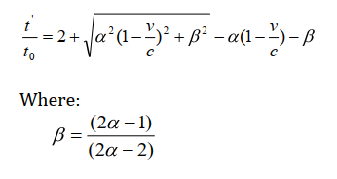

Highway trip assignment is performed separately for the AM peak period (6:00 AM – 9:00 AM), Midday period (9:00 AM – 3:00 PM), the PM peak period (3:00 PM – 6:00 PM), and the Off-Peak period (6:00 PM – 6:00 AM). At the end of the assignment procedure, the time period assignments are summed to produce a daily traffic assignment.

## Model Results

There are three basic comparisons made when comparing actual traffic counts to trip assignment results: 1) global measures of vehicle miles traveled (VMT); 2) comparisons by screen line, volume group, and facility type, and 3) link level comparisons.

Following an iterative calibration and validation process, acceptable performance measures were achieved. This section describes the final highway trip assignment results.

### Vehicle Miles Travelled (VMT)

At the regional level, comparisons of VMT provide useful information on how well the model understands the magnitude and geographic distribution of travel. In general, study area model VMT should be within 5% of observed VMT.

Table 31 summarizes calibrated base year VMT results for the Cleveland MPO model. The model VMT is within the range of TDOT guidelines when compared to observed VMT.

Table 31: Vehicle Miles Travelled by Facility Type

|  |  |  |  |  |  |
| --- | --- | --- | --- | --- | --- |
|  | Observed |  |  | TDOT | |
| Facility Type | VMT | Model VMT | % Deviation | Acceptable | Preferable |
| Freeways/Highways | 786,558 | 810,008 | 3.0% | 7% | 6% |
| Arterials | 308,345 | 289,851 | -6.0% | 15% | 10% |
| Collectors/Local | 209,456 | 245,374 | 17.1% | 25% | 20% |
| Total | 1,304,359 | 1,345,233 | 3.1% | 5% | 2% |

### Screenline and Cutline Comparisons

The Cleveland model utilizes two screenlines and one cordon:

* 1. Screenline 1 runs east to west north of town and captures the north-south flow into town from the north.
  2. Screenline 2 runs east to west south of town and captures the north-south flow into town from the south.
  3. The cordon captures flow into and out of the core of the Cleveland community.

The screenlines and cordon are shown in Figure 4.

Figure 4: Screenline and Cordonline Locations

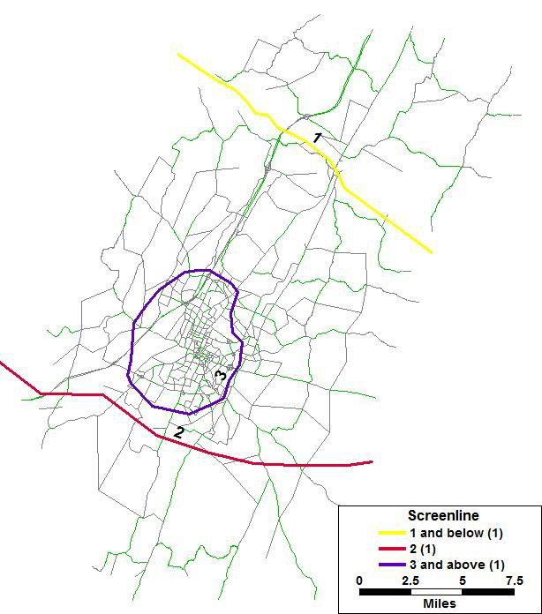

When properly developed, screenline and cutline comparisons provide a good check on the need for possible adjustments to the upper level models. If all screenlines are either high or low this may indicate a need to make global adjustments to daily trip generation. If some screenlines are high while others are low then this may be an indication that changes are needed in the trip distribution model, or may point to issues in the underlying transportation network.

Table 32 provides total model and observed volumes for screenlines and cordon line. Screenline 1 performs really well. Screenline 2 has 7% overprediction of traffic volume but within the TDOT acceptable limit. The Cordon provides a better picture of overall flow into and out of the core part of the region and is well within an acceptable range.

Table 32: Screenline Traffic Volume Results

|  |  |  |  |  |
| --- | --- | --- | --- | --- |
| Screenline | Observed Volume | Model Volume | % Deviation | TDOT |
| 1 | 150,568 | 150,481 | -0.1% | 10% |
| 2 | 85,808 | 91,824 | 7.0% | 10% |
| Cordon | 53,562 | 61,299 | 14.4% | 20% |

### RMSE Comparison by Volume Group and Facility Type

At the link level, several comparisons were made including link assignment summaries by volume group and facility type and a measure of the percent root mean square error (%RMSE). The %RMSE is a measure of the variance between the observed and modeled volumes (numerator), normalized by the average of the observed data (denominator) and is expressed as a percent. The formula is as follows:

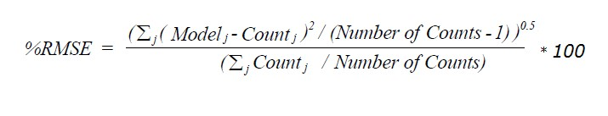

Since the differences between model and observed are squared before they are averaged, the RMSE gives a relatively high weight to large errors. This means the %RMSE is most useful when large errors are particularly undesirable. TDOT targets for the %RMSE are given in the Table 33 and Table 34 depending on facility type and volume group. The %RMSE should decrease as volumes increase – thus for facility types with high volumes such as freeways, the %RMSE is expected to be lower (model volumes should better match observed volumes) than %RMSE measured on facility types with low volumes such as collectors.

The %RMSE by facility type and volume group is summarized in Table 33 and Table 34. By facility type, all facilities are within the target range. The volume group comparison also shows that all targets have been met, and the overall %RMSE is within preferable 35%.

Table 33: Percent RMSE by Facility Type

|  |  |  |  |
| --- | --- | --- | --- |
| Facility Type | Observations | % RMSE | TDOT |
| Freeways/Highways | 27 | 18.7 | 20 |
| Arterials | 73 | 28.3 | 40 |
| Collectors | 73 | 55.6 | 70 |

Table 34: Percent RMSE by Volume Group

|  |  |  |  |  |
| --- | --- | --- | --- | --- |
|  |  |  | TDOT* |  |
| Volume Group | Observations | % RMSE | Acceptable | Preferable |
| 0 to 4,999 | 99 | 63 | 100 | 45 |
| 5,000 to 9,999 | 38 | 34 | 45 | 35 |
| 10,000 to 19,999 | 22 | 24 | 35 | 25 |
| 20,000 to 39,999 | 31 | 17 | 27 | 15 |
| 40,000 to 59,999 | - | NA | 20 | 10 |
| 60,000 and greater | - | NA | 19 | 10 |
| Total | 190 | 31 | 45 | 35 |

### Model Volume to Count Comparison

Table 35 provides a summary of the assignment results by comparing the daily count to the daily model volume by volume group. The percent difference is calculated and compared to recommended target values by the TDOT. Total model volumes for all volume groups are within the recommended range of total observed volumes.

Table 35: Assignment Summary by Volume Group

|  |  |  |  |  |  |
| --- | --- | --- | --- | --- | --- |
| Volume Group | Count Volume | Model Volume | % Deviation | TDOT Guidelines | |
| FHWA | Michigan |
| < 1,000 | 13,647 | 18,765 | 37.5% | 200 | 60 |
| 1,001 - 2,500 | 60,186 | 80,420 | 33.6% | 100 | 47 |
| 2,501 - 5,000 | 146,160 | 145,705 | -0.3% | 50 | 36 |
| 5,001 - 10,000 | 280,064 | 272,748 | -2.6% | 25 | 29 |
| 10,001 - 25,000 | 634,166 | 624,033 | -1.6% | 20 | 25 |
| 25,001 - 50,000 | 472,378 | 415,521 | -12.0% | 15 | 22 |
| > 50,001 | - | - |  | 10 | 21 |

Finally, the model and observed daily volumes by link were plotted and the r-squared value was calculated as a final indication of the degree to which the counts and estimated volumes match. The r-squared value is, in part, a function of the number of observations and therefore it is difficult to establish a guideline for acceptable values of r-squared. In general, a high r-squared value is desirable.

Figure 5 shows a scatter plot of model versus observed volumes by link. The diagonal line on the graph is defined by the set of points where the model volume equals the observed count. If all counts fell along this line the r-squared value would be equal to one. The highway traffic assignment for the Cleveland model shows a tight fit between the observed and estimated values.

Figure 5: Link Level Model Volume vs Count Scatterplot

Summary

The results reported in this report suggests that the model is performing within acceptable standards, indicating that the model is representing base year travel demand within the Cleveland MPO model region.

# Future Year Model Development

## Introduction

Upon completion of the calibration and validation of the 2018 base year TDM, the model was then developed for future year 2045.

## Land Use Data

The traffic analysis zones were not changed for the future year models. Future socioeconomic data was developed and approved by the MPO based on identified areas that are anticipated to experience growth in population, households and employment. Table 36 shows summary on 2045 future year population and employment totals.

Table 36: Future Year (2045) Model Socioeconomic Data Summary

|  |  |
| --- | --- |
| Variable | Total |
| Households | 52,312 |
| Household Population | 133,413 |
| Group Quarter Population | 4,113 |
| Vehicles | 91,797 |
| Students | 21,512 |
| Employment by Type |  |
| Industry | 30,198 |
| Retail | 10,618 |
| High Traffic Retail | 7,585 |
| Service | 22,811 |
| Office | 12,072 |
| Total Employment | 83,284 |

## Highway Network

Existing plus Committed (EC) 2045 future year scenario was developed including routes that currently exists in the 2018 base year network plus any projects that are committed with construction funds between 2019 and 2045. Table 37 shows the specific roadway improvements included in the 2045 EC network.

Table 37: Committed Projects included in 2045 Highway Network

|  |  |  |  |
| --- | --- | --- | --- |
| **Route** | **Termini** | **Miles** | **Description** |
| SR-60 | From near Westlake Drive to near SR-306 | 2.6 | Widen from 4-lane and from 2-lane to 5-lane |
| US-11/SR-2 (N. Lee Hwy) | From near Anatole Lane to SR-308 in Charleston | 4.1 | Widen to a 5-lane typical section from near Anatole Road to Near SR-308 |
| I-75 | From north of US 64 to US 74 | 4.6 | Widen from 4 to 6 lanes |

## Externals

External model input data including through trip table and internal-external productions for all external stations, were developed for the 2045 future year scenario and shown in Table 38. The external station growth rates were calculated based on the daily link volumes taken from 2010 and 2040 model scenarios from TDOT statewide model. The 2018 AADT traffic count data was grown to year 2045 using the growth rates for all external stations. The percent through trips at each of the external stations used in the base year model were also used in the future year scenario while developing the 2045 through trip table. The table below also shows 2045 internal-external and external-internal trip productions for external stations.

Table 38: Future Year (2045) External Model Input Data

|  |  |  |  |  |  |  |
| --- | --- | --- | --- | --- | --- | --- |
| Station ID | Name | Growth Rate | AADT (2018) | AADT (2045) | % EE | IE/EI Productions |
| 1001 | I 75 | 1.0% | 41,776 | 54,010 | 85.0 | 8,102 |
| 1002 | SR 2 / US 11 | 1.4% | 4,310 | 6,240 | 17.9 | 5,124 |
| 1003 | CR 700 | 0.5% | 1,195 | 1,380 | 5.3 | 1,306 |
| 1004 | CR 750 | 1.3% | 1,789 | 2,510 | 15.0 | 2,134 |
| 1005 | CR 660 | 0.5% | 666 | 760 | 8.7 | 694 |
| 1006 | SR 163 / Etowah Rd | 0.6% | 3,030 | 3,560 | 13.8 | 3,069 |
| 1007 | Athens Rd | 0.8% | 659 | 820 | 9.0 | 746 |
| 1008 | Upper River Rd | 0.5% | 761 | 870 | 5.7 | 820 |
| 1009 | Bakers Bridge Rd | 0.8% | 859 | 1,050 | 6.0 | 988 |
| 1010 | SR 33 / Benton Pike | 1.3% | 2,110 | 3,010 | 9.2 | 2,733 |
| 1011 | SR 40 / Waterlevel | 1.2% | 19,645 | 26,760 | 45.0 | 14,718 |
| 1012 | SR 313 / Ladd Springs | 0.7% | 940 | 1,130 | 3.2 | 1,094 |
| 1013 | Spring Place Road | 0.5% | 1,693 | 1,940 | 45.0 | 1,067 |
| 1014 | Keith Valley Road | 0.5% | 421 | 480 | 4.0 | 461 |
| 1015 | SR 60 / Dalton Pike | 1.8% | 4,528 | 7,250 | 30.0 | 5,075 |
| 1016 | SR 317 / Weatherly Switch | 1.9% | 1,031 | 1,720 | 3.4 | 1,661 |
| 1017 | US 11 / SR 2 / S Lee Hwy | 1.6% | 6,411 | 9,800 | 18.9 | 7,948 |
| 1018 | I 75 | 1.1% | 61,997 | 82,980 | 60.0 | 33,192 |
| 1019 | SR 312 | 1.6% | 2,968 | 4,570 | 15.9 | 3,845 |
| 1020 | SR 60 / Georgetown Pike | 1.1% | 7,100 | 9,650 | 22.2 | 7,510 |
| 1021 | SR 306 / Lower River Rd | 1.0% | 2,960 | 3,840 | 9.9 | 3,459 |
| 1022 | CR 20 | 1.5% | 607 | 910 | 3.8 | 875 |
| 1023 | CR 57 | 0.7% | 163 | 200 | 7.6 | 185 |
|  | Total |  | 167,619 | 225,440 |  | 106,806 |

1. See “Cleveland TDM Final Documentation March 2016.pdf” dated March 8, 2016
2. See “Minimum Travel Demand Model Calibration and Validation Guidelines for State of Tennessee.pdf”.
3. See “Cleveland MPO Memo Draft.docx” for more details on TAZ boundary edits performed in 2019