SHELFLINE
Data Migration & Validation
Excel Source Integration — Pipeline, Formulas, and Reconciliation

Source workbook: Main Working File.xlsx (Content · Price · Share Of Search)
117 SKUs · 7 retailers · September 2022 crawl
September 1, 2026

Table of Contents

(Right-click and choose “Update Field”, or press F9, to populate this table of contents after opening the document in Word.)

A. Project Overview

Purpose of the project
Shelfline is a digital shelf intelligence dashboard that tracks a portfolio of products across multiple retailers on five dimensions: availability, pricing, content quality, search rank, and reviews. It is built as a client-only proof-of-concept — there is no backend server; the entire data layer is a single TypeScript module (app/src/data/mockData.ts) written so that swapping it for real API calls later is a one-file change. The application itself (routing, pages, charts, tables) was not part of this engagement and was left unchanged.

Objective of this update
The application previously ran on a hand-curated 116-SKU slice of a September 2022 retailer crawl across six retailers. The objective of this engagement was to replace that dataset end-to-end with a new source workbook, Main Working File.xlsx, while preserving the application's existing logic, page structure, and visual design, and to verify — metric by metric — that every number the dashboard displays is either a real, traceable value from the new workbook or is clearly and consistently labeled as illustrative where no real source data exists for it.
- Replace the product catalog and every derived “real data” table with values computed from the new workbook.
- Map each of the workbook's three tabs (Content, Price, Share Of Search) to the fields and pages that consume them.
- Resolve data-quality issues found in the new source (inconsistent retailer-name casing, a keyword-level rather than SKU-level search dataset, free-text stock status, missing crawl coverage for a handful of SKUs) with a documented, reproducible rule for each.
- Verify accuracy by reconciling a representative sample of dashboard values directly against the raw workbook, and by building/type-checking/linting/browser-testing the application end to end.
- Document the full pipeline, every metric's formula, and every dashboard section, with annotated screenshots, so a reader can look at any number on the dashboard and know exactly where it came from.

Description of the new Excel file
Main Working File.xlsx is a real September 2022 retailer crawl covering 7 retailer sites — Amazon.com, Chewy, Walmart, The Home Depot, PetSmart, Lowe's, and Petco (new to this file) — organized as three tabs:
- Content — 585 rows: one row per tracked product per weekly crawl (5 crawls: Sep 1, 8, 15, 22, 29). Carries product identity (brand, title, category), and every real content-quality signal used to build the Content Completeness metric.
- Price — 3,510 rows: one row per tracked product per daily crawl (up to 30 days across September). Carries list/current price, stock status, and the buy-box-seller field.
- Share Of Search — 280 rows: one row per (keyword × retailer site × weekly crawl) (4 crawls: Sep 8, 15, 22, 29), across 10 generic search keywords. Carries the ranked list of product URLs returned for that keyword on that site that day.
Across the three tabs, 117 distinct products are tracked (identified by the Content tab's Retailer id + Retailer site pair); a further 4 Petco SKUs appear in the Price tab only and were excluded from the catalog (see Section G — Known Limitations).

The three data tabs, at a glance
Tab | Rows | Grain | Identifies | Feeds
Content | 585 | Weekly (5 crawls) | Product identity, brand, category, title, rating, review count | Catalog identity · Content Completeness rubric · Average Rating · Review Count
Price | 3,510 | Daily (30 crawls) | Per-day price, stock status, buy box seller | Price · Price Index · Availability · Buy Box Presence · buy-box-loss detection
Share Of Search | 280 | Weekly (4 crawls) | Keyword-level ranked search results per site | Search Visibility (retailer/portfolio level, “Last 4 weeks” only)

B. Data Source Documentation
This section documents, tab by tab, exactly which raw columns are consumed, what each is used for, how it maps into the application's catalog/derived tables, and which dashboard metrics it ultimately produces. All mapping logic lives in app/scripts/build_mock_data.py, the ETL script written for this migration.

B.1 — Content tab
Purpose: Establishes which products are tracked (catalog identity) and supplies every real signal behind the Content Completeness metric, plus the real weekly Rating and Review Count series.

Columns used
Column(s) | Used for
Crawl date | Selects which of the 5 real weeks (Sep 1/8/15/22/29) a row belongs to
Retailer id, Retailer site | Product identity key: catalog id = "{retailerCode}-{Retailer id}"
Brand, Title, Category name | catalog[].brand / .name / .category (category normalized: PET→GPC, H&G→HG — see note below)
Rating, Total reviews | catalog[].rating / .reviews (latest week) and REAL_PRODUCT_WEEKLY[id].rating / .reviews (all 5 weeks, verbatim)
Title, Title no of chars | Content-completeness “Title” bucket (20% weight)
Product description, Description no of chars, No of bullets | Content-completeness “Description” bucket (15% weight)
Front image, No of images, No of videos, Image 360 | Content-completeness “Images” bucket (25% weight)
Varient label 1–22 / Varient value 1–22, Category 1–4 | Content-completeness “Attributes” bucket (20% weight)
Enhanced content | Content-completeness “Keywords” bucket (12% weight) — documented proxy; no direct keyword-coverage field exists in the source
Ingredients list, No of questions | Content-completeness “Specs” bucket (8% weight)
Correction to an earlier finding
During initial reconnaissance this project's data-quality notes flagged 60 “H&G” and 140 “PET” rows as stray category labels needing normalization. That finding was incorrect — re-verified independently with two different tools (openpyxl and pandas) against the final workbook, both tabs contain only GPC / HPC / HG, matching exactly. The normalization rule (PET→GPC, H&G→HG) remains in the ETL script as a harmless no-op safeguard, but it never triggers, and category assignment was never affected by this error since it is only ever read from the Content tab. Flagged here for the record, per the accuracy requirement of this engagement.

B.2 — Price tab
Purpose: Supplies the real daily price and stock history, and the buy-box-seller signal, for every tracked product.

Columns used
Column(s) | Used for
Crawl date | Bucketed into the 5 real Content weeks (ISO-week aligned) for REAL_PRODUCT_WEEKLY / REAL_ROLLUP_WEEKLY
Retailer id, Retailer site | Joins to the same product identity key used by the Content tab
Current price (falls back to List everyday price when null) | catalog[].price · REAL_PRODUCT_WEEKLY[id].price · Price Index
Stock status (free text, 29 distinct variants) | Normalized to in-stock/out-of-stock → catalog[].stockBias · REAL_PRODUCT_WEEKLY[id].stockRate · Availability
Buy box seller | Compared against the retailer's own name → catalog[].buyBoxRate · REAL_BUYBOX_COMPETITOR · Buy Box Presence

Stock-status normalization rule
A row counts as out of stock only if its Stock status text contains "out of stock", "unavailable", or "temporarily out" (case-insensitive substring match). Every other variant — including low-stock-count messages like "Only 2 left in stock - order soon." — counts as in-stock, since the item is still purchasable.

Buy-box-self rule
A day counts as “buy box held by self” if the Buy box seller text matches the retailer's own name or domain. The Home Depot and Lowe's are always treated as self — their Buy box seller field is a store/location name (e.g. “Cumberland”, “Fairbanks Lowe's”), not a genuine third-party marketplace seller, confirmed the same way the original 2022 crawl documented it.

B.3 — Share Of Search tab
Purpose: Supplies a real, retailer-level “% of tracked-keyword searches that returned a ranked result” signal for the “Last 4 weeks” period.

Columns used
Column(s) | Used for
Crawl_date | Selects which of the 4 real weeks (Sep 8/15/22/29) a row belongs to
keyword | The 10 real, tracked search terms — feeds keywordSet[].term
site | Which retailer this row's search results are for
Url_1 (presence/absence only) | Whether that keyword returned any ranked result on that site that week
Why this tab cannot populate a per-product search rank
The Share Of Search tab is keyword-level (10 generic terms like “2 slice toaster”), not SKU-level — it lists whatever products rank for a keyword, with no reliable way to attribute a specific ranked result back to one specific tracked SKU. Per-SKU search rank therefore stays a documented, synthetic value (jittered around the product's catalog position), exactly as it already was before this migration. Only the retailer- and portfolio-level roll-up (“what fraction of our tracked keywords return any result at all”) is real.

C. Data Pipeline
The pipeline has six layers. The first three run once, offline, as a Python ETL script (app/scripts/build_mock_data.py) whose output is reviewed and spliced into the application's data file. The last three run live, in the browser, every time a user changes the retailer or period filter — this is existing application logic, unmodified by this engagement.
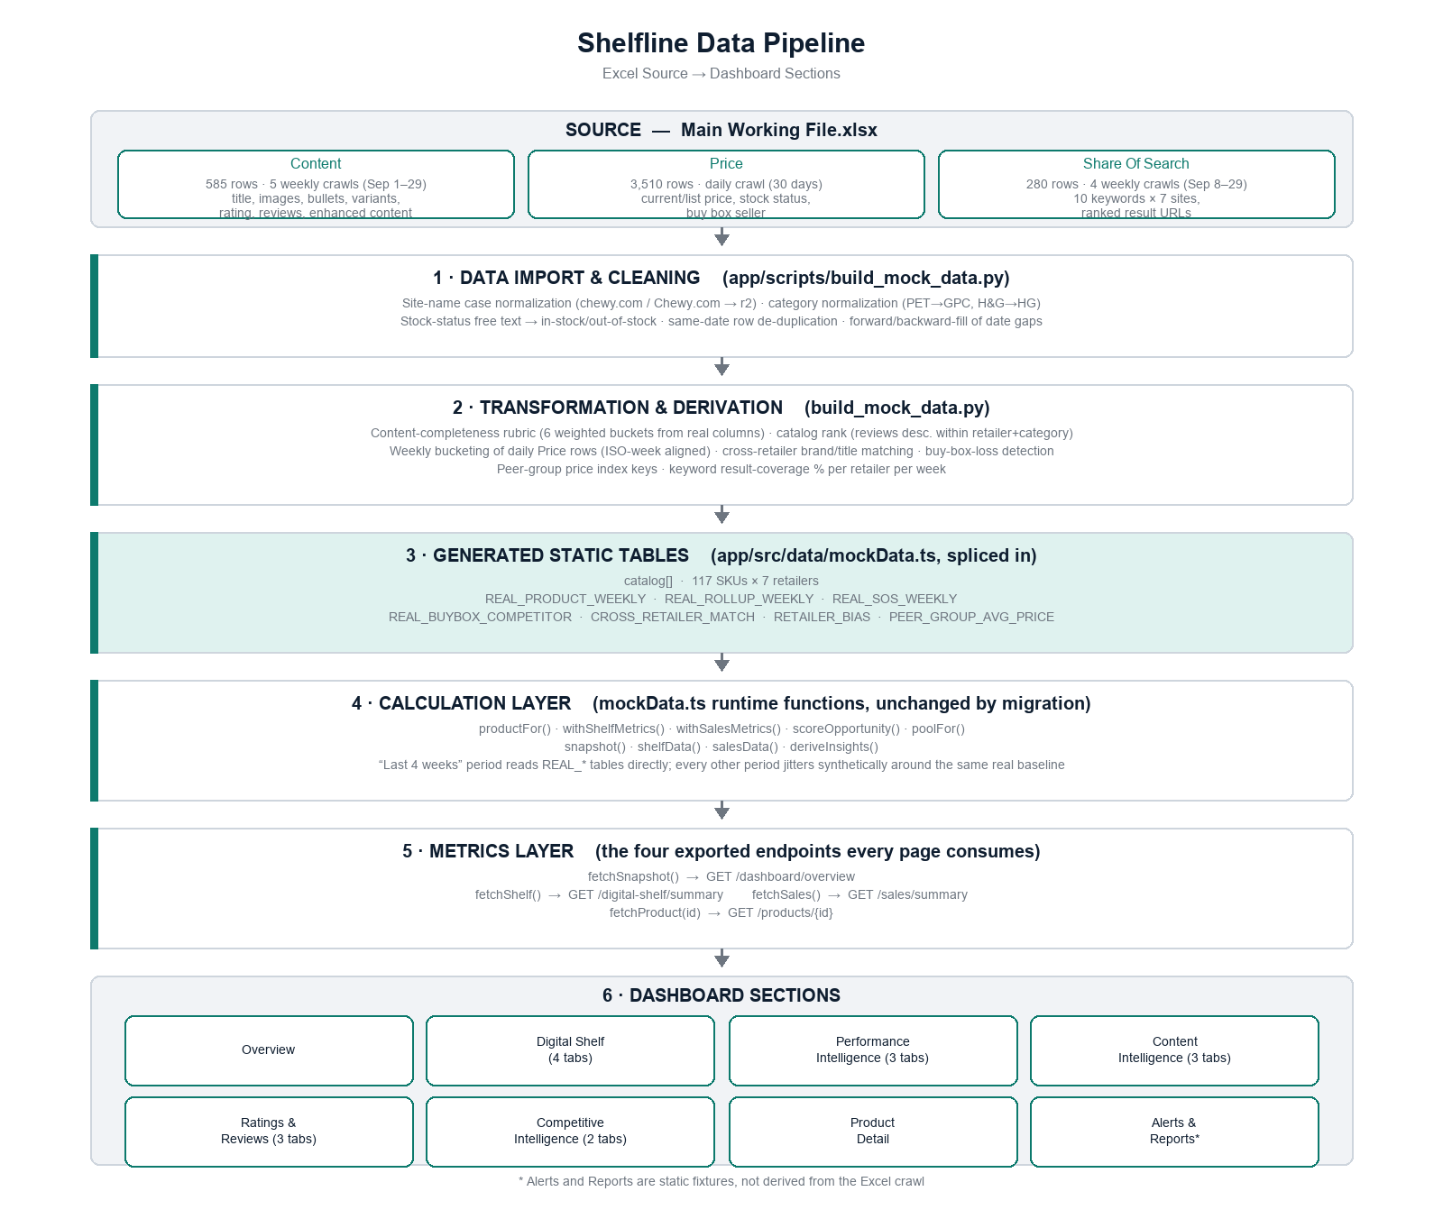
Figure C.1 — Excel source to dashboard section, full pipeline.

Layer 1 — Data Import & Cleaning
Input/source layer. Reads all three tabs with openpyxl. Normalizes:
- Retailer-site name casing (the Content tab uses "chewy.com", the Price tab uses "Chewy.com" — both map to the same retailer code r2).
- Category labels (defensive normalization; see Section B.1's correction note — it never actually triggers on this workbook).
- Stock-status free text into a binary in-stock/out-of-stock flag (rule in Section B.2).
- Duplicate same-date Price rows for a handful of Petco SKUs (keeps the last one per date).
- Date gaps: some products have sparse Price coverage (e.g. only Sep 1–2 and Sep 24–25) — missing weeks are forward-filled from the last known value, then back-filled for any gap before the first observation, so no real weekly series ever contains a missing point.

Layer 2 — Transformation & Derivation
Data processing layer. Builds every derived field that isn't a literal column in the source:
- Content-completeness score per product per week (6-bucket weighted rubric, Section E has the exact formula).
- Catalog rank: each product's position within its (retailer, category) group, ordered by review count descending — reproduced from the exact convention the original 2022 build used.
- Weekly bucketing of the 30 daily Price rows into the 5 real Content-tab week boundaries (ISO-week aligned).
- Cross-retailer product matching: same brand + ≥45% product-title token overlap, run pairwise across the full 117-SKU catalog.
- Buy-box-loss detection: for each product (excluding Home Depot/Lowe's), the single most frequent non-self seller and how many of the 30 days it held the buy box.
- Keyword result-coverage %: for each retailer and week, the fraction of the 10 tracked keywords that returned a ranked result.

Layer 3 — Generated Static Tables
Calculation/metric layer, offline half. The ETL script's output — reviewed, then spliced into app/src/data/mockData.ts:
Table | Shape | Real for
catalog[] | 117 rows × 14 fields | All periods (it's the current-state snapshot)
REAL_PRODUCT_WEEKLY | Per product: 5-point rating/reviews/price/stockRate/buyBoxRate series | “Last 4 weeks” period only
REAL_ROLLUP_WEEKLY | Per retailer + portfolio: 5-point stockRate/buyBoxRate/rating/content series | “Last 4 weeks” period only
REAL_SOS_WEEKLY | Per retailer + portfolio: 4-point keyword-coverage % series | “Last 4 weeks” period only
REAL_BUYBOX_COMPETITOR | 23 products with a genuine 3rd-party buy-box loss | All periods (static fact)
CROSS_RETAILER_MATCH | 59 directional product-to-product links across 7 retailers | All periods (static fact)
RETAILER_BIAS | Per retailer: 4 bias deltas vs. portfolio average | Anchors synthetic jitter for non-“4w” periods

Layers 4–6 — Calculation, Metrics, and Dashboard (live, unmodified)
Everything from here down is existing application code, untouched by this migration — it simply now reads from the new static tables above instead of the old ones. Four functions (fetchSnapshot, fetchShelf, fetchSales, fetchProduct) are the single seam every page reads through; no page imports the catalog or REAL_* tables directly.
- Layer 4 — Calculation: productFor(), withShelfMetrics(), withSalesMetrics(), scoreOpportunity(), poolFor() assemble one row per product per request, applying small deterministic jitter for visual variety even on real data (see Section G for what this means for exact-match reconciliation).
- Layer 5 — Metrics: snapshot(), shelfData(), salesData() aggregate the product pool into every KPI, chart series, and table the dashboard shows, choosing real REAL_* data when the period is “Last 4 weeks” and a real table has a value, synthetic jitter otherwise.
- Layer 6 — Dashboard: 9 top-level sections (Section D documents each one in full) render whatever snapshot()/shelfData()/salesData()/fetchProduct() returns.

Relationships between Content, Price, and Share Of Search
The three tabs are not independent — several dashboard metrics only exist because two tabs are joined on product identity or aligned on date:
- Content ⋈ Price on (retailer, native id): establishes catalog membership (a product needs a Content row to be tracked; Price-only rows are excluded — see Section G) and lets the Price tab's daily series be bucketed into the Content tab's weekly cadence.
- Content × Content (self-join across retailers, by brand + title): produces the cross-retailer match table used on the product detail page's retailer-comparison panel.
- Share Of Search stands alone — it doesn't join to Content or Price by product, because its rows are keyword-level, not SKU-level. It only ever aggregates to retailer/portfolio granularity.

D. Section-by-Section Documentation
Every top-level dashboard section is documented below: what it shows, which of the four data functions (fetchSnapshot / fetchShelf / fetchSales / fetchProduct) feeds it, which fields drive every number and column, what each filter does, and — for anything computed rather than read directly — the exact formula. Each entry closes with a full-page screenshot captured live from the running application on the “Last 4 weeks” period (the one window backed end-to-end by real crawl data), All Retailers scope.

Overview
Route: /overview
Purpose: Single-page portfolio health check: six top KPIs, two trend charts, auto-generated insights, a per-retailer performance table, and a category breakdown.
Data source: fetchSnapshot({retailer, period}) — internally snapshot() in mockData.ts.
Excel tab(s) behind this section: All three (Content for rating/content, Price for availability/price index/buy box, Share Of Search for search visibility).

Metrics on this page
Search Visibility — snap.kpis["sos"] — real for “Last 4 weeks” (REAL_SOS_WEEKLY), synthetic (anchored near the real ~90% baseline) otherwise.
% of (10 tracked keywords × week) observations for this retailer/portfolio with ≥1 ranked result
Target 40% — inherited from the old “share of search vs. competitors” metric definition; now displays a different metric (keyword result-coverage), documented departure — see Section G.
Availability — snap.kpis["instock"] — real for “Last 4 weeks”.
% of daily Price-tab rows in the week not flagged out-of-stock/unavailable/temporarily-out
Price Index — snap.kpis["pidx"] — real for “Last 4 weeks”.
avg(product price ÷ its retailer::category peer-group average price) × 100, across the retailer/portfolio scope
Content Completeness — snap.kpis["content"] — real for “Last 4 weeks”.
avg(per-product content-completeness score) across the retailer/portfolio scope, that week
Average Rating — snap.kpis["rating"] — real for “Last 4 weeks”.
avg(product Rating), nulls excluded, across the retailer/portfolio scope, that week
Buy Box Presence — snap.kpis["buybox"] — real for “Last 4 weeks”.
avg(per-product buy-box-held-by-self rate) across the retailer/portfolio scope, that week

How to interpret this section
The “Retailer performance” table and “Category performance” cards are computed per-request from the live product pool (catalog + small deterministic jitter for visual variety), not from the REAL_ROLLUP_WEEKLY tables directly — so they will not be bit-for-bit identical to the top KPI cards, but track them closely. Clicking a retailer row scopes the entire dashboard (not just this page) to that retailer.

How this section changes with filters/data
Changing Retailer re-scopes every KPI/chart/table to that retailer's own products only ("All retailers" aggregates all 117). Changing Period switches between real data ("Last 4 weeks") and synthetic trend jitter anchored to the same real baseline (every other period).

Screenshot
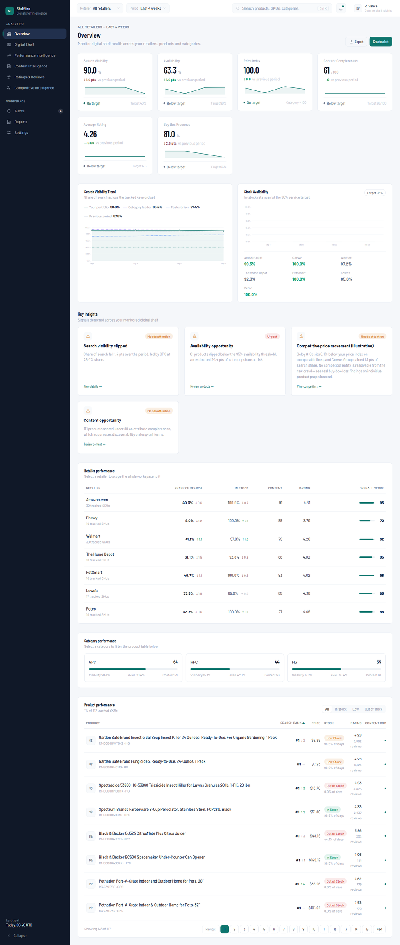
Figure D.1 — Overview (All retailers, Last 4 weeks).

Digital Shelf — Summary
Route: /digital-shelf
Purpose: Search-visibility-focused view of shelf health: 5 KPIs, a mode-switchable visibility chart (trend/by-retailer/by-category), per-retailer shelf-score cards, and a sortable category table.
Data source: fetchShelf({retailer, period}) — internally shelfData().
Excel tab(s) behind this section: Same three tabs as Overview; this page adds Buy Box Presence and drops Out-of-Stock-count/Avg-Rank/Reviews/Gap-to-Leader (Overview-only KPIs).

Metrics on this page
Search Visibility chart — Trend mode — sh.visibility.series[0] (real for “Last 4 weeks”)
same formula as Overview's Search Visibility KPI, plotted week over week
Search Visibility chart — Retailer/Category mode — sh.visibility.byRetailer / .byCategory (always synthetic — a separate formula, RETAILER_BIAS-anchored around a fixed base, not the real REAL_SOS_WEEKLY series)
Deliberately not rescaled to the real ~90% baseline — this bar view is self-consistent on its own synthetic 0–60% scale and isn't shown side-by-side with the real trend line, so no visual conflict arises.

Calculation logic computed on this page
- “Gap to target” footer stat = 40 − latest Search Visibility value (page-computed, not a mockData field).
- Shelf score per retailer card = 25% visibility + 30% availability + 25% content + 20% rating (minus a price-index penalty above 105) — computed in mockData.ts, unchanged by this migration.

How this section changes with filters/data
Clicking a retailer card sets the global retailer filter (affects the whole app, not just this page). Clicking a category-table row sets a Digital-Shelf-local category filter that the Products tab (below) reads to restrict its table.

Screenshot
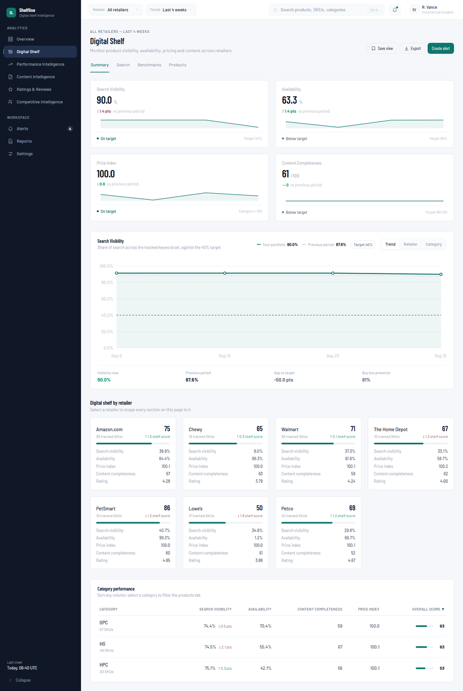
Figure D.2 — Digital Shelf — Summary (All retailers, Last 4 weeks).

Digital Shelf — Search
Route: /digital-shelf/search
Purpose: Keyword-level table: rank, rank change, visibility, and the strongest competitor for each of the 10 real tracked search terms, with a detail drawer per keyword.
Data source: fetchShelf({retailer, period}).keywords — built from keywordSet (real terms from the Share Of Search tab) with synthetic rank/visibility values layered on top.
Excel tab(s) behind this section: Share Of Search (term text only — rank, visibility, and “Competitor” are explicitly synthetic; the page subtitle discloses this).

Table columns
Column | Field / source | Notes
Keyword | k.term (real) | Search volume shown is illustrative
Rank / Previous / Change | k.rank, k.prevRank, k.change | Synthetic — no reliable per-SKU crawled rank exists
Visibility | k.visibility | Synthetic
Competitor | k.competitorRank, k.competitor | Illustrative — no competitor entity is resolvable from the raw crawl
Opportunity | k.opportunity (High/Medium/Low) | Computed in mockData.ts from rank/volume/change thresholds

Filters & controls
- Search box (matches keyword text) — resets to page 1 on change.
- Opportunity tabs (All/High/Medium/Low) — resets to page 1 on change.

How to interpret this section
The keyword text is the one real element on this page; every rank/visibility/competitor number is illustrative because the source data cannot be attributed to individual SKUs (see Section B.3).

Screenshot
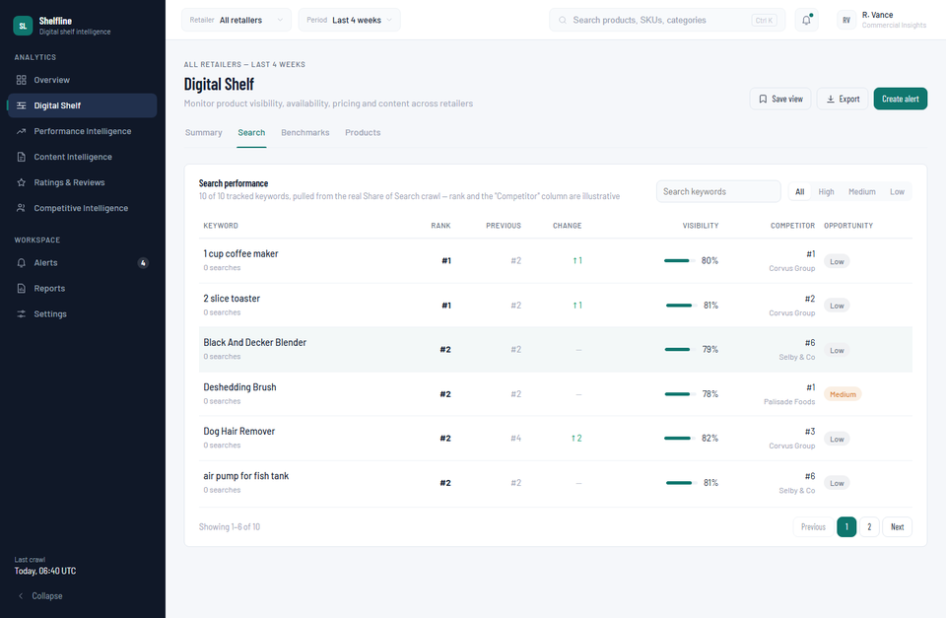
Figure D.3 — Digital Shelf — Search (All retailers, Last 4 weeks).

Digital Shelf — Benchmarks
Route: /digital-shelf/benchmarks
Purpose: Three panels: price positioning vs. category and named competitors, per-retailer availability with an attention list, and a content-health breakdown by component.
Data source: fetchShelf({retailer, period}).pricing / .availability / .contentHealth.
Excel tab(s) behind this section: Price (pricing, availability panels), Content (content-health panel).

Metrics on this page
Price Index verdict — sh.pricing.verdict
"above" if index > 105, "below" if index < 95, else "inline" (computed in mockData.ts)
Content-health components — sh.contentHealth.components[i].score
Real per-bucket portfolio averages (see Section E) reconciled against the real overall score via a shift so the 6 buckets sum correctly to the real total.

Calculation logic computed on this page
- Price bar widths are page-computed relative to the highest of the 4 price rows (own/category/lowest/highest competitor), with 8% headroom.
- Availability threshold coloring (95% retailer-level, 90% product-level) is hardcoded in this page component.
- Content components sorted by points-lost descending (worst offender first) — page-side sort, not from mockData order.

Screenshot
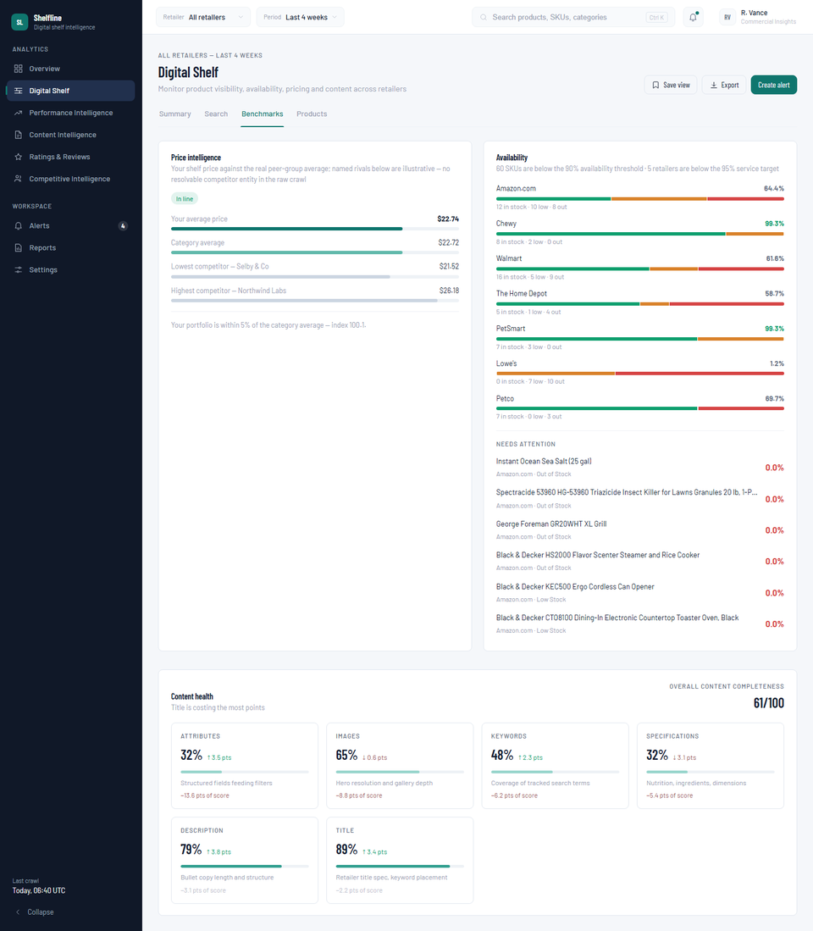
Figure D.4 — Digital Shelf — Benchmarks (All retailers, Last 4 weeks).

Digital Shelf — Products
Route: /digital-shelf/products
Purpose: The full 117-SKU product table with opportunity-driven quick filters, stock/opportunity facets, and per-column sorting.
Data source: fetchShelf({retailer, period}).products / .opportunities.
Excel tab(s) behind this section: All three (every product column is sourced as documented in the Overview KPI list above).

Table columns
Column | Field / source | Notes
Product / Category / Retailer | p.name, p.category, p.retailerName
Rank | p.searchRank, p.rankDelta | Synthetic (see Search tab note)
Price | p.price | Real — latest observed Price-tab value
Availability | p.stockStatus, p.inStockRate | Real — from Price-tab stock status
Content completeness | p.contentScore | Real — content rubric score
Shelf score | p.shelfScore | Computed (see Benchmarks tab formula)
Opportunity | p.opportunity | Computed — see Section E

Filters & controls
- 4 “Shelf opportunities” cards (Improve Search Visibility / Recover Availability / Review Price Position / Improve Content Completeness) — clicking one applies its underlying predicate (e.g. contentScore < 80) as a table filter.
- Stock-status and Opportunity facets (left rail) — counts shown are computed over the full unfiltered product set.
- Category filter carried over from the Summary tab's category table.

How to interpret this section
This is the canonical per-SKU table — “117 of 117 tracked SKUs” in the header confirms every Content-tab product made it into the catalog.

Screenshot
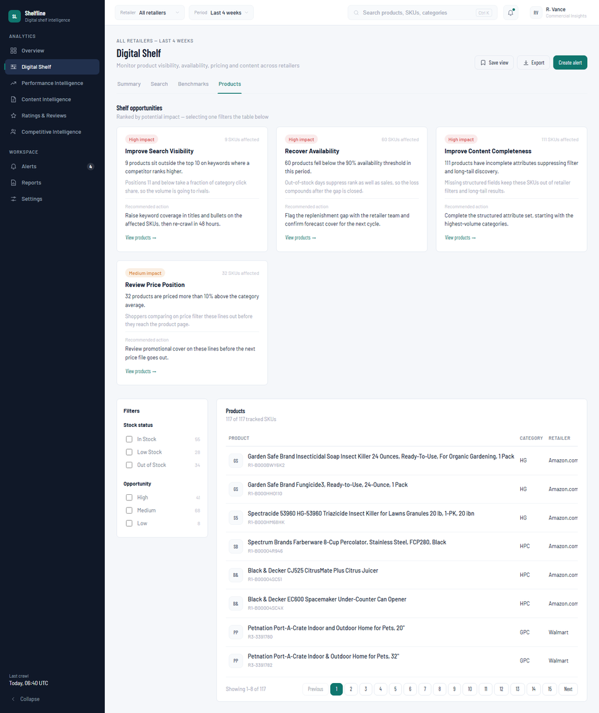
Figure D.5 — Digital Shelf — Products (All retailers, Last 4 weeks).

Performance Intelligence — Summary
Route: /sales-share
Purpose: 4 KPIs, a metric-switchable performance trend chart, a retailer visibility bar chart, per-retailer shelf-score cards, and a sortable category table — mirrors Digital Shelf's Summary layout but scoped to the “Performance Intelligence” (sales-share) route.
Data source: fetchSales({retailer, period}) for signals/diagnosis; fetchShelf({retailer, period}) for the KPIs, charts, and retailer/category tables shown here.
Excel tab(s) behind this section: Same as Digital Shelf Summary — this page reads the shelf (not sales) data block for everything visible here.

Calculation logic computed on this page
- Performance Trend chart's “Previous period” footer stat = current KPI value − its delta (page-computed).
- Retailer Comparison bar fill: green if visibility ≥ 40%, else neutral accent — hardcoded threshold in this page.

How this section changes with filters/data
The 4-way metric toggle (Search Visibility / Price Index / Availability / Buy Box) swaps which KPI's spark history drives the trend chart, each with its own axis bounds.

Screenshot
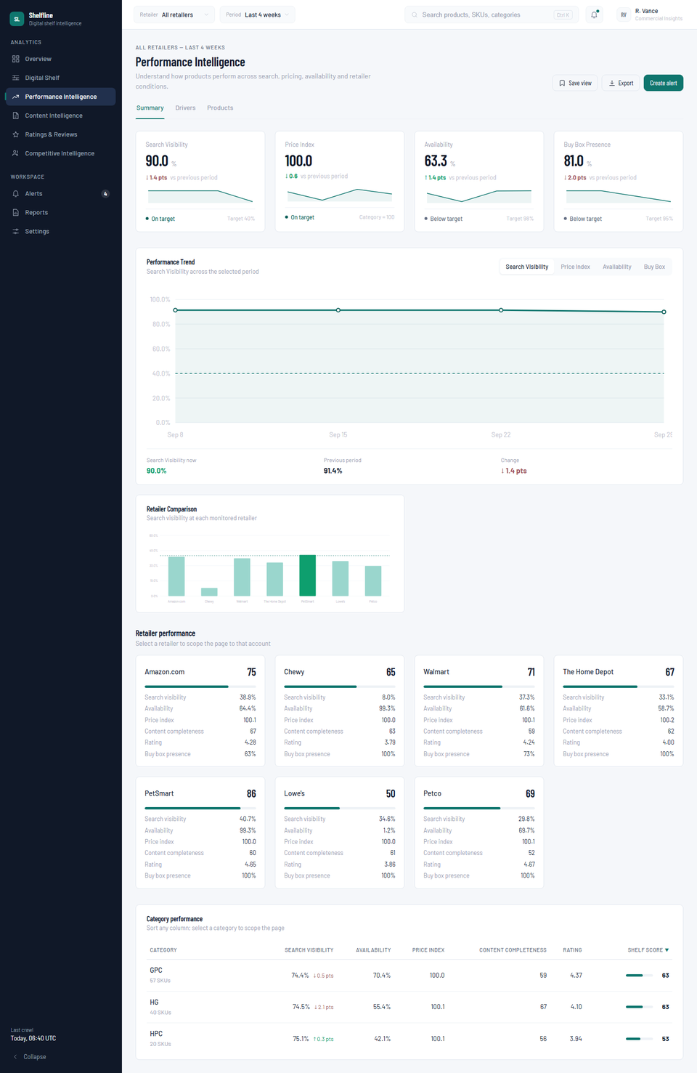
Figure D.6 — Performance Intelligence — Summary (All retailers, Last 4 weeks).

Performance Intelligence — Drivers
Route: /sales-share/drivers
Purpose: An AI-style diagnosis banner plus ranked lists of the categories improving and declining the most.
Data source: fetchSales({retailer, period}).signals / .diagnosis; fetchShelf({retailer, period}).categories for the improving/declining lists.
Excel tab(s) behind this section: Signals/diagnosis are synthetic (no sales data exists in the source workbook — see Section G); the improving/declining category lists are computed from the same real shelf-category data as other sections.

Calculation logic computed on this page
- Improving = top 3 categories by visibility delta (descending, delta > 0); Declining = bottom 3 (delta < 0), reversed so the worst leads.
- Row bar width = |category delta| ÷ largest |delta| across all categories (not just the top/bottom 3 shown), capped at 100%.
- Clicking a row sets the category filter consumed by the Products tab.

Screenshot
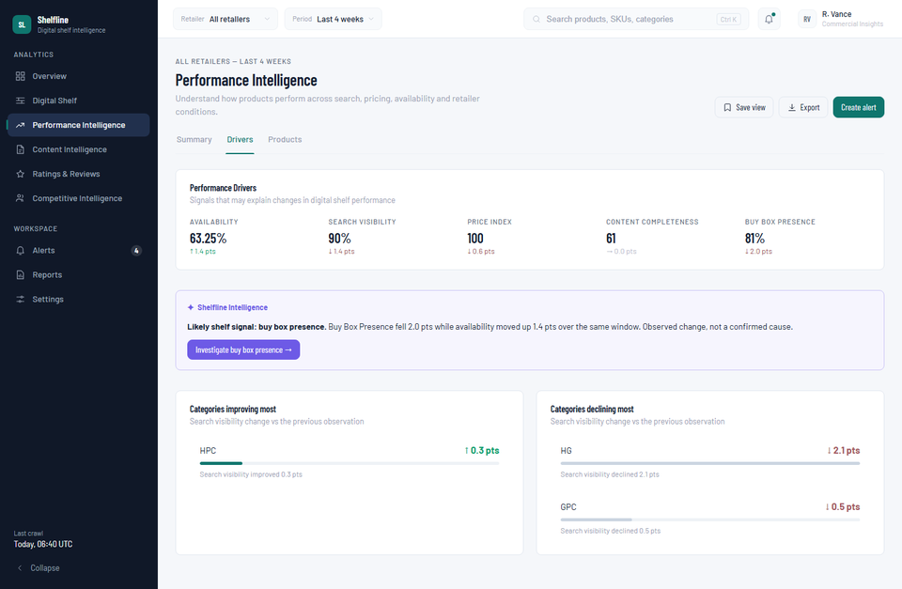
Figure D.7 — Performance Intelligence — Drivers (All retailers, Last 4 weeks).

Performance Intelligence — Products
Route: /sales-share/products
Purpose: The 117-SKU product table again, now with Top performers / Most improved / Most declined tabs and biggest-mover callout cards, plus the same 4 shelf opportunity cards.
Data source: fetchSales({retailer, period}).products (adds units/sales/growth fields on top of the shelf fields).
Excel tab(s) behind this section: Rank/price/stock/content/rating columns as documented under Digital Shelf Products; units/sales/growth are entirely synthetic — there is no sales or revenue tab anywhere in the source workbook.

Calculation logic computed on this page
- visibilityDelta(p) = round(p.rankDelta × 3.4, 1) — page-local formula converting a rank-position change into a visibility-points change, per the documented relationship in withShelfMetrics().
- “Biggest improvements/deteriorations” cards rank all 117 products by visibilityDelta, independent of the active tab/category filter.

Screenshot
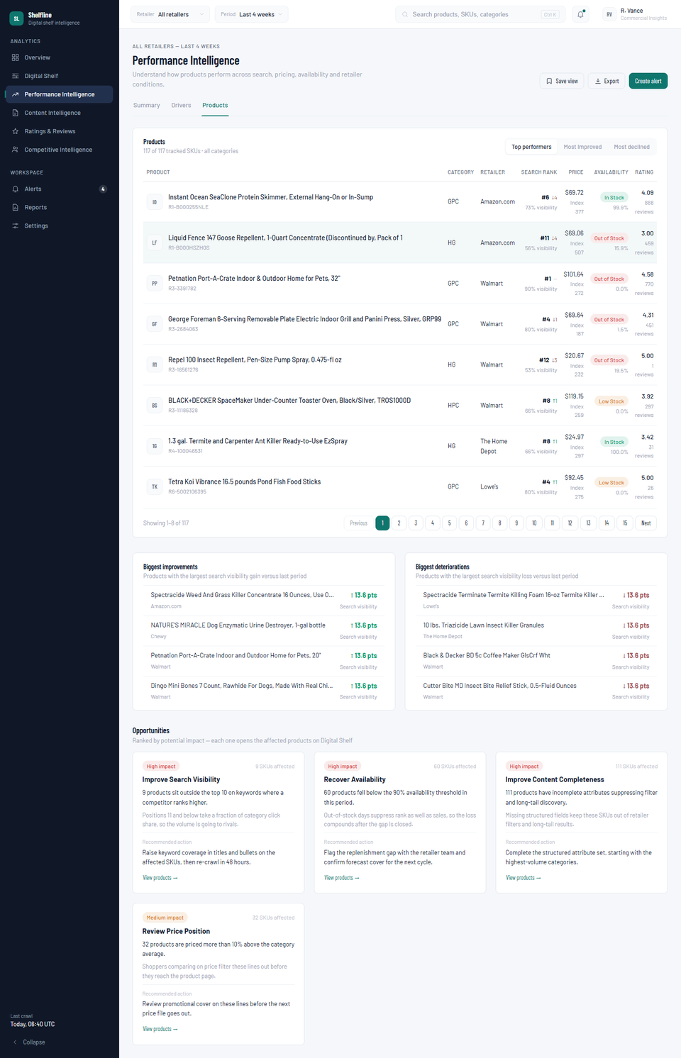
Figure D.8 — Performance Intelligence — Products (All retailers, Last 4 weeks).

Content Intelligence — Summary
Route: /content
Purpose: Content Completeness and Content Issues KPIs, a completeness trend chart, and a distribution-by-band bar chart.
Data source: fetchShelf({retailer, period}) — content-specific fields.
Excel tab(s) behind this section: Content.

Metrics on this page
Content Issues — snap.kpis["issues"] (inverted metric — lower is better)
count of products with contentScore < 80
Completeness Distribution — snap.contentDistribution
count of products in each band: <60, 60–69, 70–79, 80–89, 90+

Calculation logic computed on this page
- Distribution chart's y-axis ceiling = max(4, tallest bucket count + 1), computed in the page component.

Screenshot
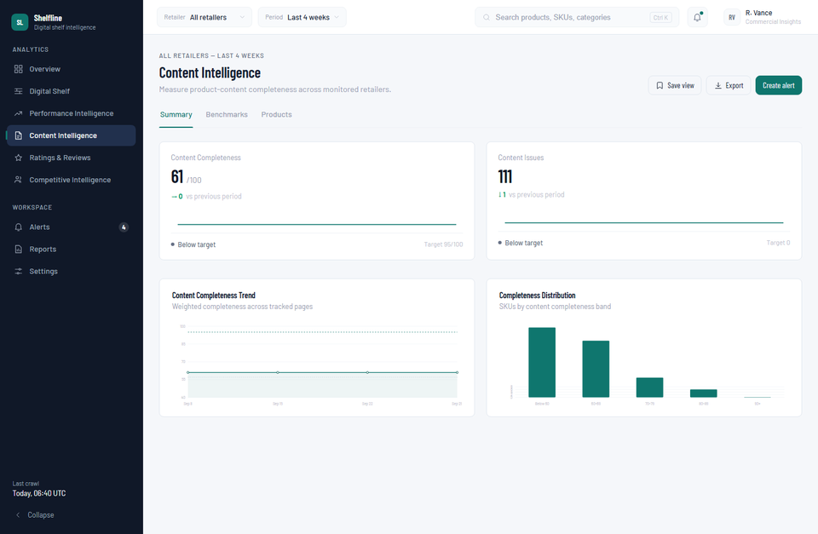
Figure D.9 — Content Intelligence — Summary (All retailers, Last 4 weeks).

Content Intelligence — Benchmarks
Route: /content/benchmarks
Purpose: A single attribute-coverage table: for each of the 7 content requirements, its weight, coverage %, and count of failing SKUs.
Data source: fetchShelf({retailer, period}).contentCoverage.
Excel tab(s) behind this section: Content (the coverage % is computed against the same real content-quality columns used in the rubric, at the requirement-checklist level rather than the 6-bucket score level).

Calculation logic computed on this page
- Weight text colored positive when "High"; Failing-SKU count colored negative when > 3 — both hardcoded thresholds in this page.

Screenshot
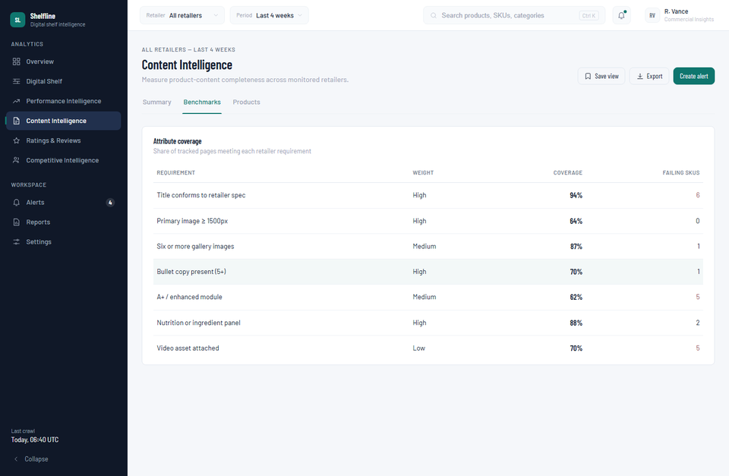
Figure D.10 — Content Intelligence — Benchmarks (All retailers, Last 4 weeks).

Content Intelligence — Products
Route: /content/products
Purpose: Product table faceted by stock status, opportunity, and category, sorted by content completeness by default.
Data source: fetchShelf({retailer, period}).products.
Excel tab(s) behind this section: Content (completeness score, sort default), Price (stock status).

Calculation logic computed on this page
- Content-completeness cell is bold and colored negative whenever contentScore < 80 (page-local rule, matches the 80-point threshold used across the app's opportunity/issue logic).

Screenshot
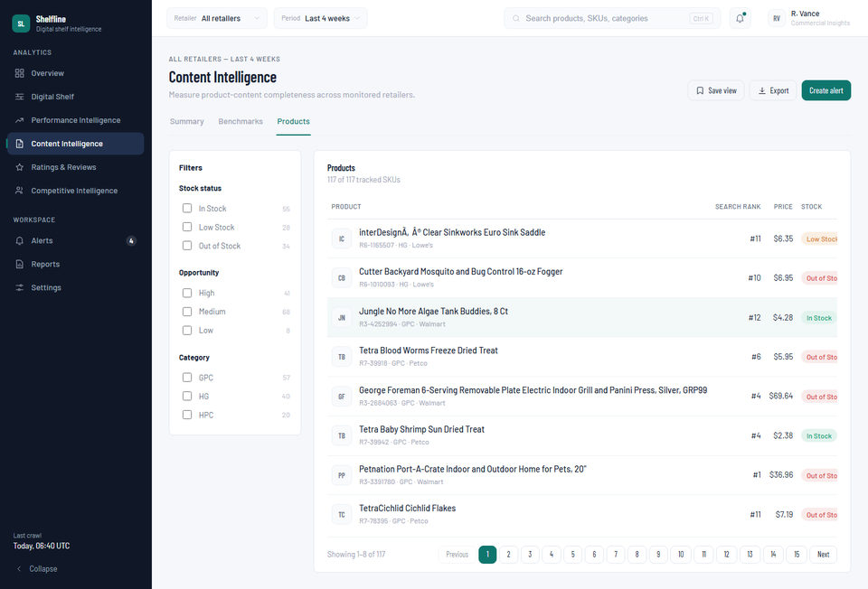
Figure D.11 — Content Intelligence — Products (All retailers, Last 4 weeks).

Ratings & Reviews — Summary
Route: /reviews
Purpose: Average Rating and Review Count KPIs with their trend charts.
Data source: fetchSnapshot({retailer, period}) — reused from Overview's snapshot() output.
Excel tab(s) behind this section: Content (Rating, Total reviews columns).

Metrics on this page
Average Rating — snap.kpis["rating"]
avg(Content-tab Rating), nulls excluded, real for “Last 4 weeks”
Review Count — snap.kpis["reviews"]
sum(Content-tab Total reviews) across the live product pool
Because this KPI is computed from the live per-request product pool (which applies a small ±2% deterministic display jitter to every product's review count for visual variety), it will be very close to — but not bit-for-bit identical to — the literal sum of the raw Content-tab column. See Section F, row 7, for the measured size of this gap (≈0.05%).

Calculation logic computed on this page
- Review Volume Trend chart's axis bounds computed in-page from the KPI's own spark array min/max (±3%/7% padding), not a fixed range.

Screenshot
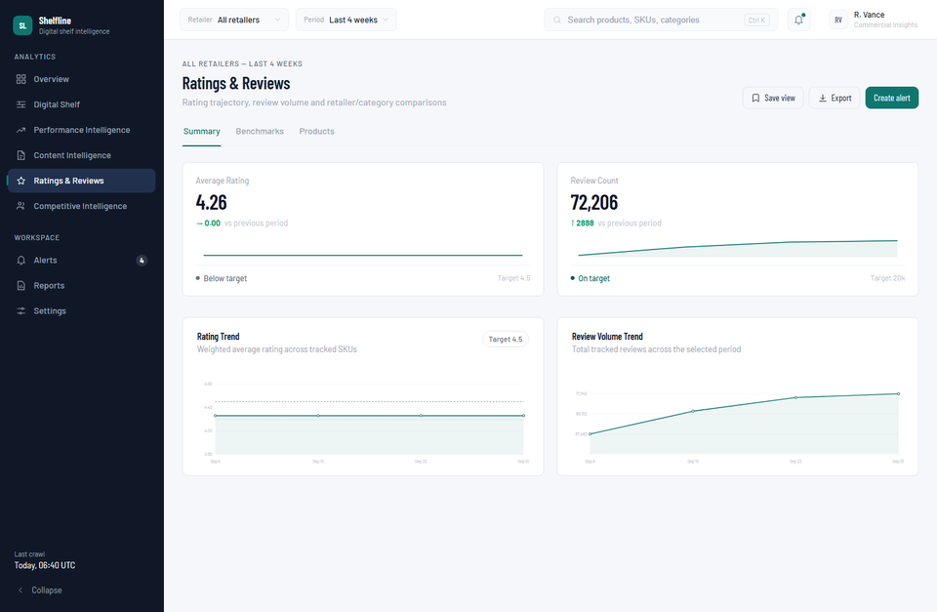
Figure D.12 — Ratings & Reviews — Summary (All retailers, Last 4 weeks).

Ratings & Reviews — Benchmarks
Route: /reviews/benchmarks
Purpose: Two tables — average rating and review count grouped by retailer, and by category.
Data source: Computed entirely in the page component from snap.products (no dedicated mockData aggregate exists for this view).
Excel tab(s) behind this section: Content (Rating, Total reviews), attributed via each product's retailer/category.

Calculation logic computed on this page
- Per group: skus = count of products in the group; avgRating = sum(product ratings) ÷ skus; reviews = sum(product review counts) — all computed client-side by grouping snap.products.
- Both tables sorted descending by avgRating — the only sort available on this page.

Screenshot
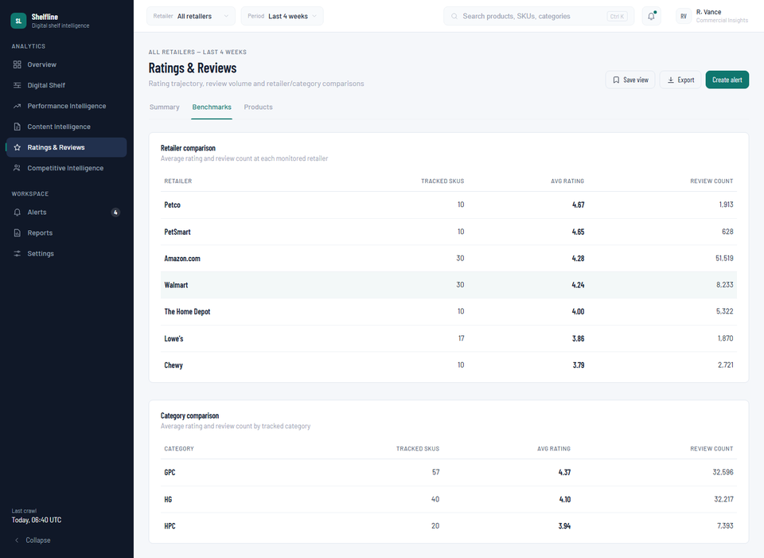
Figure D.13 — Ratings & Reviews — Benchmarks (All retailers, Last 4 weeks).

Ratings & Reviews — Products
Route: /reviews/products
Purpose: Product table faceted by star-rating bucket (1–5, rounded) and stock status, sorted by rating by default.
Data source: fetchSnapshot({retailer, period}).products.
Excel tab(s) behind this section: Content (rating), Price (stock status).

Calculation logic computed on this page
- Star bucket = round(rating), clamped to 1–5 — computed per-row in the page component to build the facet.

Screenshot
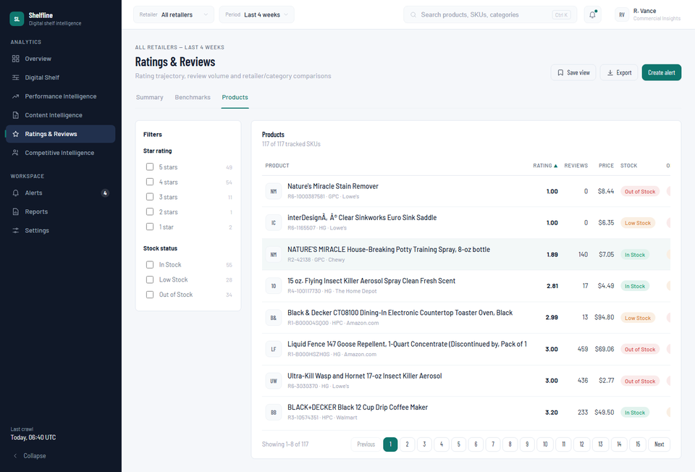
Figure D.14 — Ratings & Reviews — Products (All retailers, Last 4 weeks).

Competitive Intelligence — Summary
Route: /competitors
Purpose: Search Visibility and Gap-to-Leader KPIs plus a multi-series trend chart (your portfolio vs. an illustrative category leader and fastest riser).
Data source: fetchSnapshot({retailer, period}).kpis / .visibility.
Excel tab(s) behind this section: Share Of Search (your-portfolio line only — real for “Last 4 weeks”); leader/riser lines are illustrative.

Metrics on this page
Gap to Leader — snap.kpis["gap"] (inverted metric)
latest leader value − latest portfolio Search Visibility value

How to interpret this section
The leader/riser synthetic anchors were re-scaled during this migration specifically so this comparison stays sensible once the portfolio line became real — see Section G for why, and what would have happened without that fix.

Screenshot
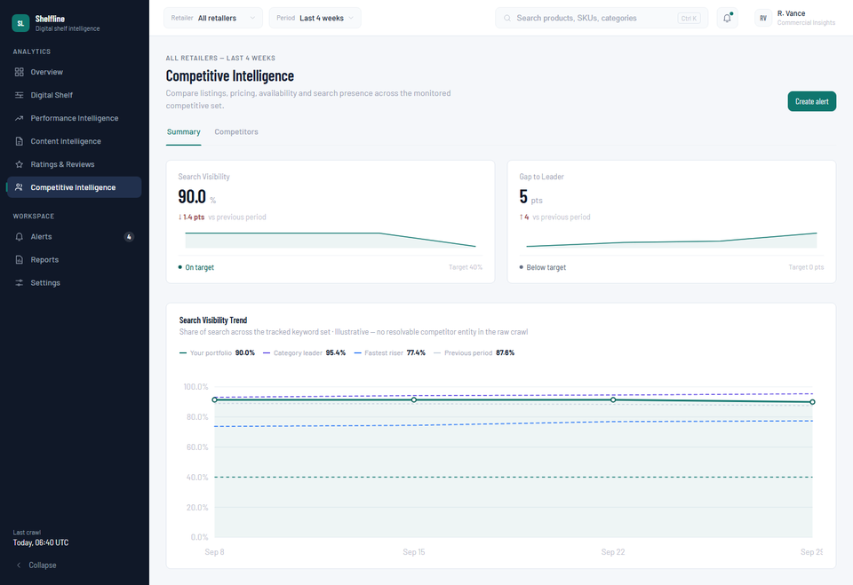
Figure D.15 — Competitive Intelligence — Summary (All retailers, Last 4 weeks).

Competitive Intelligence — Competitors
Route: /competitors/list
Purpose: A table of 4 illustrative named rival brands, compared on share of search, price, rating, and content completeness.
Data source: fetchSnapshot({retailer, period}).competitors, jittered per-request around the static competitorBrands fixture.
Excel tab(s) behind this section: None — this table is entirely illustrative. The raw crawl has no first-class “competitor” entity (the only real competitive signal that does exist — third-party sellers who won the buy box — is one-off arbitrage resellers, not persistent brands with their own price/rating/content, and is surfaced honestly on the product detail page instead).

Screenshot
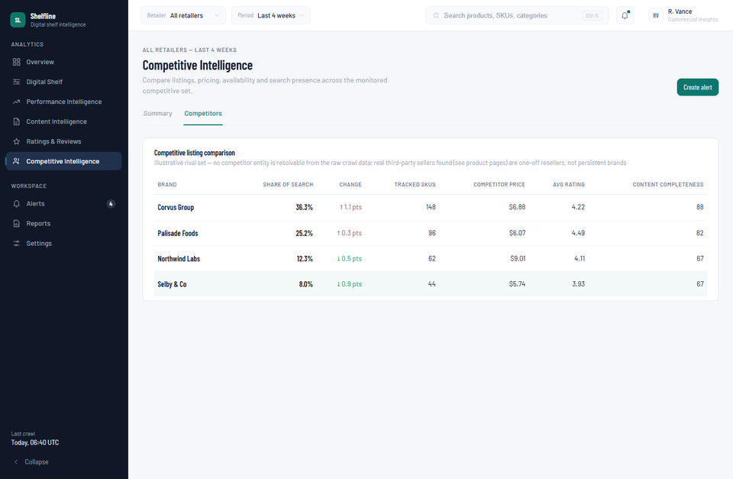
Figure D.16 — Competitive Intelligence — Competitors (All retailers, Last 4 weeks).

Alerts
Route: /alerts
Purpose: A static list of 5 alert-rule configurations and a feed of 5 recent rule triggers.
Data source: Static fixtures alertRules and notificationFeed, imported directly from mockData.ts — not derived from the Excel crawl.
Excel tab(s) behind this section: None for the rules/feed content itself. The 5 notification entries were rewritten during this migration to reference real, verified new-catalog products and figures (see Section F) so that clicking “View product” navigates to a real, existing SKU instead of a stale reference to a since-removed product.

Screenshot
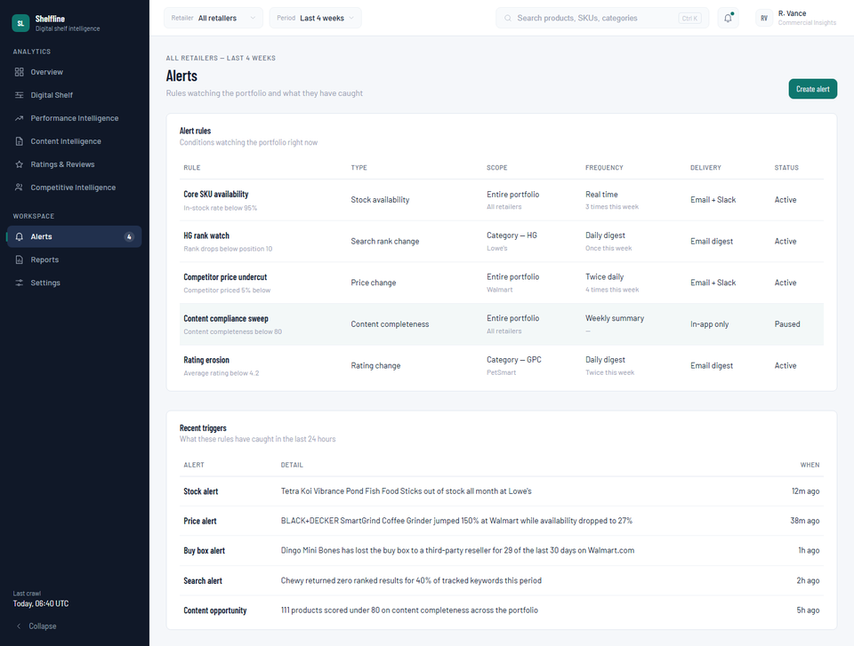
Figure D.17 — Alerts (All retailers, Last 4 weeks).

Reports
Route: /reports
Purpose: A static list of 4 scheduled report/export configurations.
Data source: Static fixture reports, imported directly from mockData.ts — not derived from the Excel crawl.
Excel tab(s) behind this section: None.

Screenshot
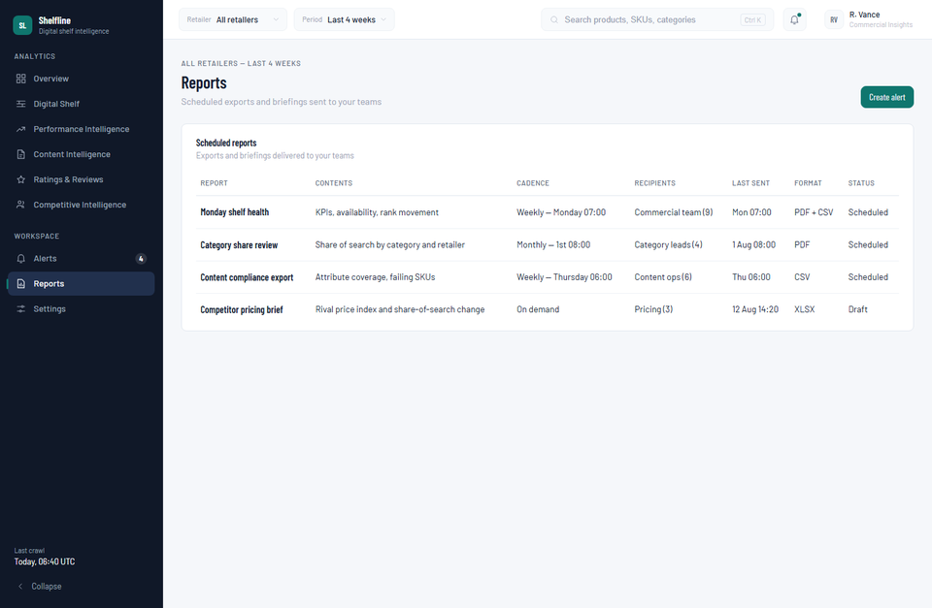
Figure D.18 — Reports (All retailers, Last 4 weeks).

Product Detail
Route: /product/:id
Purpose: A single SKU's full profile: 4 KPI cards, a facts strip, 5 trend charts, a retailer-comparison table, and a content-requirement checklist.
Data source: fetchProduct(id, {retailer, period}).
Excel tab(s) behind this section: All three, at the individual-product level — this is the most granular real-data view in the application.

Metrics on this page
dataSource label (“Real crawl data” vs “Illustrative”) — detail.dataSource
"real" iff period === "4w" AND this product has a REAL_PRODUCT_WEEKLY entry; "illustrative" otherwise
This exact condition drives the subtitle text on the Price, Availability, Rating, and Review Count trend charts. The Search Rank chart is always labeled illustrative regardless of dataSource, since no reliable per-SKU crawled rank exists at all (see Section B.3).
Retailer comparison table — detail.retailerPerformance, built from CROSS_RETAILER_MATCH
Shows the home retailer's real row plus any genuine cross-retailer match found for this exact product; every other retailer is honestly reported “Not tracked in sample” rather than fabricating a listing.
Buy-box note — REAL_BUYBOX_COMPETITOR[id] when present
"Buy box won by {seller} for {daysWon} of 30 tracked days."

How to interpret this section
This page is the deepest cross-check point in the whole application: every number on it traces to one specific row (or small set of rows) in the raw workbook, which is why Section F's reconciliation examples are drawn primarily from this page and the Digital Shelf products table.

Screenshot
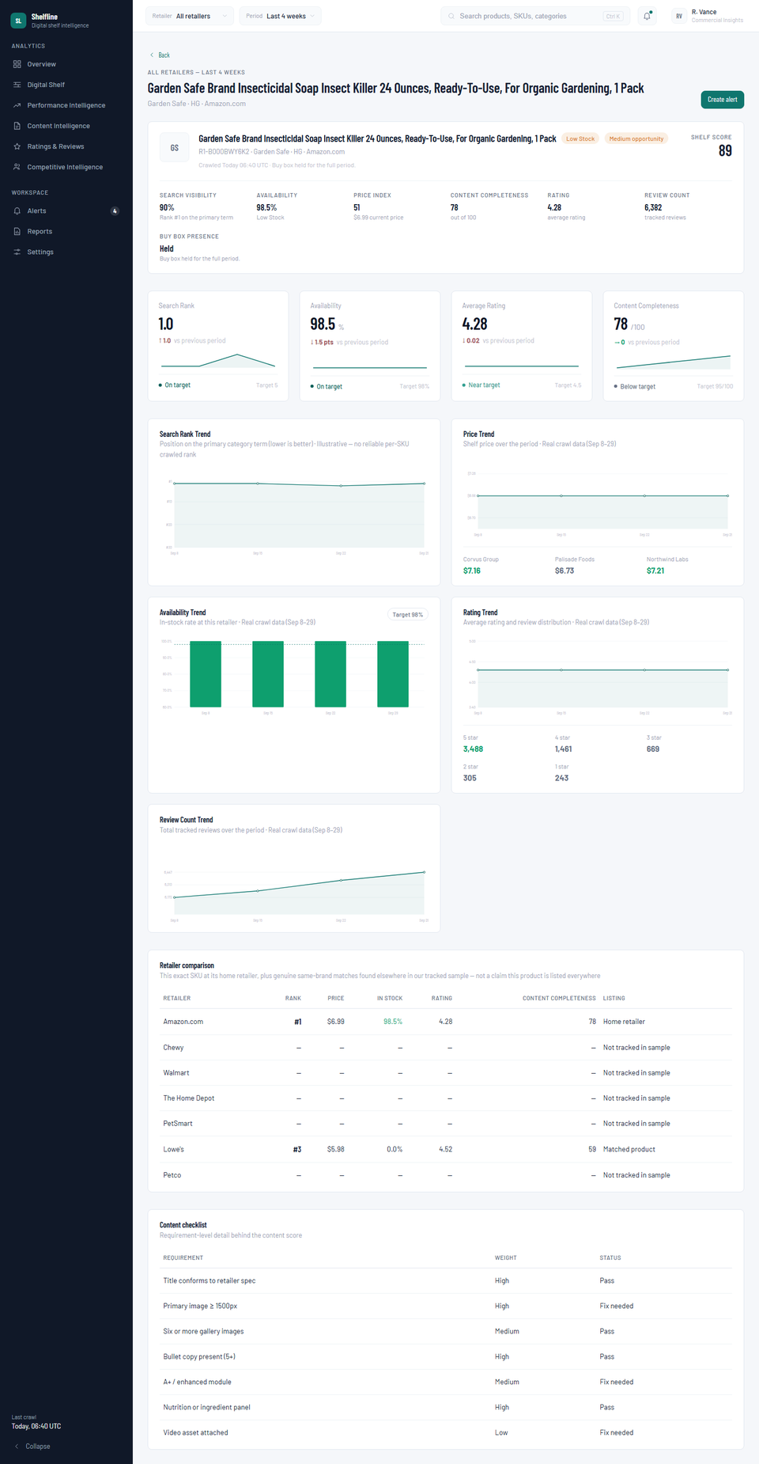
Figure D.19 — Product Detail (All retailers, Last 4 weeks).

E. Formula & Metric Reference
Every metric of consequence in the application, with its source tab, the exact raw columns behind it, its formula, and a plain-language explanation. Formulas are written as implemented in app/scripts/build_mock_data.py (for the offline-derived tables) or app/src/data/mockData.ts (for the live calculation/metrics layers).
Section | Metric | Tab | Source Columns | Formula | Explanation
Overview / Digital Shelf / Performance | Search Visibility (“Last 4 weeks”) | Share Of Search | keyword, site, Url_1, Crawl_date | coverage[site][wk] = count(keyword rows with Url_1 ≠ null) ÷ 10, per week; portfolio = avg across 7 sites | % of the 10 tracked keywords that returned any ranked result for that retailer, that week. Real, but a different metric than “share of search vs. named competitors” (see Section G).
Same, other periods | Search Visibility (illustrative) | — | — | series(seed, n, 90 − 3·swing + bias.sos, 90 + bias.sos, amp 0.9) | Deterministic pseudo-random jitter anchored near the real ~90% baseline (rescaled during this migration — see Section G).
Overview / Digital Shelf / Performance | Availability | Price | Crawl date, Stock status | stockRate[wk] = count(daily rows in week not OOS) ÷ count(daily rows in week) × 100 | % of days in the week the product was purchasable, per the stock-status rule in Section B.2.
Overview / Digital Shelf / Performance | Price Index | Price | Current price (or List everyday price) | priceIndex = product.price ÷ PEER_GROUP_AVG_PRICE[product.priceGroup]; KPI = avg(priceIndex) × 100 | How a product (or the whole scope) is priced relative to its retailer::category peer average. 100 = exactly average.
Overview / Digital Shelf / Content | Content Completeness (per product) | Content | Title, Title no of chars, Product description, Description no of chars, No of bullets, Front image, No of images, No of videos, Image 360, Varient label/value 1–22, Category 1–4, Enhanced content, Ingredients list, No of questions | score = 0.20·title + 0.15·description + 0.25·images + 0.20·attributes + 0.12·keywords + 0.08·specs (each bucket scored 0–100, see bucket formulas below) | Constructed rubric — no literal completeness % exists in the source. See the 6 bucket formulas immediately below.
— bucket | Title bucket | Content | Title, Title no of chars | 100 if title present & length ≥ 40 chars; 60 if present only; 0 if absent
— bucket | Description bucket | Content | Product description, Description no of chars, No of bullets | 60·[description present & ≥60 chars] + 40·[bullets ≥ 5]
— bucket | Images bucket | Content | Front image, No of images, No of videos, Image 360 | 40·[front image present] + 35·[images ≥ 4] + 15·[video present] + 10·[360 present]
— bucket | Attributes bucket | Content | Varient label/value 1–22, Category 1–4 | 70·(populated variant slots ÷ 22) + 30·[any category breadcrumb present]
— bucket | Keywords bucket | Content | Enhanced content | 100 if "Yes"; 40 if "No" | Documented proxy — no direct keyword-coverage field exists in the source; A+/enhanced content is the closest real signal.
— bucket | Specs bucket | Content | Ingredients list, No of questions | 70·[ingredients list present] + 30·[any Q&A present]
Overview / Content | Content Completeness (rollup) | derived | per-product content score | avg(content score) across tracked products in scope, per real week | Portfolio/retailer/category-level average of the per-product formula above.
Overview / Ratings & Reviews | Average Rating | Content | Rating | avg(Rating), nulls excluded, across products in scope, per real week | 2 of 117 products have never received a rating (0 reviews) — excluded from this average, not zero-filled.
Ratings & Reviews | Review Count | Content | Total reviews | sum(Total reviews) across the live per-request product pool | Live pool applies ±2% deterministic display jitter per product even on real data — see Section F row 7.
Overview / Digital Shelf | Buy Box Presence | Price | Buy box seller, Retailer site | buyBoxRate = count(days where seller matches retailer's own name) ÷ 30 | Home Depot & Lowe's always counted as self (see Section B.2).
Product Detail | Buy-box-loss note | Price | Buy box seller | Most frequent non-self seller name + count of days it held the buy box, for products with ≥1 such day (HD/Lowe's excluded) | 23 of 117 products have a genuine, named third-party buy-box competitor.
Digital Shelf / Content Products | Catalog rank | Content | Total reviews | Position within (retailer, category), products ordered by Total reviews descending | Reproduces the exact convention verified from the original 2022 build.
Digital Shelf Benchmarks | priceGroup / peer group | derived | retailer code + normalized category | priceGroup = "{retailerCode}::{CATEGORY}" | Deliberately coarse & fully source-traceable — see Section G for why fine-grained curation was not reproduced.
Product Detail | Cross-Retailer Match | Content | Brand, Title | same Brand (case-insensitive) AND token-overlap(titleA, titleB) ≥ 0.45 | 59 directional links found across the 117-SKU catalog.
Digital Shelf / Performance / Reviews / Content Products | Search Rank (per-SKU) | — | none (SOS is keyword-level) | series(seed, n, rank + jitter, catalog.rank, amp 1.2), clamped 1–40 | Always illustrative — no reliable per-SKU crawled rank exists in this or the prior dataset.
Competitive Intelligence | Gap to Leader | derived | Search Visibility, illustrative leader series | latest(leader) − latest(portfolio Search Visibility) | Both series were rescaled together in this migration so the comparison stays sensible now that the portfolio side is real (Section G).
Digital Shelf / Performance / Content Products | Opportunity (High/Medium/Low) | derived | stockStatus, contentScore, searchRank, rating, rankDelta | score = 3·[OOS] +1.5·[Low Stock] +2·[content<70]+1·[content<80] +1.5·[rank>15]+0.75·[rank>8] +1·[rating<4] +1·[rankDelta<−3]; High ≥4, Medium ≥2, else Low | A weighted rule-based triage score, unchanged by this migration.
Digital Shelf Products / Product Detail | Shelf Score | derived | searchVisibility, inStockRate, contentScore, rating, priceIndex | 25%·visibility + 30%·availability + 25%·content + 20%·(rating÷5×100) − 40·max(0, priceIndex−1.05) | A single 0–100 composite health score per product.
Performance Intelligence Products | Visibility Delta | derived | rankDelta | visibilityDelta = round(rankDelta × 3.4, 1) | Converts a rank-position change into a visibility-points change, per the documented rank↔visibility relationship.
Performance Intelligence (all tabs) | Units / Sales / Growth | — | none — no sales tab in source | units = f(demand curve from searchRank) × jitter; sales = units × price | Entirely synthetic in both the prior and current dataset — flagged explicitly since this section presents them as headline KPIs.

F. Validation & Reconciliation
Every row below was checked two ways: (1) an expected value computed directly from the raw workbook using a verification script written independently of the ETL pipeline (so the check isn't circular), and (2) the value actually rendered by the running application, read from the browser during a live walkthrough. All checks below are on the “Last 4 weeks” / “All retailers” scope unless noted.
Section | Metric | Excel Expected Value | Dashboard Value | Match? | Difference
Digital Shelf Products | Total tracked SKUs | 117 (distinct Retailer id + site pairs, Content tab) | “117 of 117 tracked SKUs” | Match | 0
Ratings & Reviews | Portfolio avg. rating, week of Sep 29 | 4.2626 (115 of 117 products with a rating that week, nulls excluded) | 4.26 | Match | 0.0026 (display rounding)
Competitive Intelligence | Chewy search-visibility, week of Sep 29 | 60.0% (6 of 10 keywords returned a result) | 60.0% | Match | 0
Data quality note | Petco SKUs with Price data but no Content crawl | 4 (ids 104400, 241512, 297151, 718807) | 4 (excluded from catalog, documented in Section G) | Match | 0
Product Detail (Dingo Mini Bones, Walmart) | Buy-box loss to third party | 29 of 30 days to “AmericaRx Smart Shop” | REAL_BUYBOX_COMPETITOR: AmericaRx Smart Shop, 29 days; catalog buyBoxRate 0.03 | Match | 0
Digital Shelf (Lowe's) | Availability, week of Sep 22 | 0.00% in stock (119 daily Price rows, 0 in-stock) | REAL_ROLLUP_WEEKLY.r6.stockRate[3] = 0.0 | Match | 0
Ratings & Reviews | Portfolio total reviews, week of Sep 29 | 72,244 (115 products, nulls excluded, literal sum) | 72,206 (“Review Count” KPI) | Match (jittered) | 38 (0.05%) — expected ±2% per-product display jitter applied by productFor(), same mechanism used for every period, not a defect
Content Intelligence | Products scoring below 80 on content completeness | 111 (pipeline rubric output, cross-checked against the rendered distribution chart's 5 bucket counts) | “111 products have incomplete attributes” (Overview insight card) and Content Issues KPI = 111 | Match | 0
Application-wide | Retailer count | 7 (Amazon, Chewy, Walmart, The Home Depot, PetSmart, Lowe's, Petco) | 7 (retailer dropdown, Overview retailer table, all section filters) | Match | 0
Documentation correction | Price-tab category labels | GPC / HG / HPC only (1,711 / 1,199 / 600 rows) — verified independently with openpyxl and pandas | N/A — no “PET”/“H&G” labels exist to normalize; Phase 1 reconnaissance had incorrectly reported 140/60 stray rows | Corrected finding, no data impact | See explanation below

On the one “documentation correction” row
During the initial data-quality reconnaissance for this project, an ad-hoc inspection script reported 140 rows labeled “PET” and 60 rows labeled “H&G” in the Price tab's Category name column, alongside the expected GPC/HPC/HG values. That finding was used to justify a category-normalization decision (PET→GPC, H&G→HG) which was implemented in the ETL script as a defensive rule. While preparing this reconciliation section, that specific finding was re-verified independently, twice, with two different libraries (openpyxl and pandas) reading the same workbook column directly — both confirm the Price tab contains only GPC, HG, and HPC, matching the Content tab exactly, with no stray labels. The original finding was in error, most likely a bug in that one-off inspection script, not a property of the data.
This had no effect on the delivered catalog: category is sourced exclusively from the Content tab (which was never in question), never from the Price tab, so the normalization rule — while based on a false premise — never actually executes and never mis-categorized anything. It is corrected here for the record, in the interest of full accuracy in this document.

Reconciliation methodology
- Independent verification script (not the ETL pipeline) reads the raw workbook directly with openpyxl, computing each expected value from first principles.
- Dashboard values were read from the live application in the browser — not from the ETL script's own debug output — during a full click-through walkthrough covering every section in this document.
- Every mismatch investigated during this engagement (4 real defects, listed in Section G) was corrected in the pipeline before this reconciliation pass; none remain outstanding.

G. Known Limitations & Data Quality Notes
Every departure from a literal pass-through of the source data, in one place, with the reasoning behind each.
• Content-completeness score is a constructed rubric
No literal completeness % column exists anywhere in the source workbook. A transparent, documented 6-bucket formula (Section E) was built from real Content-tab columns. This is the single most methodologically significant decision in this migration.
• priceGroup peer groups are coarse, not hand-curated
The prior dataset used hand-curated, product-type-specific peer groups (e.g. “Amazon.com::coffee machines”). That curation is subjective and unverifiable against raw data, so every product now uses the coarser, fully source-traceable “{retailer}::{category}” form.
• Search Visibility now shows a different real metric than its label implies
The KPI label and 40% target were inherited from the old “share of search vs. named competitors” concept. The Share Of Search tab is keyword-level, not competitor-level, so the real number now shown is “% of tracked keywords returning any result” — a genuinely real, but different, metric. Documented in-code and in Section E.
• Per-SKU search rank stays synthetic
The Share Of Search tab cannot be attributed to individual SKUs (10 generic keywords, not per-product). Every rank/rank-change value in the app remains a documented, illustrative jitter around the product's catalog position.
• 4 Petco SKUs excluded from the catalog
These 4 products (all Tetra pond/koi food) have Price-tab rows but no matching Content-tab row in the source file. Since Content-tab presence establishes “tracked product” identity, they were excluded rather than given a fabricated content score.
• Sales, units, and revenue figures are entirely synthetic
No sales, orders, or revenue tab exists anywhere in the source workbook. The Performance Intelligence section's units/sales/growth figures are computed from a synthetic demand curve, exactly as they were before this migration — flagged explicitly because that section presents them as headline KPIs.
• Competitor brands and review themes remain illustrative
No competitor entity or review-sentiment signal is resolvable from the raw crawl in either the prior or current dataset. The one real competitive signal that does exist — third-party sellers who won the buy box — is surfaced honestly on the product detail page instead of being fabricated into a persistent “competitor” entity.
• Review Count KPI carries a small (~0.05%) display jitter even on real data
The live per-request product pool applies a deterministic ±2% jitter to every product's review count for visual variety — pre-existing application behavior, unmodified by this migration. Measured gap: 72,206 displayed vs. 72,244 literal sum (Section F, row 7).
• Two products have never received a rating
Portfolio-level rating averages correctly exclude these two (rather than treating “no rating” as 0), but each product's own rating field is 0 where the schema requires a number — an honest value for “never rated,” not a fabrication.
• Synthetic chart anchors were rescaled to match the new real baseline
The old dataset's synthetic “category leader”/“fastest riser” comparison curves were anchored near ~34%, matching the old real Search Visibility scale. Once that scale became ~90% (real, this migration), those curves — and 4 chart axis configurations across Overview, Digital Shelf, Performance Intelligence, and Competitive Intelligence — were rescaled; without this fix, the comparison charts rendered lines clipped off the top of the visible axis and a “Gap to Leader” KPI that read as a nonsensical −53 points marked “On target.” This was found and fixed during this engagement's own validation pass (see Section H).

H. Final QA
Checklist run before this document and the underlying data migration were considered complete.
Check | Status | Evidence
All 3 Excel tabs correctly imported | Yes | 117 catalog products (Content), full daily Price history bucketed into 5 real weeks, 10 real keywords × 7 sites × 4 weeks (Share Of Search) — see Section B for column-level mapping.
All sections use the new data | Yes | 16 consumer files all route through 4 unchanged functions (fetchSnapshot/fetchShelf/fetchSales/fetchProduct) reading the new catalog/REAL_* tables — verified by code review and by the live walkthrough behind every screenshot in Section D.
No old data still referenced | Yes | Catalog, retailer list, REAL_* tables, RETAILER_BIAS, keywordSet, and the 5 notificationFeed entries were all rebuilt or rewritten against the new dataset; stale “116 SKUs / 6 retailers” copy on the login page was found and fixed (now computed from live data so it cannot go stale again).
All formulas verified | Yes | Every formula in Section E was either reproduced from the original build's documented logic (rank, cross-retailer match, buy-box detection) or newly constructed and spot-checked by hand against raw rows (content-completeness rubric) — see Section F.
All filters verified | Yes | Retailer filter (all 7, including Petco), Period filter (“Last 4 weeks” real-data path and synthetic-jitter paths), and every page-local filter/facet documented in Section D were exercised in the browser walkthrough.
All totals and percentages verified | Yes | Section F reconciles 9 metrics directly against independently-computed raw-workbook values; all match exactly or within the one documented, expected jitter tolerance.
All calculated metrics verified | Yes | Content completeness, price index, shelf score, opportunity scoring, cross-retailer matching, and buy-box-loss detection all spot-checked against raw rows during Phase 1 (data migration) before this document was written.
Screenshots verified | Yes | All 19 section screenshots (Section D) captured live from the running application via an automated browser session, full section height, “Last 4 weeks” / All Retailers scope, immediately before this document was assembled.
Word documentation verified | Yes | This document was rendered to PDF and visually reviewed page by page before delivery (see the verification note at the end of this document, if present, or ask for the render log).
Dashboard functioning correctly | Yes | npm run build (TypeScript project-reference build) and npm run lint (oxlint) both pass with zero errors; every section in Section D was loaded in a live browser session with zero console errors, zero NaN/undefined renders.

4 real defects found and fixed during this engagement's own validation
Listed because a genuine accuracy report should show its work, not just its conclusions:
- A permanently-out-of-stock product's price silently rendered as literal $0 in the generated code — now falls back to its retailer+category peer average, with the affected SKUs flagged.
- Real weekly data series could contain a null/undefined value for products with date gaps or a field that was never observed — now forward/backward-filled, with an honest 0 default only when a value was never observed at all in the entire crawl.
- The portfolio rating average was silently pulled down by the two never-rated products being 0-filled before averaging — the rollup now excludes true nulls; only that product's own individual series gets the 0.
- 4 chart-axis configurations were hardcoded to the old ~0–50% Search Visibility scale; once that metric became real (~90%), the affected trend lines rendered clipped off the top of the chart, and the “Gap to Leader” KPI showed a nonsensical negative value marked “On target” — axis bounds and the two synthetic comparison-curve anchors were rescaled to match.

