**Assignment = Alarm and Clock**

(Overview)

**Navigations:**

* Sidebar : User will be given with two options to Alarm and Clock.
* Alarm : In Alarm there will be two options. First will be **<Set Alarm>** and Second will be **<View Alarms>.**
* Clock : In Clock there will be option named **<View Clock>.**

ALARM : On the first page user will be given with an option to set the alarm. On another page named **<See All Alarms>** there will be a list of all the alarm set by the user. Here user will have an option to edit or delete alarm.

Clock : On the page named **<Clock>** the current time of INDIA will be displayed by using the carbon. The INDIAN time will be fixed but user will be given with an option to add the new country time. We will get the input from the user to and store it in the database and then by using that we will display the time of the region that user want to see.

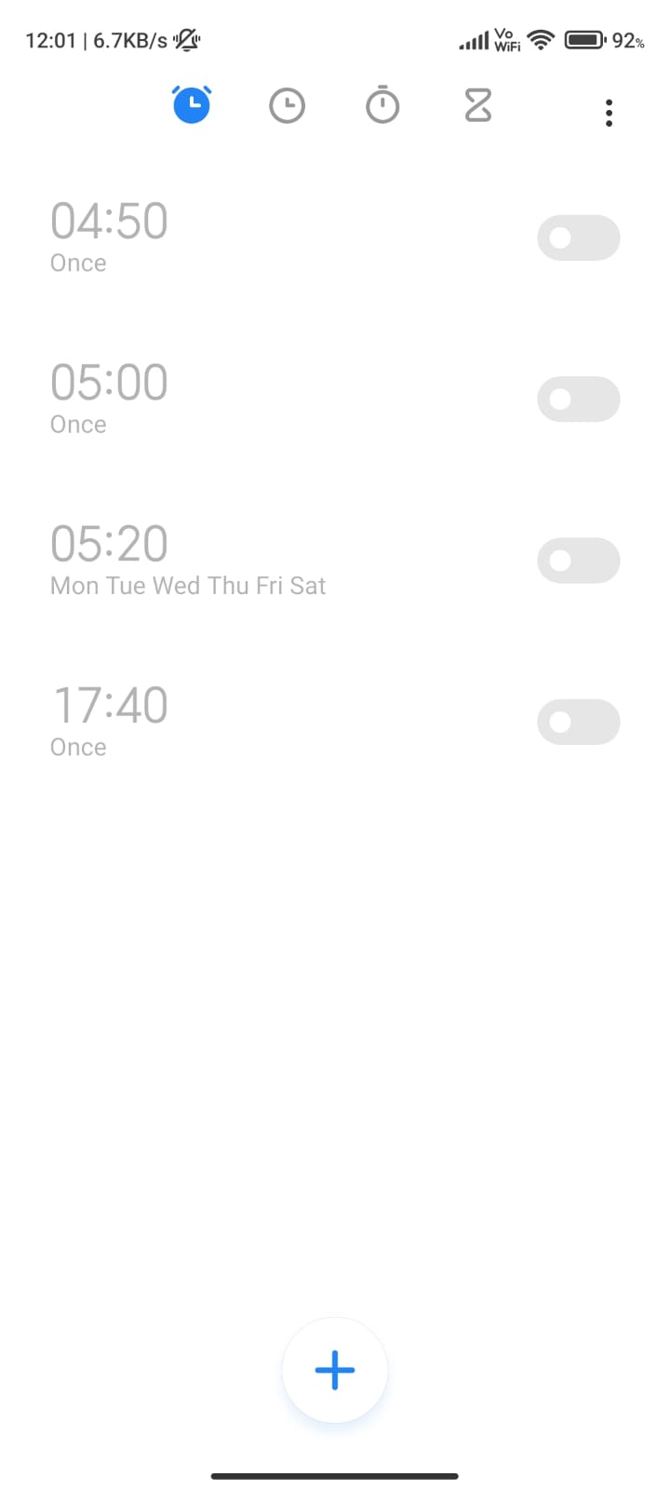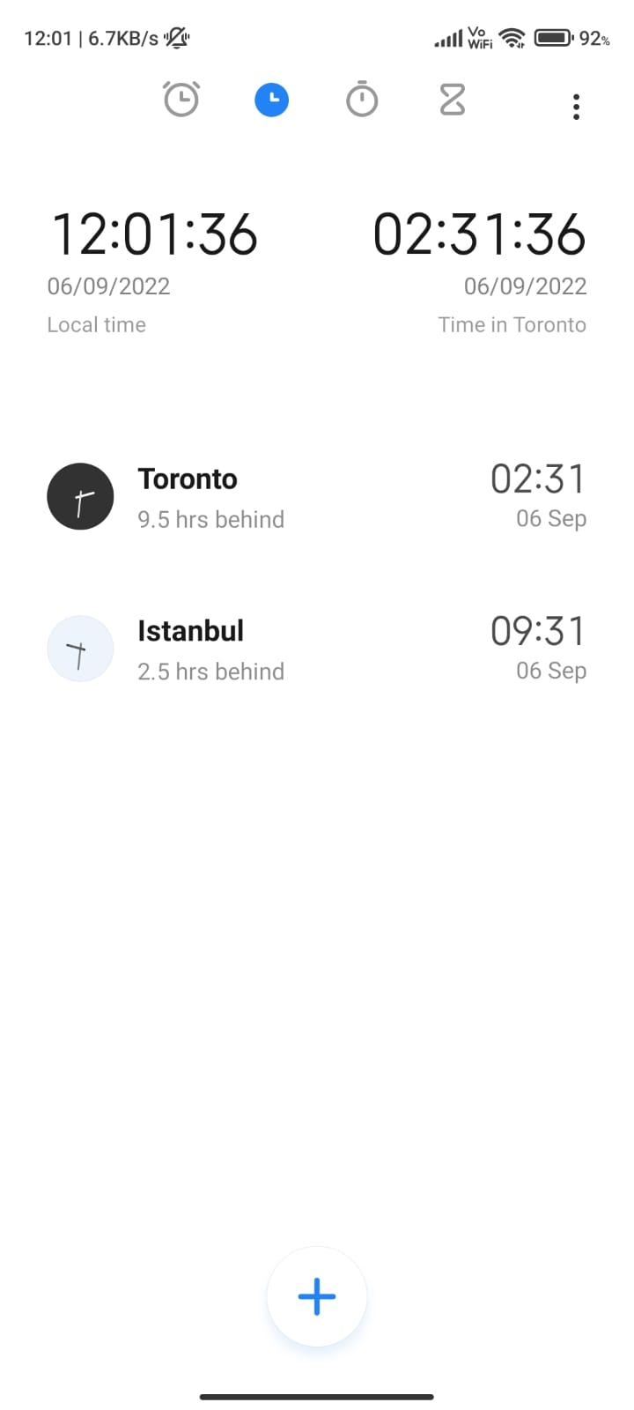**Example:**

Detailed View

* **Alarm section**
  + The first page will be index page on which the add alarm will be shown.
  + A form will be used to get the input from the user.
  + The particulars of the form will be:-
    - Time.
    - Label of the alarm.
    - Repeat type
      * Once
      * Weekday
      * Everyday
    - Save Button
    - Reset Button
  + Now, The data collected from the form will be sent to the database.
  + Now when user click the **<View Alarms>** He will be redirected to another page named viewAlarm.php
  + On viewAlarm.php we will display the alarms set the user in a Table by using a loop from database.
  + Following will be the Fields of the table
    - Time
    - Repeat Type
    - Label
    - Delete Button.
    - Edit Button.
  + User will be able to delete and update the alarm.
* **Clock Section**
  + In clock section the current time will be displayed on clock.php page in a Table using a loop.
  + Following will be the particular of that table
    - Time (in 24hrs format and it will be updated every minute).
    - Date
    - Continent Name / Time Capital (Example : Asia/Kolkata).
  + On the right corner there will be a button labelled <Add Time Zone>.
  + When User click on that button he will be redirected to a new page named addTime.php
  + On addTime.php there will be a form for the user.
  + Following will be the fields of the form
    - Continent (Select tag will be used to give user with all the valid continents)
    - Time zone (In this he will be provided with all the time zones in that specific continent)
    - Save Button
    - Reset Button.
  + After saving he will be redirected to the clock.php page where he can se the newly added time.
  + Here he will also have an option to Delete and Edit the time zone for all (Except for pre provided Indian time zone)