Wireless Sensor-based Application for Managing Theme Park

Project Proposal

**By**

Pabhawee Chuacharoen 552115037

Department of Software Engineering

College of Arts, Media and Technology

Chiang Mai University

Project Advisor

________________________

Dr.Noppon Choosri

**Abstract**

Theme park is widely popular in many parts of the world; there are varieties of theme parks that provide attractions, rides and other entertainment events to a large number of people. However, due to the high competition of the theme park industry. The Theme parks must try to create a selling point that makes their theme park attractive to potential customers.

Wireless sensor-based application for managing theme park is a web application for accumulating and displaying data that were collected from the guests via environmental sensors e.g. temperature sensor, accelerometer sensor, pulse sensor, and RFID technology with the help of Arduino microcontroller. To provide a report on visiting statistics and a unique selling-point, sensors, Wi-Fi module and RFID reader will be attached to the arduino in order to collect data from theme park's guest, and then sent them to web server, which the data will be handled and displayed.

**Document History**

|  |  |  |  |  |  |  |
| --- | --- | --- | --- | --- | --- | --- |
| Version | Status | Change Context | Viewable | Reviewer | Responsible | Date |
| V1.0 | Draft | Add chapter 1  -Introduction & Background  Add chapter 4  -Motivation  -Aims and Objectives | PC, NC | PC | PC | 02/08/15 |
| V1.1 | Draft | Fix Introduction & Background  Add chapter 2  -Business Review  -Technology Review  Add chapter 3  - ISO 29110 for Very Small Entity (VSE)  Add chapter 4  - Aim and Objective  - Deliverables and Limits  - Future Work  - Schedule & Milestone  Add Chapter 5  -Reference | PC, NC | PC, NC | PC | 03/08/15 |
| V.1.2 | Draft | Fix Business review  Fix Future work  Fix Features | PC, NC | PC, NC | PC | 06/08015 |
| V2.0 | Release | Change project name  Fix Introduction & Background  Fix Aims | PC, NC | PC, NC | PC | 26/08/15 |

PC = Pabhawee Chuacharoen , NC = Dr. Noppon Choosri

Table of Content

Chapter One | Introduction and Background 3

Chapter Two | Literature Review 4

2.1. Business Review 4

2.1.1. Vana Nava 4

2.1.2. Santorini Water 5

Fantasy RFID tag 5

2.2. Technology Review 6

2.2.1. Radio-frequency identification (RFID) 6

2.2.2. PHP 6

2.2.3. C++ 7

2.2.4. Cascading Style Sheets 3 (CSS3) 7

2.2.5. Arduino 8

2.3. Development Tool Review 9

2.3.1. Arduino Sketch 9

2.3.2. MySQL 9

2.3.3. Photoshop 10

2.3.4. NetBeans 10

2.3.5. Github 11

2.3.6. SourceTree 12

Chapter Three | Quality Standard 12

3.1 ISO 29110 for Very Small Entity (VSE) 12

• Project management process 13

3.2 Software implementation process 13

• Selected process 13

Chapter Four | Project Plan 13

4.1. Motivation 13

4.2. Aim and objectives 13

4.2.1. Aims 13

4.2.2. Objectives 14

4.3. Deliverables and limits 14

4.3.1. Deliverables 14

4.3.2. Documentations 14

4.3.3. Limits 14

4.4. Future Work 15

• Software Process 15

• Schedule & Milestones 15

4.6.1. Features 15

4.6.2. Milestones 17

Chapter Five | References 20

# Chapter One | Introduction and Background

There are several sizes of theme park and ranging from large and worldwide scale such as Walt Disney World, Europa-Park and Universal Studios Hollywood to smaller and medium-sized theme parks such as the Six Flags parks and Cedar Fair parks.

The competition within the theme park industry is high, not only they need to be competitive against other theme park, they also compete with numerous entertainment alternative such as water park and sport attraction. The competitive factors include location, price and uniqueness of the attractions and entertainments.

For this reason, The Theme park always looks for new ways to improve their guests overall experience that's why many theme parks make use of RFID technology by using them as commodities to appeal to potential customers. In order to create an uniqueness for the theme park, this project will focus on using wireless technology with the help of Arduino microcontroller integrated sensors and Wi-Fi module to collect and monitor data. The main task of the application is to accumulate information such as the number of guests that get on a ride in each day, guest's heart rate and data from the sensors through the devices, which will be attached to places within the park and guest, then display them on the website for further benefit of the guests and theme park company themselves.

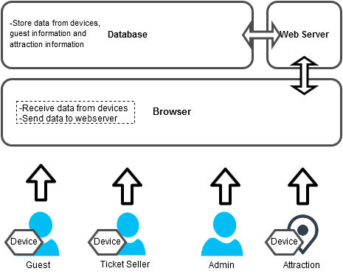

Figure 1: System architecture of Wireless sensor-based application for managing theme park

The architecture of MS4SF shown in the figure 1 consists of the following:

● Arduino: The arduino connects to RFID module ,sensors and Wi-Fi module. It’ll be deployed alongside with stations, entrance gate, exit gate rides’ entrance and ticket seller booth. The main task is to send data from arduino to web server. The person who will use this are guest and ticket seller.

● Web browser :The application that display the data, which come from Web Service.

● Web server :The container that store web data and provide web service.

● Database :The internal database of Wireless sensor-based application.

# Chapter Two | Literature Review

## Business Review

### Vana Nava

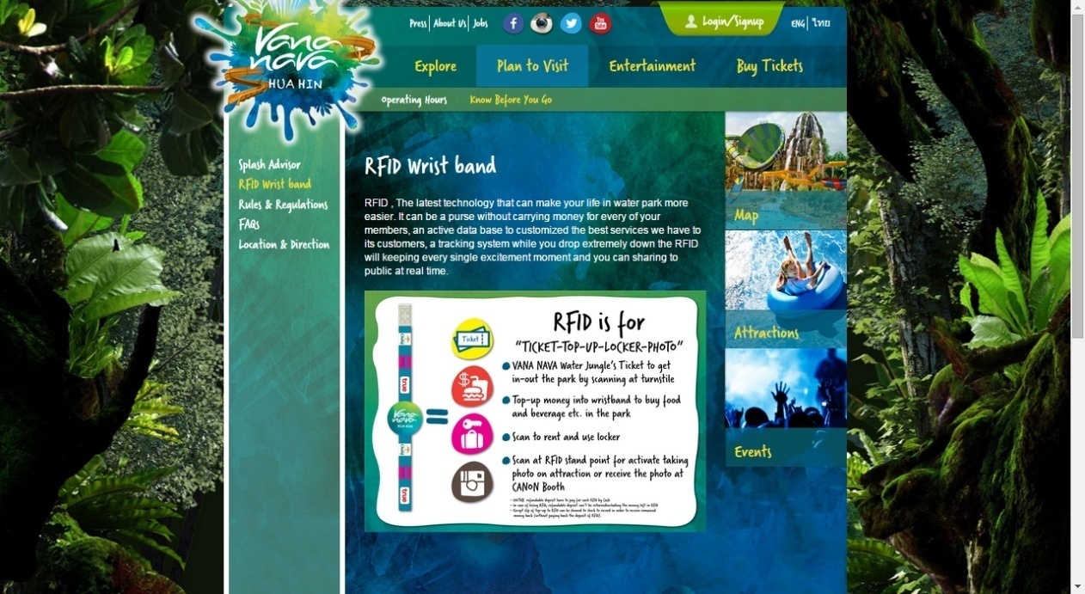

Figure 2.4: Vana Nava website (https://www.vananavahuahin.com/operating-hours)

Vana Nava is the water park in Thailand, which use RFID tag.

**Pro**

* + 1. Can in-out the park by scanning at turnstile
    2. Can top-up money into wristband to buy food and beverage in park.
    3. Can scan to rent and use locker.

**Con**

* + 1. User cannot manage by them self
    2. Tag is one time used.
    3. Easy to drop or lost it.
    4. lack of authentication.

### Santorini Water

### Fantasy RFID tag



Figure 2.5: RFID usage in Santorini (http://www.engineerfriend.com/2014/articles/santorini-water-fantasy-%E0%B8%8B%E0%B8%B2%E0%B8%99%E0%B9%82%E0%B8%95%E0%B8%A3%E0%B8%B4%E0%B8%99%E0%B8%B5-%E0%B8%A7%E0%B8%AD%E0%B9%80%E0%B8%95%E0%B8%AD%E0%B8%A3%E0%B9%8C-%E0%B9%81%E0%B8%9F%E0%B8%99/)

Santorini Water Fantasy is the water park in Thailand, which use RFID tags to handle the locker rental and also can locate the customer location on attractions and take them photo.

**Pro**

1. Easy to use in water park (water proof product)

**Con**

1. Easy to drop or lost it.
2. Lack of authentication.

## Technology Review

### Radio-frequency identification (RFID)

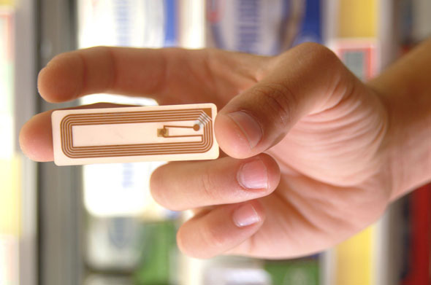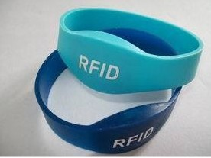

Figure 2.6: RFID tags within wristbands Figure 2.7: RFID tag (http://www.rfidworld.ca/)

#### Technology description

Radio-frequency identification (RFID) is the wireless use of electromagnetic fields to transfer data, for the purposes of automatically identifying and tracking tags attached to objects. The tags contain electronically stored information. Some tags are powered by electromagnetic induction from magnetic fields produced near the reader.[7]

#### Alternative technology

* + 1. barcode
    2. NFC (Near Field Communication)
    3. Bluetooth
    4. Infrared Tag

#### The selection of this technology

* + 1. Have longer range
    2. Cheap price
    3. Location based tracking data
    4. Small size

### PHP



• Figure 2.9: php language icon

#### Technology description

PHP is a server-side scripting language created in 1995 and designed for web development but also used as a general-purpose programming language.

#### Alternative technology

1. None (for web based, HTML is required)

#### The selection of this technology

1. Video and Audio Support.
2. Popular browsers all support HTML5 (Chrome, Firefox, Safari IE9 and Opera).
3. HTML5 is the most mobile ready tool for developing mobile sites and apps.

### C++



Figure 2.9: C++ language icon

#### Technology description

C++ is a general-purpose programming language. It has imperative, object-oriented and generic programming features, while also providing the facilities for low-level memory manipulation.

#### Alternative technology

1. None (for arduino Sketch, support only C++)

#### The selection of this technology

1. Arduino Sketch support only C++

### Cascading Style Sheets 3 (CSS3)



Figure 2.10: css3 icon

#### Technology description

Cascading Style Sheets (CSS) is a style sheet language used for describing the look and formatting of a document written in a markup language. While most often used to change the style of web pages and user interfaces written in HTML and XHTML, the language can be applied to any kind of XML document, including plain XML, SVG and XUL.

#### Alternative technology

1. CSS2

#### The selection of this technology

1. A relatively simple web language
2. Flexibility in custom development

### Arduino

### http://makeshoppgh.files.wordpress.com/2011/05/006_110430_pauls_components_3.jpg

Figure 2.13: Arduino

#### Technology description

Arduino is an open-source computer hardware and software company, project and user community that designs and manufactures kits for building digital devices and interactive objects that can sense and control the physical world.

#### Alternative technology

1. Raspberry Pi
2. LaunchPad
3. Nanode
4. Pinguino

#### The selection of this technology

1. Provides a number of libraries
2. Allows programming and serial communication over USB
3. Great communities of users

## Development Tool Review

### Arduino Sketch



Figure 2.12: Arduino icon

#### Tool description

Arduino is an open-source computer hardware and software company, project and user community that designs and manufactures kits for building digital devices and interactive objects that can sense and control the physical world.[1]Arduino boards may be purchased pre-assembled, or as do-it-yourself kits; at the same time, the hardware design information is available for those who would like to assemble an Arduino from scratch.

#### Alternative tool

1. Arduino Eclipse Plugin
2. Embrio
3. MariaMole

#### The selection of this tool

1. Easy to write code and upload it on board
2. Flexible programming environment
3. Open source software

### MySQL



Figure 2.12: My SQL icon

#### Tool description

MySQL is the world's second most widely used relational database management system (RDBMS) and most widely used open-source RDBMS.

#### Alternative tool

1. PHPMyadmin
2. Appserv
3. Apache

#### The selection of this tool

1. Get to insights faster with a complete BI platform that speeds up how you access, analyze, clean and shape both internal and external data.
2. SQL Server 2014 was designed to work in a hybrid environment that spans on-premises and the cloud.

### NetBeans



#### Tool description

NetBeans is a software development platform written in Java. The NetBeans Platform allows applications to be developed from a set of modular software components called modules. Applications based on the NetBeans Platform, including the NetBeans integrated development environment (IDE), can be extended by third party developers.

#### Alternative tool

1. Eclipse
2. Dreamweaver
3. IntelliJ IDEA

#### The selection of this tool

1. Has so many built in plug-ins.
2. Includes new features for editing/debugging HTML5.
3. Vast API of commonly used tasks.
4. Supports PHP frameworks.

### Github



#### Tool description

GitHub is a web-based Git repository hosting service, which offers all of the distributed revision control and source code management (SCM) functionality of Git as well as adding its own features. Unlike Git, which is strictly a command-line tool, GitHub provides a web-based graphical interface and desktop as well as mobile integration.

#### Alternative tool

1. Google Code
2. Bitbucket
3. CodePlex

#### The selection of this tool

1. Stores a copy of project's repository
2. Keeping track of changes
3. Quickly comparing changes

### SourceTree



#### Tool description

SourceTree is a free Mercurial and Git Client for Windows and Mac that provides a graphical interface for your Hg and Git repositories.

#### Alternative tool

1. Stash
2. Codebase
3. Tower

#### The selection of this tool

1. Managing branches in Sourcetree is easy.
2. Gives you a 'real time' view of local files.
3. Provide branch history.
4. It doesn't cost a thing to download or use SourceTree.

# Chapter Three | Quality Standard

## ISO 29110 for Very Small Entity (VSE)

ISO/IEC 29110-4-1:2011 is applicable to Very Small Entities (VSEs). A Very Small Entity (VSE) is defined as an enterprise, organization, department or project having up to 25 people. A set of standards and guides have been developed according to a set of VSEs' characteristics and needs. The guides are based on subsets of appropriate standards elements, referred to as VSE profiles. The purpose of a VSE profile is to define a subset of International Standards relevant to the VSE context.[27]

### Project management process

The purpose of the software management process is to establish and carry out in a systematic way the task of the software implementation project which allows complying with the project’s objectives in the expected quality.

The 4 Activities in project management process

1. Project Planning
2. Project Plan Execution
3. Project Assessment and Control
4. Project Closer

## Software implementation process

The purpose of the software implementation process is the systematic performance of the analysis, design, construction, integration and test actives for new or modified software products according to the specified requirements.

### Selected process

1. Software implementation process
2. Software requirement analysis process
3. Software architectural design process
4. Software construction process
5. Software integration process and test process
6. Software delivery process

# Chapter Four | Project Plan

## Motivation

Nowadays, Theme park visitors have many choices of entertainments laid out before them, this is the fact that drives theme parks into making them stand out from their competitors. The RFID technology is being utilized by a number of theme parks, making it an important asset in order to appeal to potential customers.

The reason to develop Wireless sensor-based application for managing theme park is to create an asset that attract potential customers attention and also a tool that benefit the theme park by providing a report on visiting statistics data.

## Aim and objectives

### Aims

This project aims to develop a prototype to provide a proof of concept of using wireless sensor to provides a web application that:

1. assists theme park’s employees in managing attraction information
2. assists theme park’s employees in managing guest information
3. supports decision making of theme park company
4. given the chances to attract the potential customer

### Objectives

1. To conduct the business review of theme park’s industry in Thailand
2. To specify the appropriate tools in development process
3. To identify user requirements
4. To define detailed design on software design specification
5. To implement the software design specification
6. To conduct the test according to the test plans
7. To document the test results
8. To deliver the project

## Deliverables and limits

### Deliverables

#### 1st Progress

Feature#1 Guest information management

Feature#2 Attraction information management

#### 2nd Progress

Feature#3 Collecting visiting statistics data for attraction information

Feature#4 Attractions' statistic information

#### 3rd Progress

Feature#5 Collecting data for guest information

Feature#6 Guests' personal information

### Documentations

1. Proposal
2. Project plan
3. Quality plan
4. Software requirement specification
5. Traceability record
6. Software design document
7. Testing document
8. Test plan
9. Unit test report
10. System Test report
11. 1 DVD stores client source code, relate file, all documents and poster files in PDF format
12. 1 project poster

### Limits

1. Internet connection is required
2. User needs to log-in before granting access to the application
3. The stability of the hardware
4. There are limited number of hardware available for this project

## Future Work

We might consider the following:

1. extend the variety of sensors
2. deploy more microcontroller into the environment
3. fully utilize the abilities of RFID technology

## Software Process

Our project uses iterative development process to develop the software which is a development approach that "cycles" through the development phases, from gathering requirements to delivering functionality in a working release. When the process flows into iterative, the process will start from the first step then go to the next step till the last. After that, the process will back to the first step and start again. The iteration will be repeat until

all processes planned are complete then out from the loop and go to next main phase.

**Proposal phase:** This phase is brainstorm and creating a proposal for the project.

Document plan phase: This phase is about document for planning and designs the overall

system from requirement given by the user.

Iterative all features: This phase is about separate system into many features and then iterative create all feature from the first feature till the final feature. For

this phase, it will be divided into 4 phases. There are;

**Plan:** Planning the method for creating and test each feature.

**Implement:** Implementing and coding each feature.

**Test:** Testing and fixing each feature.

**Review:** Reviewing and maintaining each feature to meet the feature plan.

**System test phase:** This phase will integrate all features into one system and then create test document from system testing.

**Deploy phase:** This phase is about deploying the whole system to server and use as a regular web application.

## Schedule & Milestones

There are three types of users:

1. Guest
2. Ticket seller
3. Admin

### Features

#### Feature#1 Guest information management

**Description:** This feature supports ticket seller in managing customer information in the system

**User:** Ticket seller

**Detail:**

**1-1 Ticket seller:** Ticket seller can register guest into the system.

**1-2 Ticket seller:** Ticket seller can view guest information from the system.

**1-3 Ticket seller:** Ticket seller can edit guest information into the system.

**1-4 Ticket seller:** Ticket seller/admin can delete guest information into the system.

#### Feature#2 Attraction information management

**Description:** This feature supports Admin in managing attraction information in the system

**User:** Admin

**Detail:**

**2-1 Admin:** Admin can add attraction information into the system.

**2-2 Admin:** Admin can view attraction information from the system.

**2-3 Admin:** Admin can edit attraction information from the system.

**2-4 Admin:** Admin can delete attraction information from the system.

#### Feature#3 Collecting visiting statistics data for attraction information

**Description:** This feature supports collecting visiting statistics datathe device attached to the ride entrance

**User:** Guest

**Detail:**

**3-1 Guest :** Guest can enter the entrance gate by representing RFID tag at RFID reader.

**3-2 Guest :** Guest can exit the exit gate by representing RFID tag at RFID reader.

**3-2 Guest :** Guest can enter attraction entrance by representing RFID tag at RFID reader.

#### Feature#4 Attractions' statistic information

**Description:** This feature supports displaying of data collected from the device attached to the ride entrance

**User:** Admin

**Detail:**

**5-1 Admin:** Admin can view daily numbers of guest in the theme park.

**5-2 Admin:** Admin can view daily numbers of guest who gets on each ride.

#### Feature#5 Collecting data for guest information

**Description:** This feature supports collecting guest and environment data from the sensors attached to the guest

**User:** Admin

**Detail**:

**4-1 Guest :** Guest can register UID into the device.

#### Feature#6 Guests' personal information

**Description:** This feature supports displaying and managing external data from the guest's monitoring device

**User:** Guest

**Detail:**

**6-1 Guest :** Guest can log in into the system.

**6-2 Guest :** Guest can log out from the system.

**6-3 Guest :** Guest can view personal information.

**6-4 Guest :** Guest can edit personal information.

**6-5 Guest :** Guest can view a list of played ride.

**6-6 Guest :** Guest can delete a list of played ride.

**6-7 Guest :** Guest can view a list of temperature, acceleration and heart rate that were collected from the device.

**6-8 Guest :** Guest can delete a list of temperature, acceleration and heart rate that were collected from the device.

### Milestones

#### 1st Progress

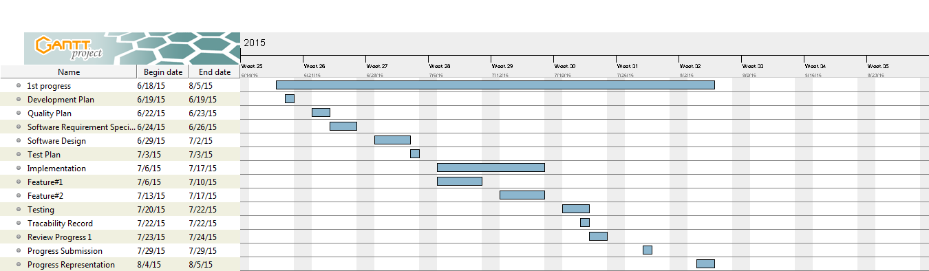

Figure 4.1: Progress 1 milestone

#### 2nd Progress

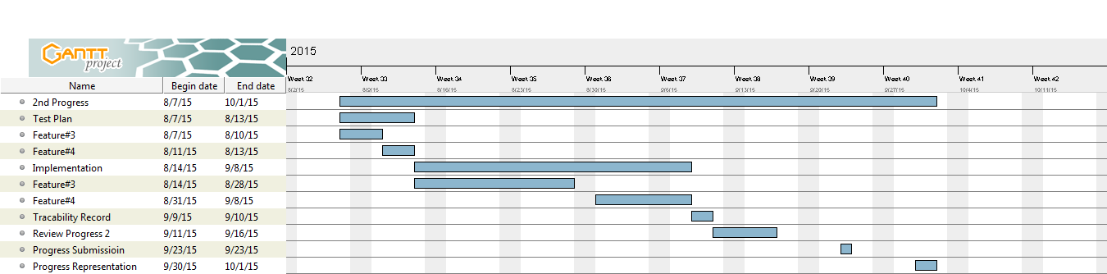

Figure 4.2: Progress 2 milestone.

#### 3rd Progress

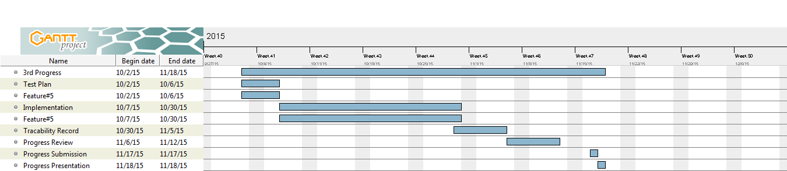

Figure 4.3: Final Progress milestone

# Chapter Five | References

[1]Amusement Park. [online] http://en.wikipedia.org/wiki/Amusement_park (Accessed on 15 May 2015)

[2]RFID Implementation in Theme Park [Online] http://www.slideshare.net/PeterSam67/rfid-implementation-in-theme-parks (Accessed on 15 May 2015)

[3]RFID Lets Theme Parks Be Fun for All[online]

http://rfid.thingmagic.com/rfid-blog/bid/50518/RFID-Lets-Theme-Parks-Be-Fun-for-All(Accessed on 15 May 2015)

[4]MagicBands Bring Convenience, New Services to Walt Disney World[online]

http://www.rfidjournal.com/articles/view?11877(Accessed on 15 May 2015)

[5]Vana Nava Waterpark[online]

http://www.vananavahuahin.com/rfid-wrist-band(Accessed on 19 May 2015)

[6]Santorini Water Fantasy :ซานโตรินีวอเตอร์แฟนตาซีสวนน้ำดิจิตอลแห่งแรกของเอเชีย[online]

http://www.engineerfriend.com/2014/articles/santorini-water-fantasy-%E0%B8%8B%E0%B8%B2%E0%B8%99%E0%B9%82%E0%B8%95%E0%B8%A3%E0%B8%B4%E0%B8%99%E0%B8%B5-%E0%B8%A7%E0%B8%AD%E0%B9%80%E0%B8%95%E0%B8%AD%E0%B8%A3%E0%B9%8C-%E0%B9%81%E0%B8%9F%E0%B8%99/(Accessed on 19 May 2015)

[7]RFID. [online] http://en.wikipedia.org/wiki/Radio-frequency_identification (Accessed on 19 May 2015)

[8]HTML5. [online] http://en.wikipedia.org/wiki/HTML5 (Accessed on 19 May 2015)

[9]JavaScript. [online] http://en.wikipedia.org/wiki/JavaScript (Accessed on 19 May 2015)

[10]Arduino. [online] http://www.arduino.cc/en/Main/Software (Accessed on 19 May 2015)

[11]My disneyexperience[online] https://play.google.com/store/apps/details?id=com.disney.mdx.wdw.google&hl=en (Accessed on 15 May 2015)

[12]Disney waiting time [online] https://play.google.com/store/apps/details?id=com.versaedge.android.wdwwaits&hl=en (Accessed on 15 May 2015)

[13]VanaNava[online] https://www.vananavahuahin.com (Accessed on 15 May 2015)

[14]Santorini Waterpark [online] http://www.santoriniwaterfantasy.com (Accessed on 15 May 2015)

[15] Orlando Resort App [online] https://play.google.com/store/apps/details?id=com.universalstudios.orlandoresort&hl=en (Accessed on 15 May 2015)

[16]Google Maps api [online] https://developers.google.com/maps/ (Accessed on 15 May 2015)

[17]C++ on WIkipedia [online] http://en.wikipedia.org/wiki/C%2B%2B (Accessed on 15 May 2015)

[18] CSS [online] http://en.wikipedia.org/wiki/Cascading_Style_Sheets (Accessed on 15 May 2015)

[19] JSON on wikipedia [online] http://en.wikipedia.org/wiki/JSON (Accessed on 15 May 2015)

[20] Android Studio [online] http://en.wikipedia.org/wiki/Android_Studio (Accessed on 15 May 2015)

[21] MySQL [online] http://en.wikipedia.org/wiki/MySQL (Accessed on 3 June 2015)

[24] Adobe Photoshop [online] http://en.wikipedia.org/wiki/Adobe_Photoshop (Accessed on 15 May 2015)

[25] IntelliJ Idea [online] https://www.google.co.th/?gws_rd=ssl#q=intellij+idea+wiki (Accessed on 15 May 2015)

[26] GitHub [online] http://en.wikipedia.org/wiki/GitHub (Accessed on 15 May 2015)

[27] Sourcetree [online] http://en.wikipedia.org/wiki/Atlassian (Accessed on 15 May 2015)

[28] ISO 29110 vse [online]http://www.iso.org/iso/catalogue_detail.htm?csnumber=51154 (Accessed on 3 June 2015)