LAND STACK
Standard Technical Document
A unified, parcel-centric, GIS-based platform for Indian land governance

Smart India Hackathon 2026 · Team GeoVault
Document version 1.0 · September 2026
Describes the working prototype: 92 synthetic parcels, 5 districts in 5 states, 47 documented API operations.

How to read this document. Every section separates what is implemented and tested in the prototype from what is a proposed production design. Endpoint tables, state-adapter mappings and model metrics are generated from the running code, so they match the software. Nothing here claims a legal or security certification.

Contents

If the contents list appears empty, right-click it in Word and choose Update Field.

1. Purpose and scope
Land records in India are held by different departments (revenue, registration, survey, planning, municipal) under different state laws, in different formats and languages. The result is disputes, delays and duplicated effort. Land Stack demonstrates a single, parcel-centric platform that links those records through one identifier, respects state differences instead of erasing them, and gives citizens and officers the right level of access.

1.1 What the prototype demonstrates
- One parcel, one identifier. Every plot has a 14-character ULPIN; all layers of information hang off it.
- Three data tiers. Base (cadastral geometry and identity), essential (Record of Rights, registration, encumbrance, land use, building permission) and additional (tax, utilities, valuation, satellite monitoring).
- State adapters. Local record names, area units and languages per state, plus ingestion mappings from each state's own field names to a common schema.
- Drawn boundaries. Plots are registered by drawing a polygon; the server computes the area and rejects self-crossing, out-of-jurisdiction or overlapping shapes.
- A complete sale-deed workflow with OTP authentication of both parties, duty computation, registration and a separate revenue-department mutation.
- Real citizen identity. Access is keyed on a unique person ID plus OTP, never on a name.
- Explainable risk analytics and a tamper-evident audit trail.
- Mobile-first delivery as an installable, offline-capable web app in five languages.

1.2 Out of scope for the prototype
Real Aadhaar/DigiLocker e-KYC, real payment gateways, real SMS delivery, live integrations with state land-record systems, live satellite imagery and legal-grade digital signatures are represented by simulations or documented interfaces only. All data is synthetic.

2. System architecture
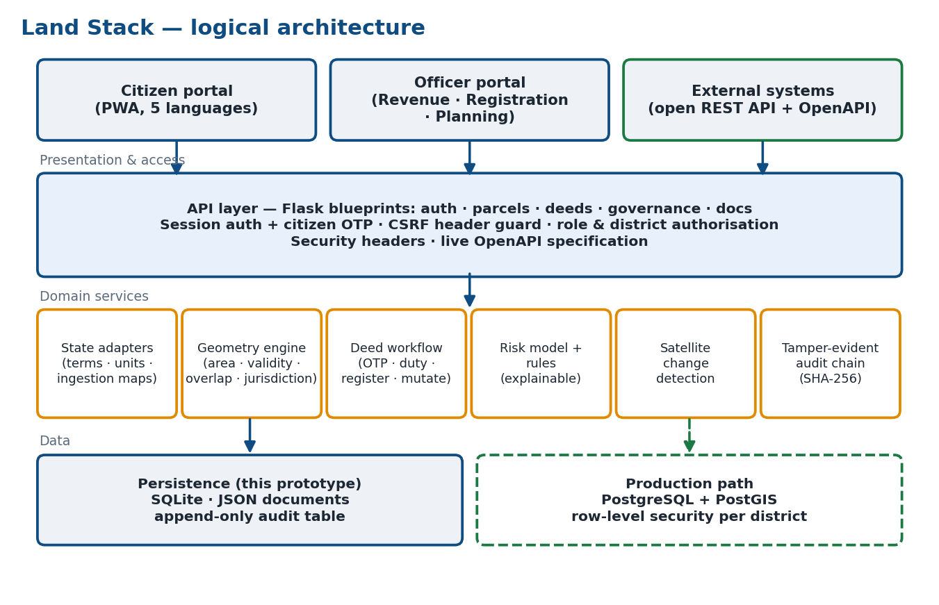
Figure 1 — Logical architecture. Solid = implemented; dashed = production path.
Layer | Component | Responsibility
Presentation | Single-page web app (plain JavaScript, Leaflet) | Citizen and officer portals, map with layer toggles, drawing tool, sale-deed screens, five UI languages, installable PWA with an offline shell.
API | Flask application, five blueprints | 47 operations. Session authentication, citizen OTP, CSRF header guard, role and district authorisation, security headers, generated OpenAPI 3 spec.
Domain | adapters, geo, services, routes/deeds | State terms/units/ingestion, geometry validation and overlap, ownership transfer, valuation, deed state machine.
Analytics | risk_model, rules, satellite | Logistic-regression risk score with per-parcel explanations, transparent rule baseline, synthetic change-detection demo.
Integrity | audit | SHA-256 hash-chained audit log with a verification endpoint.
Data | store (SQLite) | Persistent JSON documents with an indexed district column and an append-only audit table. Written in one transaction per request.

2.1 Technology choices
Concern | Prototype | Why | Production direction
Language / framework | Python 3, Flask | Fast to build and read; wide talent pool. | Same code behind gunicorn/uWSGI; services extractable per state.
Persistence | SQLite (WAL) | Zero-install, survives restarts. | PostgreSQL + PostGIS with spatial indexes and row-level security.
Geometry | Pure-Python module | No GIS install needed on a laptop. | PostGIS / GEOS topology functions.
Front end | Vanilla JS, Leaflet | No build step; runs anywhere. | Same, or a framework if the team prefers.
ML | numpy logistic regression | Explainable by construction; tiny. | Same model family first; gradient-boosted trees only if they beat it on real data.

3. Data model and schemas

3.1 Data layers
Tier | Layer | Prototype content | Visible to
Base | Cadastral geometry, ULPIN, zone code, owner name | Polygon (GeoJSON), 14-char ULPIN, A/C/U/R zone, name unless the owner chose privacy | Everyone
Essential | Record of Rights; registration; encumbrance; land-use/zoning; building permission | Owner ID and name, area, survey no., ownership history, registration record, mortgage flag, designated use, permit status | Owner; officers of that district
Additional | Property tax; utilities; valuation; satellite watch; bank/loan | Tax status and dues, water/power flags, guideline value, change-detection result; bank and loan for the owner only | Owner; district officers (bank/loan: owner only)

3.2 Canonical parcel schema (abridged)
Field | Type | Notes
ulpin | string(14) | <state 2><district 3><sequence 9>, e.g. TNCOI000000001. Illustrative structure, not the official ULPIN layout. Must carry the district prefix of the registering officer.
geometry | GeoJSON Polygon | WGS-84 (EPSG:4326), RFC 7946 order [lon, lat]. Area is derived from it, never typed in.
record_of_rights | object | owner_id (person ID), owner_name, past_owners[], area_sqm, khasra_or_plot_no, ror_last_updated.
ownership_history[] | array | Each entry: owner ID/name, from_date, to_date, basis (fresh registration, sale deed no., succession request), deed_id.
registration | object | Latest owner name, transaction type/date, registration number.
encumbrance | object | has_encumbrance, details. A mortgaged plot needs a bank NOC before a sale deed can be drafted.
land_use_zoning, building_permission | objects | Designated use, master-plan reference, permit status.
property_tax, utilities | objects | Assessee, dues, status; water and power connections.
bank_link | object | Only the last four digits of an account are ever stored; readable by the owning citizen only.
privacy | object | public_visible toggled by the owner; officers of the district still see the name.
pending_mutation | object (optional) | Set between deed registration and mutation so the temporary registration/RoR gap is shown as a normal lag.

3.3 Identity
Each person has an immutable person ID (CID-########), a name, a mobile number and a login. Parcels reference owner_id, never a name. The seed data deliberately contains two different people called "Rajesh Kumar" in different districts; an automated test proves that neither can open the other's plot. Earlier prototype versions matched by name, which is unsafe — this was the most important design correction.
Production note. The person ID is a prototype stand-in. A real deployment would bind identity to a verified credential (e.g. Aadhaar-based e-KYC or DigiLocker) under the applicable legal framework, and would never rely on a mobile number alone.

4. State adapter layer
Land is a State subject. Record names, units, field layouts and languages differ, so forcing one format nationally would lose meaning and invite resistance. Each state therefore has an adapter that (1) supplies local terms in English and the local script, (2) converts areas to that state's units, and (3) maps a raw record in the state's own field names onto the canonical schema.
State | Record of Rights | Survey term | Area units (primary first) | UI language
Tamil Nadu | Patta / Chitta  பட்டா / சிட்டா | Survey / Sub-division No.  சர்வே / உட்பிரிவு எண் | cent, acre | ta
Chandigarh | Jamabandi  जमाबंदी | Khasra No.  खसरा संख्या | marla, kanal | hi
Andhra Pradesh | Adangal / Pahani (1-B)  అడంగల్ / పహాణీ | Survey No.  సర్వే నంబర్ | guntha, acre | te
Kerala | Thandaper / Basic Tax Register  തണ്ടപ്പേർ | Re-survey No.  റീസർവേ നമ്പർ | cent, acre | ml
Rajasthan | Jamabandi (Nakal)  जमाबंदी (नकल) | Khasra No.  खसरा संख्या | biswa, bigha | hi

4.1 Ingestion mapping
An officer can paste a state-format record and preview how it maps before anything is saved (POST /api/adapters/normalize). Fields the adapter does not recognise are reported, not silently dropped; extents in local units are converted to square metres.
State | Raw field → canonical field
Tamil Nadu | patta_no → ror_reference survey_no → survey_number sub_division → sub_division owner → owner_name village → place_name extent_acre → extent:acre extent_cent → extent:cent
Chandigarh | jamabandi_no → ror_reference khasra_no → survey_number malik → owner_name sector → place_name kanal → extent:kanal marla → extent:marla
Andhra Pradesh | pahani_no → ror_reference survey_no → survey_number pattadar → owner_name village → place_name acres → extent:acre guntas → extent:guntha
Kerala | thandaper_no → ror_reference resurvey_no → survey_number owner → owner_name village → place_name extent_acre → extent:acre extent_cent → extent:cent
Rajasthan | jamabandi_no → ror_reference khasra_no → survey_number khatedar → owner_name village → place_name bigha → extent:bigha biswa → extent:biswa

Caveat. Local-script terms and UI translations were drafted for the prototype and must be reviewed by native speakers and the state revenue departments. Some units (notably the Rajasthan bigha) vary by region; the unit sizes are configuration, not law.

5. API standards
Topic | Standard used
Style | REST over HTTP, JSON bodies, resource-oriented paths under /api/.
Specification | OpenAPI 3.0.3, generated from the live routes at /api/openapi.json; interactive explorer at /api/docs. Access rules come from the same decorators that enforce them.
Authentication | Server-side session in an HttpOnly, SameSite=Lax cookie. Officers: password. Citizens: password then a one-time password sent to the registered mobile.
CSRF | Every state-changing request must carry X-Requested-With: LandStack; a cross-site page cannot send it without a CORS pre-flight, which is never granted.
Authorisation | Role (revenue / registration / planning officer, citizen) plus scope: officers act only inside their district; citizens only on plots they own by person ID.
Errors | Non-2xx responses carry {"error": "human-readable message"}; 400 validation, 401 not logged in, 403 not permitted, 404 unknown, 409 workflow conflict, 429 lock-out.
Geospatial output | GeoJSON FeatureCollection (RFC 7946) at /api/parcels, structured so it can be wrapped as an OGC API – Features collection (not implemented).
Versioning | Not yet versioned. Production should add a /v1/ prefix and a deprecation policy before external systems integrate.
Idempotency / pagination | Not implemented; list endpoints are small in the prototype. Production needs cursor pagination and idempotency keys on payments.

The full endpoint list (47 operations) is in Appendix A.

6. GIS standards and geometry rules
Rule | Implementation
Coordinate system | WGS-84 (EPSG:4326) for storage and exchange. Production should compute areas in the official projected CRS for each state.
Area | Computed server-side from the polygon in a local equirectangular projection around its centroid, then the shoelace formula. Accurate to well under 0.1% at plot scale. The seeded data is checked so each polygon's area equals its recorded area.
Shape validity | At least three distinct points; edges must not cross (bow-ties rejected); area between 5 m² and 2,000,000 m².
Overlap | A new plot is compared with every registered plot. It is rejected if more than 0.5% of the smaller plot lies inside the other or a vertex penetrates more than 0.5 m. Shared boundaries and GPS-level slivers are allowed, so neighbouring plots register cleanly.
Jurisdiction | All vertices must lie within the district's radius (a circular stand-in for the official district polygon).
Live feedback | POST /api/geo/check-boundary is called as the officer draws and reports validity, area in local units, jurisdiction and overlapping plots, so mistakes are caught before submission.
Base maps | Tile source is a single constant (MAP_TILES). The default OpenStreetMap tiles show disputed borders using a neutral international convention; deployments that must follow the official map of India should switch to an authorised provider such as Bhuvan or Mappls (own API key required).

6.1 Alignment with land-administration standards
The model maps naturally onto ISO 19152 (LADM): a person is a Party; the Record of Rights, encumbrance and registration are Rights, Restrictions and Responsibilities; a parcel is a Basic Administrative Unit with a Spatial Unit. This is a conceptual alignment for discussion, not a conformance claim.
Limits of the prototype geometry: it uses a circular jurisdiction test, a sampled overlap estimate and no topology store. These are adequate for demonstration; PostGIS with a GiST index would replace them at scale.

7. Security framework

7.1 Access model
Capability | Public | Citizen (owner) | Revenue | Registration | Planning
View owner name, survey no., zone | Yes* | Yes | Yes | Yes | Yes
Full dossier of a plot | No | Own plots | Own district | Own district | Own district
Bank and loan details | No | Own plots only | No | No | No
Hide own name publicly | No | Yes | No | No | No
Register a parcel | No | No | No | Own district | No
Draft / authenticate / register a deed | No | No | No | Own district | No
Complete mutation | No | No | Own district | No | No
Approve record-update requests | No | No | No | Own district | No
Post updates, view risk/reports/audit | No | Updates: read | Own district | Own district | Own district
* Unless the owner has chosen privacy, in which case only that district's officers and the owner see the name.

7.2 Controls implemented
- Passwords stored only as salted PBKDF2-SHA256 hashes (310,000 iterations). Five failures lock the account for five minutes.
- Citizen OTP. Six digits, five-minute expiry, single use, five attempts, stored hashed. In demo mode the API returns the OTP on screen; with LANDSTACK_DEMO_MODE=0 it is never returned.
- Deed authentication. The seller and the buyer each verify a separate OTP before fees can be recorded.
- District isolation on both viewing and acting; tests confirm an officer cannot read or change another district's plot.
- Input handling. Names are validated against an allow-list; all dynamic output in the front end is HTML-escaped. A browser test registers a plot whose place name contains an <img onerror> payload and confirms it renders as text and never runs.
- Data minimisation. Only the last four digits of a bank account are kept; a bank link is dropped on change of ownership.
- Session hygiene. Session cleared on login; HttpOnly + SameSite cookie; eight-hour lifetime; nosniff, X-Frame-Options: DENY, Referrer-Policy headers; API responses are no-store and never cached by the service worker.
- Tamper-evident audit trail (7.3).

7.3 Audit hash chain
Every action is appended to an audit log. Each entry stores the SHA-256 of the previous entry combined with its own contents. GET /api/audit-log/verify recomputes the chain and reports the first broken entry. Tests confirm that editing an entry, deleting an entry, or editing the database file directly are all detected.
What this does not do. It makes silent changes detectable, not impossible. Someone with full control of the database could rewrite the whole chain, and deleting the newest entries is invisible unless the head hash was recorded elsewhere. Production should publish the head hash periodically to a store the database administrator cannot alter.

7.4 Threat model (summary)
Threat | Mitigation in prototype | Residual risk
Credential guessing | Lock-out, hashed passwords, citizen OTP | Officers use a single factor
OTP brute force | Expiry, five attempts, single use | OTP state is in memory (lost on restart, not shared across workers)
Citizen reads another's land | Access by person ID; homonym test | Depends on real identity proofing
Officer overreach | District scoping on read and write; role separation between registration and mutation | Insider collusion across roles
CSRF / XSS | Custom header + SameSite; input allow-list + output escaping | No Content-Security-Policy yet
Record tampering | Hash-chained audit | Needs external anchoring
Bank data exposure | Owner-only, last four digits | Mock data only
Data at rest / in transit | — | Not encrypted; plain HTTP on localhost. TLS and disk encryption are mandatory in production.

Privacy law. Owner-controlled visibility, data minimisation and an audit trail follow the spirit of India's Digital Personal Data Protection Act, 2023. No legal review has been done and this document makes no compliance claim.

8. Sale-deed workflow
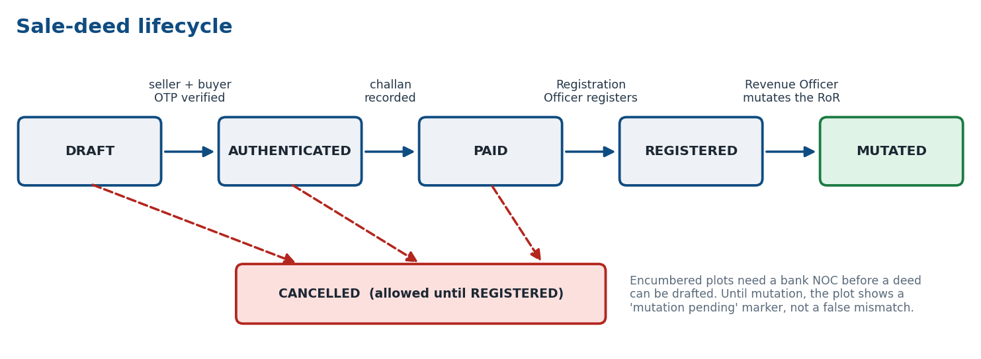
Figure 2 — Deed states. Registration and mutation are deliberately separate departments.
Step | Actor | Checks | Effect
Draft | Registration Officer, in the presence of both parties | Plot in officer's district; buyer exists and differs from seller; price > 0; no other active deed; encumbered plots need a bank NOC | Computes guideline value, stamp duty, registration fee; sends an OTP to seller and to buyer
Authenticate | Registration Officer records each party's OTP | Correct, unexpired, unused OTP | Both verified → AUTHENTICATED
Pay | Registration Officer | Both parties authenticated; valid challan reference | PAID
Register | Registration Officer | Fees paid; owner still the seller; encumbrance unchanged | Deed number issued; registration layer updated; plot marked "mutation pending"
Mutate | Revenue Officer (same district) | Deed registered | Record of Rights, ownership history, tax assessee move to the buyer; seller's bank link is removed
Cancel | Registration Officer | Only before REGISTERED | CANCELLED (fees flagged for refund)

Duty is calculated on the higher of the declared price and the guideline value. Rates in the prototype are illustrative placeholders:
State | Stamp duty | Registration fee
Tamil Nadu | 7% | 2%
Chandigarh | 6% | 1%
Andhra Pradesh | 7.5% | 0.5%
Kerala | 8% | 2%
Rajasthan | 5% | 1%

Both the citizen portal ("My Transactions") and the officer portal show the same status stepper and a full timeline of who did what and when.

9. AI/ML and monitoring

9.1 Dispute-risk analytics
Two signals are shown side by side. The rule score flags owner-name mismatches between the Record of Rights, the registration layer and the tax layer — fully transparent. The learned score is an L2-regularised logistic regression over nine record features (mismatches, encumbrance, ownership churn, recent transactions, unpaid tax, satellite flag, plot size, land use). Each score comes with its top contributing factors, so an officer can see why.
Measure | Value
Training data | 4500 synthetic parcels; labels from a documented generating process + noise
Held-out test data | 1500 held-out synthetic parcels
Base rate of "dispute" label | 15.8%
AUC (learned model) | 0.7406
AUC (rule baseline) | 0.6946
Precision / recall in top 10% of scores | 53% / 32%

Honesty note. No public dataset links these features to real land-dispute outcomes. The model is trained on synthetic records whose labels come from a documented generating process plus noise. The metrics therefore show the pipeline works and recovers that process — they are not evidence of real-world accuracy. The pipeline is designed so real, court-derived labels can replace the synthetic ones. Scores support an officer's judgement and never trigger automatic action.
- Trained on synthetic data — the AUC measures how well the model recovers the synthetic generating process, not real-world predictive power.
- The rule baseline scores lower partly because it ignores features the synthetic labels use; that gap would need to be re-measured on real case data.
- Risk scores are decision support for officers, never a basis for automated action.
- Features are limited to what the record layers contain; no personal or demographic data is used.

9.2 Satellite change detection
Watched plots show a before/after pair and a change percentage, flagging possible unauthorised construction on agricultural or non-building land. In the prototype the imagery is synthetic; production would take real multi-date imagery and compare it with the permitted-use layer.

10. UI/UX guidelines

10.1 Portals and navigation
The citizen portal (/citizen) offers Map, Search, My Land, My Transactions and Updates. The officer portal (/officer) adds Register Land, Sale Deeds, Record Updates, Risk & Anomalies, Satellite, Reports and Audit Log, filtered by the officer's role. The public page (/) offers Map and Search only.

10.2 Map layers
A layer panel exposes the three tiers: Base (parcel boundaries, zone labels), Essential (colour by zoning, encumbrance or building permission) and Additional (tax-status outline, satellite watch, utility gaps). Detail layers colour only the plots the viewer may see in full; everything else stays neutral grey, so the map never leaks restricted data.

10.3 Design tokens
Token | Value | Use
Primary | #0F4C81 | Header, primary actions, headings
Accent | #E08A00 | Active tab, call-to-action, "my plots" outline
Success / danger | #1B7A43 / #B3261E | Verified, clear, paid / errors, encumbered, due
Zone A / C / U / R | #4CAF50 #F59E0B #2F80ED #8D6E63 | Agriculture, Commercial, Urban, Rural
Background / card / border | #F4F6F9 #FFFFFF #D9E0E8 | Surfaces
Type | System UI stack with Noto Sans fallbacks for Devanagari, Tamil, Telugu, Malayalam | All text; base 15 px

10.4 Accessibility, language and mobile
- Colour is never the only signal: statuses carry text badges, and the map shows zone letters and a legend.
- Visible focus outlines, labelled controls, ARIA roles on tabs and the map, live regions for detail panels, reduced-motion respected, minimum 44 px tap targets on phones.
- Layout collapses to one column below 900 px; the layer panel becomes a toggle; tables scroll inside their own container (automatically tested: no horizontal page overflow at 390 px in Malayalam).
- Five interface languages (English, Hindi, Tamil, Telugu, Malayalam) for navigation, login, map layers and dossier labels; record names and units come from the state adapter. Officer form text is currently English only.
- Installable Progressive Web App with an offline application shell. Land data and OTPs are never cached; offline mode says so plainly.
Not yet done. No screen-reader audit, no formal WCAG conformance test, and translations are unreviewed. These are prerequisites for a public launch.

11. Deployment and scalability

11.1 Running the prototype
pip install -r requirements.txt, then python backend/app.py. The first start creates and seeds backend/data/landstack.db (about ten seconds because passwords are hashed); later starts load it. Deleting the file re-seeds. Demo logins are listed in backend/data/DEMO_LOGINS.txt and in the login screen's demo-account picker.

11.2 Proposed production architecture
Concern | Prototype | Production design
Web tier | Single Flask process | Stateless app servers behind a load balancer with TLS termination; horizontal scaling.
Database | SQLite, single writer | PostgreSQL + PostGIS, replicas for reads, point-in-time backup; row-level security by district.
Sessions, OTPs, lock-outs | Process memory | Redis (shared, expiring), so any worker can serve any request.
Spatial queries | Linear scan of parcels | GiST index; overlap and jurisdiction as SQL predicates.
Multi-state rollout | Adapters in one codebase | Each state runs its own instance with its adapter; a national index resolves a ULPIN to the owning state (federated, matching State-subject ownership of land).
Integrations | Simulated OTP, payment, bank, satellite | SMS gateway, payment gateway, bank/account-aggregator APIs, e-KYC, satellite imagery provider, behind an integration layer with retries and audit.
Audit anchoring | Hash chain in the same database | Periodic head-hash publication to an independent write-once store.
Observability | Server log | Structured logs, metrics, alerting, tracing.
Security hardening | See 7.4 gaps | TLS everywhere, encryption at rest, MFA for officers, CSP, rate limiting by IP, penetration test, secrets management.

Performance. No load testing has been done and no throughput figures are claimed. The prototype holds 92 parcels; scaling behaviour beyond that is a design argument, not a measurement.

12. Testing and quality
Suite | Scope | Tests
Core | Seed integrity, persistence across restart, homonym identity, OTP rules, lock-out, hashed passwords, CSRF, district isolation, bank privacy, privacy toggle, audit access, demo-mode gating, Referer policy for map tiles, hosted-HTTPS mode | 19
Workflows | Polygon registration (area, overlap, adjacency, bow-tie, jurisdiction, ULPIN rules, hostile input), full deed lifecycle and gates, succession, updates scoping, adapters, risk model, OpenAPI coverage, audit tamper detection | 26
Browser | Real Chromium against the real server: public view and language switching, citizen OTP login and dossier, wrong credentials, drawing a plot with live checks, XSS escaping, complete sale deed through the UI, layer toggles, mobile layout, PWA install and offline shell | 8

Total: 53 automated tests, all passing. Browser tests replace Leaflet with a small stand-in (the test environment cannot reach the map CDN), so map rendering against real Leaflet and tiles is not covered by the automated tests and should be checked by hand on a networked machine.

13. Known limitations and roadmap
Area | Limitation | Next step
Identity | Person IDs and mobile numbers are simulated | Verified credential / e-KYC integration
Data | All records are synthetic; illustrative rates and guideline values | Ingest real state data through the adapters; load official rate notifications
ML | Trained on synthetic labels | Court/revenue dispute data; re-evaluate against the rule baseline
Satellite | Synthetic imagery | Real imagery provider and permitted-use comparison
Security | No TLS or at-rest encryption; officers single-factor | See Section 11 hardening list
Scale | SQLite, in-memory OTP/lock-out state | PostGIS + Redis
Languages | Unreviewed translations; officer forms English only | Native-speaker review; full localisation
Documents | No PDF deed or encumbrance certificate | Generate signed documents
Standards | No API versioning or OGC API wrapper | /v1/, OGC API – Features

Appendix A — API endpoint reference
Generated from the running application. "Access" is enforced by the same decorators that produce this table. Every non-GET request also requires the X-Requested-With: LandStack header.
Method | Path | Access | Summary
POST | /api/login/citizen | public | Citizen login step 1: username + password, then an OTP is sent to the registered mobile
POST | /api/login/citizen/verify | public | Citizen login step 2: verify the OTP and start the session
POST | /api/login/officer | public | Officer login with username and password
POST | /api/logout | public | End the current session
GET | /api/me | public | Current session profile
GET | /api/adapters | public | State adapters: local record terms, area units and ingestion field mappings
POST | /api/adapters/normalize | officer: revenue_officer, registration_officer, planning_officer | Preview mapping a raw state-format record onto the canonical schema (nothing is saved)
POST | /api/geo/check-boundary | officer: registration_officer | Live validation for the drawing tool: shape, area, jurisdiction and overlap with registered plots
GET | /api/my-properties | citizen | Every parcel registered to the logged-in citizen, across all districts
GET | /api/parcel/{ulpin} | public | Full dossier for the owner or the district's officer; owner-name-only view for everyone else
GET | /api/parcel/{ulpin}/bank | citizen | Bank/loan details — visible to the owning citizen ONLY (not even the district officer)
POST | /api/parcel/{ulpin}/link-bank | citizen | Owner links a bank account (simulated verification)
POST | /api/parcel/{ulpin}/privacy | citizen | Owner chooses whether their name is publicly shown against this plot
POST | /api/parcel/{ulpin}/unlink-bank | citizen | Owner removes the bank link
GET | /api/parcels | public | GeoJSON FeatureCollection of parcels (base layer)
GET | /api/parcels/district-defaults | officer: registration_officer | Suggested values for the registration form — everything that repeats across a district
POST | /api/parcels/register | officer: registration_officer | Register a new parcel from a DRAWN boundary
GET | /api/search | public | Search by owner name, ULPIN or survey number
GET | /api/deeds | any logged-in user | Officers: deeds in their own district
POST | /api/deeds | officer: registration_officer | Draft a sale deed at the counter: names the parcel, the buyer and the agreed price; computes duty; sends OTPs
GET | /api/deeds/{deed_id} | any logged-in user | One deed with its full timeline
POST | /api/deeds/{deed_id}/authenticate | officer: registration_officer | The seller or buyer, present at the counter, reads out the OTP received on their mobile
POST | /api/deeds/{deed_id}/cancel | officer: registration_officer | Cancel a deed before it is registered
POST | /api/deeds/{deed_id}/mutate | officer: revenue_officer | Revenue Officer completes the mutation: RoR, ownership history and property-tax assessee move to the buyer
POST | /api/deeds/{deed_id}/payment | officer: registration_officer | Record the stamp-duty + registration-fee challan (payment gateway is simulated)
POST | /api/deeds/{deed_id}/register | officer: registration_officer | Registration Officer registers the deed
POST | /api/deeds/{deed_id}/resend-otp | officer: registration_officer | Re-issue the OTPs for parties who haven't authenticated yet
POST | /api/persons | officer: registration_officer | Create a person (identity + citizen login)
GET | /api/persons/lookup | officer: registration_officer | Find a person by name, username, person ID or mobile (needed to name a buyer or owner)
GET | /api/anomalies | officer: revenue_officer, registration_officer, planning_officer | Dispute-risk view for the officer's district: rule-based score + learned model score with explanations
GET | /api/audit-log | officer: revenue_officer, registration_officer, planning_officer | Most recent audit entries, newest first (each carries its chain hash)
GET | /api/audit-log/verify | officer: revenue_officer, registration_officer, planning_officer | Recompute the hash chain over the whole audit log and report whether it is intact
GET | /api/demo/logins | public | Demo mode only: sample officer and citizen logins for trying the prototype
GET | /api/health | public | Liveness check
GET | /api/ml/model-card | officer: revenue_officer, registration_officer, planning_officer | Model card for the risk model: data, metrics against the rule baseline, and limitations
GET | /api/parcel/{ulpin}/satellite | public | Satellite change-detection result (owner or the district's officer)
POST | /api/parcel/{ulpin}/service-request | officer: revenue_officer, registration_officer, planning_officer | Officer initiates a record-update request with the citizen present
GET | /api/regions | public | The districts in the prototype
GET | /api/reports | officer: revenue_officer, registration_officer, planning_officer | District analytics for the logged-in officer
GET | /api/requests | officer: revenue_officer, registration_officer, planning_officer | Record-update requests in the officer's own district
POST | /api/requests/{rid}/approve | officer: registration_officer | Registration Officer approves
POST | /api/requests/{rid}/reject | officer: registration_officer | Registration Officer rejects a pending request
GET | /api/satellite-image/{ulpin}/{stage} | public | Synthetic before/after tile
GET | /api/satellite-watchlist | officer: revenue_officer, registration_officer, planning_officer | Parcels under satellite watch in the officer's district
GET | /api/stats | public | Headline counts
GET | /api/updates | any logged-in user | Citizens: district-wide updates where they own land + updates addressed to their plots
POST | /api/updates | officer: revenue_officer, registration_officer, planning_officer | Officer posts an announcement for their district, or for one plot

