What’s New In PC-Squared

This document is intended to be used in conjunction with the PC² Version 9 Contest Administrator’s Guide; the document summarizes changes in new versions of PC² but assumes familiarity with the Contest Administrator’s Guide.

Table of Contents

What’s New In PC² Version 9.5.4 2
What’s New In PC² Version 9.5.3 2
What’s New In PC² Version 9.5.2 2
What’s New In PC² Version 9.5.1 2
What’s New In PC² Version 9.5 3
What’s New In PC² Version 9.4.1 6
What’s New In PC² Version 9.4 6
What’s New In PC² Version 9.3.4 7
What’s New In PC² Version 9.3.3 7
What’s New In PC² Version 9.3.2 7
What’s New In PC² Version 9.3.1 8
What’s New In PC² Version 9.3 8
What’s New In PC² Version 9.2 12
What’s New In PC² Version 9.1 14
What’s New In PC² Version 9.0 20

What’s New In PC² Version 9.5.4
- The script which are used to invoke EWTeam module, ewrun, were updated to include a workaround for a problem introduced in the Java 8 Update 161 (see http://www.oracle.com/technetwork/java/javase/9-0-4-relnotes-4021191.html#JDK-8185292 ).
- The startup directions have changed. A new script, ewteam, has been created to startup the EWTeam module. See SETUP.txt for usage.

- A new script ewzip, similar to pc2zip, has been added to provide the PC^2 development team with information to help debug issues.

What’s New In PC² Version 9.5.3
- The scripts which are used to invoke PC² modules (e.g. the Server, Admin, etc.) were updated to include a workaround for a problem introduced in the Java 8 Update 161 (see http://www.oracle.com/technetwork/java/javase/9-0-4-relnotes-4021191.html#JDK-8185292 ).
What’s New In PC² Version 9.5.3

What’s New In PC² Version 9.5.2
- Kotlin was added to the set of languages for which “auto-populate” selection is provided. This means that once the Kotlin system is installed and added to the PATH, the Contest Administrator can automatically make Kotlin available as a language selectable by teams. (Refer to https://kotlinlang.org/docs/tutorials/command-line.html for information on installing Kotlin on your computer.)

- A fix was applied for bug https://pc2.ecs.csus.edu/bugzilla/show_bug.cgi?id=1293, an issue with the CLICS Output Validator which occurs when a contest problem is configured with no input data files. For details on this bug fix see the PC² Bugzilla page linked above.

Note that this 9.5.2 update relates only to contests wishing to use the Kotlin language and/or wishing to configure contest problems with no input data while using the CLICS Output Validator. Other users may continue to use one of the previous releases (below).

What’s New In PC² Version 9.5.1
- A fix was applied for bug https://pc2.ecs.csus.edu/bugzilla/show_bug.cgi?id=1292, an issue with the PC² Admin crashing under MacOS when using the native Mac PLAF (Programmable Look And Feel) (which is the default). For details on this bug fix see the PC² Bugzilla page linked above. Note that this 9.5.1 update relates only to running under MacOS; Windows and Linux users may continue to use Version 9.5.0.

What’s New In PC² Version 9.5
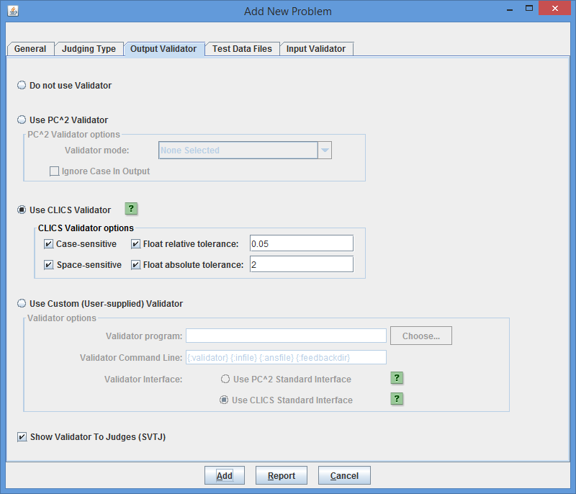
- PC² now supports output validators as described in the CLICS Problem Format Package. This includes the ability to configure tolerances (both relative and absolute) for floating point numbers in team output, as well as specification of both case-sensitivity and space-sensitivity in the output. The system contains a built-in implementation of the “CLICS Default Validator” used at the ICPC World Finals, along with the ability to support arbitrary user-written “custom validators” utilizing either the standard PC² Validator Interface or the CLICS Validator Interface. The following shows a screenshot of the new Output Validator configuration capability:

- PC² now supports the ability to define, for each contest problem, an input validator of the type described in the CLICS Problem Format Package. Input Validators are programs written (typically by the contest judges) to validate (verify) that the test data files for a problem comply with the problem input data specifications. This can significantly increase contest integrity by helping to avoid supplying invalid test data to team submissions. (Providing Input Validators is actually a requirement for all problems at the ICPC World Finals, and we recommend it for all contests.) The following shows a screenshot of the new Input Validator configuration capability:
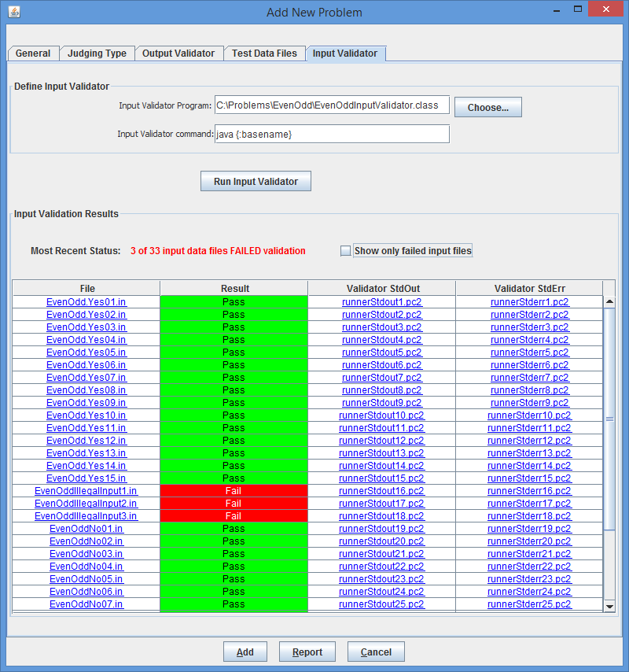
- The PC² scoreboard can now be started in “no GUI” mode, by adding the argument “--nogui” to the pc2board command. A scoreboard started in no-GUI (also called “headless”) mode does not provide a direct graphical display of the current standings – but it does continually generate all the scoreboard HTML files, including automatically updating them as contest events occur. This can be useful in a situation where the scoreboard machine is being managed remotely from a terminal without a graphical display.
- Support for additional REST-interface web services was added, including the ability to fetch runs (“submission files”) through the Event Feed/Web Services client.

- Support for configuring PC² Web Services from a properties file was added; a sample configuration file “pc2ws.properties” was added to the “samps” folder.
- Support was added for auto-population of language definitions for both Mono C# and Microsoft C#.
- Handling of problem set descriptions in YAML configuration files was updated to comply with the CLICS CCS specification at https://clics.ecs.baylor.edu/index.php/Contest_Control_System#Input_files
- The PC² API was updated to support the ability, with proper authorization credentials, to submit a run judgement. (This helps provide the ability of PC² to interface with other Contest Control Systems in “Shadow mode”.)
- “Comparator screens” on the Judge were updated to use fixed-width fonts for improved viewing.
- The ability was added to force the system to use unique ID numbers for runs at different sites (previously, run IDs were not guaranteed to be unique across sites). This provides enhanced capability for automated merging of multi-site scoring data.
- A large number of bug fixes and enhancements were added, as described at this URL: https://pc2.ecs.csus.edu/bugzilla/buglist.cgi?query_format=advanced&target_milestone=9.5.0.

What’s New In PC² Version 9.4.1
- Fix for Bug 1202 (http://pc2.ecs.csus.edu/bugzilla/show_bug.cgi?id=1202): runs judged as “Time Limit Exceeded” were under certain circumstances being incorrectly scored as “Compilation Error”.
- Fix for Bug 1193 (http://pc2.ecs.csus.edu/bugzilla/show_bug.cgi?id=1193): the results.tsv file generated by the PC^2 Scoreboard was being stored in an incorrect location.

What’s New In PC² Version 9.4
- A number of changes were made to the facility for loading (importing) contest configurations, including insuring compatibility with the latest CLICS CCS specification, supporting ISO 8061 date specifications, and supporting loading a contest configuration via a command-line option at startup.
- The system now supports “automatic contest start” operations. The Contest Administrator can set a “scheduled start time” and the system will automatically start the contest at the scheduled time.
- The system now supports a variety of “REST Web Services”, including fetching information on currently defined contest languages, problems, teams, and scoreboard in the format defined by the CLICS Draft CCS REST Interface (see https://clics.ecs.baylor.edu/index.php/Draft_CCS_REST_interface). Supported web services also include the CLICS “Contest Control” (start time pause/reset/restart) services used at the ICPC World Finals as well as numerous ICPC Regional Contests (see https://clics.ecs.baylor.edu/index.php/Contest_Start_Interface). PC² Web Services can be started either interactively via an “Event Feed” client or via a command line in “no-GUI” mode.
- The “EWTeam” web-based team interface project was integrated into the PC² distribution (so that a separate download is no longer needed in order to use the web team interface). Changes to the EWTeam itself were also implemented in order to make it compatible with a wider variety of web servers.
- Importing and saving of team information now includes the Institution Names and Country Code as specified by the ICPC CMS.
- Improvements were made to parsing and error-detection for YAML configuration files.
- Dialogs now properly track multiple-monitor configurations.
- An obscure deadlock situation which could occur on the PC² Team when making a “Test Run” was resolved.
- Numerous user interface issues were cleaned up.

What’s New In PC² Version 9.3.4
- Fix for Bug 1202 (http://pc2.ecs.csus.edu/bugzilla/show_bug.cgi?id=1202): runs judged as “Time Limit Exceeded” were under certain circumstances being incorrectly scored as “Compilation Error”.

What’s New In PC² Version 9.3.3
- Bug Fix for Bug 1084 - Cannot use Team/Judge TEST RUN Problem without input file
If you define a problem that does not Require an Input file (ie hello world) then attempt to do a test run on a team, the system still prompts you to select an input file. Then it throws an NullPointerExceptioni and on subsequent runs the team "cannot clear execute directory".
- Bug 1088 - Add support for -F option with pc2reports
For most of the pc2 modules (team, admin, server, etc.) the -F option works, but not with the pc2reports. The pc2report now supports the –F option. See –F command line option article in the wiki at http://pc2.ecs.csus.edu/wiki/Command_Line#-F_option
For complete list of bugs fixed in Version 9.3.3, use the PC² Bugzilla system and search for Target Milestone = 9.3.3

What’s New In PC² Version 9.3.2
- The Event Feed was upgraded to be compliant with the 2016 CLI CCS Specification
- A new embedded web server was added, providing support for basic web services such as the CLI CCS Specification “JSON Scoreboard”.
- A “game” feature originally present in the Judge module in PC² Version 8 was ported to V9.
- Numerous bugs were fixed, including:
  - An issue with bash/dash command syntax in some of the PC² client startup scripts
  - Various minor issues on the Admin GUI were corrected
  - An issue related to Validator output with respect to multiple test data sets
  - Multiple issues where updating the test data set for a problem corrupted the problem’s configuration
  - An issue where runs which were manually judged but where the Judge elected not to send a notification to the Team might not be scored correctly
  - A long-standing issue where GUI components from one tabbed pane would “bleed through” to another tab
For complete list of bugs fixed in Version 9.3.2, use the PC² Bugzilla system and search for Target Milestone = 9.3.2.

What’s New In PC² Version 9.3.1
- Numerous bugs were fixed, including:
  - Multiple issues with viewing Team Output when using multiple test data sets
  - Incorrect elements in the Event Feed output
  - Proper display of test data set execution time
  - Proper display of validator results
For complete list of bugs fixed in Version 9.3.1, use the PC² Bugzilla system and search for Target Milestone = 9.3.1.

What’s New In PC² Version 9.3
- Version 9.3 contains substantial new enhancements that are incompatible with Versions 9.2 and earlier. Users should not try to “mix” V9.3 components with earlier versions of the system.
- Java 7 or higher is now required to run PC².
- A significant security vulnerability was identified and closed. (The fix for this issue was also back-ported into updated releases of PC² V9.1 and V9.2 as well, and all older versions containing the vulnerability were deprecated and removed from our web page. A corresponding critical security notice was sent to all PC² mailing lists.)
- Support for loading and saving contest configuration information via “YAML” files has been added. This allows the Contest Administrator to create the contest configuration externally and then load it in a single operation, instead of entering configuration data on multiple GUI screens. This enhancement brings PC² more closely in line with the CLICS CCS Standard as shown at https://clics.ecs.baylor.edu/index.php/Main_Page. Additional information about the YAML file format is also available at the same web page.
- The PC² Server now generates an event feed as defined by the CLICS CCS Standard at https://clics.ecs.baylor.edu/index.php/Main_Page. This allows PC² to interface with a variety of external tools such as the ICPC Resolver and the ICPC Balloon Utility (see https://icpc.baylor.edu/icpctools for information on the various ICPC Tools).
- A new feature called “Profiles” has been added, allowing users to define several different “contest profiles” – for example, a “Practice Contest” profile and a “Real Contest” profile – and easily switch between profiles; this eliminates the need to create separate PC² installations for contests. (Note: Profiles are only supported in “single-site” mode – that is, when there is just a single PC² Server in the contest. Note that the addition of the “EWTeam Web Client” (see below) eliminates the need to run multiple servers in a contest other than where there is a strong concern about network connectivity reliability.)
- A new project called the “EWTeam” has been created and is included in the download distribution, under the “Projects” folder. EWTeam is a web-based team client which interfaces with the PC² 9.3 Server, eliminating the need to install PC² on each contest team machine; teams can use any browser to access the EWTeam web page and submit runs to the PC² Server. The EWTeam is described in detail in an Appendix in the updated V9.3 Contest Administrator’s Guide, including how to set up a web server so that the EWTeam can be used by contestants instead of the “pc2team” Java Application team client. (The EWTeam is also posted as a separate stand-alone project on our web page).
- The PC² Judge was enhanced with a new --nogui mode allowing it to run headless. A new script named ‘pc2aj’ was added to the script library (under ./bin) to invoke a Judge in no-GUI mode (the script was so-named because there’s no use for a headless judge unless it is doing “Auto-Judging”).
- Full support for executing multiple input test data cases is now provided. The Contest Administrator can define arbitrarily many test input data sets; a submitted run is now executed against each input data set separately. A new GUI component on the Judge provides an indication of the Pass/Fail status of each separate test data case, and allows viewing the result of each test case as well as provides a mechanism for automatically comparing each test case result with the corresponding expected judge’s output.
- The judge module now contains a start-up check to verify that the required problem data files are present, and halts (rather than attempting to judge) if the necessary files are missing.
- A completely new Judge’s Guide was written, describing the use of the Judge from logging in to judging runs to reading and responding to clarification requests from teams.
- The Contest Administrator’s Guide was updated to reflect all the changes in Version 9.3.
- A new command-line submission tool called “Submitter” was added, allowing users to submit runs to the PC² Server from a command line instead of using a GUI. A new script named ‘pc2submit’ was added to the script library (under ./bin) to invoke the Submitter. The script can be invoked with no arguments to see the proper ‘usage’. (Note that logging in using the Submitter will automatically log out any currently logged in GUI client for that team.)
- Support for several additional languages (predefined language descriptions) was added, including PERL, Python, PHP, and Ruby. Sample programs for each of these languages were added to the “./samps/src” folder. Ability to indicate that a language does not generate an executable file (rather, is interpreted) was added so that it’s not necessary to specify “fake executable file names” for such languages.
- Support for large data files was added. Previously, large data files could cause out-of-memory errors and/or excessive network traffic; a new mechanism for allowing such data files to be maintained external to the system was created.
- The system now automatically creates configuration backups. In the event of a system crash which corrupts the current configuration, the server will detect the corrupted files on restart and will refuse to restart with a bad configuration. If the corrupted configuration files are removed, the backup files can be used to restart to a known-good condition.
- Logging was improved. Previously, log files were shared by multiple threads resulting in confusion; log files are now separated.
- The HTML files generated by the Scoreboard now include a display showing “pending runs”. Various additional XSL support was also added to the “samps” folder.
- A variety of new methods were added to the PC² API.
- A number of new reports were added to the Admin “Reports” facility and the “pc2report” tool. The system also now automatically generates a set of reports when the server shuts down at the end of a contest.
- Support was added for allowing the Contest Administrator to configure the penalty point values associated with things like compilation errors, “No” judgments, and security violations.
- Support was added for the CLICS CCS “finalize” feature, allowing the Contest Administrator to mark the contest as “finalized” in the Event Feed.
- Support was added for auto-populating a variety of additional languages including PERL, Python, Python3, and C#.
- This document was created, merging the previous different “What’s New” documents for earlier versions.
- Numerous bugs were fixed, including:
  - AutoJudging incorrectly showing as “off” after the Administrator has enable it.
  - Enabling AutoJudging could lock up the Judge GUI under certain conditions
  - The Team Status screen on the Admin now properly updates when a Profile switch occurs.
  - The Server API was not exposing “Problem Short Names”, prohibiting clients from being able to match Problem Short Names with Problem Titles.
  - The Scoreboard client was not able to send balloon emails to sites with self-signed certificates.
  - The built-in internal validator was failing to correctly report Run-Time Error judgments.
  - Several instances of improper closing of FileStreams and BufferedReaders.
  - Several instances of the PC² Server API throwing NullPointerExceptions were fixed.
For complete list of bugs fixed in Version 9.3, use the PC² Bugzilla system and search for Target Milestone = 9.3.0.

What’s New In PC² Version 9.2

1. Introduction

This document describes changes and enhancements in PC² between Versions 9.2.0 and 9.1. If you are unfamiliar with PC² read the PC² Version Contest Administrator’s Guide.

2. New Features

2.1. Non GUI Server

In version 9.0 through 9.1 the only way to start a server was via a GUI login and window (aka server GUI). With 9.2 the server can be started up without a GUI using the --nogui command line option. The same login and contest password fields are needed to be supplied to startup a server.

For the first server the following command line can be used:

pc2server --nogui --contestpassword cPass --login site1 --password site1

For a secondary server the following command line can be used.

pc2server --nogui --login site2 --password site2

The server should not be shutdown like it was in Version 8, there is a Shutdown button on the Admin Site tab that should be used to shutdown a server. The Shutdown button can be used for non-GUI and GUI server.

2.2 New –F option for better security

Under most Unix systems the complete command line is listed when using a ps or similar command revealing login id’s and passwords if –login, --password or –contestpassword are specified on the command line. The –F option provides a way to read those options and values from a file. See the section “Using the –F Option” in the Contest Administrator’s Guide for more details.

2.3. Server shutdown on Admin

In version 9.0 through 9.1 the only way to shutdown a server was to use the Exit button on the Server GUI. With 9.2 an admin user can shutdown any server or all servers using the Shutdown button on the Admin Sites Tab.

2.4 Team output limit configurable

The team’s stdout and stderr output limit is now configurable, use the Administration Configure Contest tab, Settings Tab. The field name is “Maximum output size (in KB)”

2.5 Deleted Problems, Languages and Judgments

For Problems, Language and Judgments there is now a “Hide” checkbox. If selected then the item will be “deleted” or hidden from the user.

Hide Language will remove the language from both submitting runs and clars.

Hide Judgment will no longer allow a judge to select that judgement

Hide Problem will remove the language from both submitting runs and clars. Hiding a problem will also remove all problem references on the scoreboard.

2.6 Command line Report program

There is a new pc2report script which creates reports.

The pc2report only works when run under the pc2 server current working directory, if it is run under another directory the program will issue the following message:

ERROR nothing to print, no pc2 files/profiles found under <dirname>

3. Bug Fixes

A large number of bugs have been fixed between Version 9.1 and Version 9.2.

For complete list of bugs fixed in 9.2, use the PC² Bugzilla search and search for Target Milestone 9.2.0.

What’s New In PC² Version 9.1
- Introduction
This document describes changes and enhancements in PC² between Versions 9.0 and 9.1. If you are not already familiar with Version 9.0 you should be sure to read the separate document “What’s New In PC² Version 9.0” prior to this document, since many of the changes described here refer to modifications, enhancements, and bug fixes to the Version 9.0 system described in that document. If you are not familiar with PC² at all, then you should first read the “PC² Version 8 Contest Administrator’s Guide”, followed by the “What’s New In Version 9.0” document.
- New Features
  - Automated Judging
Starting with Version 9.1, PC² provides support for “automated judging” – sometimes referred to as “computer judging”. Automated judging is the ability to have team submissions automatically evaluated and to have the evaluation returned to teams without human intervention. Automated judging can be configured on a per-problem basis; that is, some contest problems may be set to be “auto-judged” while others are handled by human judges as in previous versions of the system.
    - Problem Setup
The Add/Edit Problem screens now provide three tabs: one for configuring the problem itself (as in previous versions of PC²); one for configuring the “Validator” associated with the problem (also as in previous versions); and one for configuring the “judging type” of the problem. To specify that a problem should be able to be “auto-judged”, its “type” should be changed from “Manual Judging” (the default, which is identical to the way judging worked in previous versions) to “Computer Judging”. The following shows the “Judging Type” screen used to configure a problem for auto-judging.
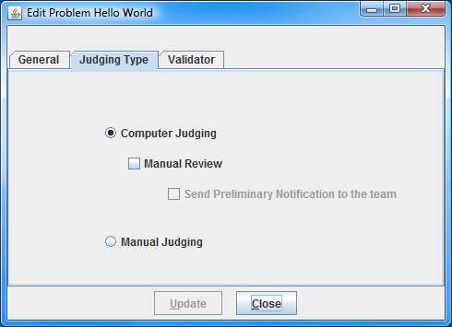
Problems which are configured for computer judging require having a “Validator” associated with them. A Validator is typically a separate user-written program that accepts as input (from PC²) the execution output of a team’s run, and returns to PC² an indication of what judgment should be applied to the run. [Note that validators have been supported in PC² since Version 8.5. However, in versions prior to the V9.1 release, validators were only used to display a “recommended response” to assist the human judge; starting with V9.1 the system supports allowing the validator to be solely responsible for determining the run judgment without human intervention.]
The specification for creating validators is exactly the same as in all previous versions of PC²; see the PC² Version 8 Admin Guide, or the Validator specification posted at the PC² website, for details. Also, as with previous versions of PC², the system provides a simple “internal” validator which may be used in lieu of a separate user-written program.
    - Judge Setup
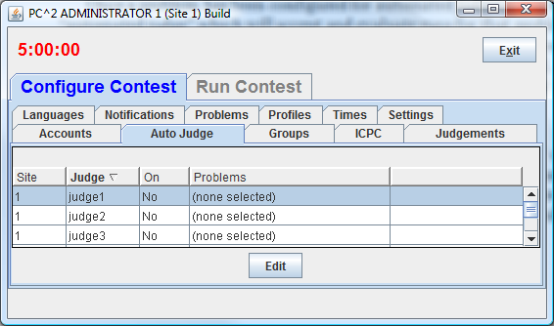
Once a problem has been configured for automated judging, it is necessary to create and start an “automated judge” which will accept and evaluate runs for that problem. The contest administrator must create one or more Judge accounts (using the normal account creation procedure) which will be used solely for auto-judging. Once these judge accounts are created, the Admin “Auto Judge” tab is used to select and edit (configure) each account which will be used for auto-judging. The following shows account “judge1” selected (highlighted) in preparation for editing (configuring for auto-judging).

Clicking the “Edit” button shown above will display the Auto-Judge Settings for the selected account as shown below. In this example there have been two problems configured for computer judging – one with the name “Hello World” and the other with the name “Sum the Ints”. The “Sum the Ints” problem has been selected (highlighted) and the “Enable Auto Judging” box has been checked; hitting the “Update” button will configure this account (“judge1”) to automatically fetch and judge any runs submitted for the “Sum the Ints” problem.
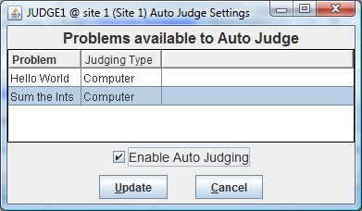
It is important to note that assigning a problem to a judge account for auto-judging requires both selecting the problem on the “Auto Judge Settings” screen and enabling auto-judging for the selected problem(s) by clicking the Enable Auto Judging checkbox. Problems which are not selected (highlighted) when the “Update” button is pushed will not be auto-judged by that judge; failing to check the “Enable Auto Judging” checkbox will disable the judge account from performing any automated judging.
The following picture shows the Admin “Auto Judge” tab after the preceding “Update” operation. Notice that judge1 has been “enabled” for auto-judging (On=Yes), and it is configured to judge “Sum the Ints” (only). It is allowable to configure a single judge account to auto-judge any number of problems (however, the problems must have been configured for “computer judging” or they will not appear on the Auto Judge Settings screen for the judge).
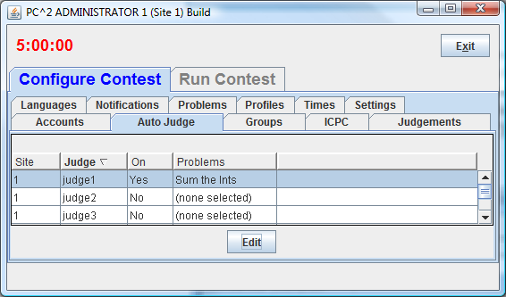

Once a judge account (or several judge accounts, each judging different problems for example) has been configured, the auto-judging process is initiated by logging a PC² client into that account. In the above example, for instance, logging “judge1” in to the contest will automatically cause any runs submitted for the “Sum the Ints” problem to be fetched and judged automatically, with the result automatically sent back to the team.

  - Preliminary Judging and Manual Review
Problems which have been configured for “Computer Judging” can be handled in multiple different ways by the system. One way is to have the system simply return the result to the team upon completion of automated judging. This is the simplest case and matches the screens shown above. This would be used when it was desired to have the contest run in “fully automated” mode with no direct human involvement in the judging process.
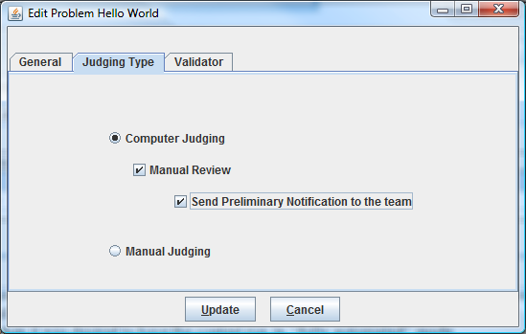
Alternatively, the system can be configured so that it first evaluates a run and then, instead of sending the result back to the team, “forwards” the run and the recommended result to a human judge for “manual review”. In this case an additional option exists: immediately notifying the team of the result of the “automated” portion of the judging process, before the completion of the “review” process by the human judge. Sending the auto-judging response to the team without waiting for completion of the human review is referred to as issuing a “Preliminary Notification”. This function can be enabled on a per-problem basis on the “Judging Type” tab on the Problem configuration screen. An example of a problem being configured for Computer Judging with Manual Review and Preliminary Notification of the team is shown below, followed by an image of the problem configuration status in the Admin “Problems” tab.

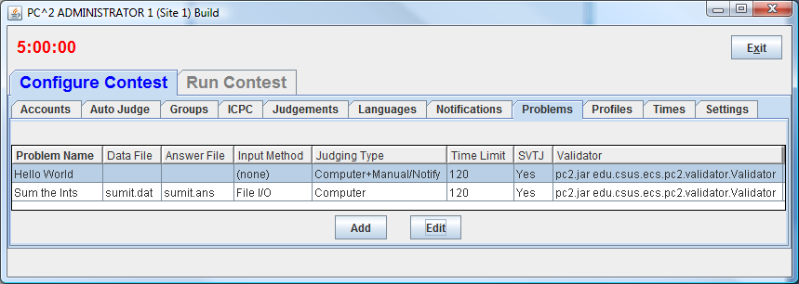
  - Run and Clarification Filtering
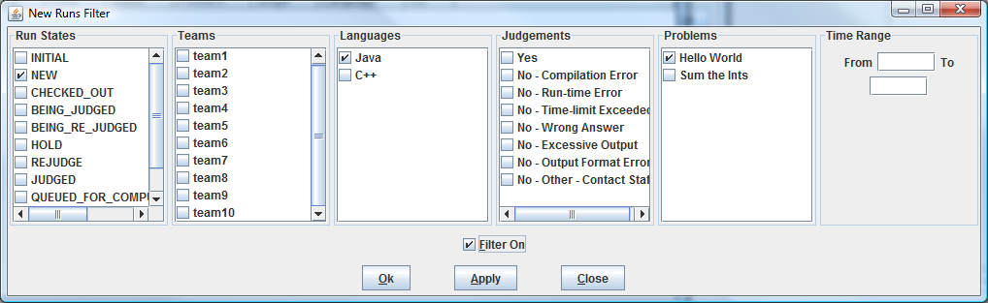
Beginning with Version 9.1, many screens which display “grids” (lists of runs and/or clarifications in the contest) also support the ability to “filter” the runs which are displayed in the grid. Clicking the “Filter” button will display a Filter configuration screen allowing the user to choose the criteria for runs which should be displayed on the corresponding grid. For example, the following shows the configuration for a filter to cause a grid to show only NEW runs written in Java for the “Hello World” problem. Note that a filter is not activated unless “Filter On” is checked.
  - Importing ICPC Data
Support for accessing data maintained at the ICPC Headquarters (for example, Registration information for teams participating in ICPC Regional Contests) has been improved in V9.1. In particular, the Admin has a new “ICPC” tab which allows for easy import of files downloaded from the Headquarters database system, along with facilities for modifying the way the team information contained in the download file is displayed on the scoreboard.
  - API Implementation
Beginning with V9.1, PC² provides a new Application Programming Interface (API). This API supports creation of arbitrary external clients which can connect to a running contest (provided they have the proper authentication credentials – specifically, a valid account and password). Once connected to a contest, the external client can “register” to listen for the occurrence of a variety of contest events. For example, clients can arrange to be notified whenever a new run is submitted, when a judgment is returned, when certain contest configuration data changes, and a host of other events. Documentation on the use of the API, including code samples showing how to create and connect a new client through the API, can be found by following the “API Documentation” link posted on the PC² Test User’s Group (TUG) page.
  - Native Look-And-Feel
Beginning with V9.1, PC² uses the local machine’s “native look-and-feel” by default. This means that running PC² on a machine will produce GUI screens and related components that have the same general appearance as other similar components on that machine. Users who wish to override this default action can do so via settings in the pc2v9.ini file. Specifically, the entry plaf=java in the [client] section of pc2v9.ini will force PC² clients to use the standard Java “pluggable look-and-feel” regardless of the underlying OS platform, whereas plaf=native will cause it to use the native platform’s look and feel (native is also the default if no relevant pc2v9.ini entry is present). Future releases may also allow other “pluggable look-and-feel” frameworks to be similarly invoked by name, but V9.1 supports only the java and native PLAF’s.

- Bug Fixes
A large number of bugs have been fixed between Version 9.0 and Version 9.1. For starters, the bugs listed in sections 7.1-7.3 of “What’s New In PC² Version 9.0” – that is, handling multiple logins using the same account, the functionality of the “Automated Judging” mode, and ability to use the “Add Accounts” button – have all been fixed in Version 9.1.
In addition, nearly 100 other bugs – some trivial, some significant – have been found and fixed in Version 9.1. For complete list of bugs fixed in V9.1, please see the PC² Bugzilla bug list posted on the PC² Test User’s Group (TUG) page.
Finally, a number of issues still remain in the 9.1 distribution. Many of these have already been fixed and will be contained in the next release, while some are still be worked on. A complete list of these issues along with their current status is also available on the TUG page. Some of the more significant issues include:
- The “countdown clock” on team machines showing the “Remaining Time” in the contest may be incorrect under certain circumstances.
- Duplicate logins to a Judge account can cause Runs to temporarily disappear from the Judge’s grid.
- Balloon notification messages may be printed whether or not a Judge specifies that a Team should be notified of a Run Judgment.
- Under certain conditions the Admin can erroneously allow the Contest Administrator to configure a problem for “Computer Judging” without requiring specification of a validator.
- If the Contest Administrator loads a replacement data file for a contest problem and the replacement file has the same name as the original file, under certain conditions the Admin fails to load the new file.
- A Judge account configured for “Auto-Judging” does not check the “run submission queue” when it is started (logged-in); any runs already in the queue will not be processed until the occurrence of the first submission after the “auto-judge” was started.
Again, many of these bugs have already been found and fixed, but those fixes are not necessarily present in the V9.1 release. See the PC² TUG page, and the PC² Bugzilla system, for further information.

What’s New In PC² Version 9.0
- “.ini” files
The use of “.ini” files has been streamlined in Version 9 (“V9”). The “sitelist.ini” and “reject.ini” files of PC² Version 8 (V8) are no longer necessary (the values formerly specified via these files are now configurable interactively). There is now just one single file used to pre-configure the system: “pc2v9.ini”. As with the old “pc2v8.ini” file, this file contains [client] and [server] sections. A minimal configuration includes a
server=xxx.xxx.xxx.xxx:portNum
line in the [client] section (specifying the IP and port number where the client should contact its server) and a
remoteServer=xxx.xxx.xxx.xxx:portNum
line in the [server] section specifying where each server other than the first server in a multi-site contest should contact a remote server to join the contest. If the “:portNum” argument is omitted on either line, a default value of 50002 is used.
- Enhanced Network Configuration
Each PC² server in a multi-site contest must have a publicly accessible IP address which can accept inbound connections on a single port. Each client must have network access to its server. Network operation behind NAT boxes is also now supported provided the above two requirements are met. It is no longer necessary to open a large range of firewall ports to use the system.
- Single-point Contest Administration
In Version 9 it is possible to manage an entire multi-site contest from one site using a single Administrator. All contest details, including generation of PC² accounts for all sites, can be done from a single Admin client; this is described in more detail below.
- Enhanced Security
Information transmitted over the network in V9, both between clients and servers and between different servers in a multi-site contest, is now fully encrypted. In addition, information stored on disk is also automatically encrypted.
- Server Control
When a PC² V9 server is started (using the command “pc2server”, as in V8), the server now displays a “login GUI” similar to that of the clients. The login account name for the first server in a contest is always “site1”, with a default password of “site1”.
Following login the server prompts for a contest password. At this point the contest administrator must choose and enter a password which will then be used to perform disk file encryption. If a contest is shut down and restarted it will then be necessary to reenter the same contest password when the server is restarted. (Note that the contest password is unrelated to the site login/password.)
In the case of a multi-site contest, only the first server prompts for a contest password; subsequent servers (that is, those with remoteServer entries in their pc2v9.ini files as described above) obtain the contest password via their secure connection to the remote server.
Once the server login sequence is completed the server displays a main GUI similar to the one shown below:
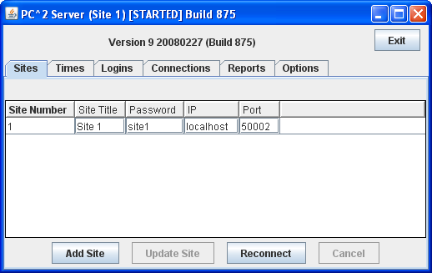

The configuration for a site (title, password, IP address, and port) can be changed by editing the fields in the corresponding row in the grid. Once a site’s configuration has been specified, click the “Update Site” button to commit the changes. Note that changes do not take effect until and unless the “Update Site” button is clicked.
For a multi-site contest, the operator of the first server must identify the other sites expected to join the contest. Click the “Add Site” button once for each site to be added, then update the IP address and port number for each site. NOTE that the default values for these entries may not be correct; be sure to configure each site carefully with that site’s IP address and port number, and also to click the “Update Site” button when done.
Once other sites have been added to the contest configuration in the first server, servers at those other sites can be started using the pc2server command. Each secondary server will prompt asking for a login account and password. The login account for a server is always siteN where N is the site number; the default password is the same (“siteN”, where N is the site number).
The default password for sites is obviously not very secure. The operator of the first server should configure new passwords for each remote site and then provide those passwords via external secure means to the remote server operator. Again, be sure to click the “Update Site” button once secure passwords have been entered on the first server.
- Administrator Options
The Admin client has been substantially reorganized in V9, and has a number of new functions. When an administrator logs in (using login account “administrator1”, password “administrator1” as in Version 8), the Admin client displays the new GUI shown below. The main window contains two primary tabs: Configure Contest, which holds functions related to pre-contest setup, and Run Contest, which holds function primarily used while the contest is running. The picture shows the GUI with the Configure Contest tab selected.
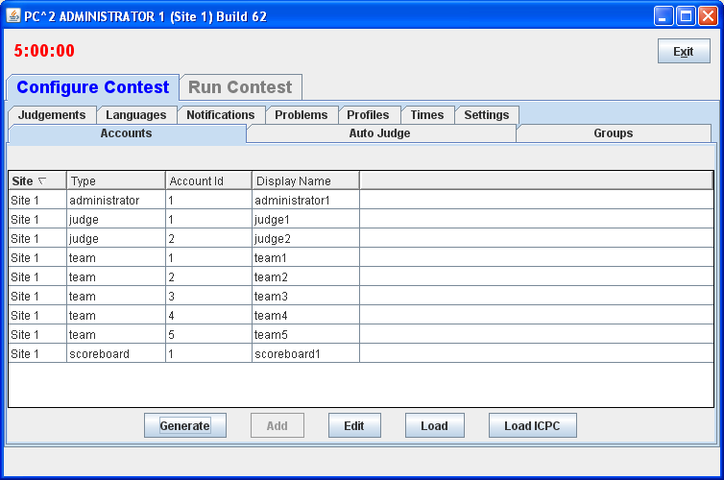
The administrator configures the contest in a manner similar to V8, using the tabs on the Configure Contest screen to:
- generate accounts (for teams, judges, etc.);
- update account details such as team names, passwords, and ICPC Registration information;
- define languages and problems for the contest;
- configure balloon notifications;
- start the contest clock at the appropriate time.
Differences in these configuration functions from V8, as well as descriptions of new functions, are given below.
  - Accounts Tab
This tab is used to generate and configure accounts. One significant enhancement in V9 is that the Administrator at one site can generate and configure accounts for all sites in the contest sites (in Version 8, each site had to have its own accounts generated separately by an Admin client connected to that site’s server). Note however that a site must be “logged in” – that is, its server must be running and connected to the contest – in order for an Admin to generate/configure accounts for that site.
Clicking the Generate button displays a dialog which allows selection of the accounts to be generated (including selecting the site for the accounts). The picture above shows the contest configuration after several accounts have been generated.
Each site can have account numbers that are the same (for example, it is permissible to have a “team1” account at both Site1 and Site2). Also, V9 allows account generation to begin at an arbitrary “base” at each site (so, for example, Site1’s team accounts could start with “team101”, “team102”, etc., while Site2’s team accounts could start with “team201”, “team202”, etc.
Once accounts have been generated, clicking on an account (row) in the Accounts grid and then clicking “Edit” invokes an Account Edit dialog which allows modification of the properties of the account.
A significant new feature of V9 is the association of permission properties with accounts; the Account Edit dialog allows the administrator to select (or remove) a variety of permissions on the account.
The Accounts tab also supports loading of account properties from an external file, similar to the way V8 did – although the format of the input file describing accounts is considerable more flexible in V9 (see the PC² Wiki page referenced below for details on the “Load Accounts” file format).
The Accounts tab also supports loading of ICPC Registration file information (for contests associated with the ICPC and using the Registration system hosted at Baylor University), similar to V8. Note: if the administrator invokes the LoadICPC function after the Load function, the “Display Names” from the ICPC Registration file will overwrite any specified in the external “Load” file. Note also: in order to associate PC² team accounts with ICPC accounts, it is necessary to “preprocess” the ICPC data file by adding a new leftmost column containing the PC² team number as described in the Version 8.5 Contest Adminstrator’s Guide, page 67.
Note that the “Add” button on this tab does not work (see “Known Features”, below).
  - Groups Tabs
The Groups tab is a new feature of Version 9; it allows associating a collection of accounts together in a “group”. For example, your contest might have several “divisions”: lower-division students, upper-division students, and graduate students. Each of these groups can be defined on the Groups tab, and then the “Edit” function on the Accounts tab can be used to associate each account with its Group. Group definitions can also be defined by loading an ICPC Registration file using the “LoadICPC” button on the Groups tab (each team in such a file has a group corresponding to its ICPC Regional Contest site). The PC² scoreboard can also be instructed to separate different accounts by Group on the standings display.
  - Languages and Problems Tabs
These tabs work the same as in Version 8, although the Problems tab provides a more flexible mechanism for configuring “Validators” into a contest (specifically, it is now possible to list an arbitrary external program to be invoked at the ‘validation’ stage of team run execution on the Judge).
  - Notifications Tab
This tab is used to tell PC² how and where to send “balloon notifications” for correct runs. It allows configuration of an email notification (by specifying an email address and an SMTP server) and/or a printed notification (by specifying a print device). Each configured contest problem can have an associated balloon color, and each contest site can have a separate balloon notification configuration (with a distinct set of email, printer, and balloon colors). Note: if a contest is configured to use balloon notifications, there should be only a single instance of the PC2 “Board” class running for the entire contest; otherwise, multiple notifications for each correct run will be issued.
  - Times Tab
This tab, like its equivalent function in V8, allows the Admin to start or stop the Contest Clock either on one specific site or on all sites at once. It also provides the ability to edit the Contest Clock on any site. Note that the “clock time” shown in the rows corresponding to each site on this tab does not dynamically update; click the “Refresh” button to update the display.
  - Judgements Tab
The possible “Judge Responses” to team runs are listed on this tab. However, the “Add” button does not work (see “Known Features”, below, for information on alternative configurations for judgement responses).
  - Additional Tabs
The following additional Configure Contest tabs have functions similar to those in Version 8, or provide additional contest status information.
- AutoJudge: shows which judge accounts (if any) have the “AutoJudge” feature enabled (see “Known Features”, below, for additional information about the AutoJudge feature).
- Settings: allows specification of the official “Contest Title” (displayed on the scoreboard; also allows setting the type of information which the Judges will see regarding the teams whose runs they are judging as well as the text of the “default answer” which judges send back to teams in reply to clarification requests.
- Profiles: provides support for creation of different “contest profiles” (for example, “Practice” vs. “Real” contest configurations) and for automatically switching between profiles. Note that this feature is not yet implemented (we just wanted to let you know we’re working on it).
  - Run Contest Screen
Clicking the Run Contest tab on the Admin displays a screen containing functions typically used during the actual running of a contest, including display of Runs and Clarification Requests. The various tabs on this screen conform for the most part to equivalent tabs in V8, although there are several additions including Connections and Logins showing the status of client communication, a Sites tab allowing editing of site information using the same interface as provided on the server GUI, Standings and StandingsHTML showing different versions of the current contest standings, and an Options tab allowing display of various logs and other contest state information.
- Known Features (OK, Bugs; we’re working on them)
  - Unique Accounts
The system does not correctly prohibit multiple logins for the same client account (in other words, for example, it is possible for multiple people to login as “judge3” if they simply both have the password for “judge3”). If such a login situation occurs, bad things can happen. It is therefore important that the Contest Administrator take steps to insure that every team, every judge, etc. has (and uses) a different account/password combination.
  - AutoJudge
The “AutoJudge” feature does not work in V9.0. Current plans call for this to be fixed by Release 9.1. Note that “AutoJudge” is the facility to send responses to teams without human intervention; this is different from the “Validator” capability – which does work (that is, a contest problem can be configured with a Validator just as in V8, and the Validator result will be displayed for the Judge).
  - Add Accounts
The “Add” button on the “Accounts” tab, intended to allow dynamic addition of accounts, does not work. Use the “Generate” button to create new accounts (generating new accounts does not affect existing accounts).
  - Edit Multiple Accounts
There is currently no mechanism to select multiple accounts for editing using the Accounts tab “Edit” function. Note however that multiple account property changes can be made using an external file and the “Load” function.
  - Add Judgements
The “Add” button on the “Judgements” tab, intended to allow dynamic addition of “judgement messages”, does not work. If your contest wishes to use a set of judgement messages other than the default ones, your messages can be installed by listing them in a file named “reject.ini” in the first server’s startup directory (as in Version 8). However, this file (as in Version 8) is only read when the server is first started; to change the messages after the start of a contest it is still necessary to shut down and restart the server.

- Additional Information
We have begun creating a “Wiki” describing how PC² is organized, how it is configured for running a contest, and how it is structured internally. Our plan is to eventually have a complete, comprehensive description of all aspects of the system available online; we already have a good start and we invite people in the PC² user community to visit our Wiki page to find additional information about the sysem and to help contribute to this effort. Please visit http://pc2.ecs.csus.edu/wiki for further details.

