

ACM
INTERNATIONAL COLLEGIATE PROGRAMMING CONTEST

California State University, Sacramento’s

PC²
Version 9.2

Contest Administrator’s
Installation and Configuration Guide

<Last Update: 2010-05-16>
Table of Contents

1. Overview 4
2. References 5

2.1. Acronyms, Terms, Definitions 5
3. PC² Startup Checklist for Geniuses 6
4. Instructions For The Rest Of Us 7

4.1. Installation 7

4.2. Uninstall 7
5. PC² Initialization Files 8

5.1. pc2v9.ini file 8

5.2. reject.ini file 9
6. PC² Startup Procedure 11

6.1. Built-in Commands 11

6.2. Server Startup 11
6.2.1. Alternate non-GUI server startup 13
6.2.2. Adding other Sites 14

6.3. Starting Clients 14
7. Configuring the Contest in PC² 16

7.1. Administrator Login 16

7.2. User Accounts 17
7.2.1. Account Creation 17
7.2.2. Account Names and Passwords 18
7.2.3. Loading Account Data 20
7.2.4. Importing ICPC Data 21
7.2.5. Restarting / Reconnecting Servers 21

7.3. Contest Problems 24
7.3.1. Defining a Problem - todo 24
7.3.1.1. Problem Dialog controls 27
7.3.2. Defining a Problem Validator - todo 27
7.3.3. Defining Automated (Computer) Judging - todo 28

7.4. Contest Languages 30
7.4.1. Defining a Language 30
7.4.2. Command Parameter Substitutions 32
7.4.3. Language Definition Examples 32
7.4.4. Language Definitions In Multi-Site Contests 34

7.5. Notifications (Balloons) – todo 36
7.5.1. Defining a Notification 37
7.5.2. Email Server Advanced Settings 38

7.6. Contest Profiles - todo 38
7.6.1. Switching Profiles - todo 38
7.6.2. Cloning Profile - todo 38
7.6.3. New Profile - todo 38

7.7. Options (Settings tab) 39
7.7.1. Edit Scoring Properties 40

7.8. Sites 40
8. Starting the Contest 42

8.1. Clock Control - todo 42

8.2. Contest Length - todo 43

8.3. Multi-Site Clock Control - todo 44

8.4. Practice Sessions: Resetting A Contest - todo 46
9. Monitoring Contest Status 47

9.1. Team Startup Status - todo 47

9.2. The Runs Display - todo 48

9.3. Editing Runs - todo 49

9.4. Filtering Runs - todo 51

9.5. Clarifications - todo 52

9.6. Reports – todo 52
10. The PC² Scoreboard 55

10.1. Overview - todo 55

10.2. Starting the Scoreboard - todo 55

10.3. Scoreboard Updates 56

10.4. Scoreboard HTML Files 57

10.5. Scoring Groups - todo 58

10.6. Scoring Algorithm 59

10.7. Adding new HTML Files - todo 60

10.8. Export Data File 60
11. Shutting Down 61

11.1. Shutting down server 61

11.2. Shutting down clients 61
Appendix A – pc2v9.ini Attributes 62
Appendix B – Networking Constraints - todo 64
Appendix C – PC² Server Command Line 65
Appendix D – ICPC Import/Export Interfaces - todo 66
Appendix E – Validators - todo 70
Appendix F – Language Definitions 78
Appendix G – Extending using PC² API 83
Appendix H – Frequently Asked Questions - todo 84
Appendix I – PC² Distribution Contents 85
Appendix J – Log files 86
Appendix K – Getting help 87

Draft Revisions Comments – TODO these will be removed when the section/doc is final.
Date | Description | By
3/13/2010 | Added Alternate non-GUI server startup section with example | dal
5/16/2010 | Updated Edit Problem  Update Appendix I samps dirs | dal

Overview
PC² is a dynamic, distributed real-time system designed to manage and control Programming Contests. It includes support for multi-site contests, heterogeneous platform operations including mixed Windows and Unix in a single contest, and dynamic real-time updates of contest status and standings to all sites. This manual describes the steps required to install, configure, and run a contest using PC². Further information on PC², including how to obtain a copy of the system, can be found at http://www.ecs.csus.edu/pc2.

PC² operates using a client-server architecture. Each site in a contest runs a single PC² server, and also runs multiple PC² clients which communicate with the site server. Logging into a client using one of several different types of PC² accounts (Administrator, Team, Judge, or Scoreboard) enables that client to perform common contest operations associated with the account type, such as contest configuration and control (Administrator), submitting contestant programs (Team), judging submissions (Judge), and maintaining the current contest standings (Scoreboard).

PC² clients communicate only with the server at their site, regardless of the number of sites in the contest. In a multi-site contest, site servers communicate not only with their own clients but also with other site servers, in order to keep track of global contest state. The following communication requirements must therefore be met in order to run a contest using PC²: (1) a machine running a PC² server must be able to communicate via TCP/IP with every machine running a PC² client at its site; and (2) in a multi-site contest, every machine running a PC² server must be able to communicate via TCP/IP with the machines running PC² servers at every other site. In particular, there must not be any firewalls which prohibit these communication paths; the system will not operate if this communication is blocked. It is not necessary for client machines to be able to contact machines at other sites.

Each PC² module (server or client) reads one or more initialization files when it starts; these files are used to configure the module at startup. The client module also tailors its configuration when a user (Team, Judge, etc.) logs in. In a typical PC² contest configuration, each Team, Judge, etc. uses a separate physical machine, and each of these machines runs exactly one client module. It is possible to have multiple clients running on the same physical machine, for example by having different users logging in to different accounts on a shared machine. In this case, each user (Team, Judge, etc.) will be executing their own “Java Virtual Machine (JVM)”, and must have their own separate directory structure – including their own separate copy of the PC² initialization files in their account.

Setting up and running a contest using PC² involves the following steps: (1) installing Java and PC² on the contest machines; (2) creating/editing the necessary initialization files; (3) starting the server(s) and clients(s); (4) configuring PC² for the contest via an Administrator client; and (5) starting the contest so that users (Teams and Judges) can log in. These steps are listed in checklist form in the next chapter, and are described in detail in the remainder of this manual.

References

Here are a list of web references

PC² home page
http://www.ecs.csus.edu/pc2

pc2 Wiki – up to date articles and information about pc2
http://pc2.ecs.csus.edu/wiki/Main_Page

pc2 Bugzilla - defect tracking and reporting for pc2
http://pc2.ecs.csus.edu/bugzilla/

Acronyms, Terms, Definitions

Term | Definitions
SVTJ | Show Validation To Judges – a Problem setting which indicates whether to show the validation results to Judges

PC² Startup Checklist for Geniuses

For those people who hate to read manuals and would rather take a chance with a shortcut list, here is a very terse summary of the steps necessary to install PC² and get it running. Please note that this is provided as a convenience for geniuses (or gluttons for punishment). The remainder of the manual was written to help everyone else. If you have problems after following this list, please read the rest of the manual before sending us a request for help.
- Install Java version 1.5 or greater
- Install PC² by unzipping the PC² Distribution to the PC² installation directory;
- Add the Java bin directory and the PC² bin directory (installation directory/bin) to the PATH;
- Edit the pc2v9.ini file to point servers and clients to the server IP:port and to specify the appropriate site server name; put the modified .ini file on every server and client machine;
- Start a PC² server using the command "pc2server".
- Login using the name "site1” and password "site1"
- Enter a contest password, for example use the password "contest" (this is the contest security password)
- Start a PC² Administrator module using the command "pc2admin" and login using the name "administrator1" and password "administrator1".
- Configure at least the following contest items via the Admin
- Accounts (generate the necessary accounts);
- Problems (create one or more contest problems, specifying the problem input data file if there is one);
- Languages (create one or more contest languages, specifying the language name, compile command line, executable filename, and program execution command line).
- Press the "Start ALL" button on the Administrator module Time tab
- Start a PC² client on each Team (using pc2team) and Judge (using pc2judge) machine and log in using the Admin created accounts and passwords.
- Start a PC² client (using pc2board) on the Scoreboard machine and log in using the "board1" Scoreboard account/password; arrange for the scoreboard-generated HTML files to be accessible to user’s browsers.

Instructions For The Rest Of Us
In the event that the preceding checklist is a bit too terse, the remainder of this manual discusses the details of using PC² to configure and run a contest. The first step is to install the necessary software, as described in this chapter. The remaining chapters of the manual cover initialization files, starting the system, configuring the system for a contest, starting the contest, using the PC² scoreboard, and special considerations for multi-site contests without an active network connection between sites. In addition several appendices cover details of certain topics.

Installation
- Install the Java Software Development Kit (SDK) or Java Runtime Environment (JRE), version 1.5 or later on each machine. The remainder of this manual assumes that “$JAVAHOME” represents the SDK installation directory. For information on obtaining the Java SDK, visit http://www.javasoft.com
- Add “$JAVAHOME/bin” directory to the PATH environment variable on each machine (i.e., for each user).
- Create a directory on each machine to house the PC² system. The remainder of this manual assumes that “$PC2HOME” represents the PC² installation directory.
- Download the file pc2-9.1.4-1908.zip (or pc2-9.1.4-1908.tar.gz) from the PC² website into the $PC2HOME directory (that is, into the directory into which you want PC² installed).
- Unzip the pc2-9.1.4-1908.zip file, being sure to tell the unzip program to “retain directory hierarchy” and “preserve case sensitivity”. This will create a directory name pc2-9.1.4, which contains bin, lib, doc, samps and other directories, (See Appendix named PC² Distribution Contents) It should also create several “.ini” files, scripts in the bin directory, along with directories named “doc” and “samps”, which contain the system documentation and a variety of sample scripts, files, and other goodies you might want to examine. The file “doc/index.html” can be used to browse the documentation.

Uninstall
To uninstall PC² it is only necessary to undo the above installation steps; that is, remove the $PC2HOME directory and its contents and restore the system environment variables to their former values . PC² itself does not make any changes to any machine locations outside those listed above either during installation or execution. In particular, for example, it makes no entries in the a Windows Registry or environment, nor does it copy any files to locations outside the installation directories in any environment.

PC² Initialization Files

When a PC² module (server or client) begins running, it reads a set of one or more “initialization files” from the directory in which it was started. The Contest Administrator must ensure these files are present as needed, and edit them as necessary, prior to starting a PC² module. This chapter describes the principle initialization files and their contents (note: some default versions of the initialization files are provided with the PC² distribution package; these must be edited as necessary). Further descriptions of initialization files and their contents can be found in the Appendices.

pc2v9.ini file
Every PC² module reads a file named “pc2v9.ini” at startup. This file provides key initialization information to the module. The file is formatted in sections. Each section starts with a section-name in square brackets; for example, [server]. Each PC² module reads the entire file, but silently ignores any information which does not pertain to it. All lines starting with “#” or “;” are comments and are also ignored, as are blank lines. The following different section names are recognized: [server] and [client]
Each section is made up of lines containing "attribute assignment" statements of the form
attributeName=value
The “attributeName” is a predefined string chosen from list of PC² configuration attributes. The “value” is the value to which the corresponding attribute is set when the pc2v9.ini file is read by a module. No spaces are allowed in front of the “value” after the equal-sign.
Some attribute assignment statements are specific to particular sections and have no meaning for other sections (or for the modules that read them). Other attribute assignments are relevant to multiple sections/modules and can appear in different sections.
A complete list of the predefined attributes is given in the Appendices. Most attribute assignments are optional and default values are used if an attribute assignment is not present in the pc2v9.ini file. However, certain attributes must be specified in the pc2v9.ini file in order for the system to function properly.
Based on these rules, a minimum sample pc2v9.ini file is shown below. Note that since all modules ignore sections and attributes which do not apply to them, it is permissible to create a single pc2v9.ini file containing all the required entries and put this same file on all machines at a given site.
# sample pc2v9.ini file

[client]
# Tell PC² where to find its server (IP and port)
server=192.168.1.117:50002

The sample pc2v9.ini file shown above would be appropriate for both client and server machines in a single-site contest
For a multi-site contest, one additional requirement exists for the pc2v9.ini file. In a multi-site contest, the server at one of the sites is designated the “primary server” and servers at all other sites are designated “secondary servers”. When a primary server is started, it waits for other servers to contact it. When a secondary server is started, it automatically attempts to contact the primary server; this is how the inter-server communication in a multi-site contest is established. (The distinction between whether a server waits to be contacted (is a primary) or initiates remote contact (is a secondary) is in fact the only distinction between “primary” and “secondary” servers.)
In a multi-site contest exactly one of the servers should be started as a primary server (it does not matter which site has the primary server; once communication is established all sites run as peers). The servers at all other sites should be started as secondary servers. Designation of a server as primary or secondary is controlled by the contents of the pc2v9.ini file.
By default (that is, in the absence of any information in the pc2v9.ini to the contrary), a server assumes it is a primary server when it starts. Designating a server as a secondary server is accomplished by providing an additional entry in the [server] section of the pc2v9.ini file of the server. This additional entry, known as the remoteServer attribute, tells the secondary server the IP address and port number at which it should attempt to contact the primary server. If this remoteServer attribute is not present in the pc2v9.ini file when a server starts, the server implicitly assumes it is a primary server.
Thus for example, the pc2v9.ini file on the primary server in a multi-site server might look like the entry in the sample above (since it does not contain any remoteServer attribute), whereas the pc2v9.ini file on machines at a second site might look like:

# sample pc2v9.ini for a second site

[client]
# tell where to find its server (IP and port)
server=192.168.1.104:50002

[server]
# Tell how to contact the primary server
remoteServer=192.168.1.117:50002

Note that the (sample) IP address given in the [client] section of this pc2v9.ini file for a secondary site is the (hypothetical) IP address of the server for that site, whereas the IP address given in the remoteServer attribute in the [server] section is the address of the primary server – the address which the (secondary) server should use to contact the primary server and “join the contest”.

reject.ini file
Note: With version 9.2 the administrator can add, edit and hide Judgment names using the Judgment tab (under the Configure tab).
When a the first server in the contest is started, it reads a file name “reject.ini” which contains the “reject messages” which can be sent from the Judges back to Teams when the Team submits a program which is not a correct solution. The Contest Administrator must edit the file reject.ini in the $PC2HOME directory on the server machine so that it contains one line of text for each “NO” message to be sent from the Judges to Teams when a run is rejected.
For example, if the Contest rules specify that the Judges will return one of the three messages “Runtime Error”, “Time Limit Exceeded”, or “Wrong Answer” for failed runs, put each of these messages on a separate line in the reject.ini file. Note that the reject.ini file must exist and be properly edited prior to starting the first server. The secondary servers (which have remoteServer in their respective pc2v9.ini files) will use the judgements from the first server.
The contents of the reject.ini file thus determines the set of choices from which a Judge can choose when responding to a team’s submission. PC² automatically provides the Judge with a choice of “Yes” (this is a correct solution to the problem), plus each of the messages listed in the reject.ini file. PC² automatically prepends the characters “No – ” to each “reject” message sent to a team when a Judge determines that the submission is not a correct solution to the problem. The text strings in the reject.ini file should contain only the distinguishing portion of the message.
Blank lines are ignored, lines with leading a hash (#) are ignored.
All lines are trimmed using the Java String.trim() method which trims whitespace from the start and end of each line.

PC² Startup Procedure

Built-in Commands
Once PC² has been installed and the necessary “.ini” files have been properly set up (edited), the normal PC² startup procedure is to start a primary server, then start an Admin client connected to that server and use the Admin client to configure the contest details (problems, languages, etc.). Once the contest has been fully configured using the Admin client, secondary servers can be started at remote sites (if any), followed by additional clients at both the primary and (in the case of a multi-site contest) secondary sites.
The PC² distribution comes with a collection of “command scripts” designed to simplify starting the various modules. The available command scripts and their corresponding functions are listed below. To invoke the specified function, simply type the corresponding command at a command prompt while in the $PC2HOME/bin directory.

Command | Function
pc2server | Starts a PC² Server
pc2admin | Starts a PC² Client expecting an Administrator login
pc2team | Starts a PC² Client expecting a Team login
pc2judge | Starts a PC² Client expecting a Judge login
pc2board | Starts a PC² Client expecting a Scoreboard login

Thus the normal startup procedure would be to type the command “pc2server” to start a server, then in a separate command window to type the command “pc2admin” to start an Administrative client to be used to configure the contest details in PC². Once the contest details are configured, other clients can be started (as well as servers at other sites) using the appropriate commands.

Server Startup
When a server is started (using the command “pc2server”), the user will see a login window, thus:
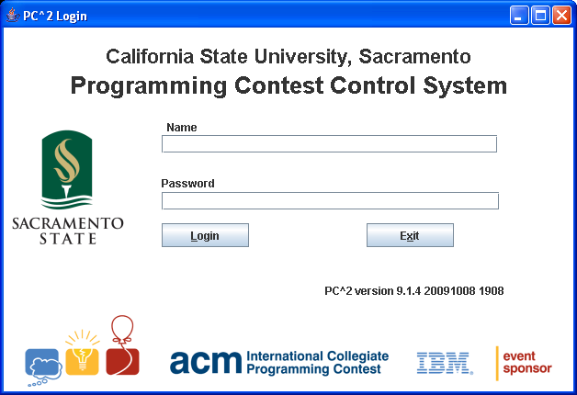

Use the login: site1 and the password: site1
On the primary server only there will be a prompt for a contest password. The contest password is used by the PC² encryption to encrypt all PC² files.
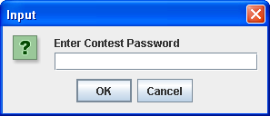

Upon successful login the Server GUI appears, thus:
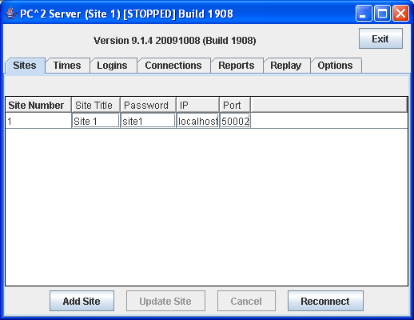
Figure 1 - Server GUI Sites Tab

Alternate non-GUI server startup

There is a non-GUI startup for the PC2 Server using the –-nogui command line argument. Since there is no entry of login, password and contest password via GUI these must be entered on the command line. For example for the primary server:

pc2server --nogui --login site1 --password site1 --contestpassword contest

An example for site 2 is:

pc2server --nogui --login site2 --password site2

An example startup for a server is
CSUS Programming Contest System
Version 9.2beta 20100312 (Friday, March 12th 2010 04:44 UTC) Java ver 1.5.0_05
build 2043 Windows XP 5.1 (x86)
Build 2043
Date: 3/11/10 9:14 PM
Working directory is C:\test\2043

Thu Mar 11 21:14:33 PST 2010 server (Site 1 - Site 1) started
3/11/10 9:16 PM: Clock: 1 CLOCK_STARTED
3/11/10 9:16 PM: Site: 2 ADDED Site 2
3/11/10 9:16 PM: Site: 3 ADDED Third Site
In the example above the server is started when the “started” line appears. In this example the contest clock was started then Site 2 and Site 3 were added. A limited

New sites can be entered using the Sites tab (under the Run Contest tab) on the Administrator module.

Adding other Sites

To add sites use the Add Site button to create a new row in the grid. Note: adding site(s) is a two step process use Add Site then Update Site button to add/save the site. Next for each site directly enter the IP (Host) for the site and the Port number. Press the Update Site button to save the site info.

Unlike Version 8, in Version 9 each site must login using the login name and password from the Sites Tab (see the Sites Tab figure above). By default the site password is “site” and the Site number, for example site2, site3, site4. The default sites login and passwords are:

Site Number | Login | Password
1 | site1 | site1
2 | site2 | site2
3 | site3 | site3
4 | site4 | site4

Starting Clients

Once a PC² server is running at a site, users (Contest Administrators, Judges, and Teams) at the site can start PC² clients to login and use the system. The normal procedure is first to start a client using the “pc2admin” command and login as the “root” administrator in order to configure the contest. Subsequently each Contest Judge would start a client using the “pc2judge” command, and each Team would start a client using the “pc2team” command. The Contest Administrator would normally also start a PC² scoreboard using the “pc2board” command, logging in using the PC² account “board1”.
Each time a client is started, the client will read its pc2v9.ini file to determine its site name and the location of its server, and then contact the server. Following this initialization sequence, the client will display a “login” window as shown below, indicating that it is ready to accept a user (Team, Judge, Administrator, or Scoreboard) login. Depending on the logging levels specified in the client’s pc2v9.ini file, the progress of these steps will be displayed and/or written to the file pc2.log in the client’s startup directory. If any errors occur or the client fails to produce the login screen, check the log file in the logs directory for more details.

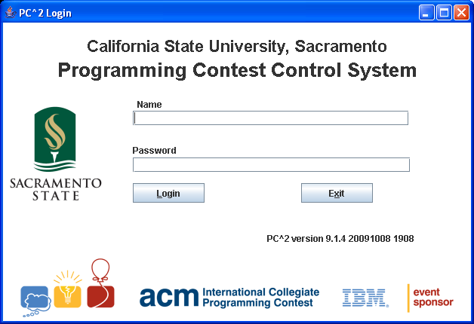

Configuring the Contest in PC²

Administrator Login
Once PC² is set up and running, it is necessary to “log in” to the system via a client login window in order to use the system. A PC² “account” is required in order to log in. Initially only a single account exists; the account name (“login ID”) of this single account is “root”. This account is a master Administrative account which is used to configure the PC² system initially for the contest. Regular users (especially Teams) should NOT be given access to this account.
The default password for the root account is root (same as the login name). Note that the default master password is given right here in this paragraph of this document, which is publicly available on the Web.
Caveat Administrator : change the root password!

Passwords can be changed via the “Manage Accounts” function on the “Accounts” tab; see below.
After logging in to the “root” Administrator account, the following screen will be displayed. This is referred to as the “main Administrator screen”. It provides a series of “tabs” across the top to select various contest administration functions. The tabs which are used to configure the contest prior to starting are described in the remainder of this chapter. Tabs used to start the contest and monitor its progress are covered in the following chapters.

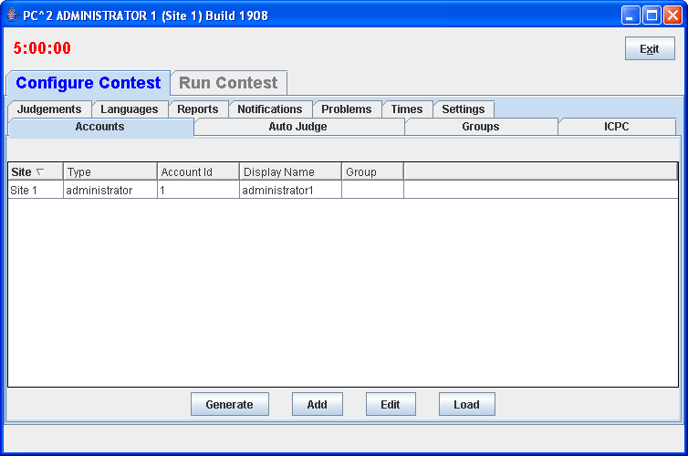

User Accounts

Account Creation
Before any logins other than root can occur, it is necessary to create user accounts. To create accounts for users, click the Generate button on the Accounts tab on the Configure Tab on the Administrator screen. This will display the following screen:
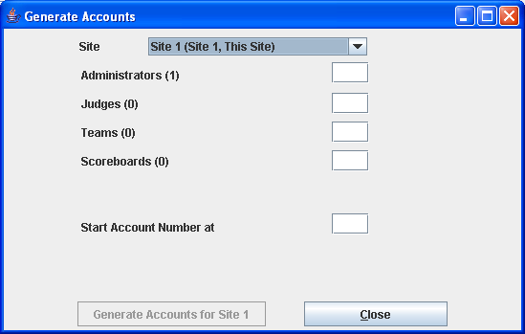

Note that the (1) to the right of the “Administrators” label means that currently one Administrator account exists – that one account is the root account – and no other accounts exist. It is necessary to create one Team account for each team at this site, one Judge account for each person who will be judging the contest at this site, and at least one Scoreboard (“board”) account if the PC² scoreboard is going to be used at this site for tracking contest results. (It does not hurt to generate a few extra accounts in each category, for flexibility.)
Enter the desired number in each box, then click the Generate button. Depending on the number of accounts, number of sites, and communication delays, it will take anywhere from a few seconds to several minutes for the account generation to complete. Once the accounts are generated the system will automatically return to the main Administrator screen. PC² accounts always start with the word team, judge, admin, or board, followed by a number. See the next section for information on viewing/changing the state of generated accounts.
Accounts in PC² are site-specific. This means that in a multi-site contest, an Administrator at each site must login as root and create the accounts for that site. (It is possible to have a single person handle account creation for all sites in a multi-site contest, by starting separate Administrator clients which have server IP addresses in their pc2v9.ini files pointing to different site servers. In any case, however, it is necessary to start a separate Administrator client connected to each site server and create the accounts to be used at that site; there is no way in the current version of PC² to perform multi-site account creation using just a single Administrator client.)

Account Names and Passwords
Each generated account will be created with a password, but at present the default (only available) specification for passwords on newly-generated accounts is “Passwords same as Account Name”. This means for example that the password for the account “team1” is “team1”; the password for the account “judge1” is “judge1”; etc. Each account name and password are created with all letters in lowercase.
Passwords for accounts can be changed from their default values by editing each account. To do this, click on the “Manage Accounts” radio button on the Accounts tab of the main Administrator screen, then use the “Account Type” drop-down list to select the type of account you wish to manage (change). For example, the following screen displays the list of Team accounts.

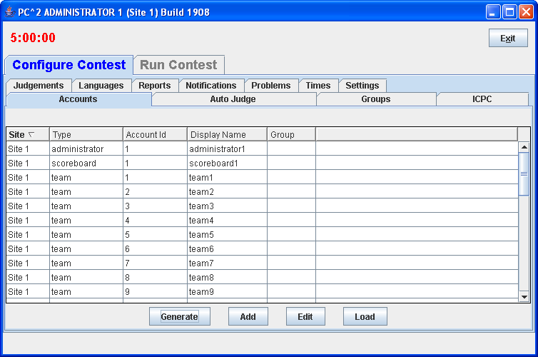
To edit an account, click on the account in the display grid to select it (“team2” has been selected in the display shown above), and then click the “Edit” button. This will display a new “Edit Account” window, shown below:

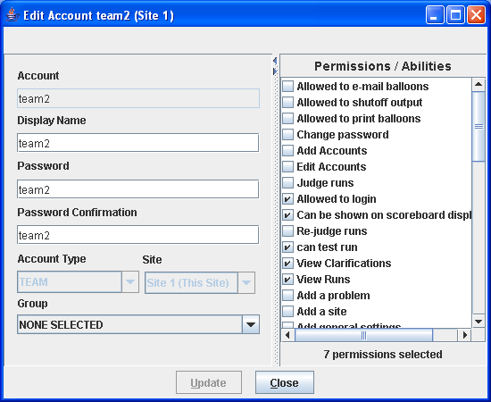

The “Display Name” for an account is the name which will appear on the PC² Scoreboard; this can be set to any desired value (such as the name of the team’s school, or the team member’s names). The “Password” and “Verify Password” fields can be used to set any desired password for the account.
The “Active” checkbox determines whether a team account will be considered in computing the scoreboard standings; if there are some team accounts which will not be used then you should uncheck their “Active” checkboxes – otherwise they will appear on the scoreboard as teams which have solved no problems. Note that the “Active” checkbox only determines whether a team appears on the scoreboard; teams which are not “Active” can still log in, submit runs, and otherwise participate in the contest. This is designed to allow “guest” or other “non-competitive” teams to participate. (To prohibit any activity from a team account, change the account password.)
The “Region ID” field is used to associate accounts with different “regions” or “groups”. This is used in conjunction with the PC² scoreboard for displaying rankings of different subgroups (see the chapter on the PC² Scoreboard for further details).
Note that PC² accounts are unrelated to any user accounts which may otherwise exist on the systems being used for the contest (for example, user accounts provided by the operating system).
In a multi-site contest, newly created PC² accounts are automatically distributed throughout the entire system, including across multiple remote sites. As previously noted, accounts are “site-specific”. Note also, however, that accounts at different sites are numbered using the same sequence; the first team account at Site 1 is called “team1”, and the first team account at Site 2 is also called “team1”, etc.. Accounts are therefore identified by always giving both the Site number and the Team number, as in “Site1Team1”, which is a different account from “Site2Team1”.

Loading Account Data
Since editing account data (e.g. Display Names, Passwords, etc.) interactively for every account is cumbersome, it is desirable to be able to prepare the data “offline” ahead of time and then load it into PC². This can be done by preparing an “account data” file and using the Load button on the Accounts tab load the data into the system.
An “account data load file” consists of a series of text lines, a single line that defines the account data fields that will be loaded followed by lines which contain information for each account.
The format of the account data load file is as follows. File lines starting with ! or # in the first column are ignored. Each non-comment line has fields, separated by a <tab> (ASCII 8).
The first line of the file must contain the field names to be loaded. The site and account fields are required, the field names are:
site – site number
account – team login name (ex. team1, judge4, scoreboard2)
password – account password
group – group name
displayname – display name for account on server
alias – a alias display name shown to judges
permdisplay- true or false, display on scoreboard
permlogin – true or false, allowed to login

For example, to initialize accounts “team1”, “team2”, and “team3” so that the “team1” account displays on the scoreboard with the name “Number 1” and has a password of “pass1”, while the “team2” account displays on the scoreboard with the name “Team Number 2” and has a password of “myPass”, and the “team3” account is made inactive (does not display on the scoreboard), the following entries would be placed in the load accounts data file for teams:

site<tab>account<tab>displayname<tab>password<tab>permdisplay
1<tab>team1<tab>Number 1<tab>pass1<tab>true
1<tab>team2<tab>Team Number 2<tab>myPass<tab>true
1<tab>team3<tab>My School Name<tab><tab>false

In the example above to view the tab character the <tab> represents a single tab character.
Imported values overwrite any values that were in the system previously. Also, it is not necessary to provide a record in the data file for every account; the site and account fields determines which accounts will be modified (all unlisted accounts will remain unchanged).

To load the account load file use the Load button on the Accounts Tab (under the Configure tab). The load button will display a File Open dialog, select the name of the account load file and click Ok, next the Review Account Loading dialog will appear.
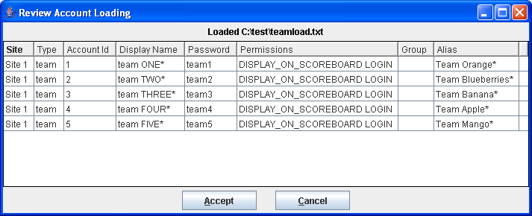

Any changes/differences that will be applied will have an asterisk at the end. Click on Accept to apply the changes.

Importing ICPC Data
PC² was designed for supporting the ACM International Collegiate Programming Contest, including its local and Regional contests worldwide. The ICPC maintains an online Contest Registration system which is used by Regional Contest Directors (RCDs) around the world to manage participation in the various ICPC Regional Contests. PC² provides interfaces to import contest registration data from the ICPC Registration system, and also to export contest results back to the ICPC web site. See the Appendix on ICPC Import/Export Interfaces for further information on importing/exporting ICPC Registration system contest data.

Restarting / Reconnecting Servers
During a contest there may be a loss of connectivity between sites. In Version 8 one had to shutdown (kill) the server and restart it. In Version 9 there is a Reconnection feature on the Sites Tab.
To determine whether a site is connected to another site use the Login Tab, if the server from that site can be seen in a row is in the Logins grid. For the example below on Site 1, Site 2 is logged in as Site 2 server (Number) 0.
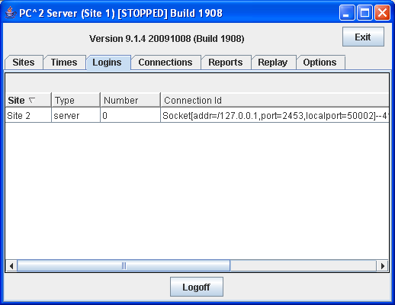

Select the site in the grid to reconnect to and click the Reconnection button.

Contest Problems

Defining a Problem - todo
PC² must be provided with information about the problem set to be used in the contest. To enter this information, click on the Problems tab at the top of the main Administrator screen. This will produce a display similar to the following:
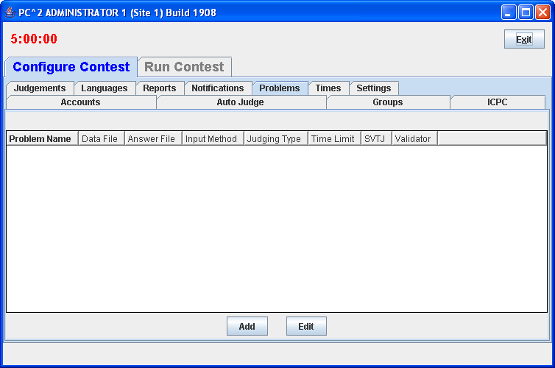

Note that initially no problems are listed since none have been added to the system. To add a problem, click the Add button. This will produce the “Add New Problem” dialog shown below.

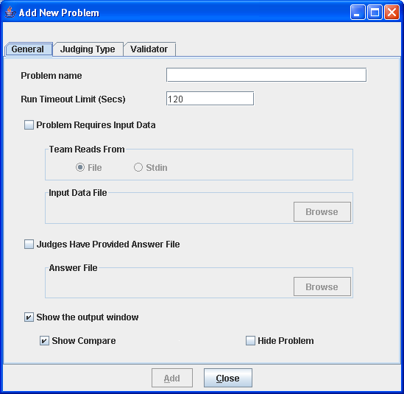

To define a contest problem to the system, perform the following steps using the Add New Problem dialog:
- Enter the problem name in the top textbox.
- If the problem requires an input data set, click the “Problem Requires Input Data” checkbox and then
- select either “Stdin” or “File”, depending on whether the problem description tells teams to write their programs to obtain input data from “standard input” or from a file, then
- use the Browse button to select the data file.
- If the Judges have provided an “Answer File” (a file showing the expected output of a program correctly solving this problem), click the “Judges Have Provided an Answer File” button and then use the Browse button to select the Answer File.
- Click the Update button to store the problem information.

As each set of contest problem information is entered, it will be displayed on the main Administrator screen (when the Problems tab has been selected). To change some previously entered information for a problem, click on the problem row in the main display to select it, then click the Edit button. This will return to the Edit Problem dialog, where changes can be made.
The following additional notes apply when entering data using the Edit Problem dialog:
- The Run Timeout Limit value (shown as 120 in the sample screen above) is not enforced by PC², in the sense that the system does not automatically stop a submission from executing when the time limit is reached. Rather, a count-up timer is displayed during program execution so that the Judge can tell how long the program has been executing, and the counter value turns RED when the specified timeout limit is reached. The timer also includes a button to allow the Judge to terminate the program
- The content of the input data file for a problem is stored internally when the Update button is pressed (that is, PC² makes an internal copy of the file). For this reason, editing the user’s copy of the file will not automatically change the data presented to team programs. To modify the data file for a problem, the contest administrator must EDIT THE PROBLEM and load the new copy of the data file, then press the Update button again.
- The Validator tab on the Edit Problem dialog is used to interface an automated judging program for this problem to PC². See the Appendix on Validators for further details.
- All team program output is expected to go to “standard output” (where it is captured by PC² and saved for display to the Judges). More specifically, there is no mechanism in the current version of PC² for dealing with programs which are written to send their output to a destination other than “stdout” (for example, programs which send their output to a file).
- Contest problems in PC² are global, in the sense that once a problem definition is entered by the Contest Administrator that problem definition is broadcast to all sites. There is no mechanism for having teams at different sites in a multi-site contest see different descriptions of the same problem. If there is some reason that different descriptions are needed for the same problem (for example, if a problem needs to be described differently at different sites due to OS differences), it is necessary to enter the different problem descriptions effectively as different problems. (While this is not very elegant, it is also something that we rarely – virtually never – see in real contests… Said another way, PC² views a contest as a set of teams all working on an identical problem set.) Note also that contest problems must appear in the same order at each site in a multi-site contest; see the chapter on Loosely-Coupled Multi-Site contests.
- PC² copies the input data file for a problem into memory each time a team program for that problem is executed (this is how the architecture manages the insertion of the input data into the input stream of the team program). If the size of the input data set (file) for a problem is particularly large and the system has a relatively small amount of memory, it is possible to exceed the memory limits of the Java Virtual Machine (JVM). This problem can be circumvented by utilizing a script for the “Program Execution Command Line” which copies the required data file into the execute directory and then invokes the team program. (See the following section on Contest Languages, and the Appendix on Language Definitions, for further details.)

Problem Dialog controls
    - Show the output window – shows the PC2 output window upon completion of execution/validations
    - Show Compare – shows the PC2 compare window upon completion of validation
    - Hide Problem – do not show this problem to the teams, will not show this problem on the Scoreboard HTML/output

Defining a Problem Validator - todo

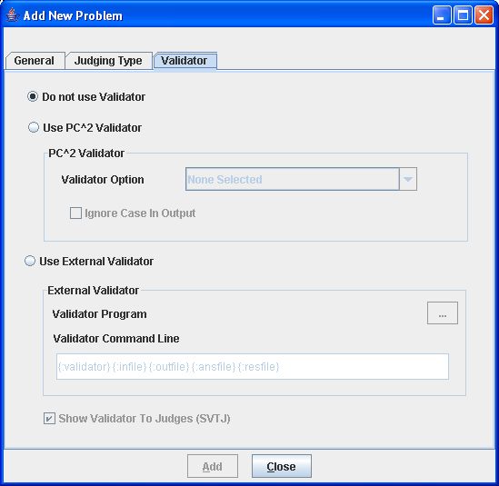

Defining Automated (Computer) Judging - todo

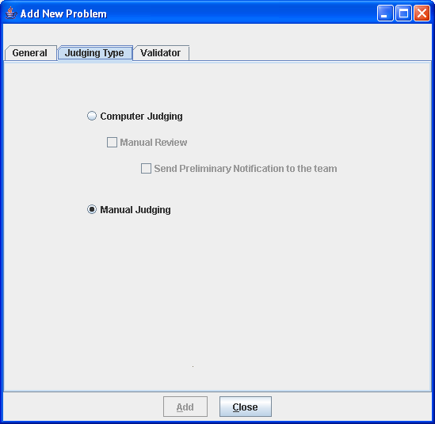

Contest Languages

Defining a Language
PC² must be provided with information about the programming languages used by contestants (Teams). To enter this information, click the Languages tab on main Administrator screen. This will bring up a display similar to the following:

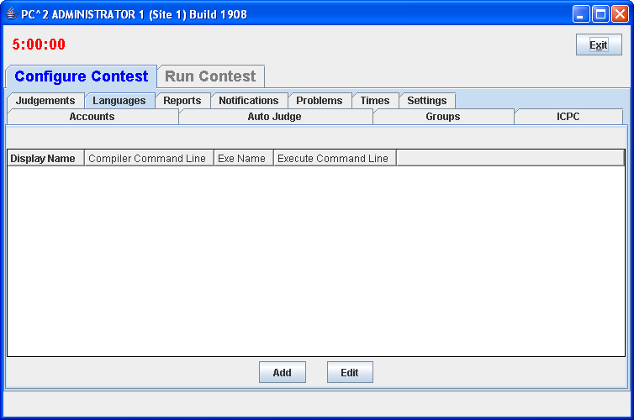

Note that the display is empty because no languages have been defined yet. To add a language description, click the Add button. This will bring up an Edit Language dialog, similar to the one shown below, containing four fields used to describe the language to PC².
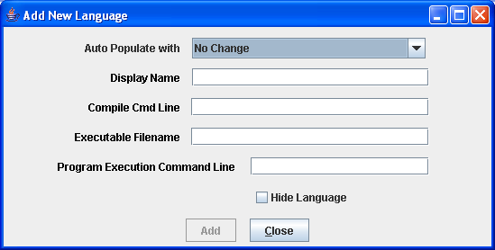

The “Display Name” for a language is the name which Teams will see when they are asked to specify the language in which they have written a program which they are submitting. The Display Name can be any arbitrary text; it does not have to be a real language name (for example, “Local C Compiler” could be a legitimate language Display Name).
The “Compile Cmd Line” field is used to specify the command line which is used to compile source code and produce an “executable program file” in the language.
The “Executable Filename” field is used to tell PC² the name (or more correctly, the form of the name) of the output (executable program) file produced by the compilation process. PC² clears its internal execution directory of any instance of the specified executable file prior to compilation, and checks for the existence of the specified executable file following compilation. It interprets the existence of a new executable file as evidence of successful compilation.
The “Program Execution Command Line” field is used to specify the (form of the) command line required to execute (run) the resulting program. Execution is only performed if the preceding steps were successful in producing a new executable file.
The Contest Administrator must define each language to be used in the contest by filling in the four language definition fields, replacing the default values shown above with the appropriate values for the language being defined. (Note that the preceding example screen shows values called “command parameter substitutions” in the language definition fields; see the following sections for further details on the definition fields.)
Once the definitions for a language have been entered, click the Update button to store the information and return to the main Administrator screen. The language names will be displayed under the Languages tab on the main Administrator screen, as shown below. To add more languages, click the Add button again to return to the Edit Languages screen. To modify a previously-entered language, click on the row containing the language description to select it and then click the Edit button. See the Appendix on Language Definitions for further details.

Command Parameter Substitutions
The four language description fields in the Edit Language dialog can be “hard-coded” by entering fixed values if desired. For example, the Display Name for a language is normally fixed for the duration of a contest (e.g., “Java”, or “C++”, or “Pascal”).
However, entering fixed values for the Compile Command, Executable Filename, and Program Execution Command fields can be extremely cumbersome and inflexible – the details of these fields may need to change with each different program file submission, for example. In order to provide more flexibility, PC² supports the use of “parameter substitutions” in these fields.
PC² parameter substitution fields are indicated by matching curly braces, with the first character inside the left curly brace being a colon (‘:’). Following the colon character is exactly one of the predefined PC² parameter substitution keywords. Any number of command parameter substitution fields may appear anywhere in a language description field. The currently defined parameter substitution keywords and their corresponding meanings are given below.

Keyword | Meaning
mainfile | Replace with the full name of the submitted file, including any extension (but excluding any ‘path’ specifier on the front of the filename)
basename | Replace with the base component of the file name, omitting any extension (and excluding any ‘path’ specifier on the front of the filename)
The following section shows examples of language definitions, including the use of command parameter substitution fields.

Language Definition Examples
The following screen shows a set of filled-in fields defining a language named “C” and using the GNU GCC compiler.
The compile command line invokes the compiler (“gcc”) and passes it an argument specifying use of the math library (“-lm”). The compile command line also specifies the assignment of a specific name to the “object” (compiled output) file (the “-o” argument), followed by the name to be assigned to the object output file. In this case, the object output file is to have the same name as the base name of the input source code file. (So for example if a team submitted a file named “proga.c”, the object output file would be named simply “proga”, since that is the value to which the “{:basename}” substitution parameter would be expanded.)
The final argument on the compile command line gives the name of the source file to be compiled, which would be expanded from “{:mainfile}” to become “proga.c” if that was the name of the submitted main program source file.
The Executable Filename field indicates that the executable file which produced by the compile command has the same name as the base name of the submitted program; this is because the compile command specifies (via the “-o” argument) that this is the executable file name which should be produced.
The Program Execution command field specifies that the command used to execute the compiled program is simply the same as the name of the executable file produced by the compilation step (and specified in the Executable Filename field), which in this case is again the base name of the original source code file.
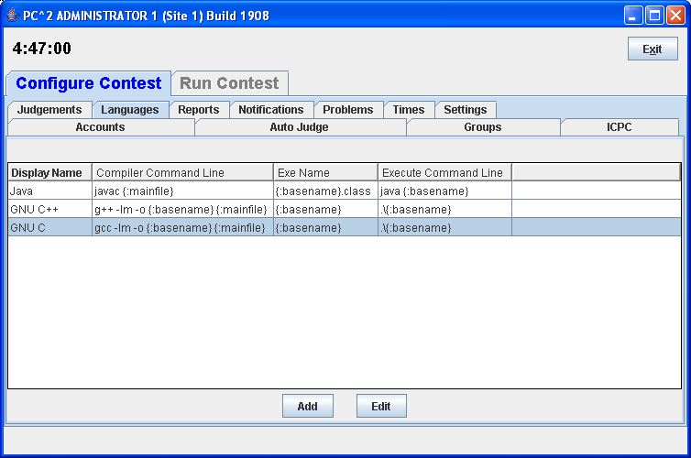

If a team were to submit a C program in a file named proga.c using the above language, PC² would first execute:
gcc –lm –o proga proga.c
to compile the program (substituting proga for the {:basename} parameter and proga.c for the {:mainfile} parameter). It would then check for the existence of an executable file named proga, and if that file exists then PC² would request the underlying operating system to execute the command:
proga

The following screen shows a second language definition example: a definition for a language with the display name “java”:

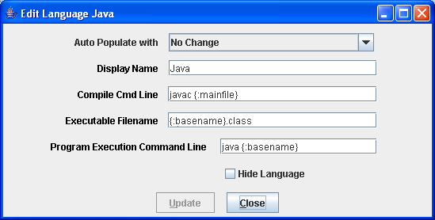

If a team were to submit a Java program in a file named sumit.java using this language definition, then PC² would execute the following command to compile the program:
javac sumit.java
Then PC² would check for the existence of an executable file named sumit.class and if that file exists then PC² would execute the following command to run the program:
java sumit

Note that the form of the language definition fields differs somewhat between the previous example (C) and the second example (Java). This is because of the different ways in which these two languages define the compilation and execution process. Notice also, however, that while the language paradigms are different, the use of command parameter substitutions allows the Contest Administrator easily to provide descriptions of how to handle the differences. The appendices contain further samples of language definitions for specific compilers.

Language Definitions In Multi-Site Contests
Language definitions in PC² are global. This means that, just as with Contest Problem definitions, when a language definition is entered at one site in a multi-site contest, that language definition will be visible at all connected contest sites. However, unlike the situation with Contest Problems (where the problem definitions are usually identical across sites), language definitions may differ between sites – even for the “same language”.
For example, it may be the case that every site allows the use of the “C” language. However, it may also be true that the specific command sequence to invoke the C compiler may differ between sites: a different C compiler might be used at different sites, or even if the same compiler is used it may be necessary to allow for differences in the “path” needed to access the compiler or for other environmental differences.
One way to deal with differences in language details between sites is to create a different PC² language description for each different language/site combination. This can quickly become cumbersome, however; for example, if there are four languages (e.g. C, Java, Pascal, and Perl) and five sites using those languages, it could require entry of up to 20 different language descriptions (Site1C, Site2C… Site1Java, Site2Java,… etc.). This can become particularly unwieldy for Teams, who must search through a list of 20 different languages looking for not just the correct language but the correct language for their site.
To avoid this combinatorial explosion of language definitions, a simple technique can be used when defining languages in a multi-site contest: use of generic language scripts, tailored at each site for the site-specific configuration.
For example, consider a contest using, say, C, Java, and Pascal. The Contest Administrator should define those three languages in PC² using the actual language names (“C”, “Java”, and “Pascal”) as the PC² “language Display Names”. However, rather than defining a specific compilation command for each language (which may differ between sites), each language should have as its compilation command a command which invokes a language-specific (but site-independent) script (or “batch file”) designed to compile a program in that language.
In other words, for the above three languages, PC² language definitions would be created to define the “compilation command” for the language named “C” to be the invocation of a script (batch file) named “compileC” (or “compileC.bat”); the compilation command for Java would be the invocation of a script named “compileJava”; and the compilation command for Pascal would be the invocation of a script named “compilePascal”.
Then, at each site, the Site Director is responsible for placing on machines at that site a set of scripts or batch files of the corresponding names (e.g. compileC, compileJava, and compilePascal). Within each script at each site is a set of site-specific commands which perform the necessary steps (compile a C program, compile a Java program, or compile a Pascal program) in the appropriate site-specific manner.
Note that if necessary, the same technique of “generic scripts” which vary between sites can also be used in specifying the details of “Program Execution Command Line” for languages. That is, the Contest Administrator can specify “executeC”, “executeJava”, and “executePacal” scripts for the program execution language definitions in PC² and then arrange for appropriately different script contents at each site.
Note also that PC² “command parameter substitutions” may be used in compilation and execution command lines independently of whether the command is invoking a script or not; in this way the Contest Administrator can arrange to pass necessary data (such as the main program file name and/or the base name) to a script.
Using generic script names in PC² language definitions and providing site-specific implementations of each language script at each site allows the Contest Administrator to significantly reduce the number of language definitions which teams must deal with, while at the same time retaining the flexibility necessary for dealing with site differences in a multi-site contest.

Notifications (Balloons) – todo
In many contests (including the ICPC World Finals), balloons are used to indicate to contestants and spectators alike the general state of the contest. Each time a team solves a problem, a balloon of a specific color is sent to the team and attached on or near their machine. As the contest progresses, the contest floor gradually fills up with a multi-colored display showing how various teams are doing in the contest. (This is a colorful and normally well-received operation; if you have never tried it, we recommend doing so.)
Using balloon notifications in a contest does present some additional management overhead (keeping track of which team should get what color balloon, etc.). Since PC² was designed to support the ICPC World Finals (as well as its Regional and Local contests), it contains some built-in support for “balloon operations”. Selecting the Options tab on the main Administrator screen and then clicking on “Balloon Options” will cause a dialog similar to the one shown below to appear; this dialog is used to configure the handling of balloons in a contest.

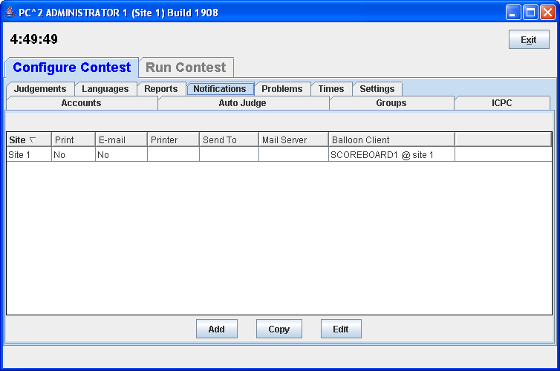

Defining a Notification
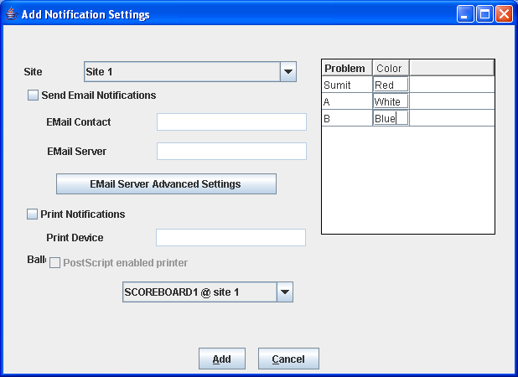

Balloon options include ability to specify the color of balloon associated with each problem; sending messages to a printer each time a balloon should be delivered to a team; and sending an email message via a specified email (SMTP) server to an arbitrary email account each time a balloon should be delivered to a team. Printed and emailed messages contain the relevant details such as Team, problem, and balloon color. Each of these options can be selected on a per-site basis (so that, for example, sites can use different color balloons for a given problem).
Generation of balloon notifications is handled by the PC² Scoreboard machine. Once email and/or printing notification is enabled, every “YES” judgment detected by the PC² Scoreboard “board1” account will cause an email notification and/or a printed notification to be sent to the configured location.
To enable the use of email balloon notifications, check the “Enable Emailing” box, then enter in the appropriate text boxes the full name of an SMTP email server accessible to the PC² Scoreboard machine along with a valid email address.
To enable the use of printed balloon notifications, check the “Enable Printing” box, then enter in the appropriate textbox the device identifier of a printer accessible to the PC² Scoreboard machine. If it is also desired to print notifications of “NO” judgments, check the “Enable Sending No’s” box.

Email Server Advanced Settings
This provides a way to specify a number

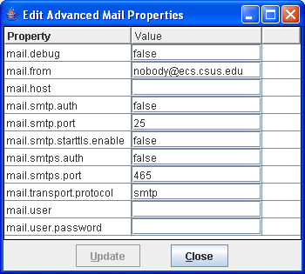

Contest Profiles - todo

Switching Profiles - todo

Cloning Profile - todo

New Profile - todo

Options (Settings tab)
The Settings tab on the main Administrator Configure Tab displays a screen which allows selection of additional options which can be used to display and/or control various aspects of a contest.
todo – replace this Settings Screen Cap
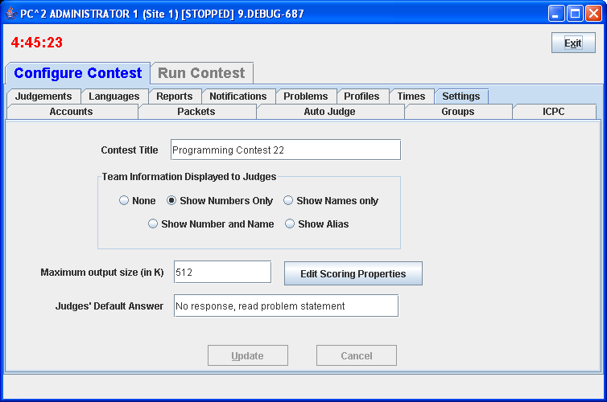
Contest Title - Specifies the contest title which is to be displayed on the scoreboard.
Team Information Displayed to Judges - Specifies whether or not to reveal the identify of Teams to the Judges while a run is being judged. In the examples below team 5 has a display name of “CSUS Hornets” and an alias of “Team Orange”
    - None – show *** for team name
    - Show Numbers only – show team# for team name, ex team5
    - Show Names only – show display name only, ex CSUS Hornets
    - Show Number and Name, ex 5 CSUS Hornets
    - Show Alias – show an alias for the team name, ex Team Orange

Maximum Output Size - Specifies the maximum amount of output, in Kbytes, which a team program is allowed produce to stdout or stderr. Any output beyond this amount is discarded by the system. The default value is 512 K (1/2 MB).
Edit Scoring Properties – specifies the scoring point penalties, see section Edit Scoring Properties.
Judges’ Default Answer – specified the clarification answer sent to teams if judge selects the Default Answer button while answering a clarification.

Edit Scoring Properties
The Edit Scoring Properties provides a way to modify the PC2 Scoring Algorithm, this algorithm is used to determine the contest standings. These values add time to the total time for a team on the standings.

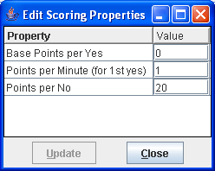

Base Points per Yes – for the first Yes/Correct solution per problem add this number of points to the Team’s Time.
Points per Minutes (for 1st yes) – for the first Yes/Correct solution per problem multiply this value with the elapsed time minutes and add the result to the Team’s Time.
Points per No – for each solved problem, multiply this value by the number of No/Incorrect runs before the first Yes.

Sites
This tab on the Administrator main screen displays a list of all the sites in the contest; this list should be checked to verify that PC² knows about all sites. If the site is currently active (connected to the rest of the contest) the IP address for that site’s server is displayed.
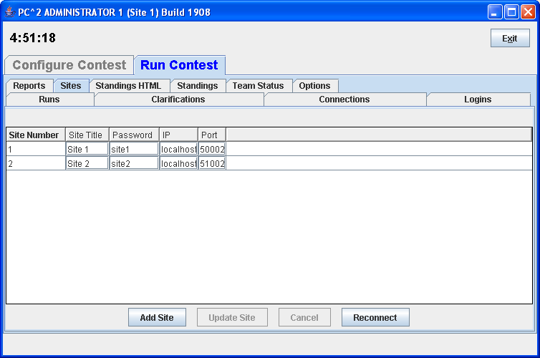

Starting the Contest

Clock Control - todo
Once the contest has been has been fully configured in PC², the contest clock must be started before teams can submit runs (the Team client will not allow run submissions if the contest clock has not been started). The Times tab on the Configure Contest tab on the Administrator screen is used to control the contest clock display and to start and stop the contest clock. Clicking the Times tab produces a screen similar to the one shown below:

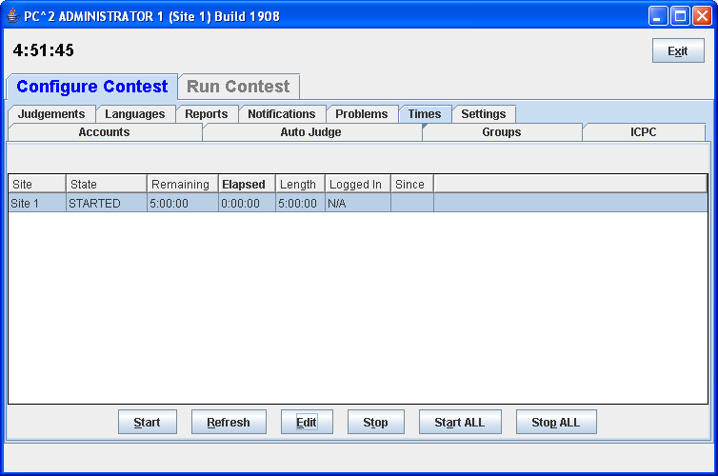

The Start button is used to tell PC² to start the contest clock for the selected site. Pressing Start starts the contest clock running for that site and allows teams at that site to submit runs. Pressing the Start ALL starts the contest clock at all sites.
The amount of time remaining in the contest at the current site is displayed in the top left part of the window just below the window title, the example above shows 4 hours 51 minutes and 45 seconds. The remaining time automatically starts counting down as soon as the Start button is pressed. It continues to automatically update (count down) as long as the contest clock is running. The remaining and elapsed time in the grid will not update automatically, to update those times use the Refresh button
It is important to note that, from the point of view of PC², the contest does not start until the Start button is pressed. For this reason it is important that the Contest Administrator remember to press the Start button at the actual time the contest starts. Failure to do this can produce erroneous scoring results.
Typically, for example, a contest is deemed to have “started” when the contest problems are distributed to the teams. If the PC² Start button is not pressed for another, say, 15 minutes, then that 15 minutes will not be considered to have been part of the contest by PC². If a team were to submit a run 20 minutes after the contest started (i.e. 20 minutes after the problems were handed out), the timestamp on that run would show a contest elapsed time of 5 minutes, not the correct value of 20 minutes. This would produce erroneous values on the scoreboard.
The Stop button is used to tell PC² to stop the contest clock for the selected site. The Stop button can be used to insert a pause in a contest (for example, to allow a break for lunch). During the time the contest is stopped, the contest clock at the site does not count down, and teams are prohibited from submitting runs. Also when stopped the contest clock displays in RED. When the Start button is pushed again, the contest clock for the site picks up where it left off.
Note that this means that if a team submits a run one minute before the contest clock is stopped, and then the clock is stopped for 30 minutes of real time, and then the team submits another run immediately after the contest clock is restarted, the timestamps on the runs will be one minute apart. In other words, PC² does not consider time during which the contest clock is stopped to be part of the contest. (If this is undesirable – that is, if the Contest Administrator wishes all time which elapses to be counted, then simply do not press the “stop” button once the contest has been started. )
If the “Stop clock at end of contest” is not checked, then PC² continues to accept runs after the contest clock counts down past zero, and such runs are treated (and scored) exactly as runs submitted before the clock expired (except of course that their “submission time” will be larger).

Contest Length - todo
The Edit button on the Time tab displays the Edit Contest Time dialog (shown below) which allows the Administrator to change the elapsed, remaining or contest length.
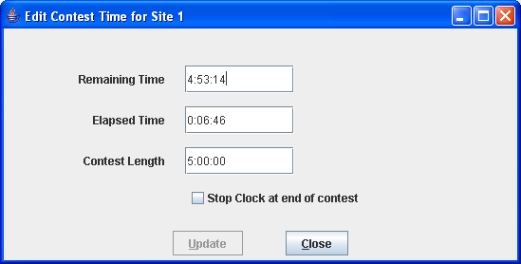

The time values in the Contest Time dialog do not update automatically when the contest is running; they display only the instantaneous time values at the moment the dialog is activated. If the contest is stopped when the dialog is activated, those times remain accurate indefinitely.
If a new Contest Length which is less than the current Elapsed Time is entered, the system displays a warning message to inform you that setting the contest length to a value less than the elapsed time will effectively mean the contest is over. If you decide to accept this condition, then if “Stop clock at end of contest” is checked then the contest will be automatically stopped. If automatic stop has not been enabled then the contest clock will indicate that time has moved past the end of the contest by displaying the Remaining Time as a negative number in RED.
PC² can be instructed to automatically stop accepting runs from teams at this site for scoring when the contest clock reaches zero (no time remaining). This is done by checking the “Stop clock at end of contest” checkbox on the Edit Contest Time screen.

Multi-Site Clock Control - todo
As described above, the contest clock in PC² operates on a per-site basis. That is, each site in a multi-site contest has its own contest clock, and PC² keeps track of “contest time” independently at each site. This is done to allow support for independent time-management constraints at different sites, and allows scoring to be done accurately without worrying about differences in timing between sites (e.g., a necessary pause at one site which does not affect other sites).
Each PC² site server determines the time of submission of a run from a team in terms of “contest elapsed time”, which means that a submission will be marked (“time-stamped”) according to the contest elapsed time at that site. The scoreboard in turn computes rankings based on this “submission time”, which means that overall (multi-site) rankings will be determined according to “contest elapsed time” at the site from which each run originated. This method puts teams at all sites on an equal competitive footing regardless of differences in the time at which the contest actually starts at each site.
However, this mechanism (keeping track of contest time independently at each site) can produce erroneous scoring results if the Contest Administrator does not take care to control the multi-site contest clocks correctly. Specifically, in a multi-site contest it is important that the clock at each site be started at the moment the contest starts at that site.
Typically, for example, a contest is deemed to have started at a site at the moment the contest problems are distributed to teams at that site. If this event (problem distribution; contest start) happens at different real times at different sites, then a Contest Administrator at each site should press the Start button at that site precisely when the contest starts at that site – regardless of whether the contest has started simultaneously at other sites. In this way, runs submitted by teams at each site will be correctly time-stamped with the true “contest elapsed time” as their “submission time”.
If all sites in the contest are fully connected, and the contest problems are handed out at the same instant at all sites, then a single Contest Administrator can easily coordinate the start of “contest time” at all sites correctly, simply by using the “Start All Sites” button on the Time Tab. This button performs the same function as Start except that it applies the corresponding action (starting the contest clock running) simultaneously to all connected sites. (Use the Admin Sites tab to determine which sites are connected; connected sites are those that have valid IP addresses displayed in the Sites screen).
In a fully-connected multi-site contest where Contest Administrators at each site have agreed (e.g. by telephone or other method) on the precise instant at which all teams at all sites will received the contest problems and thus the time at which the contest officially starts, having a single Contest Administrator press the Start All Sites button is the preferred (safest) way to coordinate the start of a contest. Likewise, if all sites are tightly coordinated, the Stop All Sites buttons can be used to stop the contest clock simultaneously at all connected sites.
However, if there are some sites which do not have network connectivity, or some sites at which the distribution of the contest problems (and hence the start of the contest) is delayed for some reason, it is critical that a Contest Administrator at that site makes certain that the contest clock is started at that site at the moment the problems are handed out (or whatever other criteria determine the moment in time when the contest starts at that site).
We have seen more than one instance of a situation in a multi-site contest where the contest problems were handed out at all sites (hence, the contest is effectively under way at all sites), but one or more sites failed to notify PC² that the contest had started (either because the sites were not networked, or because the Start All Sites button was not used). In this case, if say 30 minutes elapsed before PC² is notified to start its contest clock at one site, then teams at that site will effectively get 30 “free” minutes – a run submitted 31 minutes after the problems were handed out will appear to PC² at that site to have been submitted “1 minute into the contest”.
Caveat Administrator:
It is critical that the PC² “contest clock” be started, at every site, at the time the contest starts at that site.
In addition, recall that as noted previously the Stop clock at end of contest checkbox is entirely local in function. This box must be separately checked on the Admin client for each site where it is desired that the contest stop automatically when the Remaining Time clock counts down to zero.

Practice Sessions: Resetting A Contest - todo
In many contests, the overall contest activity starts with a “practice session” prior to the start of the actual contest. The primary objective of the practice session is to ensure that all teams are familiar with the operation of the contest environment (PC² in the present case) prior to the start of the real contest. The practice session might provide teams with a trivial “practice problem” to solve (“print your team name” or “read a file containing integers and print the sum of the integers”, for example), and then require all teams to login to PC² and test out the run submission mechanism by writing and submitting a solution to the practice problem. Some contests also require teams to practice using the PC² “clarification system” during the practice contest. A practice session also has the advantage of giving the Judges practice with how PC² works prior to the start of the real contest.
In order to run such a “practice contest” prior to the start of the real contest, it is necessary to configure PC² for the practice contest. Most of the configuration is identical to what is required for setting up the real contest – creating and configuring accounts, defining languages, etc. The only real difference is typically with the specification of the problem set: the practice problem must be configured into the system for the practice contest (it is undesirable to configure the real problems ahead of time, as this would mean the problem names would be visible to the teams during the practice). However, most configuration items other than the problem set are usually exactly the same during a practice contest as they are during the subsequent real contest.
At the end of such practice contest, it is necessary to “reset” the state of the system by removing from the database all runs, clarification requests, judgements, etc. which were submitted during the practice contest. However, it is at the same time desirable to avoid removing from the system the “configuration information” such as account names, passwords, language definitions, etc.

Monitoring Contest Status

Team Startup Status - todo
The Team Status tab on the main Administrator screen is used to track the status of Teams once a contest has been started. This is particularly useful during a “practice contest” held just prior to a real contest; it allows the Contest Administrator to verify that all teams have been able to login and use the basic PC² functions successfully.
A sample Team Status screen is shown below. Initially all teams are displayed in RED, indicating that the team has not made any contact with the PC² server. When a team logs in, their display changes to YELLOW; when they have submitted at least one run or clarification request their display changes to MAGENTA or BLUE respectively; once a team has successfully submitted both a run and a clarification the display changes to GREEN, indicating the team has successfully performed all the basic PC² functions and should be ready to use the system in the real contest. (The screen below shows teams in each of these states, although it may be hard to read if you are not looking at a color copy of this manual.)

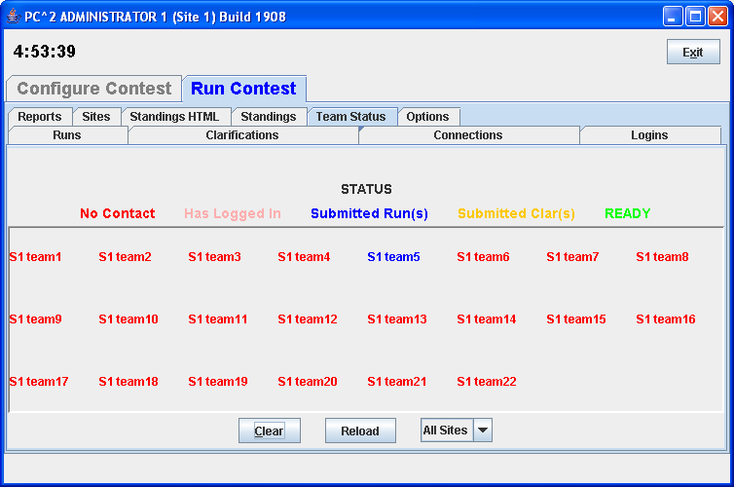

There is one situation which can arise in a contest whereby the Team Status display will not accurately reflect the contest state. If a team logs in while there is no Admin client running, but does not submit any runs or clarifications, then logs out before the Admin client logs in, then that team login will not appear on the Team Status display (the team will show as “No Contact”). A team must either already be logged in when the Admin client is started, or must login while the Admin is logged in, or must leave at least one run or clarification request in the system during the team login, in order for the Admin client to recognize that the team has logged in. Note that under normal circumstances an Admin client is always started, and remains running, for the duration of a contest, so this situation will rarely occur.

The Runs Display - todo

The Runs tab on the main Administrator screen displays a grid showing all the runs which have been submitted so far in the contest (from all teams, at all sites). The run display grid can be sorted on any column by clicking in the column header; clicking multiple times toggles the sort between ascending and descending order. The columns can also be resized by moving the column separators in the header. An example run grid is shown below.

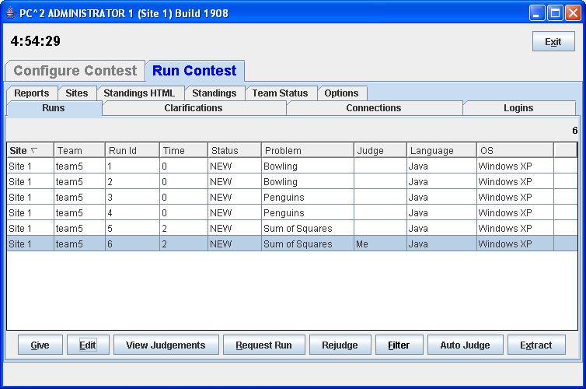

The Runs display provides a number of capabilities for the Contest Administrator. One function of this display is to provide the ability to select a run which has already been judged (and hence no longer appears on the Judge’s grid of available runs) and “give it back to the Judges” so that it may be re-judged. (Note that this assumes an Administrative decision to re-judge a run has been made for some reason; this is not a normal contest operation.)

To give a run back to the Judges, click on the row containing the run to select it, then click the Give button. This will cause the run to appear on the Judge’s screens so that it can be selected and re-judged. (Note: when a Judge selects a run which has been sent for re-judging, a warning message is displayed on the Judge’s screen asking for verification that the run really is intended for re-judging.) A run does not disappear from the Administrator’s grid when it is sent for re-judging; the Administrator always has a complete listing of every run submitted in the contest, from all teams at all sites.
A second purpose of the Runs display is to allow the Administrator to “take a run away” from a Judge. This can be used, for example, to take back a run which was given in error to the Judges for re-judging. Any time there is a run on the Judge’s display grid which should not be there (because it has already been judged and is not intended to be re-judged, for example), click on the run in the Administrator’s Runs display then click the Take button. This will remove the run from the Judge’s screens.

Editing Runs - todo

Another function of the Runs display is to allow the Contest Administrator to edit various parameters associated with a specific run – for example, to mark a specific run as “deleted” or to change the effective submission time of a run. This allows the Contest Administrator to make decisions regarding unanticipated situations affecting how a run should be considered in scoring.
To edit a run, select the run in the Runs grid and then press the Edit button. This will bring up the following Edit Run dialog :

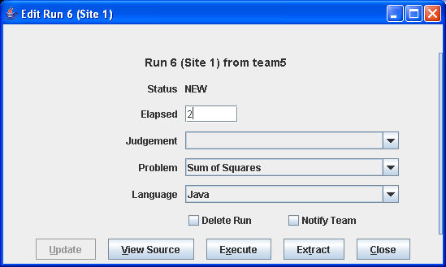The

“Problem”, “Language”, and “Judgment” drop-down lists allow the Administrator to alter the specification of the corresponding attributes associated with the run. It is allowable to change multiple attributes of a run during a single edit (although this would be usual; normally, editing a run is done for a specific purpose such as correcting a judging error).
Changing the “Problem” attribute will have the effect of changing the way in which this run is considered in scoring: it will be counted as a run for the newly specified Problem (however, this will only have an actual effect on the scoring results if the Team has correctly solved the newly specified Problem; see the chapter on the Scoreboard for details). Changing the “Language” attribute will have the effect, if the run is subsequently re-executed, of changing the language definition (compiler invocation) used to compile and then execute the run. Changing the “Judgment” attribute will have the effect of causing the newly specified judgment to be the one used by the Scoreboard in determining whether the Team has correctly solved this problem.
“Elapsed Time” represents the elapsed time in minutes from the start of the contest (contest elapsed time, not counting minutes during which the contest clock was stopped) at which the run was received. The Administrator can change this value as desired. Note that Elapsed Time is considered the “team submission time” and is used to determine the calculation of penalty points assigned to the run.
“Proxy Site” is an internal value used to indicate whether, in a multi-site contest, this run has been handed off from its originating site to another site for handling; this should normally not be changed. (See the chapter on Loosely-Coupled Multi-Site Contests for further information on Proxy Sites.)
Checking the “Mark Run as Deleted” box will cause the run to be completely ignored in all scoring computations. Elapsed Time, Judgment value, and all other attributes of a run which is marked “Deleted” have no effect on scoring. (“Deleted” runs do not actually get removed from the database (nor from the Runs display), they are simply marked as such to indicate they should be ignored for scoring purposes.) If a run has been previously marked as deleted and subsequently the Mark Run as Deleted box is unchecked, the run is once again considered in further scoring computations, with no indication that it was previously “marked as deleted”.
The “Suppress Team Notification” checkbox is used to indicate whether or not the Team which submitted this run should be sent a notification of the “Judgment” value applied to this run after it has been edited. Normally, editing involves correcting an internal administrative error and it is not desirable to notify the Team of any editing, so the default operation is to suppress Team notification. If it is desired that the Team should receive a notification of the result of editing the run (for example, a judgment was changed from NO to YES and the Contest Administrator wishes the Team to know this), uncheck the “Suppress Team Notification” checkbox.
The Execute button on the Edit Run dialog allows the Contest Administrator to execute a run just as it would be executed on a Judge’s machine. This is useful, for example, when a Team submitted a run with an incorrect language specification (which most likely caused a Judge to render a “Compilation Error” judgment for the run), and it is desired to determine what the result would have been if the language specification had been correct. The Language drop-down list can be used to change the language attribute of the run, and it can then be executed at the Admin workstation. Note, however, that the Execute function will only work correctly on the Admin workstation if the workstation has been configured with the necessary language compilers, in the same way as on a Judge’s machine.
Once a run has been edited (and re-executed if desired), pressing the Update button will store the new specification of the run’s attributes in the database and, if team notification has not been suppressed it will send a notice of the run status to the Team. Note that once an update has been applied, the former state of the run is lost; there is no way to restore a run to a prior state once it has been edited (other than simply re-editing the run and changing the values back – but PC² does not keep track of the old run state once the Update button has been pushed).

Filtering Runs - todo
It is frequently desirable to view a subset of the complete set of runs which are currently in the database. For example, the Contest Administrator may be interested in looking at all the runs for a given Problem, or all the runs from a given Team, or all the runs submitted during a specific window of time, or some combination of these.
The Administrator Runs display has associated with it a filter which can be used to apply a set of filtering criteria to the runs which are displayed. Pushing the Filter button on the Runs display screen will produce the following dialog, which is used to set the filtering criteria:
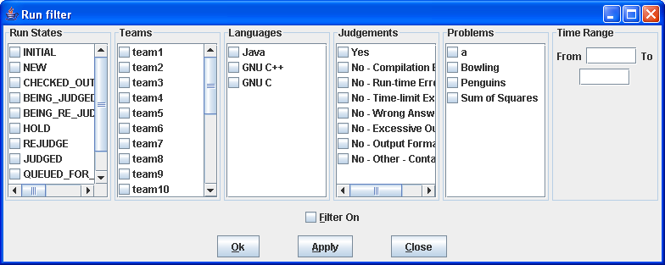
Selecting a set of items in the filter dialog indicates that those items should be displayed on the Runs grid. For example, to specify that the Runs grid should display all (and only) runs from Team 1 at site “CSUS” for the problem named “Penguins”, you would select “Penguins” in the Problems column, “Team1” in the Teams column, “CSUS” in the Sites column, and “All” in the Language, OS, and Time columns, and then press the Update button. The Runs grid would then apply the specified filter criteria to all runs, displaying only those that match the selected criteria. As another example, to display all (and only) runs which were submitted during the first 20 minutes of the contest, you would enter “0” in the “From” time field, “20” in the “To” time field, and select “All” in the Problems, Teams, Sites, Language, and OS fields, and then press the Update button.
The filter is designed with the expectation that at least one entry will be selected in each column. The “Clear All” button in each column is provided as a convenience to allow “de-selection” of all entries in anticipation of then selecting one or more entries in the column. However, clearing all criteria in a column does not make sense as a final filtering operation: if “Clear All” were allowed as the final choice in a column (that is, if no entry in the column was selected following a “Clear All” for the column), this would imply that no runs should be displayed (since no runs would match the filtering criteria of “nothing selected”). For this reason, the filter ignores a “Clear All” condition if it is the last operation performed on a column and instead effectively selects all the criteria in that column. In other words, pushing “Clear All” as the last operation on a column is effectively the same thing as pushing “Select All” on that column.
The same logic applies to the “Clear All” button near the bottom of the screen, which is used to initially clear all entries in all columns, in anticipation of then selecting at least one entry in each column. If this global “Clear All” is the last operation selected prior to pressing the Update button, the filter interprets this as a request to disable the filtering operation entirely; that is, to display all runs on the Runs grid. Thus, the global “Clear All” button is effectively a “Filter Off” (no filtering) button.
In order to remind the user when filtering of runs is taking place, any time a filtering operation has been selected the “Filter” button on the Admin screen will change color to blue and will indicate “on”, like so: Filter (ON). Disabling filtering (using the “Clear All” button as described above) will return the Filter button to its normal state.

Clarifications - todo

The Clars tab on the main Administrator screen displays a grid showing all the Clarification Requests which have been submitted so far in the contest (from all teams, at all sites), in a format similar to the Runs grid. Like the Runs grid, the Clarification Request grid can be sorted and resized by manipulating the columns headers. The Give and Take function work like the Give and Take on the Runs pane. Note that there is no filter operation supported for Clarification Requests.

Reports – todo
The Reports tab on the main Administrator screen provides a variety of options for generating statistical reports about a contest, both during and after the contest. The Reports screen looks like the following:

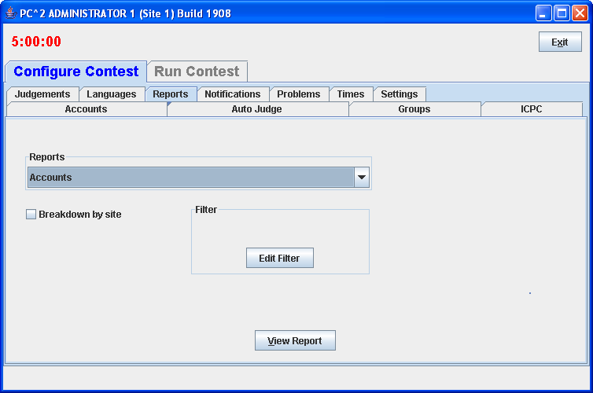

The “Report Option” drop-down list allows choosing one of a number of different report formats. The list of available reports is summarized in the table shown below. Pressing the “View” button will pop up a display showing the content of the selected report, and will also write the selected report in text form to a file (located by default in the $PC2HOME directory) using the file name given in the “Report File Name” text box.

Report | Description
Account Permissions Report | For each client list their Permissions/Abilities
Accounts | List summary of accounts per site, and individual accounts sites, logins, passwords.
All Reports | List contents of all reports
Balloons Delivery | List of all balloon deliveries by team, by problem and time of delivery
Balloons Summary | List summary of which teams should have which color balloons.
Clarifications | List all clarifications
Client Settings | Various settings like Notification settings
Contest | Contest settings in XML (work in progress)
Contest Analysis | Summary of submissions, unjudged runs, various checks on runs.
Evaluations | One line per judgement output
Extract Replay Runs
Fastest Solved by Problem | List all run solving problems by fastest, by problem, and fastest solution showing rank, elapsed, team name
Groups | List of Groups (Regions)
Internal Dump | An internal dump of a bunch of config settings
Judgement Notifications
Judgements | List of judgments
Languages | List Languages
Logins | List who is logged in
Notification Settings
Problems | List problems
Run 5 field | List of runs: run #, team #, problem letter, elapsed time, judgement
Run Notifications Sent
Runs | List of runs, with run#, run state, team #, team name, whether judgement sent to team and details on each judgement
Runs (Version 8 content and format) | List of runs with detail (see below)
Runs grouped by team | List of runs, grouped by team, then by problem, helpful in calculating scoring.
Solutions By Problem | For each problem show number of run with No, Yes, and percentage correct
Standings XML | Standings in XML format
Submissions by Language | A summary of how many teams used which languages.

The PC² Scoreboard

Overview - todo
PC² contains a separate “Scoreboard” module which keeps track of the current standings in a contest. The scoreboard provides several functions: it automatically generates HTML pages describing the current state of the contest in a variety of formats; it generates email and/or printed “balloon notifications” (when that option has been selected by the Contest Administrator; see the section on “Options”, above); and it provides the capability to generate an “export” file containing contest standings data (in the form required for importing to the ICPC Registration system).
The HTML files generated by the scoreboard are placed in a directory named “html” (lower case) directly beneath the $PC2HOME directory. Balloon notifications are sent to destinations as configured by the Contest Administrator. The export data file is placed in the $PC2HOME directory.
The following sections describe the details of the generated HTML files and the export data file. They also describe the overall scoreboard operation, including the scoring algorithm used to compute contest standings.

Starting the Scoreboard - todo
To start a scoreboard, go to a command prompt, be sure that the working directory is $PC2HOME (the PC² installation directory) and type the command “pc2board”. This will start a PC² client expecting a scoreboard login.
Once the Client login window appears, enter the scoreboard account name “board1” and the board1 account password as defined when PC² accounts were created,. This will bring up the PC² Scoreboard display window (next page), indicating that the scoreboard program is running.
The scoreboard automatically generates a complete set of HTML files to the html/ directory as soon as it is started. Thereafter it generates updated HTML files periodically according to an algorithm described below. Each time a new set of HTML files is generated the scoreboard display window is updated to show the most recent update time.
Under normal circumstances it is only necessary to have a single PC² scoreboard running, even in a multi-site contest. The scoreboard automatically receives update information from every site server, and generates HTML files describing the overall contest status (including all sites). These HTML files can be copied to a publicly-accessible location for access by a browser (see below), so participants at any location can see the current standings. In addition, a single scoreboard (running under the “board1” account) can generate balloon notifications for all sites. Thus there is rarely a need for running more than one PC² scoreboard in a contest, and this is the recommended mode of operation.

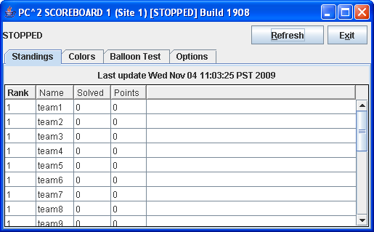

Scoreboard Updates
Once it is running, the scoreboard waits passively until some contest event occurs which could alter the data it should display (this could be a submitted run, a judgment decision by the Judges, a change in a team name, or various other events). When any such event occurs, the scoreboard obtains from the server an update of the contest state, computes the new standings based on this information, and regenerates the HTML display files.
Events that will cause a scoreboard update: run judgement, run submission, account name changes, group name changes, scoreboard settings changes and lastly if a user clicks the Refresh button on the board display. The date/time of the last scoreboard update is present on the scoreboard main window.

Scoreboard HTML Files
Each HTML file generated by the PC² scoreboard is a complete stand-alone HTML document (i.e. is bracketed by <html> … </html> tags). Each document <head> includes a <title> tag, into which PC² places the Contest Title as specified by the Contest Administrator (see Options, above). Each document <body> contains an imbedded <table> holding contest status information. Each HTML file is also in an XML formatted file.
The <table> in each different HTML file contains a different set of contest information, such as team rankings, run submission statistics, etc. (see below). The information outside the <table> can be edited/replaced as desired, for example by adding additional header information, frames, or any other HTML constructs. However, it is important to keep in mind that the set of HTML files is completely regenerated on every scoreboard update; changes made manually to an HTML output file will only persist until the next scoreboard update.
The following HTML files are always generated by the scoreboard:

File Name | Table Contents
full.html | Columns showing rank, team display name, number of problems solved, and penalty points, with rows ordered by rank. This is the standard “contest standings” display.
fullnums.html | Same as full.html except that the Team Display Name is preceded by the Team Number followed by a dash.
final.html | Standings as they are displayed at the conclusion of the ACM ICPC World Finals – Penalty Points are considered and displayed only for the top ten teams; the remaining teams who have solved at least the median number of problems are grouped alphabetically by number solved; the rest of the teams are listed as “Honorable Mention”.
sumtime.html | A grid showing, for each team and each problem, the number of runs submitted by the team for the problem, and, if the team has solved the problem, giving the contest elapsed time of the team’s solution.
sumatt.html | A table similar to the sumtime table but instead of giving the time of solution for solved problems simply indicates “Y” or “N” according to whether the team has solved the problem.
summary.html | A table combining the full and sumtime displays described above – that is, a showing rank, team display name, number of problems solved, penalty points, and number of runs submitted and solution time for each problem, with rows ordered by rank.
The most common way to take advantage of the HTML files generated by the PC² scoreboard is to run a separate external process (e.g. a batch script) which repeatedly copies the current HTML files to some external location (web site), reformats them if desired, and makes them available to teams and spectators using a browser.
There are several advantages to this method of operation. First, the details of the appearance of the scoreboard can be customized by the Contest Administrator external to PC². Thus the Contest Administrator can choose to take advantage of the full set of scoreboard screens, or can choose to omit some or all of them. In addition, it is not necessary for teams, judges, spectators, etc. to run separate PC² scoreboards, since most users will already have access to a browser. The Contest Administrator can arrange that the external scoreboard script builds the desired scoreboard display and puts the resulting HTML in a standard public location accessible to all user’s browsers.

Scoring Groups - todo
In addition to the above files, the scoreboard can generate separate HTML files showing rankings based on the concept of “groups” or “regions” with which a team is associated. For example, in the ICPC World Finals, teams compete not only for placement in the overall world-wide standings, but also among teams from their own region of the world for the regional championship. Other examples include situations where it is desirable to break contest teams up into separate groups based on level of experience (e.g. “lower division” and “upper division” students), and in multi-site contests where it is desirable to be able to display rankings that show only those teams participating at a given site.
Every PC² account has associated with it a “Group ID” identifying the “region” or “group” to which the account belongs. By default all accounts have a Group ID of zero (which is considered a valid Group ID); hence all teams are by default in the same “region” (group). Changing the Group ID for a particular team associates that team with other all teams having the same Group ID (see the section on Editing Accounts, earlier in this manual).
By default, the scoreboard ignores Group IDs. However, it is possible to make the scoreboard pay attention to Group IDs (that is, pay attention to team groupings), and when this is done it will cause the scoreboard to automatically generate additional HTML files, as follows:

File Name | Table Contents
regions.html | A single table showing the top team in each region (team grouping).
groupX.html | This represents several different HTML files, one for each group “X” (group1.html, group2.html,…. ). Each groupX.html file contains the same contents as the file full.html described above, except that the data is restricted to teams which are defined as belonging to “group X”.

There are two ways to cause the scoreboard to pay attention to regional groupings of teams (and hence generate the additional region HTML files). One is to use the “import ICPC data” function on the main Administrator screen. The imported ICPC data contains information identifying for PC² both the number of regions into which teams have been partitioned, and the “region ID” and “region name” associated with each team. This information both enables the automatic generation of the regional HTML files, and tells the system how determine the region with which a given team is associated.
The Contest Administrator must also take care to assign a Group ID to each account according to the region to which the account belongs. All accounts in the contest (even accounts across multiple sites) which belong to the same region or group should have the same Group ID number, since this is how the scoreboard determines the association between an account and its region. (This assignment is handled automatically when the Import ICPC data operation is used.)
For example, if it was desired to separate all contestants into “Lower Division” and “Upper Division” groups, all accounts used by teams in the “Lower Division” might be given Region ID values of “1” while all accounts used by teams in the “Upper Division” might be given Region ID values of “2”. Note that in a multi-site contest, all Lower Division teams would need to have the same Region ID (2), regardless of the site at which they were located.

Scoring Algorithm
The algorithm used in PC² to compute Rank and “Score” (Penalty Points) is the one used in the ACM ICPC World Finals, which is as follows:
- Teams are ranked according to the number of problems solved; a team solving more problems is always ranked higher than a team solving fewer problems.
- Within a group of teams solving the same number of problems, teams are ranked by increasing “Penalty Points” (that is, the team with the lowest number of Penalty Points is ranked highest within the group). Teams only accrue Penalty Points for problems which the team has solved; unsolved problems do not affect the scoring in any way. Teams accrue Penalty Points for solved problems in two ways:
- One point for each minute elapsed from the start of the contest until the problem was solved (the time of SUBMISSION is counted as the “time solved”; it does not matter how long it took the Judges to judge it).
- A specific number of penalty points for each INCORRECT submission submitted to the Judges prior to a correct solution for the problem (runs submitted after a correct solution are not counted in the scoring).
- If two or more teams have the same number of solved problems and exactly the same number of Penalty Points, ties are broken in favor of the team with the earliest time of the last correct submission (that being the time when the team “finished” the contest).
Examples of the PC² scoring algorithm can be found in the Wiki article Scoring Algorithm at http://pc2.ecs.csus.edu/wiki/Scoring_Algorithm.

Adding new HTML Files - todo

(Describe using XSL files to add new HTML files)

Export Data File
The scoreboard provides the ability to generate a text file containing data describing the current contest standings. Since this capability was provided for purposes of exporting contest results back to the ICPC Registration system, the button on the scoreboard display which is used to invoke it is labeled “Export ICPC”. However, the use of the export operation is not restricted to interfacing with the ICPC Registration system; it simply generates a file containing text records made up of comma-separated fields.
The export data file contains, for each team, a record giving the number of problems solved, the total number of penalty points accrued on solved problems, and the time of last submission of a correct solution (used in the ICPC World Finals as a tiebreaker). See the Appendix on Import/Export Interfaces for further details on the format of the export data file.
The export data file “pc2export.dat” is located in the $PC2HOME directory.
In Version 8 the export data file was generated by pressing the Export ICPC button the Scoreboard.
In version 9 the export data file is generated by pressing the Refresh button on the Scoreboard. The export data file is also regenerated each time the scoreboard HTML is updated.

Shutting Down

Shutting down server

Each site server can be shutdown by using the Exit button on the Server GUI. For non-GUI servers use the Shutdown button on the Site tab to shutdown the server.

Shutting down clients

When a site server is shutdown, all connected client modules will be shut down. When a site server is shutdown all connected servers will not be shutdown. To shutdown other sites server use the Shutdown button on the Site Tab.

Appendix A – pc2v9.ini Attributes
As described in the chapter on PC² Initialization Files, the pc2v9.ini file consists of up to six sections: [server], [client] , [admin], [judge], [team], and [board], with each section containing one or more "attribute assignment" statements of the form attributeName=value. Lines in the file which begin with a “#” or “;” character are ignored, as are blank lines. Attribute names (left side of the equal-sign) are not case sensitive; however, string data on the right side of the equal-sign is case sensitive.
The following list gives the attributes which can be defined in each section of the pc2v9.ini file, along with a description of their function. Some attributes may appear in more than one section.

[server] section attributes:

port=<portNumber>
Tells the server the port number on which it should expect to be contacted by clients, and by other PC² servers in a multi-site contest. This attribute may be omitted from the pc2v9.ini file, in which case it defaults to 50002. Note that if you choose to assign a specific port number, then all clients and other servers contacting this server must also be told to use this same port number (this is specified with the “server=” attribute in the case of clients, and with the “remoteServer=” attribute in the case of other servers). Note also that if you choose to assign a specific port number, the port number should be greater than 49151 according to the conventions established by the IANA (Internet Assigned Numbers Authority).

remoteServer=<IPAddress>:<portNumber>
Tells the server the IP address and port number of a remote PC² server at another site which it should contact in order to join a multi-site contest. The <portNumber> must be specified and must match the port number being used by the server at the remote site. The appearance of this attribute makes this server a “secondary” server; if this attribute is not defined in the [server] section then this server is a “primary” server and waits passively to be contacted by other site servers.

[client] section attributes:

server=<IPAddress>:<portNumber>
Specifies the IP address and port number at which the client module should attempt to contact the PC² server. Every client module MUST have a “server=<IPAddress>:<portNumber>” entry in the [client] section of its pc2v9.ini file. The IP address and port number must correspond to the address of the machine running the PC² server and the port number at which the server on that machine is expecting to be contacted.

Appendix B – Networking Constraints - todo
As mentioned in the beginning of this manual, PC² modules must be able to communicate with each other via TCP/IP: clients must be able to communicate with their servers, and servers in a multi-site contest must be able to communicate with other servers. If client machines reside on the same LAN segment as their server, and if all servers have publicly routable IP addresses which can be reached by other servers, then communication should work with no problems.
However, given the wide variety of network configurations which can exist – firewalls, NAT, and VPNs, just to name a few – there may be some constraints in a given network setup which will cause problems in setting up a contest using PC². In order to understand how to avoid (or circumvent) these problems, it is useful to have some understanding of how PC² networking is implemented.
PC² is written in Java and uses Java Sockets, each connection to a server requires a public single host (or IP) and port which is not blocked by firewall.
In a multi-site contest each server contacts every other server so there must not be a firewall that blocks the sending/receiving of data.
Another constraint on networking has to do with NAT (Network Address Translation).

Appendix C – PC² Server Command Line

The command to start a server is:
bin/pc2server
typed in the $PC2HOME directory.
The server accepts a number of command line options when it is started. One option is -h (or --help), which produces the following “usage” output:

$ java pc2.server.Server –help
Usage: Starter [--help] [--server] [--first] [--login <login>]
[--password <pass>] [--site ##] [--skipini] [--ini filename]

As seen from the “usage” output, the server also accepts the following command line options:

--first : indicates that this server is a primary server and should not attempt to contact any other servers (ignores any remoteServer= attribute in pc2v9.ini)

--join : indicates that this server is a secondary server and should attempt to contact a remote server to join a contest. Uses the remoteServer= attribute in pc2v9.ini, if there is one, to determine what remote server to contact; if no attribute is defined, prompts at the console for IP:port connection information

-- server: indicates that this Starter is to run as a server, otherwise starts as a client.

--login : specify the PC² login account name

--password : specify the PC² password

--site : (author note: complete this entry)

--skipini : ignore the pc2v9.ini file

--ini : specify an override ini filename

Appendix D – ICPC Import/Export Interfaces - todo
E.1 Importing ICPC Registration Data
As mentioned earlier in this manual, PC² was designed for supporting the ACM International Collegiate Programming Contest, including its local and Regional contests worldwide. The ICPC maintains an online Contest Registration system which is used by Regional Contest Directors (RCDs) around the world to manage participation in the various ICPC Regional Contests. PC² provides interfaces to import contest registration data from the ICPC Registration system, and also to export contest results back to the ICPC web site.
To import ICPC Registration data to PC², the RCD must first log into the ICPC Registration system and download the “PC² Initialization” zip file which is automatically created and updated as registration data changes occur. Once the PC² Initialization data file is downloaded, it should be “unzipped” at any convenient location.
Unzipping the PC² Initialization data file will produce three separate files: “PC2_Contest.tab”, containing details about the organization of the contest (such as the formal name of the contest); “PC2_Site.tab”, containing data identifying the sites in the contest; and “PC2_Team.tab”, containing data about the teams that are registered in the contest.
The PC2_Team.tab file consists of text-based tab-delimited records, one record for each team registered in the contest. The tab-delimited field contents of each record are as follows:
1) An integer giving the ICPC Team ID (note that this is not the same thing as the PC² Team ID; see below).
2) An integer giving the ICPC Region ID (the “region” or “group” to which the team belongs).
3) A single character indicating the Team’s “registration status” for the contest – typically either ‘P’ (pending), ‘A’ (accepted), or ‘C’ (cancelled). PC² ignores records containing ‘C’ in this field.
4) A string giving the Team Name; for example, “The Top Coders”.
5) A string giving the full name of the Team’s school; for example, “California State University, Sacramento”.
6) A string giving the Team’s school name in “short form”; for example, “CSUS”.
7) A string giving the Team’s school’s URL; for example, http://www.csus.edu.
8) A string giving the Team’s school’s country code (three letters); for example, “USA”.
9) A single character ‘Y’ or ‘N’ indicating whether the Team’s school has a graduate program . PC² ignores this field (but it must be present).

PC² can “import” this team data and use it to define things such as the team’s Display Name on the scoreboard. PC² will associate consecutive records in the PC2_Team.tab file with consecutive PC² accounts – the first record in the file will automatically be associated with “team1” at the site specified in the record, etc. (Note that PC² does not use the ICPC Team ID field for purposes of identifying a team.)
If the contest administrator wishes to associate registered teams with PC² accounts in a different order, the PC2_Team.tab file can be edited (rearranged) to present the records in the desired order – the team which should be “team1” in PC² should appear first in the file, etc. Alternatively, if the PC2_Team.tab file is copied to a new file named “_PC2_Team.tab”, the new file can be edited by adding a new leftmost column containing a PC² team number. PC² checks for the existence of this file and, if it is present, uses that file not only to load the ICPC data but to determine, based on the value in the first field in each record, to which PC² account each record in the data applies.
Once the PC² Initialization data has been unzipped and the PC2_Team.tab file edited if desired, the next step is to press the “Import ICPC Data” button on the PC² Administrator main screen (under “Manage Accounts” on the Accounts tab pane). This will cause PC² to display a “file selection” dialog; this dialog is used to identify for PC² the set of .tab files which should be imported. To make this identification, simply navigate to the directory containing the unzipped ICPC PC² Initialization data files, and select any one of the “.tab” files in that directory. This will cause PC² to load all three of the initialization files. Note: all initialization “.tab” files must all reside in the same directory.
If this is the first time an ICPC Import has been done, PC² will show a dialog displaying the names of the contest sites as defined in the ICPC data and asking the administrator to provide a specification of the association of those site names with the site names which PC² already knows about (from its sitelist.ini file). Once this is complete, PC² saves the region-association information and then finishes the association of ICPC Registration data with PC² accounts; the results can be viewed on the Accounts tab on the Administrator main screen, just as if the data had been entered manually. (Note: the account display on the Administrator screen is not dynamically updated upon completion of an ICPC import; click to another view and then back to the “Manage Accounts” view in order to see the imported data.)
Note that each record in the ICPC PC² Initialization data contains multiple names associated with each team – the team name, the full name of the school, and a short version of the school name. PC² can be configured to use any one of these names, or a combination of them, as the name to be displayed on the scoreboard. See the appendix on pc2v9.ini file entries, under the [admin] section, for details.
PC² expects quotation marks in the team data to be “quoted”. That is, if any field in the data contains a quotation mark (″), then (1) the entire field must be surrounded by an additional matching set of quotation marks, and also (2) each quotation mark which is part of the data must be doubled. Thus for example a team name like The ″TOPS″ Team should appear in the import data file as ″The ″″TOPS″″ Team″. If the PC² Initialization file exported from the ICPC web site contains data with quotes, it may be necessary edit the data by hand (or load it into a program such as Microsoft’s Excel and then save it) to insure that quotation marks are properly formed. If this is not done prior to importing the data into PC², you may see “format error” messages in the log file, and the data containing the quotes will not be displayed properly.
E.2 Exporting Contest Data

Pressing the “Export ICPC” button on the scoreboard display causes the scoreboard to generate a text file containing the current contest standings in a form required by the ICPC World Finals results display algorithm. This file is made up of a series of text records, one record for each team in the contest. Each record contains a set of comma-separated fields. The fields in each record are:
    - ICPC Team ID (note: not the PC² team number).
    - Rank in contest (this field is blank if the team falls in the “Honorable Mention” category as defined by the scoring display algorithm for the ICPC World Finals; see the description of the file final.html in the chapter on the PC² Scoreboard for details).
    - A non-negative integer giving the number of problems the team has solved.
    - A real number giving the total number of penalty points accrued by the team.
    - A real number giving the time of the last submission by the team, taking into account only the problems which the team has solved (used as the ICPC World Finals tiebreaker determination).
The records in the file are sorted by team rank based on problems solved and penalty points. In particular, teams that fall into the “Honorable Mention” category as defined by the ICPC World Finals results display algorithm will still appear in rank order in the file, as defined by number of problems solved, penalty points accrued, and tie-breaking time of last submission.
The exported data file contains all the information necessary to update the ICPC web site registration system with the results of a contest. It is primarily intended to provide an automated mechanism for Regional Contest Directors to post the results of Regional Contests. The export data file can also be imported into any program that wishes to make use of the standings data.
Note that if no “ICPC Import” operation was performed prior to invoking the “Export ICPC” operation, then PC² will have no record of the ICPC Team ID associated with each team. In this case the “Team ID” value in field #1 in the exported file will be zero. This problem can be circumvented in contests other than Regional Contests (that is, contests where there is no ICPC data to import) by creating a local version of the “PC2_Team.tab” file, entering the appropriate PC² team account number in lieu of the ICPC Team ID. This will cause the “Export ICPC” operation to generate a file containing all the data necessary to compute complete contest standings utilizing PC² account numbers.

Appendix E – Validators - todo
F.1 Overview
PC² allows the Contest Administrator to configure each problem so that it has associated with it a validator program whose purpose is to help automate the judging process. A “validator” is a program which is given, as input, the output of the execution of a run (that is, the output of a program submitted by a team).
Validators can operate in one of two ways: passively or actively. A passive validator is a program which accepts the team program’s output and displays it in some useful form for examination by the human judge. An active validator is a program which not only accepts the team program’s output but contains logic designed to make a determination, according to some set of rules, regarding the correctness of the output. An active validator can also return the result of its determination to PC².
An example of a passive validator would be the use of a “side-by-side” file comparison utility which displays the team program output beside an “answer file” provided by the Judges ahead of time. This allows the judge to use the validator to examine the output and compare it with the correct answer, perhaps taking advantage of special capabilities of the validator program (for example, syntax-driven color highlighting of differences between the team program’s output and the correct answer file). When the judge is satisfied, the validator is terminated and the judge uses the PC² Judge client interface to enter a judgment.
An active validator is one which automatically examines the team program output and makes some determination of its correctness. The validator must contain program logic which directs how it determines correctness. This logic could be hard-coded within the validator (in which case the validator is almost always problem-specific), or could be more general (for example, instructions directing application of “difference testing” between the program output and a Judge’s “answer file”). In either case an active validator is one which is designed to make an “automated” determination of the correctness of the output of a team’s program.
For active validators, a set of conventions defined within PC² provide a mechanism for the validator to return to PC² an indication of what judgment it thinks should be applied to the run. However, such a validator response is never blindly accepted as the final determination of the judgment to be applied to a run. Rather, the validator output is displayed to the human judge as a “recommendation”. It is ultimately up to the human judge to accept the validator recommendation (or not). That is, it still requires the judge, at a minimum, to press a button to accept the validator recommendation.
F.2 Validator Configuration
By default there is no validator attached to (associated with) a contest problem in PC². Validators can be attached to a problem by the Contest Administrator by using the Validator tab on the Edit Problem dialog. This displays the Validator configuration screen, as shown below. When the Contest Administrator configures a problem to use a validator, then when a Judge executes a team program the specified validator will automatically be invoked as soon as the team program completes execution.
The Validator screen allows the Contest Administrator to choose one of two options for attaching a validator to the problem being defined: either the simple built-in PC² validator, or an arbitrary separate external program. If a separate external program is selected it can be either a standard system program (such as a “diff” utility or a split-screen file-compare utility) acting typically as a passive validator, or it can be a program written specifically for the validation of output from programs for this particular contest problem, i.e. an active validator.
The Contest Administrator can choose whether or not to display the validator result to the judge. Checking the box “Show Validation To Judges (SVTJ)?” when configuring a validator will cause the response returned by the validator to appear on the Judge’s display when the run finishes executing. If the checkbox is unchecked, the validator result will not be visible to the judge. The checkbox should normally be unchecked when using passive validators, which do not return meaningful result information (if SVTJ is checked and a passive validator is used, the response displayed to the judge will always be “Undetermined”).
The following sections describe the built-in PC² validator, the use of an existing external program as a validator, and the creation and use of a special-purpose problem-specific validator. For problem-specific validators, the ICPC standard for interfacing such validators to a contest control system such as PC² is described.
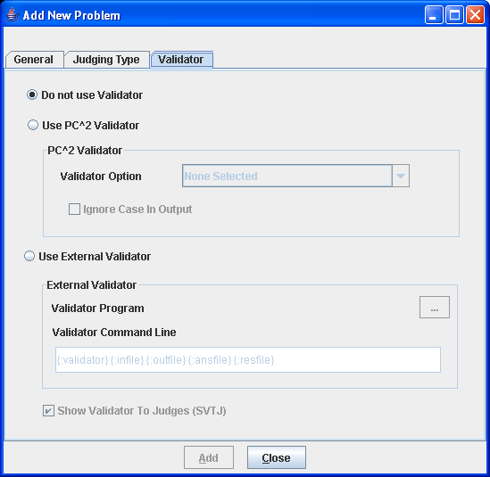

F.3 PC² Built-In Validator
PC² contains a built-in validator which can be used to compare the output of a submitted program with the “answer file” provided by the judges (specified when a contest problem is configured). The built-in validator is essentially a very simple version of the standard Unix “diff” file comparison utility. Selecting the “Use PC^2 Validator” option enables a drop-down list showing the various comparison options, which are listed in the following table.

PC² Validator Option | Meaning
1 | Perform a standard “diff”: a character by character comparison of files differences
2 | Ignore whitespace at start of file
3 | Ignore leading whitespace on lines
4 | Ignore all whitespace on lines
5 | Ignore empty lines
6 | 2 then 3
7 | 2 then 4 (implies 3)
8 | 2 then 5
9 | 3 then 5
10 | 4 then 5 (implies 2 then 3)

When using the PC² built-in validator it is important to understand the exact meaning of the options which specify combinations (options 6 and higher). In particular, “X then Y” means that the validator first checks the output using case X and then checks the output using case Y, independently. Note that this is not the same thing as performing a single test applying both conditions simultaneously. This can produce unexpected results.
For example, “check the output, ignoring white space at start of file” followed by “check the output, ignoring empty lines” is not the same as “check the output ignoring white space at start of file and also ignoring empty lines”; if there are empty lines in the output file but not in the answer file, then when it validates using the criteria “ignore white space at start of file” the output will FAIL due to the empty lines in the answer file. Be sure you understand the operation of the built-in validator before using it!
The PC² built-in validator is an active validator – meaning that it automatically returns to the Judge a recommendation for the judgment which should be applied to the run whose output was diff’d against the answer file. If SVTJ was checked when the validator was attached to the problem, then the returned recommendation is displayed for the judge.
F.4 Using An Existing External Tool As A Validator
If the Contest Administrator selects Use External Validator on the Validator configuration screen, it tells PC² to use an external program as a validator for the problem being configured. In this case PC² needs to be given two sets of information regarding the external program which is to be used: (1) the name of the file containing the validator, and (2) the command sequence which PC² should use when invoking the validator.
To understand how this works, suppose it is desired to use an external program named “gvim” as a validator for a certain contest problem. Further, suppose gvim is a program which can be given an argument, “-d”, along with two additional arguments specifying file names, and that what it does in this case is display the contents of those two files side by side, highlighting the differences.
What the Contest Administrator wishes to do is have PC² invoke gvim every time a run for this particular problem is submitted and executed by a judge, and pass to gvim two files: (a) the output of the team’s program, and (b) the answer file (correct output) for the problem (provided ahead of time by the judges). This will allow a judge to compare the team’s output with the correct output, using the capabilities of the gvim program to assist them.
Since our hypothetical gvim program already exists and is not (likely) written to understand how to make programming contest-related decisions about the correctness (or not) of the differences between two files, we will use gvim as a passive validator (one which does not return a value to PC²). In that case the Contest Administrator would uncheck the SVTJ box, and then would select Use External Validator on the Validator screen.
In the Validator Program textbox the Contest Administrator enters the file containing the gvim program. This might be something like
/usr/local/bin/gvim
or
C:\Program Files\gvim\gvim.exe
Use the “browse” button (the button showing “…”) to select the validator program file name. Typically this is an executable program, but it could be any file. A legitimate file must be selected even if this field is not actually used.
In the Validator Command Line textbox the Contest Administrator enters the command to be used by PC² to invoke the validator. This command can include parameter substitutions similar to those allowed when configuring languages. As when defining languages, parameter substitutions are indicated by a set of matching curly braces with a colon as the first character and containing a substitution keyword, for example, {:infile} The following table shows the substitutions which will be performed by PC² prior to invoking the validator:

Keyword | Meaning
validator | Represents the file name given in the Validator Program box. Note that it is not a required that the “validator program” actually be an executable program; it could for example be a text file.
infile | Represents the problem data input file as configured in the problem.
outfile | Represents the output sent to stdout by the team program when it was executed by the judge.
ansfile | Represents the judge’s answer file as configured in problem.
resfile | Specifies the name of the file into which an active validator must place an XML representation of the judgment.

Thus to invoke gvim as described above the proper Validator Command Line entry would be:
{:validator} -d {:outfile} {:ansfile}
This would invoke the gvim program ( {:validator} ) with a “-d” argument, passing it the team program output ( {:outfile} ) and the judge’s correct-answer file ( {:ansfile} ).
Note that while the above example uses an existing program (gvim) as the “validator program”, it is not a requirement that this actually be an executable program. As an example, the “validator program” file might be a text file containing a set of “rules” describing how to determine the correctness of a team’s output, and a completely separate program could be invoked via the Validator Command Line entry, perhaps passing the “validator program” file as a parameter.
For example, suppose a contest problem required teams to write a program to generate output which conformed to a set of lexical rules. If there existed a program named “analyze” which performed lexical analysis of the contents of a file according to a set of rules specified in another file, then the Contest Administrator might create an appropriate set of rules (the rules to which the team program’s output must conform) in a file named rules.dat, select rules.dat as the “Validator Program” file, and then specify the following as the Validator Command Line entry:
analyze {:validator} {:outfile}
This would invoke analyze as the program to be executed during the validation step, passing it rules.dat and the team output file as input. (What analyze would do with this is left as an exercise for the reader – but see the following section.)

F.5 Implementing a Validator
The use of an existing system tool (e.g. gvim) as a validator has the drawback that such validators typically must be passive, since they normally have knowledge of neither how to make decisions regarding correctness of team program output nor how to return such decisions to PC² even if they did know how to make them. The built-in PC² validator can be used as an active validator since it knows how to make decisions and knows how to return them, but as mentioned previously it is an extremely weak implementation.
Thus, it is desirable to have a mechanism which allows the use of a special-purpose program written specifically to be an active validator. In order to support the use of such validators, it is necessary to define a set of standards for interfacing validators to the system. Because a validator is a problem-specific (not contest-specific or contest control-system specific) entity, ideally these standards should be uniform and general enough that a conforming validator (and its corresponding contest problem) could also be used in conjunction with contest control systems other than PC².
Under the auspices of the ICPC, the PC² development team has worked with a number of other contest system development teams to define such a standard. Known as the ICPC Validator Interface Standard, it specifies two interfaces: the invocation interface from a contest control system to a validator program, and the result interface from the validator back to the contest control system.
The following subsections give a brief summary of the interfaces defined by the standard, followed by a description of the PC² implementation of the standard. Since PC² complies with the standard, any validator written to comply with these interfaces can be used as an active validator for a problem in PC².

F.5.1 Invocation Interface

The standard mandates that the contest control system is responsible for invoking the validator and passing it at least four command line parameters, as follows:

parameter1: a string specifying the name of the input data file which was used to test the program whose results are being validated.

parameter2: a string specifying the name of the output file which was produced by the program being validated when it was run using the data file named in parameter1 (that is, the name of the file containing the output to be 'validated').

parameter3: a string specifying the name of an arbitrary "answer file" which acts as input to the validator program. The answer file may, but is not necessarily required to, contain the "correct answer" for the problem. For example, it might contain the output which was produced by a "Judge's Solution" for the problem when run with the data file named in parameter1 as input. Alternatively, the "answer file" might contain information, in arbitrary format, which instructs the validator in some way about how to accomplish its task.

parameter4: a string which specifies the name of the "result file" which the validator must produce. The content of the result file produced by the validator is defined in the following section.

The requirements for passing parameters to a validator can be met by the Contest Administrator in PC² through the use respectively of the {:infile}, {:outfile}, {:ansfile}, and {:resfile} command substitution parameters in the Validator Command Line; PC² will automatically insert the appropriate values for the problem when the validator is invoked. Also, as required by the standard, the data file, program output file, and the answer file are in the current directory when the validator program is run. These conditions taken together specify how an arbitrary validator program should expect to be invoked by PC².

The standard specifies that the contest control system may pass additional command line parameters to a validator, as long as the first four command line parameters are specified as listed above, and that the interpretation of any such parameters is up to the validator. The Contest Administrator in PC² can pass arbitrary additional parameters to the validator by including them in the Validator Command Line after the four required parameters.

F.5.2 Result Interface

The standard requires that the validator result be returned in the “result file” whose name is specified by parameter4 (above), and that the contents of the result file must be a valid “XML Document”. This means that it must start with a valid XML declaration, such as

<?xml version="1.0"?>

The root element of the XML document must be of the form

<result outcome = "string1"> string2 </result>

The tag name “result” is fixed and required by the standard, as is the attribute name “outcome”.

“string1” is an “outcome string” defining the result (outcome) which the validator is reporting to the contest control system. If the value of “string1” is “accepted” (or any case-variation of that word), the standard specifies that the validator is indicating that the program output file “passed” the validation test(s). If “string1” contains any value other than a form of the word “accepted”, the standard specifies that the validator is indicating that the program output file “failed” the validation test(s).
In PC², the appearance of any form of the word “accepted” in the “string1” attribute of the result element in the result file causes PC² to assign a recommendation of “YES” to the run being executed. Recommendations are displayed to the judge if the SVTJ checkbox has been checked when the validator is configured with the contest problem.
If the value of “string1” is not some form of the word “accepted”, then PC² compares the actual string value to the “reject messages” originally defined in the reject.ini file. If “string1” matches one of the reject messages, then PC² assigns that message as the recommendation for the run being executed; otherwise, it assigns a recommendation of “Undetermined” to the run.
“string2” is an arbitrary message string being returned from the validator to the contest control system. The standard specifies that the interpretation of this string is up to the contest control system. PC² does not use the “string2” parameter from the result file.

F.5.3 PC² Extensions
The standard specifies that the XML <result> element produced by the validator may include other attributes in addition to the “outcome” attribute, and may also include additional (nested) elements; it also specifies that the interpretation of any such additional attributes and/or elements is up to the contest control system. Such additional attributes can be used to implement a variety of features.
PC² makes use of additional attributes to implement a form of security. Specifically, it expects the validator to define an additional attribute named “security” and to return in that attribute the name of the result file. That is, PC² expects the XML result file to look like:

<?xml version="1.0"?>
<result outcome="string1" security="resfile"> string2 </result>
where “resfile” is the value which was passed to the validator as the name of the file into which the results should be placed (and where string1 and string2 are as described above).
Each time PC² invokes a validator it generates a unique random name for the result file. When the validator returns PC² examines the contents of the result file and verifies that the security attribute value matches the file name. Since a user (team) program cannot know ahead of time what result file name PC² will generate, it is not possible for a user program to generate a “fake” result file which somehow gets used in place of one generated by the validator. While this is not a complete guarantee of security, it does make it much more difficult for a user program to circumvent the operation of the validator.

Appendix F – Language Definitions
As described earlier in this manual, PC² must be given a “language definition” for each language to be used in the contest (that is, for each tool which teams can use to write and submit programs). The language definition consists of four distinct text strings: the “Display Name”, the “Compile Command Line”, the “Executable Filename” specification, and the “Program Execution Command Line”.
In order to help in understanding how such language definitions work (and so that you will be better able to develop your own language definitions), it is useful to understand what it is that PC² does with a language definition. Language definitions are used by PC² in two circumstances: when a Team invokes a TEST RUN operation, and when a Judge or an Admin invokes an EXECUTE operation. The following algorithm describes the sequence of steps which PC² follows when either the TEST RUN button on the Team, or the EXECUTE button on the Judge or Admin is pressed.
- The entire contents of the “execute” directory (beneath the $PC2HOME directory) are deleted. If something prohibits this clearing, the system stops and displays a warning message, and all remaining steps are skipped.
- The submitted files are copied to the execute directory.
- If the file whose name is specified as the “Executable Filename” in the language definition exists in the execute directory, it is deleted. This prohibits a team from submitting an executable file (or more correctly, they can submit it but it will never be executed).
- The command specified as the “Compile Command” in the language definition is executed, using appropriate command parameter substitutions as defined earlier in this manual.
- PC² checks for the existence in the execute directory of a file whose name matches the specified “Executable Filename”. If this file exists, it must have been created by the execution of the “Compile Command”. (This is how PC² determines whether compilation was successful.)
- If the specified “Executable Filename” exists (hence, the “Compile Command” was successful), then the following operations are performed:
  - The data file associated with the problem (if any) is copied into the execute directory.
  - The command specified as the “Program Execution Command Line” is executed, using appropriate command parameter substitutions as defined earlier in this manual.
  - If this is an EXECUTE operation on a Judge or Admin (as opposed to a TEST RUN on a Team), then if there was a “Validator” associated with the problem, then the following operations are performed:
    - The “answer file” associated with the problem (if any) is copied into the execute directory.
    - The command specified as the “Validator Command Line” is executed, using validator command parameter substitutions as defined earlier in this manual (see the Appendix on Validators).
    - If “Show Validator Result To Judge” (SVTJ) was checked when the Validator was associated with the problem, PC² reads the result file created by the Validator (see the Appendix on Validators) and displays the appropriate result for the Judge.

Some examples of PC² language definitions which have been used in past contests and were known to work in those environments are shown below. Each definition consists of four lines, corresponding to the four text field entries required on the Edit Language screen when defining a new language under the main Administrator screen.
No guarantee is made that these definitions will work in your environment, nor that they will not become obsolete due to changes made by the various language tool vendors. All we can tell you is that all of these language definitions have been used successfully in past contests. Use them at your own risk.

Language: Java
Java
javac {:mainfile}
{:basename}.class
java {:basename}
Java

Language: GNU C++
GNU C++ (Unix / Windows)
g++ -lm -o {:basename}.exe {:mainfile}
{:basename}.exe
.\{:basename}.exe
GNU C++

Language: GNU C
GNU C (Unix / Windows)
gcc -lm -o {:basename}.exe {:mainfile}
{:basename}.exe
.\{:basename}.exe
GNU C

Language: Perl
Perl
compilePerl {:mainfile}
OK
perl {:mainfile}
Perl

Language: Microsoft C++
Microsoft C++
cl.exe {:mainfile}
{:basename}.exe
.\{:basename}.exe
Microsoft C++

Language: Kylix Delphi
Kylix Delphi
dcc {:mainfile}
{:basename}
.\{:basename}
Kylix Delphi

Language: Kylix C++
Kylix C++
bc++ -A {:mainfile}
{:basename}
.\{:basename}
Kylix C++

Language: Free Pascal
Free Pascal
fpc {:mainfile}
{:basename}
.\{:basename}
Free Pascal

One of the ramifications of the sequence of language-handling steps described above is that a team cannot submit a program whose file name is the same as the “Executable Filename” specified in the corresponding language definition. For example, if the Contest Administrator configured a language by saying that the result of a compile operation for the language was to produce an executable file whose name was always “a.out”, then if a team submitted a source code program in a file named “a.out”, then the source code program file would get deleted (step 3) prior to the compile step.
Normally this difficulty is eliminated through the use of command parameter substitutions; the Contest Administrator would not normally specify “a.out” as the expected executable file to be generated by the compilation steps, but rather would use a specification such as “{:basename}.out”, and further a team would normally submit source code in a file named, e.g. “a.c” rather than “a.out”.
However, there is one scenario under which the mechanics of language handling by PC² can cause difficulties (or at least, confusion). This is the case of purely interpreted languages, such as Perl or shell-script. In these cases there is no “compilation” step which is expected to generate an “executable” file; the “source file” is effectively the same as the “executable” file (in the sense that the source file undergoes no transformation prior to invoking “execution”, since “execution” involves running an interpreter against the original source program).
For example, in the case of Perl, the Contest Administrator might attempt to configure the language definition as:
Perl
/bin/perl -c {:mainfile}
{:mainfile}
/bin/perl {:mainfile}
This definition says that the language Display Name is “Perl”; that the “Compile Command” invokes /bin/perl ( the Perl interpreter) with the “-c” (check syntax) argument and the submitted file, that the result of “compilation” is to produce an “executable” file whose name is the same as the submitted file, and that following the “compilation” step PC² should check for the existence of the submitted file and if present it should invoke /bin/perl again, this time executing the Perl commands in the submitted file.
However, this language definition will not work, because of the steps which PC² follows: it will delete the submitted source code (.pl) file prior to invoking the compilation command. Again, the reason for this is that it checks for the existence of the specified “executable file” after the compilation step, and assumes that if the file exists then the compilation was successful. Thus if a team submitted a source file named “myFile.pl”, since the submitted file is the “executable file” which would be input to the Perl interpreter, the “executable filename” (after command parameter substitution) would also be “myFile.pl” – but the file would have been deleted.
It is still possible to use such languages with PC². The trick is to create a separate “script” file which acts as the “Compile Command” and has the effect of creating a separate file which has the same name as that specified for the “Executable Filename” and which PC² can test for after compilation and prior to invoking program execution.
For example, suppose the Contest Administrator creates a shell script file named “compilePerl” with the following contents (the example presumes a Unix-like environment, but a similar approach can be taken in a Windows system):

#!/bin/csh
perl –c $*
if ($? == 0) then
touch OK
endif
This script basically says: run the “C-Shell” interpreter (line 1); have it execute the perl interpreter and perform a syntax check (-c) on the arguments passed to the script ($*) (line 2); check the system “status variable” ($?) and if it is zero (meaning no errors occurred) (line 3) then create a file named “OK” (line 4).
With this compilePerl script accessible via the PATH variable, the following language definition will allow a Perl program to be submitted and processed by PC² :

Perl
compilePerl {:mainfile}
OK
perl {:mainfile}
This language definition will invoke the compilePerl script telling it to syntax-check the submitted program file, then if the file “OK” exists (which will only happen if the Perl syntax-check was successful) it will invoke the Perl interpreter to execute the submitted program. Note that while this example is for Perl, other languages such as Bourne Shell (and other shells), Python, Ruby, and ‘awk’ can also use a similar solution.
The above example should provide some insight into the types of operations which the Contest Administrator can invoke from PC² . For example, it is possible to create a script file which is invoked for the “Program Execution Command” and does any desired operation, such as copying a data file into the execute directory prior to running the intended program. Basically any desired operation can be performed at either the “compile” or “execute” step, as long as one has a clear understanding of the PC² language processing algorithm described above. This organization of language processing gives a great deal of flexibility to the Contest Administrator.

Appendix G – Extending using PC² API
While the client interfaces (Admin, Judge, Team, and Board) in PC² are intended to be as general as possible, there may be situations where users would like a client to operate differently. For example, a user may wish to create a scoreboard that uses a different scoring algorithm, or to create a different sort of contest system interface for Teams. To support this, PC² provides a mechanism for users to create their own “custom clients” which interface with the rest of the PC² system.
The PC² API Java doc is in the distribution under doc/api/index.html. In the API Java doc there are code snippets which show how to use the API.
To use the API you must add the pc2.jar in the CLASSPATH (or build path).
The API in version 9.2 on has been used to implement a scoreboard and read-only access to the contest data is implemented.
Use the ServerConnection class to connect to the PC² server. Here is the code snippet from the ServerConnection Java doc that shows how to connect to the server and access the contest data.

String login = "team4";
String password = "team4";
try {
ServerConnection serverConnection = new ServerConnection();
IContest contest = serverConnection.login(login, password);
//... code here to invoke methods in "contest";
serverConnection.logoff();
} catch (LoginFailureException e) {
System.out.println("Could not login because " + e.getMessage());
}

After a successful connection, the IContest instance can be used to access the contest data/information.

Appendix H – Frequently Asked Questions - todo
This appendix covers some of the common questions we get. For additional information, visit the PC² web page FAQ at http://www.ecs.csus.edu/pc2/doc/faq/index.html.

TODO: ADD FAQ AS OF FINAL DRAFT DATE

Appendix I – PC² Distribution Contents
This appendix covers the contents of a PC² software distribution Each distribution contains a single (base) directory which contains these directories and files.
Directories
Directory Name | Contains
bin | scripts to start PC² modules
data | XML Stylesheets and other data files
doc | API and user documentation
lib | PC² Java library (jars)
samps | sample files
samps/data/xsl | XSLT files
samps/scripts | compile and other scripts
samps/src | Samples in C, C++, Java, etc.
samps/web | web resources and scripts
samps/web/xsl | samples for group XSLT for HTML

Files
Filename | Description
README | Late breaking and important info
VERSION | Version information

Example of directories found in a PC² distribution
pc2-9.1.4
pc2-9.1.4/bin
pc2-9.1.4/data
pc2-9.1.4/data/xsl
pc2-9.1.4/doc
pc2-9.1.4/doc/api
pc2-9.1.4/doc/api/edu
pc2-9.1.4/doc/api/edu/csus
pc2-9.1.4/doc/api/edu/csus/ecs
pc2-9.1.4/doc/api/edu/csus/ecs/pc2
pc2-9.1.4/doc/api/edu/csus/ecs/pc2/api
pc2-9.1.4/doc/api/index-files
pc2-9.1.4/doc/api/resources
pc2-9.1.4/lib
pc2-9.1.4/samps
pc2-9.1.4/samps/data
pc2-9.1.4/samps/data/xsl

Appendix J – Log files
There are 4 different log file types:
  - startup log files – logging information before a module is logged in
  - module log files – logging information for a logged in module/client, typically these are the files to check for errors when running PC²
  - evaluations/judgements log – on server only, one line per judgment
  - security log files – logging security issues when the happen

Module Log file name | Description
evals.log | evaluations log
pc2.startup-2.log | startup log – first startup
pc2.startup-1.log | startup log – second startup
ADMINISTRATOR1@site0-0.log | Administrator 1 log
pc2.startup-0.log | startup log – first startup
SCOREBOARD1@site0-0.log | Scoreboard 1 log
SERVER0@site1-0.log | Site 1 log
TEAM3@site0-0 | Team 3 log
TEAM2@site0-0 | Team 2 log
JUDGE2@site0-0 | Judge 2 log

evals.log – a line per each judgment, see http://pc2.ecs.csus.edu/wiki/Evals.log for more details.
Example security log files:
ADMINISTRATOR1@site1.security-0.log
ADMINISTRATOR1@site1.security-1.log

Appendix K – Getting help
Before getting help from the PC2 Team
There are a number of documents and references that contain information about using PC2, take the time and search these references before sending an email to the PC2 team.
- Search this document for an answer
- Search the PC2 Wiki or use Google
http://pc2.ecs.csus.edu/wiki/Main_Page
- Search the on-line FAQ
http://www.ecs.csus.edu/pc2/doc/faq/
- Search PC2 Bugzilla
http://pc2.ecs.csus.edu/bugzilla/
Getting help from the PC2 Team
If you can not find an answer to your question, send the PC2 team an email at pc2@ecs.csus.edu.
If you have attempted to use the PC2 system and are having a problem, please email us a pc2zip file. This file is created by using the pc2zip script to create a special .zip file in the archive directory.

See the Appendix titled “Networking Constraints” for further details on using PC² over networks.
This example shows build 1908 for PC2 version 9.1.4
In a Windows environment the command scripts are all “batch files” whose names correspond to the given command name followed by “.bat”. In a Unix environment the command scripts are all Bourne Shell scripts whose names match the given command names. Thus the same command name can be used regardless of the underlying OS.
If there is still PC² data present from a previous contest, e.g. from a practice session, the normal startup procedure is to first type the “pc2reset” command
All database and submission files, log files and reports are not encrypted.
The Add Site button is on the Sites tab on both the Server module and Administration module (under Run Contest tab).
In the case of users logging in to a server (e.g. via Xterminals under Unix) rather than where each user has their own machine, each user must start a client on the server via their terminal window. Each client must be started in its own separate directory, which must contain the appropriate initialization files. Under Xwindows, the DISPLAY environment variable can be used to direct PC² graphical output from the client back to the Xterminal.
Log file names are described in the appendix huh
Visit the ICPC web site at http://icpc.baylor.edu/icpc/ for further details.
Note that teams can be instructed to write programs which read from “stdin” even though the administrator provides the input data in a file; PC² arranges that the content of the specified file is available in the current directory at runtime (for the case of reading from a file), or that the content of the file is presented to the program’s standard input channel (if that input selection is specified).
In the current version of PC², only one input data set is allowed per problem. To test programs against multiple data sets, place all the data sets in a single file, put a “counter” record at the front specifying the number of data sets, and include instructions in the problem description telling teams to process the input data this way. And yes, it’s another thing on our list of desired improvements for a future version of the system…
There is in principle no reason a contest administrator could not use the PC² “Validator” capability to effectively examine and process output sent to a file by a team’s program – including displaying that output for the Judges. While this is not the primary intent of the Validator capability, it could be used as an effective workaround for this limitation. See the Appendix on Validators for details.
More specifically, it is handled by a PC² Scoreboard machine logged in under the PC² account “board1”; there must be a PC² “board1” account running in order to use balloon notifications.
To load/specify team aliases see the section Loading Account Data
If the contest clock for another site is already started, then this command causes no harm.
The remaining time is also displayed on the Team and Judge client screens, and also counts down automatically; however, it is displayed only to a resolution of one minute on those screens. When the Team or Judge window is minimized the remaining time countdown is displayed in the title.
This checkbox is on the Edit Contest Time window (use the Edit button to show this window)
If a new site server is started after the Start All Sites button is pressed, it will be necessary to use an Admin client to start the contest time for that site. Alternatively, you could use Start All Sites to start all sites including the new site
It is assumed that the Contest Administrator understands the ramifications of changing run attributes; for example, that changing the Elapsed Time affects the number of penalty points assigned to the run, changing the Problem affects how many runs a team has submitted for a given problem, etc. PC² is not smart enough to decide whether you should change the attributes of a run; it just gives you the capability to do so.
The Judge client provides a similar filtering operation; the discussion here on filters applies equally to the Judge.
Example single line of output: run 59|site 1|proxy |team 11|team11:Crimson Pride (WSU)|prob D - Obstacle Course-6938491730217106684:D - Obstacle Course|lang GNU C++-1782097724418977383:GNU C++|tocj |os Linux|sel false|tocj false|jc true|182|rid Run-2641274401129060175|mmfr true|del? false|jt 0|jby judge5|jci Yes|
Recall that by default, account passwords are the same as the account name. However, if the scoreboard account password(s) are not changed by the Contest Administrator, it would mean that any team could start a scoreboard running on their own machine, allowing them to look at the contest standings even during times when the Contest Administrator has decided to hide that information (such as near the end of the contest, which is the policy in some contests). We strongly recommend changing the scoreboard account passwords.
The reason for using the “board1” scoreboard account is that “board1” is the only account which is capable of also generating balloon email/print notifications. If the contest is not using balloon operations, then all scoreboard accounts will work the same. However, we strongly recommend using only a single scoreboard machine, logged in as “board1”, for the entire scoring operation in a contest – even in the case of a multi-site contest.
Currently the ICPC defines six world “regions” (called “Super Regions” for historical reasons), and awards the Super Regional Championship to the top team in each Super Region as part of the Word Finals competition each year. The current ICPC Super Regions are: Africa and the Middle East, Asia, Europe, Latin America [comprising Central and South America], North America, and the South Pacific.
Note: if multiple teams are tied for the top position in a region after taking into account number of problems solved, penalty points, and time of last correct submission, the region entry in the regions.html file will simply display <TIE> without displaying a team. If this happens, check the regionX.html file to determine the standings.
In the current version of PC² this description is taken literally: the data in each regionX.html file is the same as that which appears in the full.html file. In particular this includes ranking numbers; thus, regionX.html files display a team’s ranking in the overall contest, not just in the region as might be expected. However, teams will be ordered in descending rank order so it is easy to discern relative rankings.
In the ICPC World Finals the number of penalty points for each incorrect submission prior to solving a problem is always 20; this is also the default value in PC² (although PC² allows the Contest Administrator to change this value using a Configuration Option).
http://www.iana.org/assignments/port-numbers
The PC² initialization data is contained in a file whose name on the ICPC web site is typically something like “CI532.zip” – “Contest Information for contest number 532”. However, both the naming convention for the file, and the exact location of the file on the web site, are outside the scope of (i.e., not controlled by) PC².
The region-site association data is saved in a file named “_pc2_site.tab”. If this file exists when an Import ICPC Data operation is performed, PC² does not prompt for the region-site association information, but uses the contents of the “_pc2_site.tab” file instead. To force it to reread new imported site information (for example on a subsequent Import), delete the file “_pc2_site.tab”.
Actually, the export data file is automatically generated (updated) each time the contest standings change; pressing the “Export ICPC” button simply displays a message showing its location.
However, to our knowledge as of this writing (July 2003) the upload functionality on the ICPC web site has not yet been implemented. This is a separate operation outside the scope of PC²; RCDs should check with the ICPC Contest Manager as to the availability of this function.
Yes, we know it’s a crummy implementation. More motivation for you to write your own validator, as described in the following sections.
In fact gvim is a program which exists on many systems and operates exactly like this. However, for the sake of this example, consider it to represent any arbitrary program; you don’t need to know anything about gvim to understand the example.
It is arguable that a better name for this feature would have been “Validator File” rather than “Validator Program”, since it does not have to be a program.
http://www.ecs.csus.edu/pc2/doc/valistandard.html
The interface descriptions contained here are necessarily terse; see the standard for complete details.
Strictly speaking, the XML standard does not require that a document contain an XML header to be a valid XML document. However, the current PC² implementation expects a validator result file to have an XML header.
Note: as mentioned previously, PC² appends the five characters “No – ” (that is, the word “No” followed by a space, a hyphen, and another space) to each “reject” message found in the reject.ini file. Therefore the strings contained in the “string1” attribute returned by a validator should also contain those characters.
In Version 9 the execute directory name is based on the logged in user, for example team 3 site 1 execute directory is named: executesite1team3 judge 3 site 2 would be named executesite2judge3.

