
California State University, Sacramento’s
ACM
INTERNATIONAL COLLEGIATE PROGRAMMING CONTEST

PC² Version 9
Contestant’s Guide

This guide is intended to familiarize you with the process of submitting programs to Contest Judges using the PC² (“P-C-Squared”) Programming Contest Control system. Starting PC² will bring up the PC² login screen, shown below:
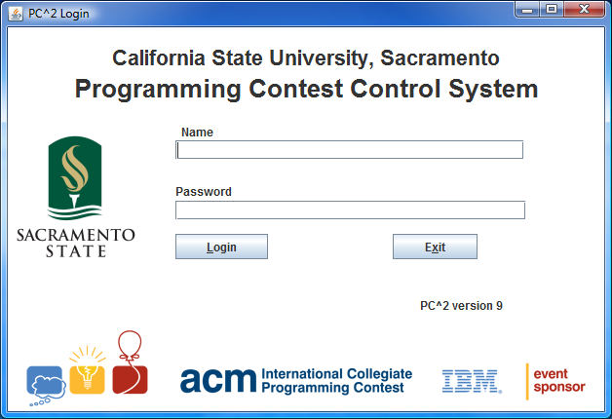

To login to PC², click once on the Name box on the login screen, enter your assigned team ID, press the TAB key or click on the Password box, then enter your assigned password. Your team ID will be of the form teamxx, where xx is your assigned team number (for example, “team3” or “team12”). After entering your team name and password, click on the Login button.

Submitting a Program to the Judges

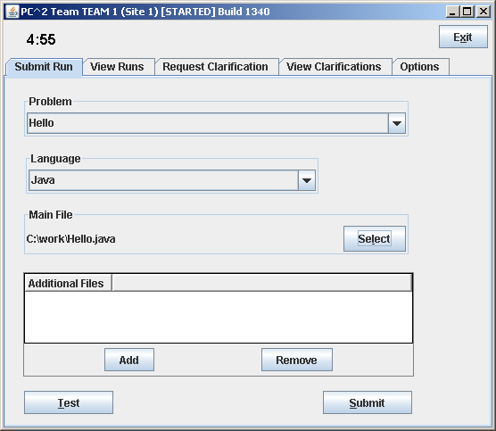
Once the system accepts your login, you will be at the PC² Main Menu screen, shown below. Note that the team ID and the team’s site location are displayed in the title bar, and the amount of time remaining in the contest is displayed below the title bar.

Clicking on the SUBMIT RUN tab near the top of the screen displays the run submission screen, which is shown above.
Clicking in the Problem box will display a drop-down list of the contest problems; choose the problem for which you wish to submit a program (called a “run”) to the Judges (in the example, a problem named “Hello” has been chosen).
Clicking in the Language box will display a list of the programming languages allowed in the contest; choose the language used by the program that you wish to submit to the Judges (in the example, “Java” has been chosen).
To submit a program to the Judges, you must specify the name of the file containing your main program. Click on the Select button to invoke a “File Dialog” which lets you locate and select your main file. The dialog lets you automatically navigate to the correct path and file location (in the example, the main program file “C:\work\Hello.java” has been selected). Select only source code files for submission to the Judges. Do not submit data files or executable files.
Test Runs
Once you have selected the problem, language, and file to be submitted to the Judges, you should click the Test button. This will make a “TEST RUN”, meaning it will compile and execute your program on your machine, using an environment as nearly identical to that of the Judges as possible (except that it will use your data file, not the Judge’s data file).
It is important to make a Test Run before submitting your program to the Judges. Just because your program runs the way you intend in the development environment in which you created it does NOT mean that it will necessarily run precisely the same way in the Judge’s environment. Making a Test Run will check this. Test Runs do not count against your score in the contest, but they may save you a lot of time and penalty points by identifying environment problems or differences before you submit the program to the Judges.
NOTE: prior to making a Test Run, you must insure that the data file for the program exists, in the same directory as the source code file.

Once you are satisfied with the results of your Test Run, click the Submit button. The confirmation dialog shown on the left below will appear; verify the data and then click YES to confirm the submission and send the run to the Judges.
When your run submission has been received by the Judges you will get a “Run Received” confirmation message as shown on the right below.
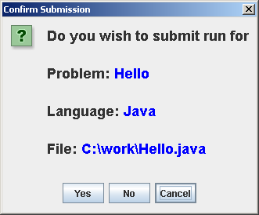
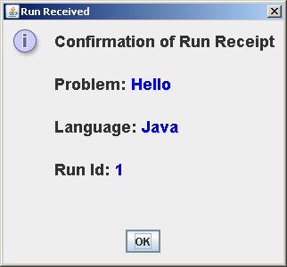

Run Results
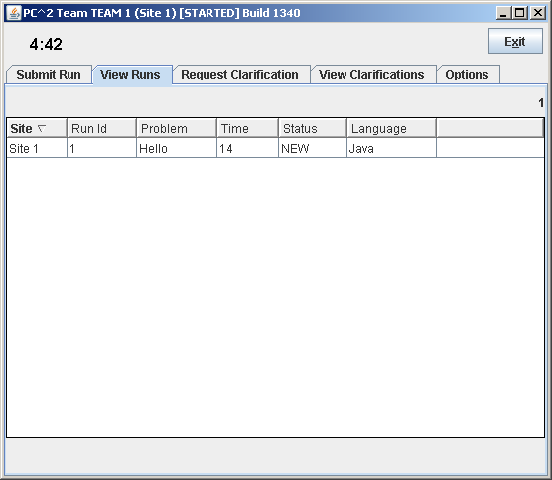
To see the status of runs you have submitted, click the VIEW RUNS tab. This will display a screen similar to the one shown below.
When a run is first submitted, the “Status” will be NEW, as shown above. The columns on the VIEW RUNS display can be resized by clicking in the column header margin and sliding the margin left or right. The Runs display can be sorted based on any column by clicking in the desired column header. Clicking again in the column header will toggle the sort between ascending and descending order.
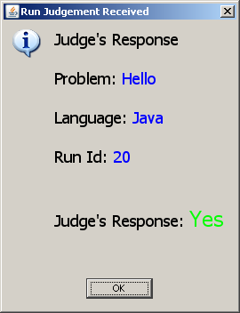
When the Judges finish judging your submitted program, a Judge’s Response message similar to the one shown below will pop up (provided that PC² is still running on your machine):
The Judge’s Response message identifies the submission and includes an indication of whether the submitted program correctly solved the problem or not. The “Status” field on the VIEW RUNS grid will also change to reflect the Judge’s response.

Contest problems are sometimes configured to support what is called preliminary judging, which means that the system will return an automated preliminary response immediately following a submission for that problem.
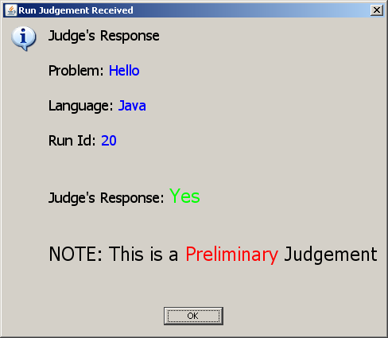
Preliminary responses represent the system’s “best estimate” of what the judges are likely to return for the problem. If a run is submitted for a problem which is configured for preliminary judging, then a “preliminary judgment” message similar to the one shown below will pop up very shortly after the run is submitted (assuming PC² is still running on your machine):

Note that while preliminary responses are intended to help teams by providing rapid feedback, they are not official results. The judges may later return an official Judge’s Response with either the same or a different result.

Clarification Requests
If you feel that one of the Contest problem statements is ambiguous, you may submit a “clarification request” to the Judges. To submit a clarification request, click the Request Clarification tab near the top of the Main screen. This will bring up a display similar to the following:
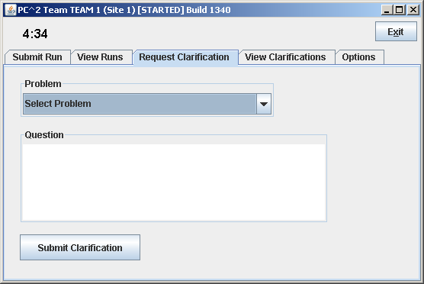
Click the “Problem” box and select the problem for which you are submitting a clarification request, type your question in the text box in the center, and click the “Submit Clarification” button.
Note that while the Judges in a contest will consider requests for clarification of ambiguities in a problem statement, they will not normally respond to other types of questions. If you submit a “clarification request” which asks about something which the Judges feel is adequately covered in the problem statement, they may simply respond to your clarification request with an answer such as “No Response – Read the Problem Statement”.
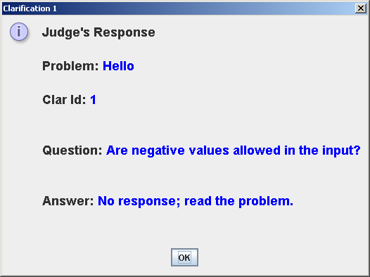
When the Judges respond to your submitted clarification request, a “Judge’s Response” message similar to the one shown on the right will pop up on your screen (provided that PC² is still running on your machine).

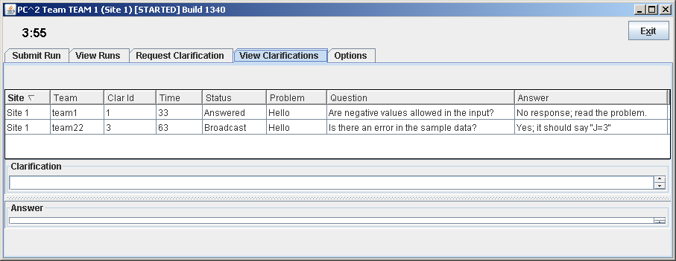
To go back at a later time and view the Judge’s responses to previous clarification requests, click the VIEW CLARIFICATIONS tab. This will display a screen similar to the one shown below. Note that the grid displays not only clarification requests/responses for your team, but also any “broadcast” clarifications from the Judges. It is your team’s responsibility to check the Clarifications grid periodically for any such broadcast clarifications from the Judges.
The columns in the display grid can be resized and sorted in the same way as previously described for the Runs display. If a clarification request or corresponding answer text is too long to be easily viewed in the grid, simply click on the grid row containing the clarification request; the clarification request and corresponding answer will be displayed in the boxes below the grid.
Exiting PC²
The Exit button logs your team out and shuts down PC² on your machine. This does not affect the status of runs or clarification requests previously submitted, and any Run or Clarification responses sent by the Judges while PC² is shut down will be viewable in the corresponding grids the next time you login. Note however that the dynamic “instant notification” messages which pop up on your screen to notify you of responses from the Judges will not appear unless you are logged in to PC².
Additional Note
Under some operating systems, when PC² is started there will be a “command window” in the background. This window may be “minimized”, but it must not be closed. Closing the command window will terminate PC².

Note: the Contest Administrator has a mechanism which allows suppression of Judge’s Response messages and the display of run status near the end of a contest; you will only be able to see the status of runs which were submitted prior to the suppression time determined by the Contest Administrator. Check with your Contest Administrator to determine what suppression time, if any, is being enforced.
Check with the Contest Administrator to determine which problems, if any, have been configured for preliminary judging.

