SMART CAMPUS ENERGY ANALYTICS
AND ANOMALY DETECTION USING IoT AND MACHINE LEARNING
PROJECT REPORT
BACHELOR OF ENGINEERING
Department of Electronics and Communication Engineering
Academic Year 2026–2027
Presented by : C Pratham

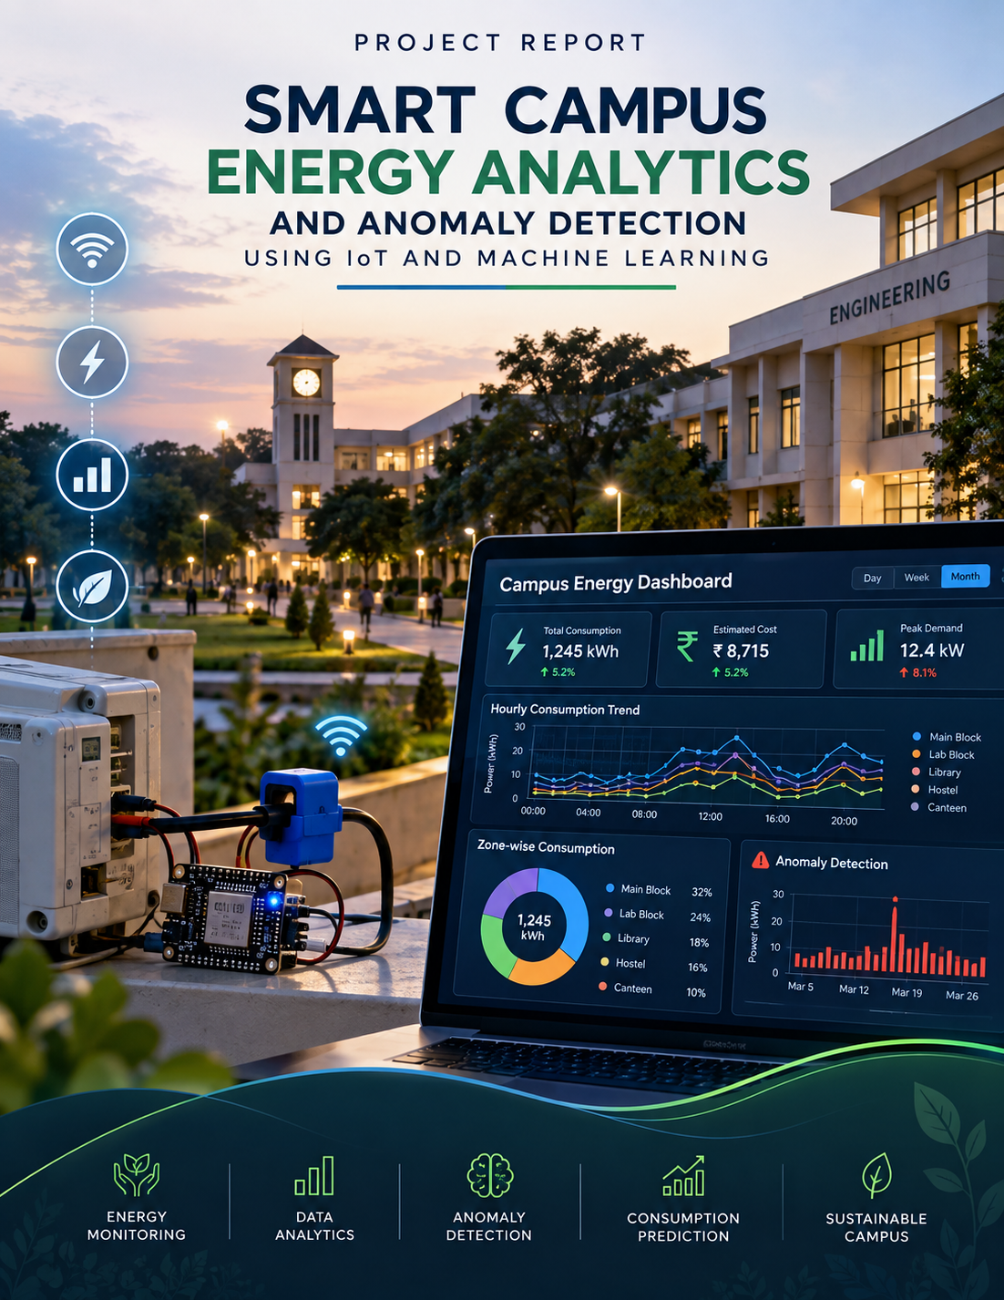

ABSTRACT
Electricity consumption in educational institutions varies significantly with laboratory activity, occupancy, working hours, weather, and equipment usage. Manual monitoring makes it difficult to identify unusual consumption patterns and quantify avoidable energy use. This project presents a Smart Campus Energy Analytics and Anomaly Detection System that combines IoT-ready energy measurement, data analytics, machine learning, and dashboard visualization.
The prototype uses a 90-day hourly dataset covering five campus zones. Python and Pandas are used for data preparation and exploratory analysis. Isolation Forest is used to identify abnormal consumption observations, while Random Forest Regression is used to estimate energy consumption from contextual variables such as hour, temperature, occupancy, day of week, and month. Power BI can be used to convert the processed data into an interactive dashboard.
The system is designed as a practical, low-cost project: the current report uses simulated data for repeatable testing, while the same CSV schema can later be populated from an ESP32 and energy-meter sensor. The output helps users understand consumption trends, high-use zones, estimated electricity cost, and unusual events.

TABLE OF CONTENTS
1. Introduction
2. Problem Statement
3. Objectives
4. Existing System
5. Proposed System
6. System Architecture
7. Hardware and Software Requirements
8. Methodology
9. Dataset Description
10. Data Preprocessing
11. Exploratory Data Analysis
12. Anomaly Detection
13. Energy Prediction
14. Power BI Dashboard Design
15. Results and Discussion
16. Advantages and Limitations
17. Future Scope
18. Conclusion
19. References

1. INTRODUCTION
Energy management is an important operational problem in large buildings because consumption changes throughout the day. Laboratories, computer rooms, libraries, workshops and administrative areas have different usage profiles. A simple monthly electricity bill provides the total cost but does not show where, when or why unusual consumption occurred.
Data analytics provides a way to convert raw meter readings into useful information. By combining time-series analysis, statistical summaries, anomaly detection and predictive modelling, an institution can identify recurring patterns and investigate unexpected events.
This project proposes a campus-scale analytics pipeline. Energy readings are treated as time-stamped observations associated with a campus zone. The pipeline cleans the data, calculates key performance indicators, detects abnormal observations and produces visual summaries suitable for decision-making.

2. PROBLEM STATEMENT
Campus electricity consumption is often monitored mainly through periodic meter readings or utility bills. Such monitoring has limited visibility into hourly behaviour and makes it difficult to identify abnormal events quickly.
The project addresses the following problem: how can hourly energy data from multiple campus zones be transformed into a practical analytics system that can identify high-consumption periods, estimate cost, detect unusual consumption and predict expected usage?

3. OBJECTIVES
• Collect or simulate time-stamped energy data for multiple campus zones.
• Clean and structure the data for analysis.
• Identify daily, hourly and zone-wise consumption patterns.
• Estimate electricity cost from energy consumption.
• Detect abnormal energy readings using an unsupervised machine-learning method.
• Build a predictive model for energy consumption.
• Prepare data for an interactive Power BI dashboard.
• Design the system so that simulated data can later be replaced with live ESP32 sensor data.

4. EXISTING SYSTEM
Traditional approaches commonly depend on utility bills, manual meter readings, spreadsheets or isolated monitoring devices. These approaches can provide aggregate consumption but may not provide continuous zone-level analytics. Manual inspection also makes it difficult to detect subtle deviations from normal behaviour.
The proposed approach extends basic monitoring with a structured data pipeline, analytics and machine-learning components.

5. PROPOSED SYSTEM
The proposed system contains five logical layers: sensing/data generation, storage, preprocessing, analytics/ML, and visualization. In a physical prototype, an ESP32 reads an energy meter and sends readings through Wi-Fi. For this academic implementation, a realistic synthetic dataset is provided so the complete analytics pipeline can be demonstrated without waiting for long-term sensor collection.
The analytics layer calculates consumption and cost indicators, while Isolation Forest flags observations that differ strongly from normal patterns. A Random Forest model estimates expected consumption from contextual variables. The dashboard layer presents the results through charts and KPIs.

6. SYSTEM ARCHITECTURE
The overall flow is:
Energy Meter / Synthetic Data → ESP32 or CSV → Data Storage → Python/Pandas → Data Cleaning → Exploratory Analytics → Anomaly Detection + Prediction → Power BI Dashboard → User/Facility Team.
For a physical prototype, the energy meter can be connected to an ESP32. The ESP32 transmits readings using Wi-Fi. A database or cloud endpoint can store readings. The Python pipeline can periodically retrieve the data and update the dashboard dataset.

7. HARDWARE AND SOFTWARE REQUIREMENTS
Hardware:
• ESP32 development board
• PZEM-004T or equivalent energy-monitoring module
• AC load/test load appropriate for the laboratory environment
• Wi-Fi connection
• Optional OLED/LCD display
• Breadboard, connectors and regulated power supply as required
Software:
• Python 3.x
• Pandas
• NumPy
• Matplotlib
• Scikit-learn
• Microsoft Power BI Desktop
• Arduino IDE or PlatformIO for ESP32 programming

8. METHODOLOGY
Step 1: Define zones and measurement variables.
Step 2: Collect live readings or generate a controlled prototype dataset.
Step 3: Store timestamp, zone, energy, temperature and occupancy-related variables.
Step 4: Clean missing, duplicate and inconsistent records.
Step 5: Perform exploratory data analysis.
Step 6: Calculate zone-wise energy and cost.
Step 7: Apply Isolation Forest to detect unusual observations.
Step 8: Train a Random Forest regression model for energy prediction.
Step 9: Export summary tables for Power BI.
Step 10: Interpret trends and investigate abnormal events.

9. DATASET DESCRIPTION
The supplied dataset contains 10,800 hourly records across 5 campus zones over 90 days. The zones are ECE Lab, Computer Lab, Library, Administrative Block and Workshop.
Important columns:
• Date – calendar date.
• Hour – hour of day from 0 to 23.
• Zone – campus area.
• Temperature_C – simulated ambient temperature.
• Occupancy – simulated occupancy indicator.
• Energy_kWh – hourly energy consumption.
• Injected_Anomaly – known anomaly marker used only for evaluating the demonstration data.
• DayOfWeek / Month / IsWeekend – derived time features.
• Estimated_Cost_INR – Energy_kWh multiplied by an assumed ₹8.50/kWh demonstration tariff.
The synthetic data intentionally contains a small number of high-consumption events so the anomaly-detection workflow can be demonstrated.

10. DATA PREPROCESSING
The first stage converts dates into useful time features. Day-of-week and month numbers are derived from the date. A weekend flag is generated to distinguish typical working days from weekends.
Numerical variables are checked for missing values and unreasonable readings. For a live implementation, duplicate timestamps, sensor dropouts, communication failures and sudden impossible readings should be handled using validation rules before analysis.

11. EXPLORATORY DATA ANALYSIS
Exploratory analysis is used to answer practical questions: Which zone consumes the most energy? What time of day has the highest average consumption? How does consumption vary from day to day? Which zones contribute most to estimated cost?
The following charts were generated from the prototype dataset.
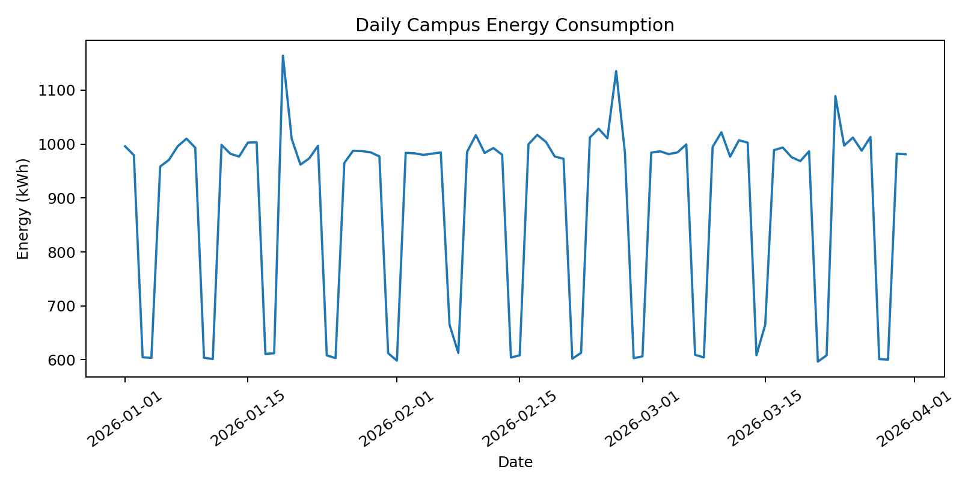
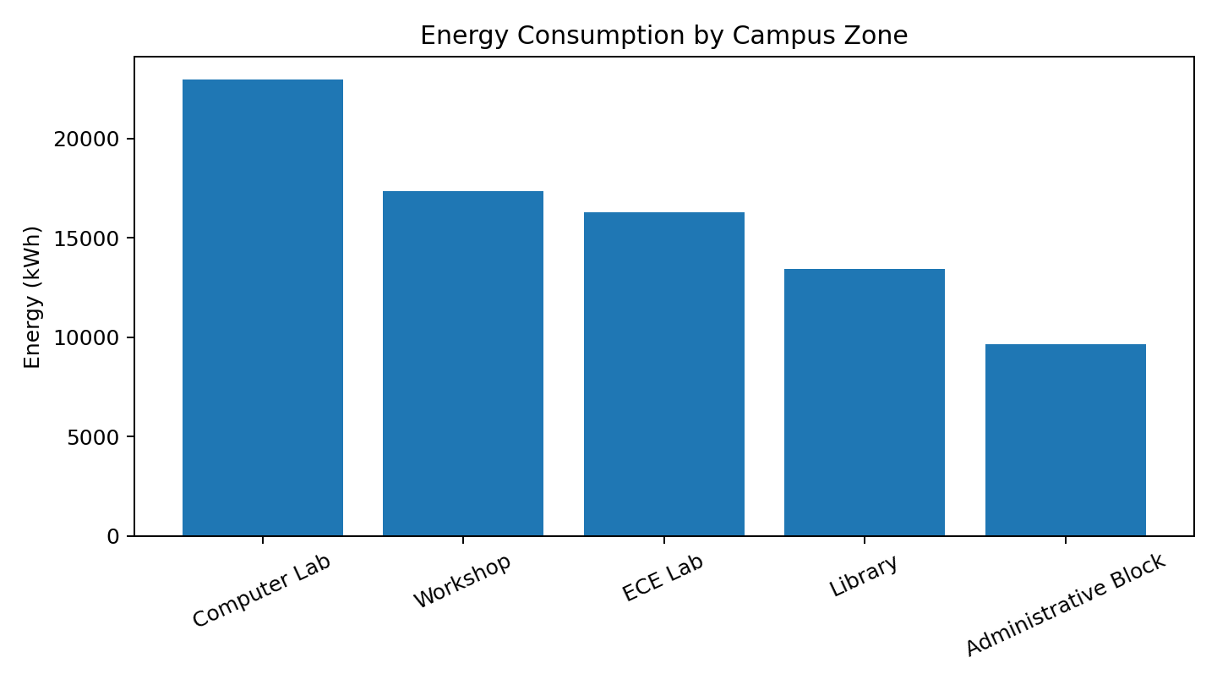
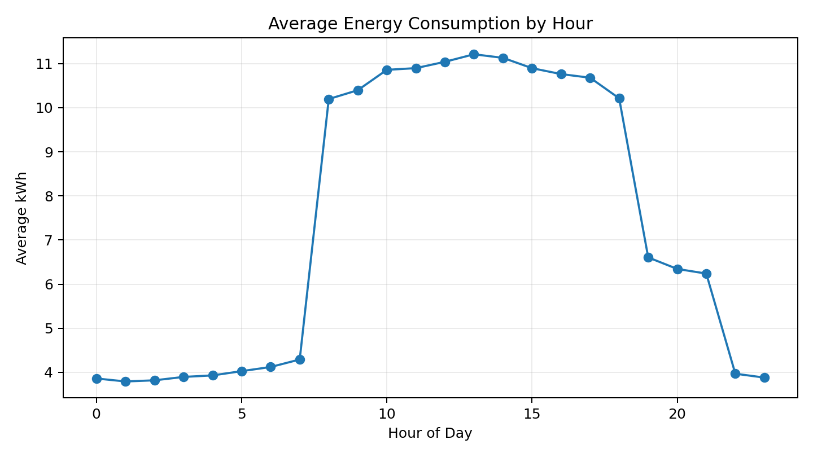
Figure 11.1–11.3: Prototype consumption trends and zone comparison.

12. ANOMALY DETECTION
Isolation Forest is an unsupervised machine-learning technique suitable for identifying observations that are relatively isolated from the normal data distribution. The demonstration model uses Energy_kWh, Temperature_C, Occupancy and Hour as input features.
In a real campus deployment, an anomaly should not automatically be interpreted as equipment failure. It is an investigation signal. For example, a laboratory may legitimately consume more electricity during a practical session. The dashboard should therefore display the time, zone and context so the user can verify the event.
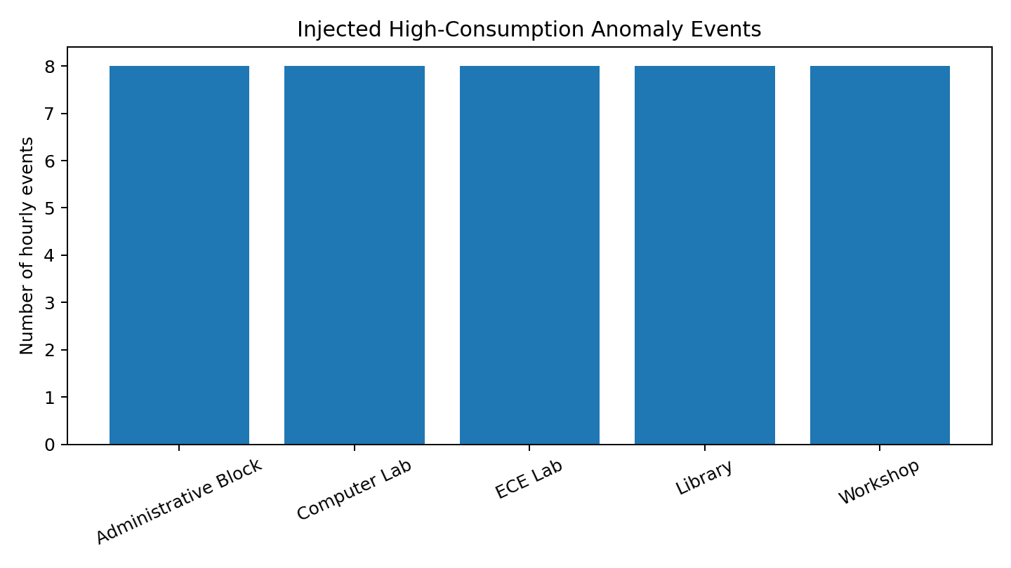
Figure 12.1: Demonstration anomaly events included in the synthetic dataset.

13. ENERGY PREDICTION
A Random Forest Regression model is used to estimate energy consumption from hour, temperature, occupancy, day-of-week and month features. The dataset is divided into training and test subsets.
The evaluation metrics are Mean Absolute Error (MAE), Root Mean Squared Error (RMSE) and R². These metrics describe how closely the model's predictions match the test observations. In a production system, a chronological time-based split would be preferable to a random split because future data should not influence training.

14. POWER BI DASHBOARD DESIGN
Recommended dashboard pages:
Page 1 – Campus Overview:
• Total energy consumption
• Estimated electricity cost
• Average hourly consumption
• Total anomaly events
Page 2 – Zone Analysis:
• Zone-wise energy bar chart
• Zone-wise cost
• Average occupancy
• Zone filter/slicer
Page 3 – Time Analysis:
• Daily consumption trend
• Hourly consumption profile
• Weekday vs weekend comparison
Page 4 – Anomaly Monitor:
• Date and time
• Zone
• Observed energy
• Context variables
• Anomaly flag
Page 5 – Prediction:
• Actual vs predicted consumption
• Model error metrics
• Feature importance

15. RESULTS AND DISCUSSION
The prototype demonstrates that the same dataset can support descriptive analytics, anomaly detection and prediction. The zone summary shows differences in consumption between campus areas, while the hourly analysis reveals the effect of operating hours.
The anomaly experiment contains deliberately injected high-consumption events. This gives the student a known set of events against which the anomaly-detection workflow can be inspected. In a live system, the injected marker would not exist; the model would identify candidate anomalies and a human operator would investigate them.
For the prediction model, the report intentionally avoids presenting a fabricated accuracy claim. When the supplied Python script is executed, it prints MAE, RMSE and R² generated from the actual run.
Zone | Total kWh | Estimated Cost (₹) | Avg Occupancy
Computer Lab | 22958.4 | 195,146.08 | 23.8
Workshop | 17357.9 | 147,542.00 | 24.1
ECE Lab | 16276.3 | 138,348.33 | 24.2
Library | 13445.0 | 114,282.62 | 24.2
Administrative Block | 9632.5 | 81,876.28 | 24.1
Table 15.1: Zone-wise prototype summary.

16. ADVANTAGES AND LIMITATIONS
Advantages:
• Practical and easy to demonstrate.
• Combines IoT, analytics, ML and visualization.
• Can start with simulated data and later use live sensors.
• Produces clear charts and KPIs.
• Suitable for data-analytics-oriented interviews.
Limitations:
• The current dataset is simulated rather than collected from an actual campus.
• Energy tariffs can vary by institution and time.
• Occupancy is simulated in the prototype.
• Anomaly detection requires contextual interpretation.
• A production deployment would need secure communication, reliable storage and sensor calibration.

17. FUTURE SCOPE
Future work can connect multiple ESP32 nodes to a central database, add real-time alerts, integrate weather data, forecast demand using time-series models, estimate carbon emissions, compare buildings using normalized metrics, and create automated maintenance tickets for persistent anomalies. The project can also be extended to solar generation and battery-storage analytics.

18. CONCLUSION
The Smart Campus Energy Analytics and Anomaly Detection System provides a practical framework for converting energy readings into actionable information. The prototype demonstrates data preparation, exploratory analysis, anomaly detection, prediction and dashboard design in one integrated project.
The main strength of the architecture is that it does not depend on the simulated dataset. The same schema and Python pipeline can accept real energy-meter readings when an IoT prototype is connected. This makes the project suitable for an academic demonstration while leaving a clear path toward a real deployment.

19. REFERENCES
1. Pedregosa, F. et al., “Scikit-learn: Machine Learning in Python,” Journal of Machine Learning Research, 2011.
2. McKinney, W., Python for Data Analysis, O’Reilly Media.
3. Microsoft Power BI documentation, Power BI Desktop and data visualization documentation.
4. ESP32 technical documentation, Espressif Systems.
5. PZEM-series energy monitoring module documentation.
6. Official Python, Pandas, NumPy, Matplotlib and scikit-learn documentation.

20. POWER BI DASHBOARD AND REAL-TIME OUTPUT
The following dashboard mock-up is designed to match the proposed Power BI implementation. It uses the project dataset and demonstrates the exact types of visuals, KPIs and monitoring indicators that can be recreated in Power BI Desktop.

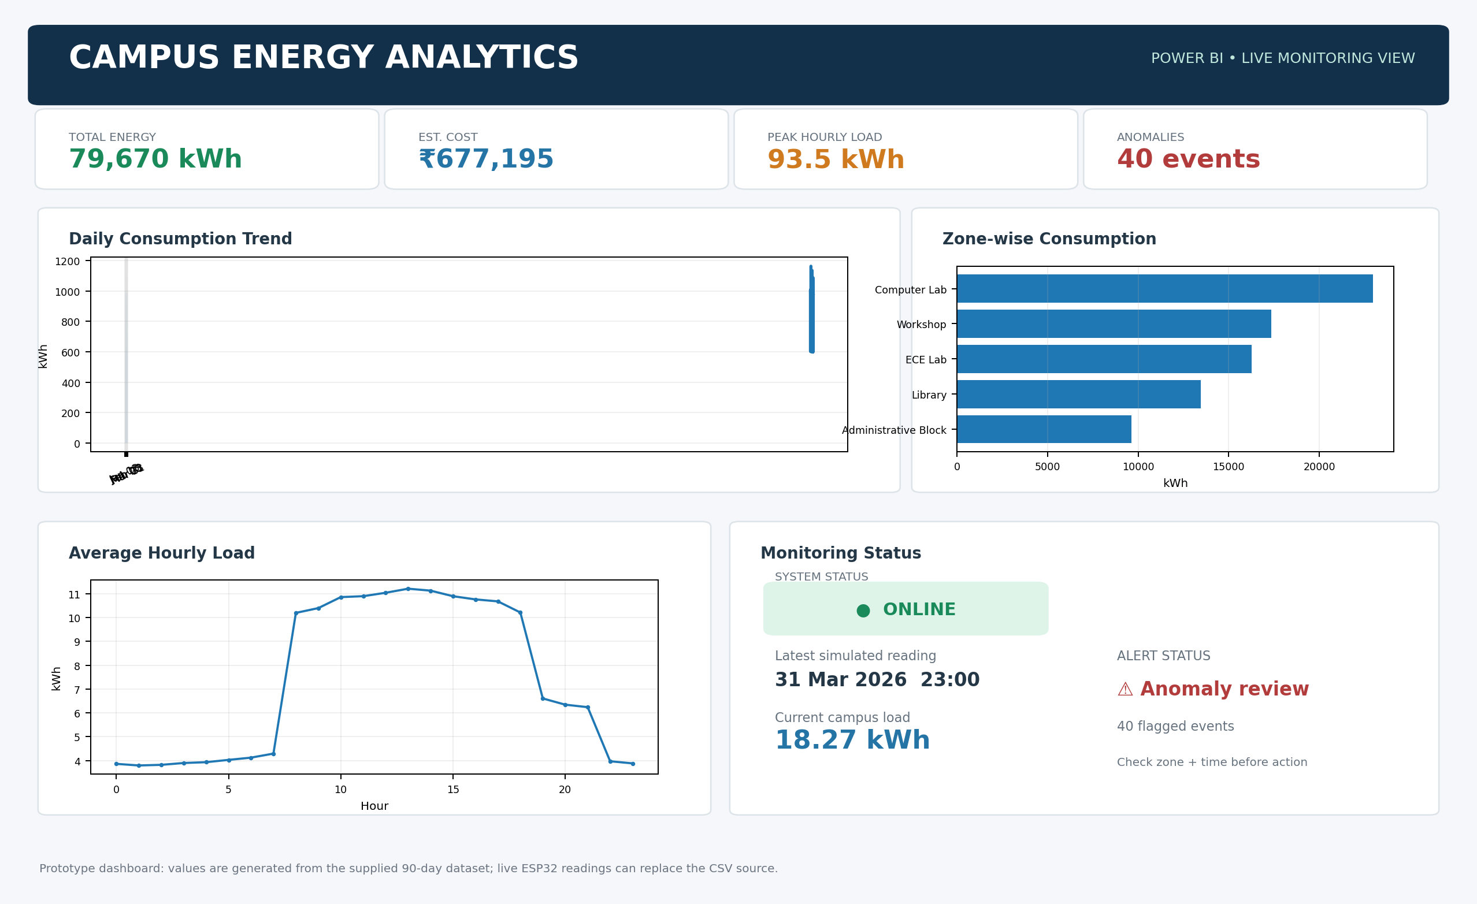
Figure 20.1: Power BI-style campus energy analytics dashboard using the project dataset.
The dashboard contains four KPI cards, a daily consumption trend, zone-wise consumption, an hourly load profile, and a monitoring-status panel. In the final implementation, Power BI can refresh the dataset from a database or streaming source connected to the ESP32 energy meter.

20.1 Real-Time Objects / Project Outputs
The project output is not limited to graphs. The monitoring interface exposes practical real-time objects: current campus load, estimated cost, expected load, system status, zone-level readings, occupancy, temperature, anomaly flags and the latest update timestamp.
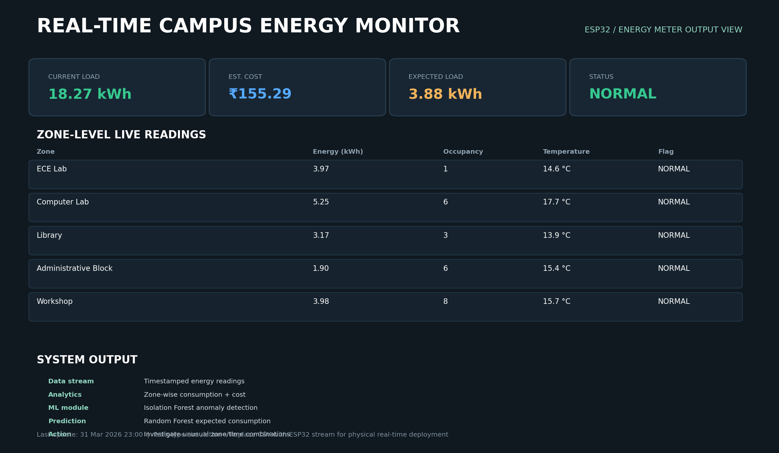
Figure 20.2: Real-time monitoring/output screen. Values shown are the latest record in the prototype dataset.

20.2 Main Real-Time Objects
Object | Example Output | Purpose
Current Load | 18.27 kWh | Shows the latest campus energy reading.
Estimated Cost | ₹155.29 | Converts energy into an illustrative cost.
Expected Load | 3.88 kWh | Compares current behaviour with expected hourly usage.
Zone Reading | Computer Lab: 5.25 kWh | Identifies the current highest zone reading.
Anomaly Status | NORMAL | Highlights readings requiring investigation.
Timestamp | 31 Mar 2026 23:00 | Shows data freshness.

APPENDIX A – PYTHON IMPLEMENTATION
The complete executable Python script is supplied separately as smart_campus_energy_analysis.py. The main pipeline is reproduced below for reference.
# Smart Campus Energy Analytics and Anomaly Detection
# Run: pip install pandas numpy matplotlib scikit-learn
import pandas as pd
import numpy as np
from sklearn.ensemble import RandomForestRegressor, IsolationForest
from sklearn.model_selection import train_test_split
from sklearn.metrics import mean_absolute_error, mean_squared_error, r2_score
import matplotlib.pyplot as plt

df = pd.read_csv("smart_campus_energy_dataset.csv", parse_dates=["Date"])
df["DayOfWeekNum"] = df["Date"].dt.dayofweek
df["MonthNum"] = df["Date"].dt.month
df["IsWeekend"] = (df["DayOfWeekNum"] >= 5).astype(int)

# ---------------- EDA ----------------
print("\nTop energy-consuming zones:")
print(df.groupby("Zone")["Energy_kWh"].sum().sort_values(ascending=False))

print("\nAverage consumption by hour:")
print(df.groupby("Hour")["Energy_kWh"].mean().round(2))

# ---------------- Anomaly Detection ----------------
features = ["Energy_kWh", "Temperature_C", "Occupancy", "Hour"]
iso = IsolationForest(contamination=0.01, random_state=42)
df["Anomaly_Flag"] = iso.fit_predict(df[features])
df["Anomaly_Flag"] = df["Anomaly_Flag"].map({1:0, -1:1})

print("\nDetected anomalies:")
print(df[df["Anomaly_Flag"] == 1][["Date","Hour","Zone","Energy_kWh"]].head(20))

# ---------------- Prediction ----------------
# For a simple academic demo, predict energy from contextual features.
X = df[["Hour","Temperature_C","Occupancy","DayOfWeekNum","MonthNum","IsWeekend"]]
y = df["Energy_kWh"]
X_train, X_test, y_train, y_test = train_test_split(
X, y, test_size=0.2, random_state=42
)
model = RandomForestRegressor(n_estimators=150, random_state=42)
model.fit(X_train, y_train)
pred = model.predict(X_test)

mae = mean_absolute_error(y_test, pred)
rmse = np.sqrt(mean_squared_error(y_test, pred))
r2 = r2_score(y_test, pred)

print(f"\nPrediction MAE : {mae:.2f} kWh")
print(f"Prediction RMSE: {rmse:.2f} kWh")
print(f"Prediction R2 : {r2:.3f}")

# ---------------- Dashboard-ready summary ----------------
summary = df.groupby("Zone").agg(
Total_Energy_kWh=("Energy_kWh","sum"),
Avg_Energy_kWh=("Energy_kWh","mean"),
Estimated_Cost_INR=("Estimated_Cost_INR","sum"),
Avg_Occupancy=("Occupancy","mean")
).sort_values("Total_Energy_kWh", ascending=False)

summary.to_csv("zone_summary_for_powerbi.csv")
print("\nSaved zone_summary_for_powerbi.csv")

