**POC-8**

ABDUR RAHMAN .M.R

2ND YEAR CSE

Host your HTML website on the internet using **GitHub Pages**

**Step 1: Create a GitHub Repository**



**Step 2: Upload Your HTML Files**

**Upload via GitHub Website**

1. Open your repository on GitHub.
2. Click **Add file → Upload files**.
3. Drag and drop your HTML, CSS, and JS files.
4. Click **Commit changes**.

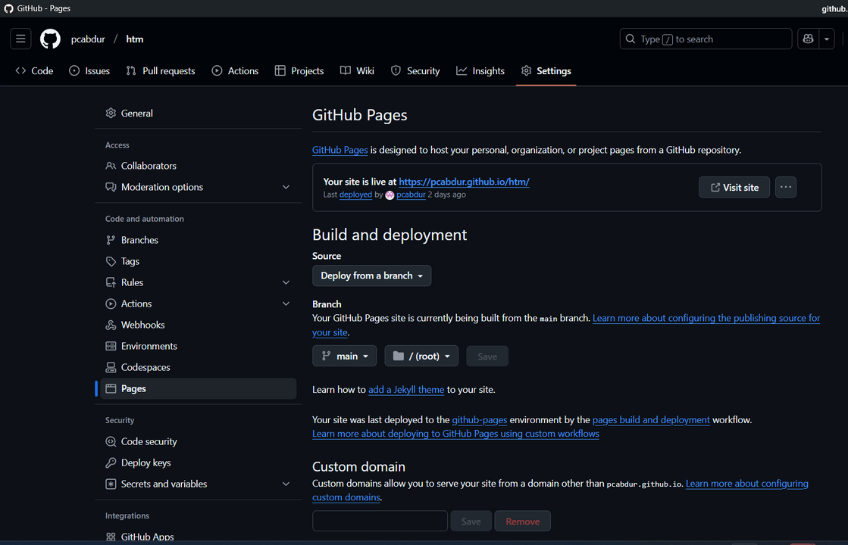

**Step 3: Enable GitHub Pages**

1. Go to your repository on GitHub.
2. Click **Settings** → **Pages** (left sidebar).
3. Under **Branch**, select main and click **Save**.

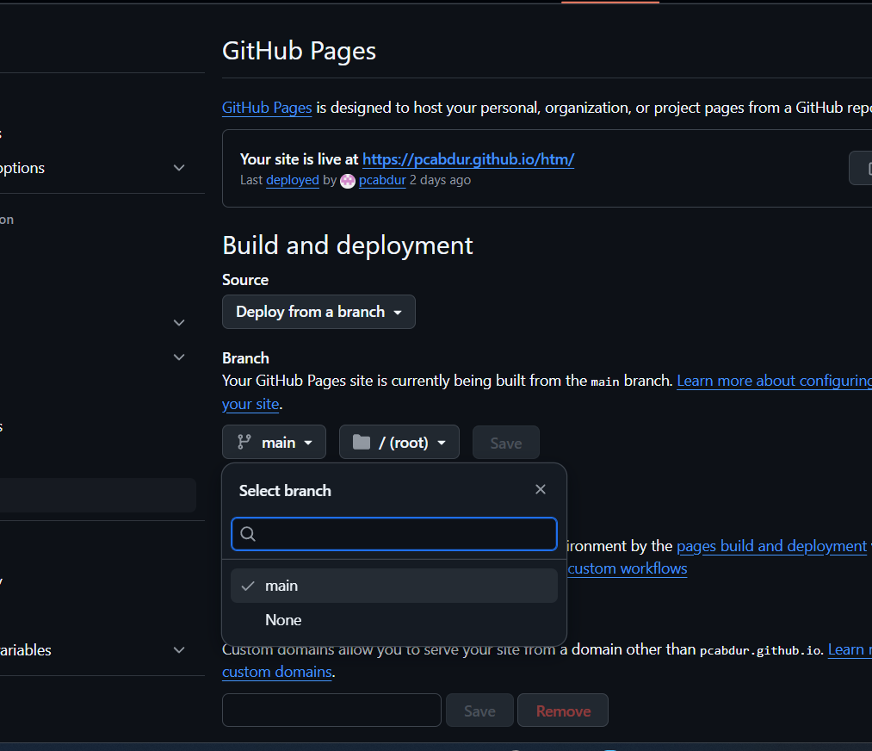

**Step 4: Test Your Website**

* Open the URL in your browser.

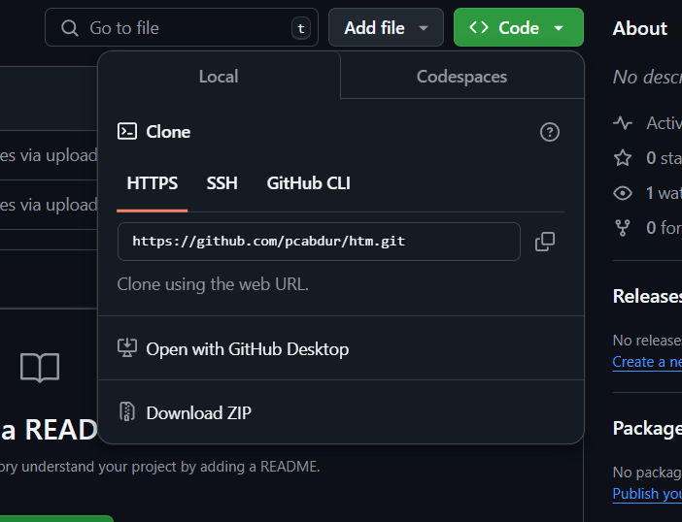

AFTER COPING THAT CHANGE IT LIKE <https://pcabdur.github.io/htm/>

