**POC-9**

**ABDUR RAHMAN .M.R**

**2ND YEAR CSE**

**Step 1: Log in to AWS Management Console**

**Step 2: Navigate to EC2**

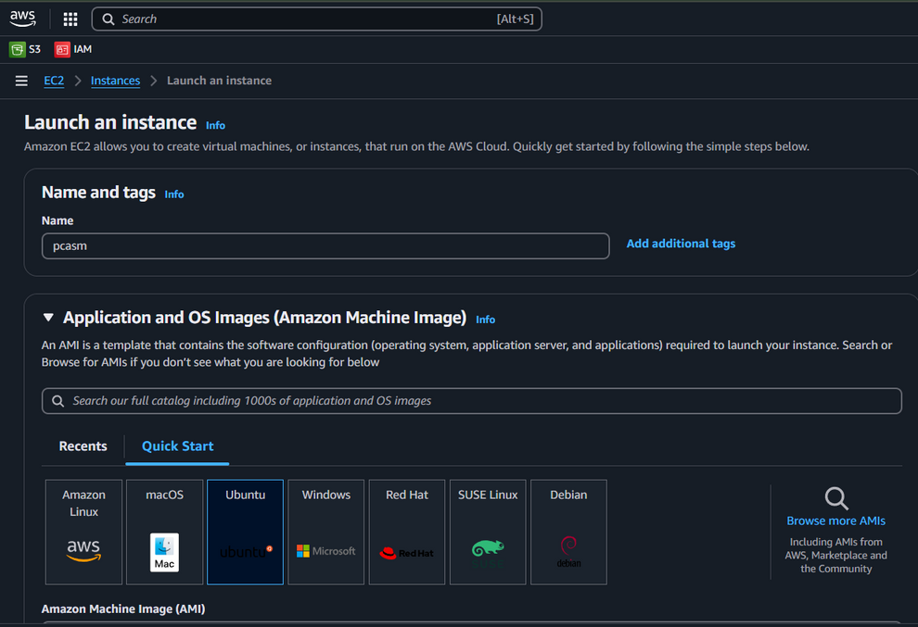

**Step 3: Launch Instance**

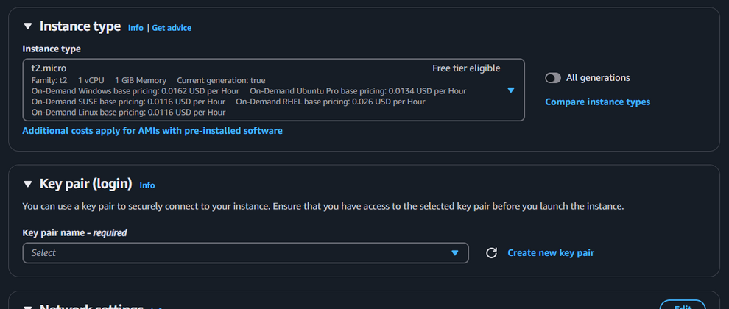

**Step 4: Choose an Instance Type**

**Step 5: Configure Instance**

**Step 6: Review Instance Configuration**

**Step 13: Connect to Your EC2 Instance**

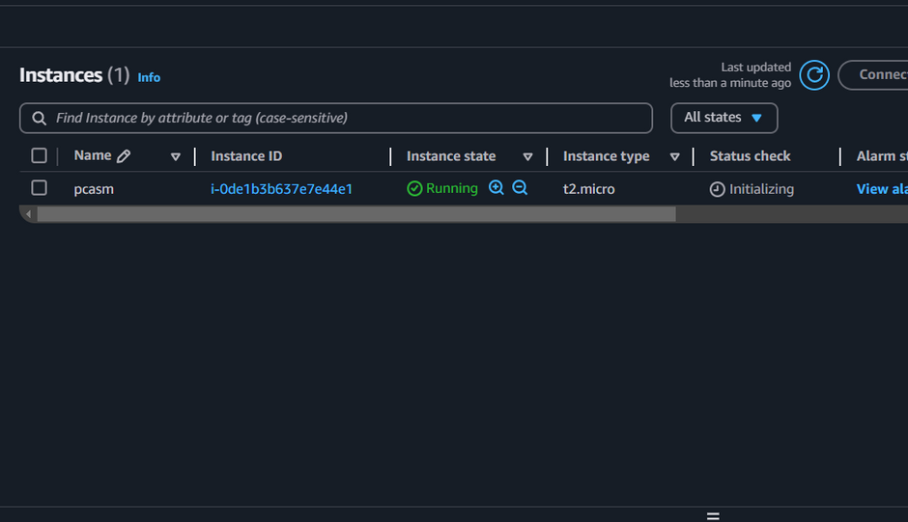

**THANK YOU !**