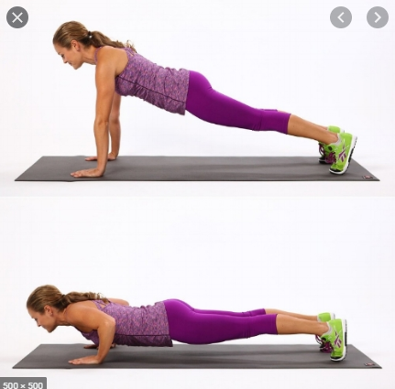**pushups**

Beginner: 25 Reps

Advanced: 50 Reps

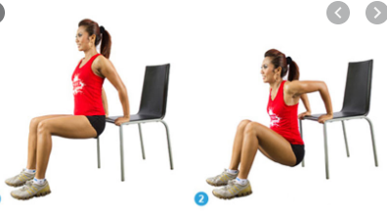**Dips Between Chairs**

Beginner: 20 Reps

Advanced: 50 Reps

**elastic band Row**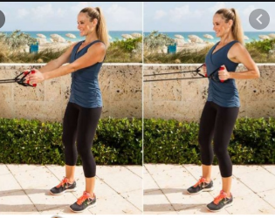

Beginner: 30 Reps

Advanced: 50 Reps

**Sit ups**

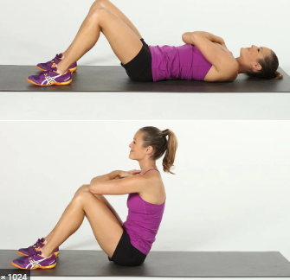Beginner: 30 Reps

Advanced: 100 Reps

**Bent-leg Raises crunch**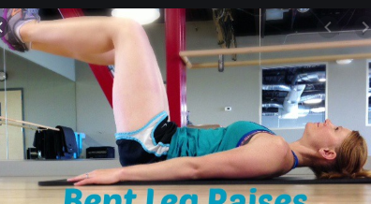

Beginner: 25 Reps

Advanced: 50 Reps

**Bent-Over Twists**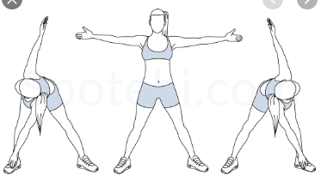

Beginner: 25 Reps

Advanced: 50 Reps

**Knee Bends (Squats)** 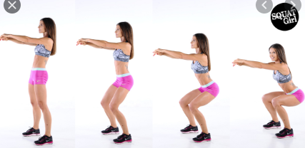

Beginner: 25 Reps

Advanced: 50 to 70 Reps

**Calf Raises** 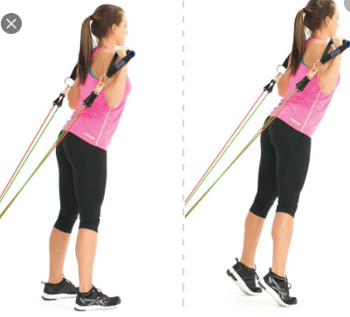Beginner: 25 Reps

Advanced: 50 Reps

**Chin ups** 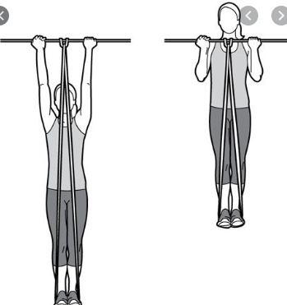

Beginner: 10 Reps

Advanced: 30 Reps