Notes on UEFI and Legacy-Bios troubleshooting

Booting a UEFI-capable system in legacy-bios mode is analogous to a traditional bios boot. The legacy-bios will look to the system mbr to provide bootloader information. Installation of MX is fully supported in legacy-bios mode, including installation of grub to the Master Boot Record (mbr). As long as all other OS's on the system are also installed in legacy-bios mode, then dual/multi booting should not be an issue.

1. Installing grub to the Efi System Partition (ESP) is technically possible when booting in legacy-bios mode. However, the kernel module efivars does not load in legacy-bios mode. Without that module, grub-install cannot update the system UEFI to tell it of the existence of the new bootloader. The efi files will copy to the ESP but the UEFI system will not know they are there.

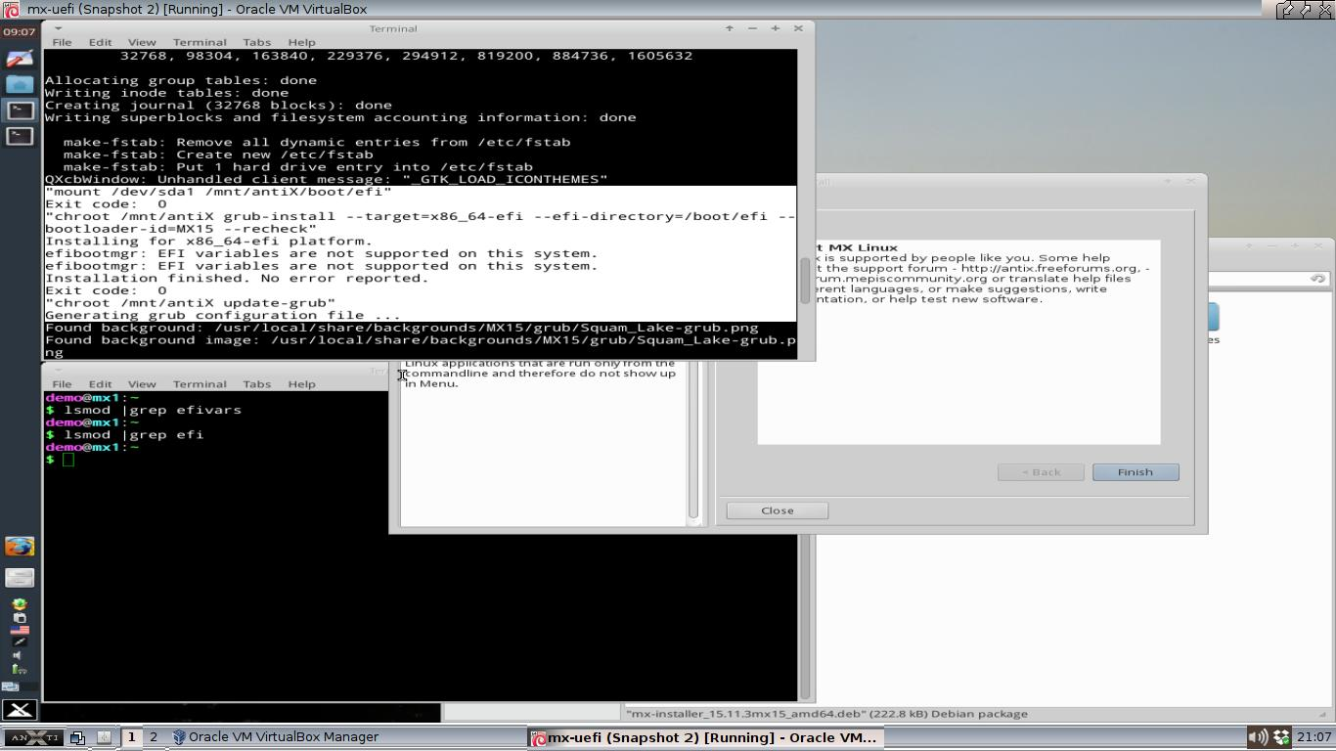

2. In addition, since grub was installed to the ESP and not the MBR (master boot record, the traditional location for a bios-based system), upon reboot even in legacy-bios mode, the system will not boot.

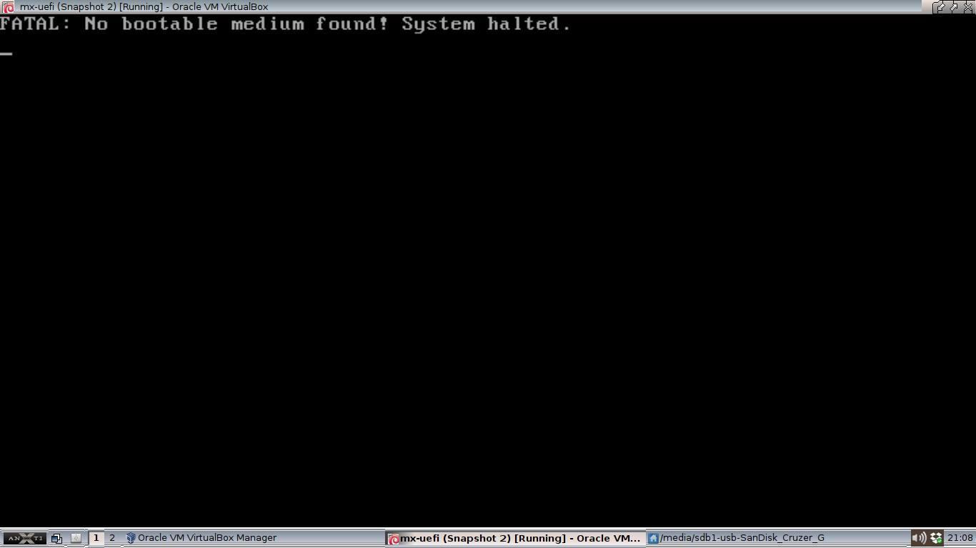

3. IF the system is set to UEFI mode, it may be possible to use the computer's own UEFI setup (sometimes still called bios setup by system manufacturers) to create a custom boot entry and allow the system to boot. This varies widely by system, and ranges from very easy to very difficult.

4. Switching between UEFI and legacy-bios mode may lead to previously installed systems being unable to boot. All OS's installed in a multi-boot configuration must use the same boot system (either legacy-bios or UEFI, but not mixed).

UEFI mode installation

1. The recommended method to install to UEFI system should be then to boot in UEFI mode first. Installing grub to the ESP will work as intended, including updating the UEFI system.

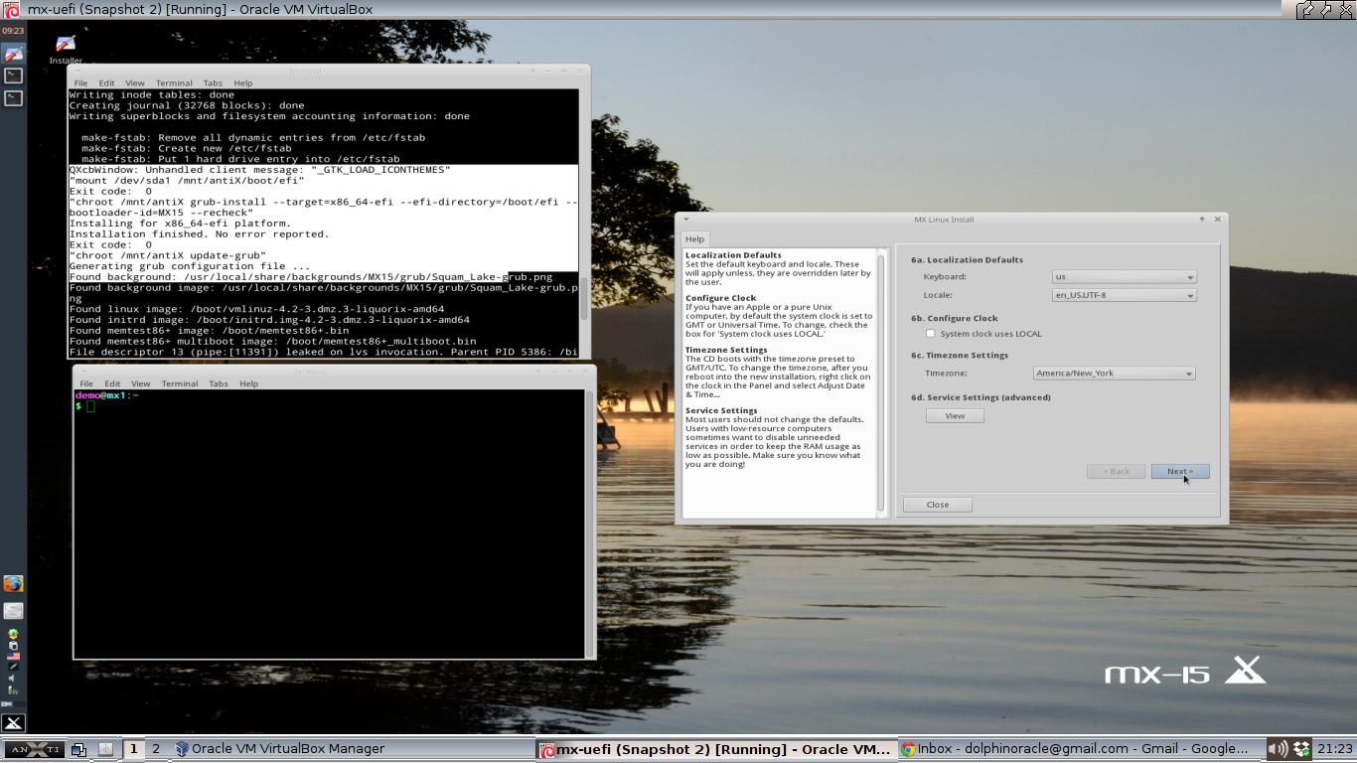
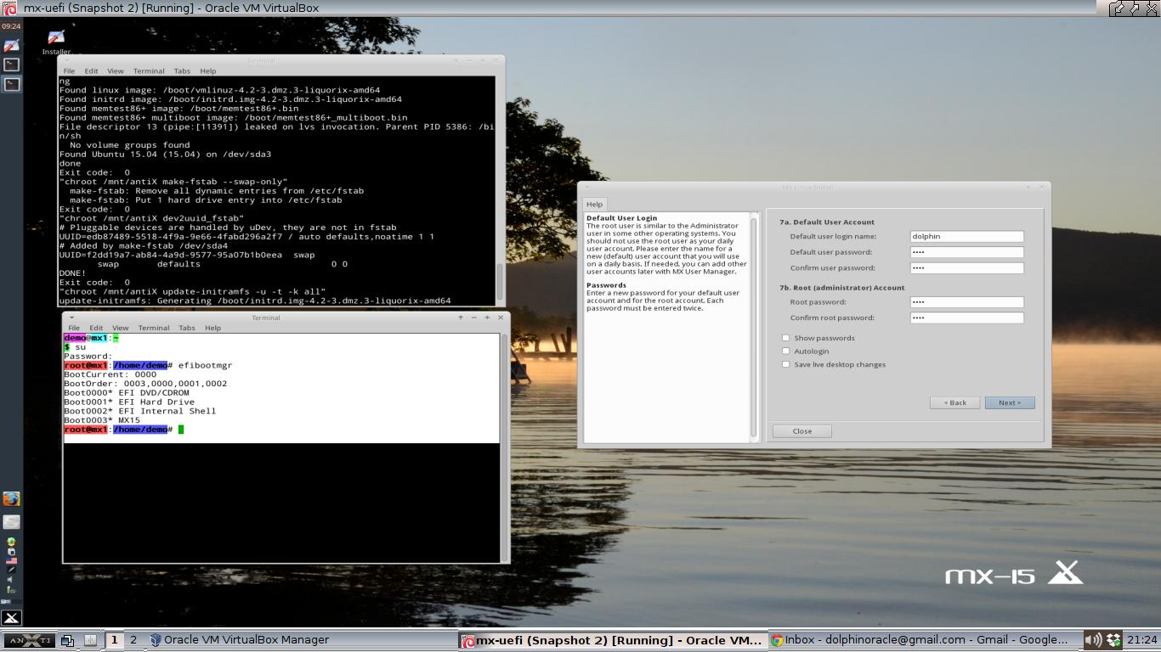
2. Once grub-install is complete, efibootmgr will report an updated boot option and boot order. Note in the screenshot below that Boot0003 MX15 now exists, and that in the boot order 0003 is first. Assuming the system UEFI is compliant with the UEFI standard, grub should take over bootloader duties upon reboot.

3. There may be some vendor-specific UEFI implementation issues. Some vendor UEFI's expect the bootloaders to be in \EFI\BOOT\ instead of \EFI\vendor\ . Others are hardcoded to look for the MS Windows bootloader files. Such UEFI implementations are problematic because the don't meet the UEFI specification.

So how do GPT and MSDOS partition table types fit into all this?

1. MSDOS partition tables are the traditional partition setup for personal computers (PCs). The MSDOS partition tables limit drives to 4 primary partitions, but a special Extended partition that contains other logical partitions may also be set up. Partition sizes are limited to 2TB on msdos partitions.

2. GPT partition tables allow much larger partition sizes, and are not limited to only 4 primary partitions.

3. Both MSDOS and GPT disks can be booted by legacy-bios systems. MSDOS disks use an Master Boot Record (MBR) for storing bootloader information. GPT disks also allow for legacy-bios boot through the use of a special “Protective” MBR. As such, as long as the user's PC/Bios can recognize a GPT disk, GPT disks can be used in the same manner as MSDOS disks and do not require a UEFI system.

4. GPT disks are more widely seen in systems supporting the UEFI system rather than traditional bios. Grub-install in a UEFI environment currently requires a GPT formated disk. The mx-installer will currently fail at grub-installation if a system boots in UEFI mode but the disk is an MSDOS partition tybe. Consequentially, the “auto install use whole disk” option in the installer should not be used with UEFI systems unless they are using a legacy-bios mode. For now, partitioning on UEFI systems must be done manually.

