Title:  Authors: | MVPDM software tool  Pablo Carballeira López, pcl@gti.ssr.upm.es  Jesús Gutiérrez Sánchez, Jesus.gutierrez@univ-nantes.fr  Narciso García Santos, narciso@gti.ssr.upm.es

Introduction
This contribution follows the work presented in previous contributions on subjective perception of SMV and FN content [1], and presents a GUI software tool that implements the MultiView Perceptual Disparity Model (MVPDM) [2].
The tool is still in a preliminary development phase, and any feedback or contributions for its development will be useful and very welcome. This document describes a basic user guide of the MVPDM tool and a list of future enhancements.
Currently, the MVPDM tool can be used to predict the perception of speed comfort and smoothness of view-sweep sequences created from SMV content, such as the ones used to evaluate the results of the CFE on FTV [3]. Furthermore, it can serve to design SMV camera arrangements, based on the perceptual predictions of the MVPDM. Future work will add more functionalities to it.

User guide
Figure 1 shows the main window of the MVPDM GUI tool. In the following we describe the usage of the MVPDM tool. The steps must be executed in the following order.
- Initialization:
- Configure MVDPM parameters (currently the tool only works for alpha=1.5 and beta=-0.6) and scene parameters: Znear, Zfar, camera parameter file, camera ID and depth map file of the camera at located at the cameraID position. It is recommended that cameraID corresponds to a central camera.
- Press Create MVPDM to update the update the parameters.
- Perceptual disparity:
- Press Compute d_perc to compute the perceptual disparity.
- View sweep tests:
- Configure number of cameras, frame rate and fpv (frames per view) of the view-sweep sequence.
- Press Compute MVPDM to obtain VR, VSS and VD values.
- Press Compute prediction to obtain a prediction on the speed comfort and smoothness for the corresponding view-sweep sequence.
- SMV design:
- Press Design Linear SMV for linear arrangements or Design Arc SMV for arc arrangements. The result indicates the maximum baseline (in the units of the camera parameter file) or arc (radians) for the SMV arrangement for a comfortable view-sweep, according to the MVPDM model
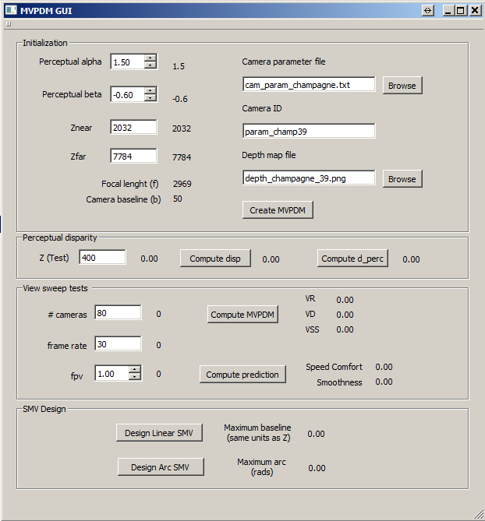
Figure 1 MVPDM GUI main window

Future developments
Future enhancements to the MVPDM tool will include:
- Enable depth sequences as input (currently only one depth frame is enabled).
- Update the tool to work with parameters different than alpha =1.5, beta = 0.6.
- Enable higher precision for the SMV design function.
- Design of FN view paths based on the MVPDM predictions.

References
- P. Carballeira, J. Gutiérrez, F. Morán, N. García, “SMV/FN subjective assessment: MultiView Perceptual Disparity Model,” contrib. M38063, 114th MPEG meeting, San Diego, US, Feb. 2016.
- P. Carballeira, J. Gutiérrez, F. Morán, J. Cabrera, F. Jaureguizar, N. García, “Multiview Perceptual Disparity Model for Super Multiview Video” IEEE Journal of Selected Topics in Signal Processing, Special Issue on Measuring Quality of Experience for Advanced Media Technologies and Services, (accepted and scheduled for Feb. 2017) (doi:10.1109/JSTSP.2016.2617302)
- ISO/IEC JTC1/SC29/WG11, “Call for Evidence on Free-Viewpoint Television: Super-Multiview and Free Navigation,” Output doc. N15348, 112th MPEG meeting, Warsaw, PL, Jun. 2015.

