# 1. What's the percentage split between members and casual users?



# 2. What is the average duration of a ride in the months considered? Average overall and per user type.



# 3. What is the average distance between pick up and drop-off? Average overall and per user type.



# 4. What is the max and min distance of drop-off for each type of user?



# 4a. How many rides have the start and drop-off location at the same station (drop-off distance = zero)?



# 5. What are the top 3 drop off distances per user type and their start and end station names?

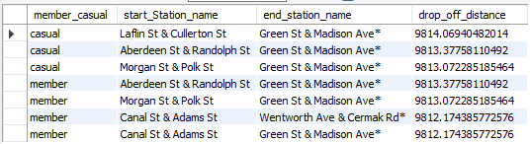

# 6. Which season has the highest/lowest number of rides? Average overall and per user type.

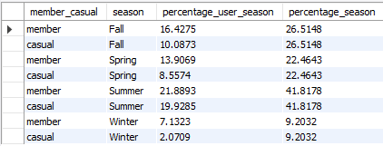

# 7. Which day of the week has the highest/lowest number of rides? Average overall and per user type.

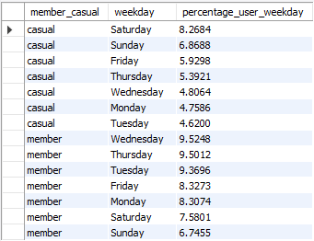

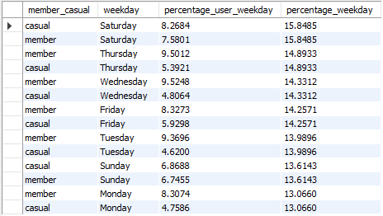

# 8. What are the top 3 start and end stations? Count per user and display all in in one output.

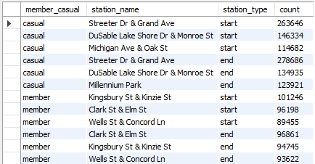

# 9. What is the most/least used type of bike? Count overall and per user type.

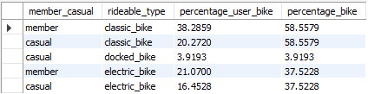

# 10. How do users behave over the time of the day? Is there a preferred time for going on a ride?

