**Example shell commands for navigation**

|  |  |
| --- | --- |
| cd *dirname*  cd ..  cd \  cd ..\..  (Tab)  cd %HOME% | Change working directory to be *dirname*  Change working directory to be the current one's parent  Change working directory to be the user's home directory  Goes back two directories toward the root  Complete name of directory or file  Takes you to the User’s directory, but only on C: |
| ls  edit *.*  explorer .  exit | List files in working directory  Open all files in current directory for editing in Notepad++  Show Finder for the working directory  Close the Terminal window |

**Other shell commands**

dir Lists the directory of files and folders

explorer . Opens the Windows folder of the working directory

pwd Prints you the path of the working directory

touch Creates an empty file in the current directory

mkdir *dirname* Makes a directory to be *dirname*

cat *filename* Prints the text of the file

cp *filename newname* Copies afile and gives it a new name

rm *filename* Deletes a file

rmdir *dirname* Deletes an empty directory

-r recursive, all folders deep

-I ???

-4 provides lines before and after to give you context

-u universal format, easier to read

**Example commands for Ruby web servers**

|  |  |
| --- | --- |
| bundle  rackup  (Ctrl-C) | Install gems listed in Gemfile in working directory  Start the web server indicated in config.ru in working directory  Terminate program that's currently running in this Terminal tab |

**Example shell commands for navigating command history**

|  |  |
| --- | --- |
| history  (up arrow)  (Ctrl-R) | List previously entered commands  Step backwards in history through previously entered commands  Search for previously entered command |

**Example HTML tags**

* + - * + <h1>Headline</h1>
        + <p>Paragraph</p>
        + Line 1<br>Line 2
        + <ul>  
             <li>Item 1  
             <li>Item 2  
          </ul>
        + <table border="1">  
             <tr>  
                 <th>Header for column A  
                 <th>Header for column B  
             <tr>  
                 <td>Row 1 for column A  
                 <td>Row 1 for column B  
          </table>
        + Enter some text: <input type="text">
        + <button>Click me</button>

1. **How to search and replace in a directory with Notepad++**
   * cd to the directory you want to search in
   * Open Notepad++ with edit .
   * Under the Search menu, choose Search In ____
2. **How to search in a directory with grep**
   * cd to the directory you want to search in
   * grep -ri --color "title" . # to search for the word title
3. **Example of comparing the contents of two directories with diff**
   * cd
   * cd 2013-q3-rails-1
   * diff -ru 103c-html-practice/ 103f-html-practice/
4. **Example of how to clone from GitHub**
   * Go to https://github.com/davincicoders/2013-q3-rails-1
   * Find the clone URL on the right margin
   * Change it to SSH if it's showing HTTPS
   * git clone [git@github.com:davincicoders/2013-q3-rails-1.git](mailto:git@github.com:davincicoders/2013-q3-rails-1.git)

**Example of how to fork from GitHub**

* Log into GitHub and browse to a repository you want to copy
* Towards the upper right corner, click Fork
* When it asks “Where should we fork this repository?” select @yourname

**Example of how to delete a repository from GitHub**

* Log into GitHub and browse to your list of repositories
* Select the repository you want to delete
* Along the right side, select Settings
* Scroll to the bottom and select Delete this repository

**Create new repo in GitHub**

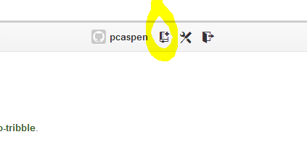

Name it and save

**Creating conflict**

First person to push does not have to resolve conflict

Second person pushes changes and gets error message

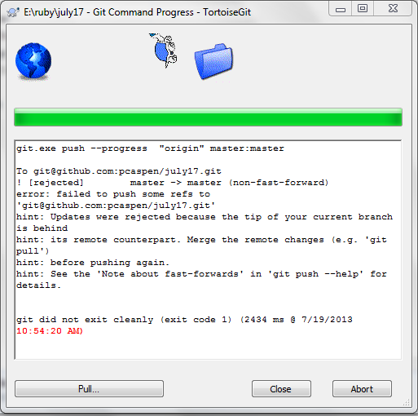

Pull changes to get Frankenstein file

Only gives you one error message. Hit CLOSE and NOT ABORT

Do you want to see changes? Yes

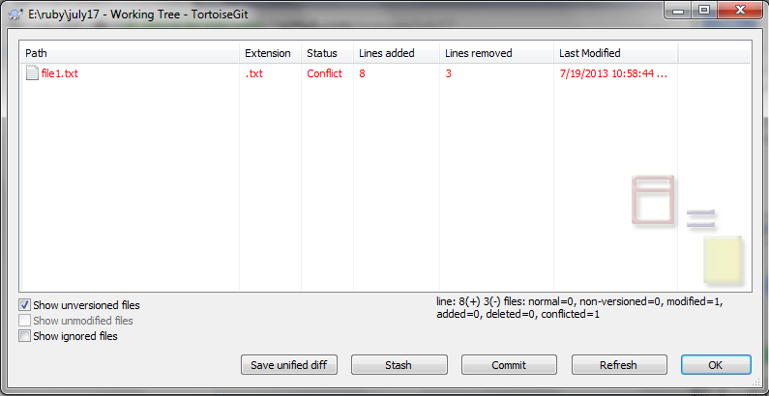

Right click the file and select Edit OR go to Notepad++ and manually edit and save file

Right click and select Resolved

Are you sure? Yes

Select Commit button

Push

1. **How to push to GitHub**
   * git push

Create file in directory with touch *filename*

Go to Explorer, right click, TortoiseHub and Add

Select files and hit Okay

Commit by right-click Git commit master

Write a note in the Message field (wont' work otherwise)

Select Okay

Select Push

Select Okay

Select Close

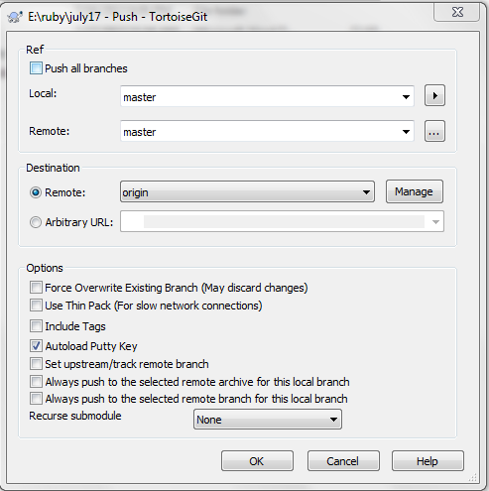

To actually push this files, go to explorer and right click on the root folder, do TortoiseGit push.

**TO BE TITLED**

Add someone’s repository to your desktop

Click on a repository

On the Unwatch button click on the number of watchers

Click on someone

Click on their shared repository and copy the SSH address

1. **How to merge in new commits from a repository of yours on GitHub:**
   * git pull

1. **How to merge in new commits from instructor's repository on GitHub:**

TortoiseGit Pull

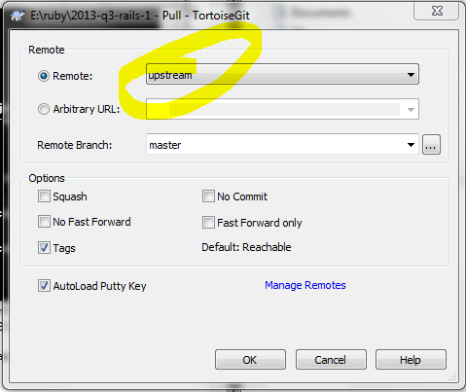

1. **How to handle error messages after attempting to merge:**

|  |
| --- |
| error: The following untracked working tree files would be overwritten by merge:  change2  Please move or remove them before you can merge.  Aborting |

* + Run gitx
  + Find each untracked working tree file in the unstaged section
  + Choice 1: Right-click a file and choose Discard (lose your changes)
  + Choice 2: Left-click a file to stage it (keep your changes)
  + Run git pull upstream master again

|  |
| --- |
| error: Your local changes to the following files would be overwritten by merge:  change3 Please, commit your changes or stash them before you can merge. Aborting |

* + Run gitx
  + Find each file mentioned in the staged or unstaged section
  + Choice 1: right click, unstage, right click, discard
  + Choice 2: commit and merge
  + Run git pull upstream master again

|  |
| --- |
| Auto-merging change3  CONFLICT (add/add): Merge conflict in change3  Automatic merge failed; fix conflicts and then commit the result. |

* + Choice 1: undo the merge by running git merge --abort
  + Choice 2: edit each of the conflicted files and search for ===, then choose either the part above or below the ===, deleting the <<< or >>> and === lines

Run git commit -a from the command line and save and exit the text editor

**Inspect Element in any Webpage**

Right click on any webpage and use Inspect Element.

Click element to get detailed code

**What relation is there between file paths and web paths, if any?**

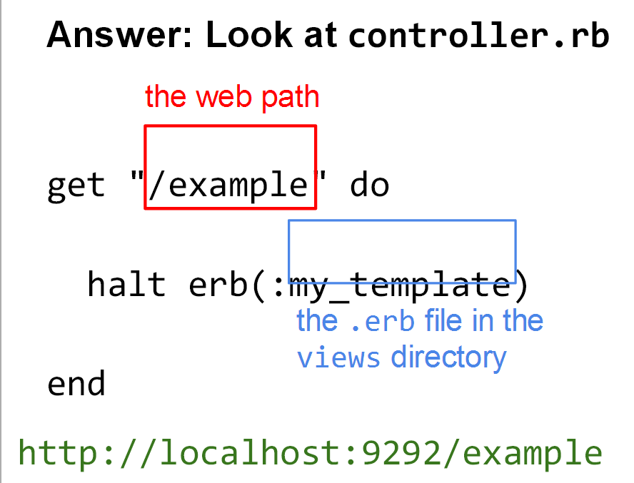

**Paths**

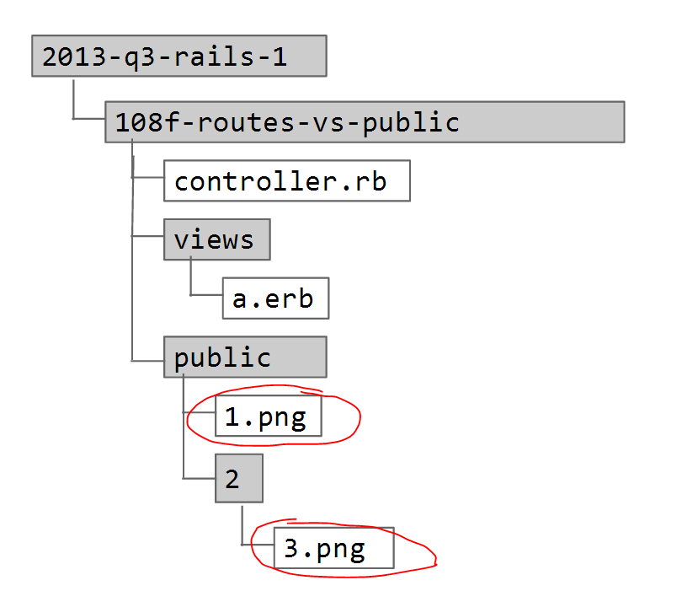

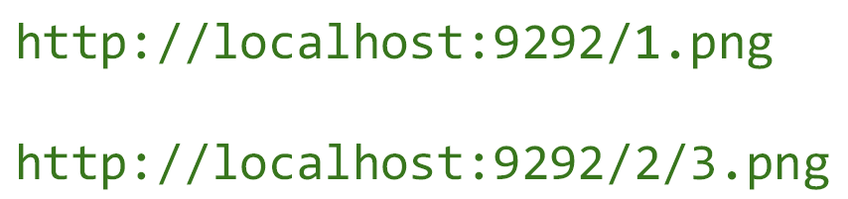

**routes, paths, handlers, halt erb, public directory**

1. **How to see the list of routes (doesn't include public directory)**

rake routes

1. **How to define a GET route and a handler for it**get "/hello" do  
    halt erb(:the_page)  
   end
2. **Example of how to link to another page inside HTML**<a href="/page2">Next page</a>
3. **Example of how to embed an image inside HTML**
   1. Create a public directory
   2. Create an images directory under public
   3. Save a pipe.png to public/images
   4. Add <img src="/images/pipe.png"> to your ERb file
4. **Example of how to link to a stylesheet from HTML**
   1. Create a public directory
   2. Create a stylesheets directory under public
   3. Create an application.css inside public/stylesheets
   4. Add the following to your ERb file, inside the <head> tag:  
      <link href="/stylesheets/application.css"  
       rel="stylesheet" type="text/css"> 🡨 **goes in the erb file**

Alternatively:

<link rel="stylesheet" type="text/css" href="/stylesheets/application.css"> **AND**<p>Status: <span class='<%= @status_css_class %>'><%= @status_text %></span></p>

1. **Example of how to link to external Javascript from an HTML <head> tag**
   1. Create a public directory
   2. Create a javascripts directory under public
   3. Create an application.js inside public/javascripts

Add the following to your ERb file, inside the <head> tag:  
<script src="/javascripts/application.js"></script>

**Instance variables, <%= %>, layouts, <title>**

<%= means evaluate and print Ruby expression, plugin the result

<% %> 🡪 called erb tags

layout.erb goes in the views folder; contains the header and footer so other views don’t have to

<%= yield %> will print code on webpage verbatim if using Sinatra  
<%== yield %> means plugin original erb file

== means doesn’t escape HTML, I want to include the formatting

“ or ‘ in links 🡨 put backslash before quotes to escape

**Instance variable 🡪 something that gets passed to the erb file**

1. **Example of setting an instance variable in a GET handler in the controller**  
   get "/welcome" do  
    @name = "Bob"  
    halt erb(:letter)  
   end
2. **Example of evaluating and printing an instance variable inside an ERb view**  
   <p>Dear <%= @name %>, </p>
3. **Example of a layout to save as layout.erb in the views directory**<html>  
    <head>  
      <title><%= @title %></title>  
      <link href="/stylesheets/application.css"  
            rel="stylesheet" type="text/css">  
    </head>  
    <body>  
      <h1><%= @title %></h1>  
      <%= yield %>  
    </body>  
   </html>
4. Example of an if statement inside an ERb view  
     
   <% if @price != nil %>  
    Price: <%= @price %>  
   <% else %>  
    No price provided  
   <% end %>  
     
   **Start writing if/else statements:**  
   <% if true %> (always true) <% if false %>   
     
   <% end %> <% end %>

Note: when using if statements in Ruby, don’t forget to use the == when something is equal to

1. **Example of an if statement inside an ERb view**  
     
   <% if @glycemic_index <= 55 %>  
    Low  
   <% elsif @glycemic_index < 70 %>  
    Medium  
   <% else %>  
    High  
   <% end %>
2. **Example conditions for if statements**
   1. @temperature > 0
   2. @temperature >= 0
   3. @temperature == 0 (equal to)
   4. @temperature != 0 (not equal to)
   5. @temperature <= 0
   6. @temperature < 0
   7. @operating_system == "Linux"
   8. @operating_system != "Mac"
   9. @assigned_agent == nil
   10. @assigned_agent != nil
   11. @is_finished == true
   12. @is_finished == false

**HTML <pre></pre> tags 🡪 <pre>**Text in a pre element  
is displayed in a fixed-width  
font, and it preserves  
both      spaces and  
line breaks  
</pre>

When printing a string of preformatted letters/characters, inserting \n in like inserting a soft break

If you need to print the backslash character (\), you will need to include two of them in the preformatted text

**Active Record, all, methods, raise, comments, each Wednesday, July 24**

1. **How to drop the current app's database and reload the schema and seed data**  
   rake db:reset  
     
   Drops database located in config directory, name in quotes in database line  
   NOTICE: can usually be ignored; low priority  
   .yml file 🡪 database configuration  
   Table name is plural  
   Individual row is singular of table name  
   Rows are inherently unordered; need to tell it which order you want records in; common to sort by id, but not necessary  
   Calling a method – sending a message to an object
2. **How to see the schema and data for the current app's database's tables***(Note: this command only works with customized Rakefiles that were provided to you)*rake db:dump
3. **Example of how to raise an error to inspect a variable named @things**raise @users.inspect  
     
   Enables you to purposely cause your program to stop running  
     
   Within the erb file, you can use <% @tables.inspect %>
4. **Example of how to query a table**@users = User.all

1. **Example of how to print out the value of a variable from ERb**  
   <%= @users.inspect %>
2. **Example of showing an array of Active Record objects as an HTML table in ERb**  
   | x | 🡪 I want you to use each method called x; loop variable; connection between the outside when we’re saying calling each and the contents of each loop  
     
   <table border="1">  
    <tr>  
      <th>ID</th>  
      <th>Name</th>  
      <th>Created at</th>  
    </tr>  
    <% @users.each do |user| %>  
      <tr>  
        <td><%= user.id %></td>  
        <td><%= user.name %></td>  
        <td><%= user.created_at %></td>  
      </tr>  
    <% end %>  
   </table>
3. **How to comment Ruby code**  
   # This is a one-line comment.  You have to write # before each line.  
   # In TextWrangler, select a block and type Command-/

**Three possibilities for commenting ERb code**  
<!-- HTML comments are visible to users with View Source -->  
  
<% if false %>  
 Code inside is parsed but not evaluated and is invisible to users  
<% end %>  
  
<%# Normal Ruby one-line comments keep code inside from being parsed  
 # and evaluated, but you have to type # before each line. %>

**Differences between erb tags**

<% 🡪 evaluate  
<%= 🡪 evaluate and print

**find, named params, migrations, models, seeds Friday, July 26**

1. **Example of how to link to item detail pages from an ERb page**<% @vehicles.each do |vehicle| %>  
    <a href="/vehicle/<%= vehicle.id %>">Show</a>  
    <br>  
   <% end %>
2. **Example of a GET route for an item detail page**  
     
   get "/products/:id" do  
    id = params[:id]  
    @product = Product.find(id)  
    halt erb(:show)  
   end
3. **Example of how to create a new migration***Note: for Rails the command is: rails g migration create_fruits*  
   rake db:new_migration[create_fruits]
4. **Example migration**  
   class CreateFruits < ActiveRecord::Migration  
    def up  
      create_table :fruits do |t|  
        t.string :name  
        t.integer :price_per_lb_in_cents  
      end  
    end  
    def down  
      drop_table :fruits  
    end  
   end
5. **Command to run all migrations that haven't run yet**  
   rake db:migrate

1. **Command to rollback the last migration**  
     
   rake db:rollback

1. **Example model file to create as user.rb in the models directory**class User < ActiveRecord::Base  
   end

1. **Example command to test whether table and model are correctly set up***Note: for Rails the command is: echo User | rails console*

**In Windows:**rake console 🡪 then enter Duck (name of table)

**Example db/seeds.rb**  
Item.create(description: "cast-iron skillet", sku: "S13")  
Item.create(description: "glass vase", sku: "V07")

**Indenting**

Did previous line open a new container?

Yes 🡪 indent

No 🡪 is it an end? Yes? 🡨 reduce indent

No 🡪 Keep it the same

**To delete a mal-formed database and tables**  
  
rake db:drop  
rake db:create  
rake bd:migrate

**Method examples:**

find  
all  
create

# How to do a database homework assignment

Go into folder and run bundle and rake db:reset

**rake db:new_migration[initial_schema]**

Open the new file that was created in db\migrate and edit it to create the migration program

**class CreateWorldCities < ActiveRecord::Migration**

**def up**

**create_table :world_cities do |t|**

**t.string :name**

**t.string :country**

**t.integer :time_zone_offset**

**t. float :population_in_millions**

**end**

**end**

**def down**

**drop_table :world_cities**

**end**

**end**

Open the schema.rb file and confirm it is empty

Run the migration with rake db:migrate

Confirm the migration worked by running rake db:dump (should see headings with no data) or you can look at the schema.rb file.

If it does not look like you expected, you can run rake db:rollback to roll back one step in the migration process at a time.

Create the model file (each table gets their own) by naming it the singular name of the plural table name. Include small case and underscores. The file type is .rb. In the case of the table world_cities, the model file is called world_city.rb. The content is:

**class WorldCity < ActiveRecord::Base**

**end**

The class name removes underscores and capitalizes initial word and each word after an underscore. It’s also singular.

Test things to see if the table and model are set up correctly by typing in the terminal:

**rake console**

Wait for the prompt and then type in the class name. In this case, it’s WorldCity. It should spit out the column names and types.

If you need to create your own seed.rb file, it goes in the db directory and has the following format:

**WorldCity.create(**

**name: "London",**

**country: "United Kingdom",**

**country_flag_filename: "gb.png",**

**time_zone_offset: 0,**

**population_in_millions: 8.3**

**)**

**WorldCity.create(**

**name: "New York City",**

**country: "United States of America",**

**country_flag_filename: "us.png",**

**time_zone_offset: -5,**

**population_in_millions: 8.3**

**)**

**WorldCity.create(**

**name: "Shanghai",**

**country: "China",**

**country_flag_filename: "cn.png",**

**time_zone_offset: 8,**

**population_in_millions: 23**

**)**

To seed the database run rake db:seed.

Rackup and create the controller.rb, index.rb and show.rb files.

Check out your progress on [http://localhost:9292](http://localhost:9292/)

**form helpers, POST handlers, new, save!, redirect, CRUD**

1. **Suggested edit to views/layout.erb to allow form submissions**  
   <%== form_tag request.path_info %>  
    <%== yield %>  
   </form>
2. **Examples of form helpers in ERb**  
     
   <%== text_field_tag :subject, "Call me", size: 40 %>  
   https://lh4.googleusercontent.com/dHHoAeASUz7R2c1fuFdnSpYPul4U_ZnKWi0vOotNglICL_mxEQnrcXOIcb1FvTnsgb03a0woB9SUjCDTlO-yfD4FKrTFiL0-oqM22MH2CeObmL-JnKSvaOhh  
     
   <%== text_area_tag :body, "Please call me ASAP.", rows: 3, cols: 40 %>  
   https://lh4.googleusercontent.com/pjTl1dttV9l2Paj49cBF9aDPoU-OwRmVcVExTbileuRAkA0llUw8e0iywGW_HV0x402qX5qJpXRLcqynshQD7l14WUwMNqrTLXLZsBXF3djnZ2VgX0iLJugj  
     
   <%== submit_tag "Send" %>  
   https://lh5.googleusercontent.com/Y_I6cCPDhFalg03DIF-9KEy45Ncd20ftglPT5ONynSSYiO2EZIGyX3cXsnhGEXChMguT-PCN6D77jro0gJs7P0R54s3RfDYr-SZi1pXo3kJpVdoKdeHCyxh6
3. **Example of a POST handler in the controller to create a database row**  
   post "/contact_us" do  
    message         = Message.new  
    message.subject = params[:subject]  
    message.body    = params[:body]  
    message.save!  
    redirect "/thank_you"  
   end
4. **Example of a POST handler in the controller to update a database row**  
     
   post "/messages/:id" do  
    message         = Message.find(params[:id])  
    message.subject = params[:subject]  
    message.body    = params[:body]  
    message.save!  
    redirect "/thank_you"  
   end