Final Report and Comprehensive Analysis
Predicting Term Deposit Subscription — Bank Marketing Dataset
Machine Learning Engineer Internship — Week 6 Final Deliverable
Prepared by: Aswathi

Table of Contents

1. Project Overview
This project set out to build a complete, end-to-end machine learning pipeline predicting whether a bank client will subscribe to a term deposit, using the UCI Bank Marketing dataset — real data from a Portuguese bank's telemarketing campaigns. The problem was framed from the outset as a binary classification task with a specific business purpose: helping a bank prioritize which clients are worth calling.
The project's importance within a Machine Learning Engineer's role lies not just in producing a working model, but in demonstrating the full discipline around one: honest problem framing, defensible preprocessing decisions, rigorous evaluation, and transparent reporting of both successes and limitations. That discipline — more than any single metric — is what this report aims to demonstrate.

Strategy Recap (from Week 1)
The original plan identified class imbalance and potential data leakage (via the duration feature) as the two highest risks to the project. Both were later confirmed as real, measurable issues once the data was actually explored — validating the value of planning ahead of implementation rather than discovering these mid-project.

2. Methodological Recap
The table below summarizes what each week of the project actually delivered, tying the final report back to the full body of work rather than only its final results.
Week | Deliverable | Summary
1 | Project Planning & Strategy | Defined the problem (predict term deposit subscription), objectives, 6-week timeline, resource needs, and 5 key risks with mitigations.
2 | Data Preprocessing & Feature Engineering Strategy | Profiled real data quality issues (19.5% "unknown" in default, 96% pdays sentinel values), and planned cleaning, encoding, and scaling strategy.
3 | Model Implementation & Code Documentation | Implemented a Logistic Regression baseline with class_weight='balanced'; documented workflow and added defensive error handling.
4 | Model Evaluation & Validation | Ran 5-fold stratified CV, computed metrics by hand, analyzed individual misclassified examples, tested 5 decision thresholds, and documented 6 specific limitations.
5 | Model Optimization & Experimentation | Ran GridSearchCV (Logistic Regression) and RandomizedSearchCV (Random Forest); found a genuine trade-off, not a clean winner.
6 | Final Report & Comprehensive Analysis | Consolidated the full project into this end-to-end report with comparative charts and final recommendation.

2.1 Data Preprocessing (Week 2)
Exploratory analysis found the dataset's missingness was hidden behind the string "unknown" rather than true nulls — most notably 19.5% of the default column — and that the pdays column used 999 as a sentinel for "never contacted," affecting 96% of records. Both were treated as informative rather than defective: "unknown" was kept as its own category, and pdays was split into a contacted_before flag plus a cleaned numeric column.

2.2 Model Implementation (Week 3)
A Logistic Regression baseline was selected for its interpretability — directly relevant to a bank wanting to understand why a client was flagged — and trained with class_weight='balanced' to counter the dataset's 89/11 class imbalance. duration was deliberately excluded from the deployment-realistic model, since it is only known after a call happens and would leak the outcome.

3. Experimental Analysis

3.1 Baseline Evaluation (Week 4)
5-fold stratified cross-validation produced a mean recall of 0.615 (std 0.073), closely matching the held-out test recall of 0.600 — confirming the model was not overfit. The chart below shows recall's stability across each individual fold:
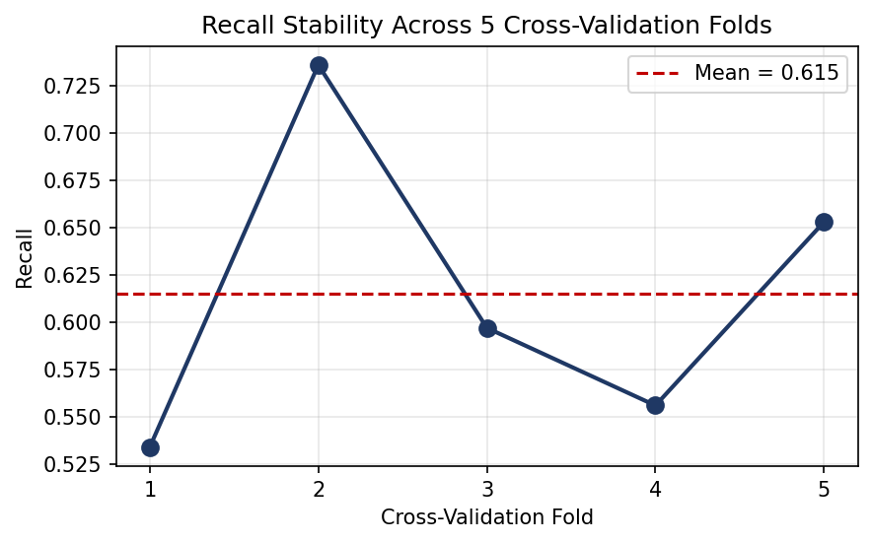
Figure 1: Recall across 5 cross-validation folds, Week 4 baseline model.
Error analysis went beyond aggregate metrics: 89% of missed subscribers (false negatives) had no prior campaign contact on record, versus only 59% of correctly caught subscribers — showing the model leans heavily on prior campaign history as a signal, and is comparatively weaker at identifying genuinely new prospects.

3.2 Optimization Experiments (Week 5)
Two tuning experiments were run: a grid search over the baseline model's own hyperparameters, and a randomized search over a Random Forest — chosen specifically to test whether a non-linear model could resolve a false negative/false positive pair that were nearly identical on every available feature in Week 4.
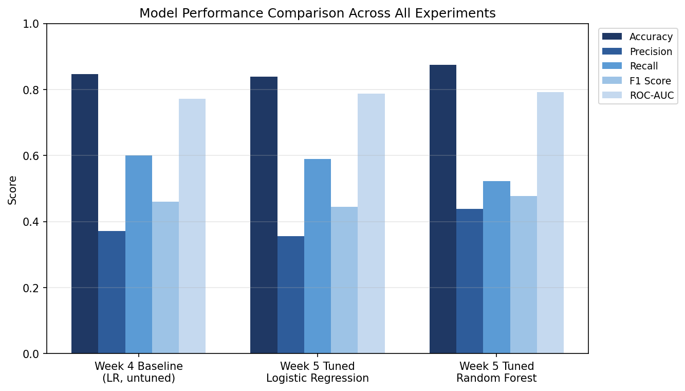
Figure 2: Performance comparison across the baseline and both tuned models.
Model | CV F1 | Accuracy | Precision | Recall | F1 | ROC-AUC
Week 4 Baseline (LR, untuned) | 0.427 | 0.846 | 0.372 | 0.600 | 0.460 | 0.772
Week 5 Tuned Logistic Regression | 0.435 | 0.839 | 0.356 | 0.589 | 0.444 | 0.787
Week 5 Tuned Random Forest | 0.489 | 0.875 | 0.439 | 0.522 | 0.477 | 0.792

The result was genuinely mixed rather than a clean win for either model: Random Forest improved F1, precision, accuracy, and ROC-AUC, but at a real cost to recall — the metric prioritized from Week 4 onward because missing a genuine subscriber was judged costlier than one extra unsuccessful call. Testing the specific problem pair directly showed Random Forest resolved the false positive but still missed the false negative, suggesting that particular case lacks sufficient signal in the available features regardless of model choice.

3.3 Recommended Model
Given the project's stated priority on recall, the Week 4 Logistic Regression baseline (class_weight='balanced', no hyperparameter changes) is the final recommended model. Its confusion matrix on the held-out test set:
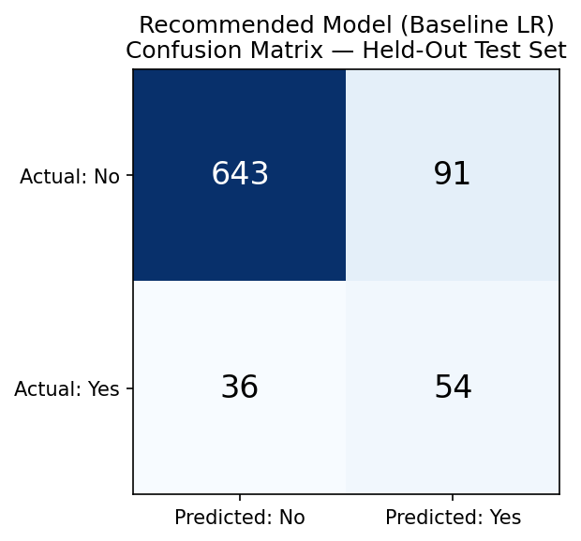
Figure 3: Confusion matrix for the recommended model on the held-out test set.
This model correctly identifies 54 of 90 genuine subscribers (60% recall) while maintaining a stable, cross-validated performance profile — a defensible, explainable choice for a bank prioritizing not missing real opportunities over minimizing wasted calls.

4. Lessons Learned and Recommendations

4.1 Lessons Learned
Planning pays off concretely, not just procedurally: the class imbalance and data leakage risks flagged in Week 1 — before any data was even loaded — turned out to be the two most consequential issues in the entire project. Planning ahead of implementation surfaced them early enough to design around them properly, rather than discovering them mid-pipeline.
"Clean" data can still hide real problems: a standard missing-value check reported zero issues, yet nearly one-fifth of one column was effectively missing, encoded differently. This was the single most important preprocessing lesson of the project: always understand how a specific dataset represents gaps, rather than trusting one generic check.
More complexity does not automatically mean a better model: Random Forest outperformed on four of five metrics, yet was not selected, because the one metric it lost on (recall) was the one tied to the actual business priority. Model selection is a business decision informed by technical results, not a leaderboard ranking by any available metric.
Honest limitations are more valuable than confident overstatement: identifying that a false negative and false positive example were nearly indistinguishable on every available feature was a more useful finding than any single accuracy number — it revealed a genuine ceiling on the current approach, not just a number to report.

4.2 Recommendations for Future Work
- Engineer non-linear representations of age and other features suspected of non-linear relationships with the outcome, to test whether they meaningfully improve on the current linear model.
- Establish a real cost ratio between a false positive (wasted agent call) and a false negative (missed deposit opportunity) with the bank, and use it to formally optimize the decision threshold rather than defaulting to 0.5.
- Test gradient boosting methods (e.g. XGBoost or LightGBM), which often outperform Random Forest on tabular data of this kind, as a further comparison point.
- Investigate SMOTE or other resampling techniques as an alternative to class_weight='balanced' for handling class imbalance.
- Monitor for concept drift if this model were ever deployed on new campaign data, since the current results are based on one historical campaign period.

5. Conclusion
This project delivered a complete, evidence-based machine learning pipeline: from an initial plan that correctly anticipated the project's two biggest risks, through preprocessing grounded in real data profiling, to a baseline model that was rigorously evaluated, honestly critiqued, and deliberately not replaced by a technically stronger but strategically worse-fit alternative. The final recommendation — keep the interpretable, recall-prioritizing Logistic Regression baseline — reflects a project that treated model selection as a reasoned decision tied to a stated business goal throughout, rather than a search for the single highest metric.

