Methodological Notes – Dimensionality and Reliability Assessment of MMAB-NCAS

Objective
This section documents the psychometric evaluation of the MMAB-NCAS instrument (22 items, Likert 1-5), applied to 3,600 synthetic respondents generated via large language model prompting. The analysis focused on evaluating the dimensional structure, internal consistency and item-level properties using modern psychometric techniques. The goal was to test whether the empirical structure aligns with the theoretical model and to inform decisions on item retention or exclusion.

1. Descriptive Structure and Scaling Assumptions
A structural check confirmed balanced coverage across response options in most items, with expected asymmetries in items related to advanced blockchain practices. All items (q1 to q22) were recoded as numeric and treated as ordered categorical indicators.

2. Internal Consistency – Cronbach’s Alpha and McDonald’s Omega
Internal consistency was evaluated for the full scale and each of the three latent dimensions across maturity levels (novice, intermediate, advanced). The results were as follows:
Cut | Profile | Dimension | n_items | Alpha | Omega
full_scale | all | all | 22 | 0.984 | 0.984
 | novice |  |  | 0.981 | 0.981
 | intermediate |  |  | 0.982 | 0.982
 | advanced |  |  | 0.982 | 0.984
dimension | all | governance_strategy | 6 | 0.937 | 0.940
 | all | operational_integration | 6 | 0.953 | 0.952
 | all | sustainability_scalability | 10 | 0.967 | 0.968
Interpretation: All reliability indices exceed conventional thresholds (>.90), indicating high internal consistency. The proximity between Alpha and Omega suggests minimal violation of tau-equivalence, with Omega confirming robustness under congeneric assumptions.
Reference: McDonald (1999), Raykov & Marcoulides (2011)

3. Dimensionality Assessment

3.1 Parallel Analysis (Spearman Matrix)
A parallel analysis using Spearman correlations was conducted to determine the number of latent factors. The actual eigenvalues and the average simulated eigenvalues based on 1000 permutations are shown below:
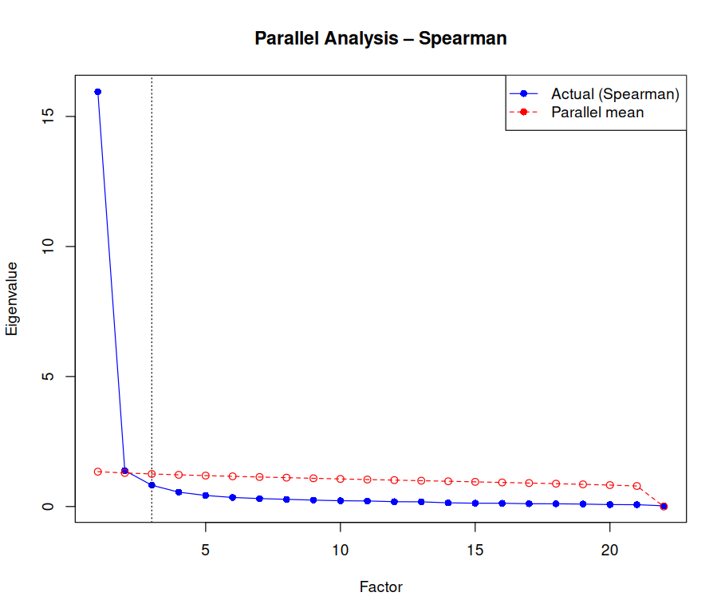
Interpretation: The first three factors had eigenvalues exceeding those expected by chance, confirming the retention of a three-factor solution.
Reference: Horn (1965), Costello & Osborne (2005)

3.2 Exploratory Factor Analysis (EFA, ML + Promax)
A 3-factor solution was estimated using maximum likelihood extraction and Promax rotation. The salient loadings (|lambda| ≥ 0.30) are shown below:
ML2 ML3 ML1
q1 - 0.92 -
q2 - 0.829 -
q3 - - 1.091
q4 - 0.806 -
q5 - - 0.664
q6 - 0.521 -
q7 0.924 - -
q8 - 0.597 -
q9 0.715 - -
q10 - - 0.657
q11 - - 0.656
q12 1.01 - -
q13 0.435 0.468 -
q14 - 0.355 0.388
q15 0.854 - -
q16 - - 1.096
q17 - - 0.641
q18 0.368 0.417 -
q19 0.405 0.384 -
q20 - 0.581 -
q21 0.599 - -
q22 0.874 - -

Interpretation: Most items loaded strongly onto their theoretical dimensions, but cross-loadings in items q13, q14, q18 and q19 suggest partial multidimensionality and potential semantic overlap.
Reference: Fabrigar et al. (1999), Osborne & Costello (2009)

4. Confirmatory Factor Analysis (CFA)
The theoretical 3-factor model was tested using lavaan with DWLS estimation for ordinal indicators. Modification indices were extracted to evaluate local dependence.
Top 10 Residual Covariances (MI):
lhs | rhs | MI
q15 | q22 | 792.7
q3 | q16 | 751.2
q16 | q22 | 600.9
q3 | q22 | 592.5
q17 | q22 | 477.6
q7 | q22 | 414.3
q2 | q17 | 375.7
q10 | q22 | 329.9
q15 | q16 | 328.2
q9 | q12 | 324.9
Interpretation: High residual covariances, particularly involving items in the sustainability dimension (q15–q22), suggest strong local dependence or redundancy.
Reference: Brown (2015), Kline (2016)

5. Bifactor CFA
A bifactor model was estimated with a general factor (G) and three orthogonal specific factors (F1, F2, F3). Model fit was acceptable:
- CFI: 0.999
- TLI: 0.999
- SRMR: 0.056
- RMSEA: 0.112
Interpretation: The general factor explained substantial shared variance across all items (Std.all ≈ 0.99), confirming a strong general maturity dimension. Several specific factors (notably F3) retained significant residual loadings (e.g., q16 = -0.736), indicating structured multidimensionality.
Reference: Reise et al. (2007), Rodriguez et al. (2016)

6. Item Response Theory (GRM)
A graded response model was fitted to assess item-level discrimination and information contribution. The test information curve and standard errors are shown below:
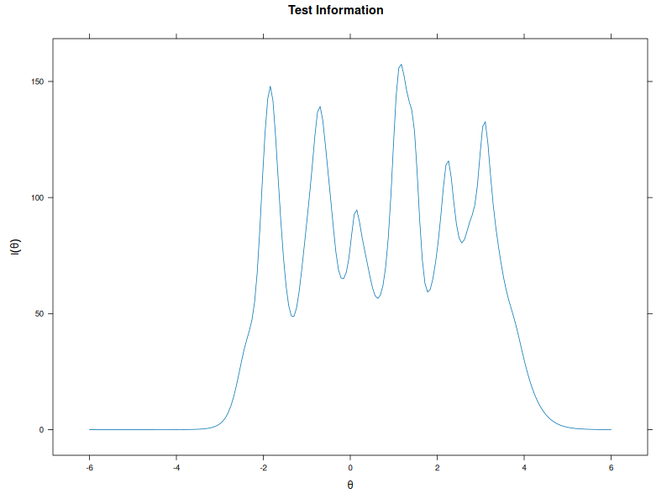
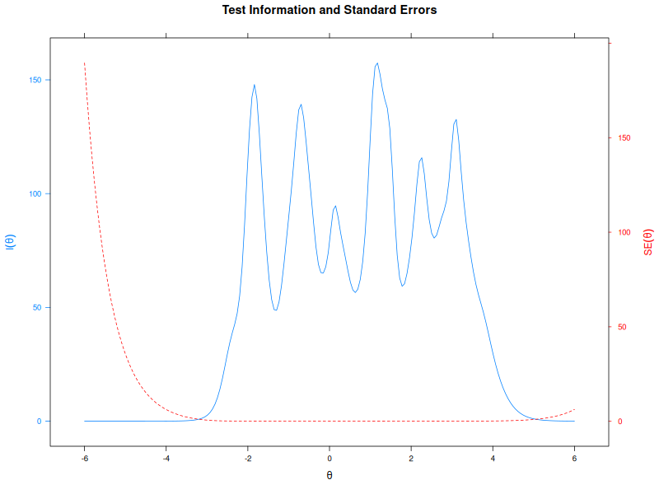
Summary of Item Discrimination:
All items had high discrimination values (a ≈ 0.90–0.99), with total explained variance at 91.8% (SS loadings = 20.2). Items q1 to q22 had h2 ranging from 0.792 to 0.975.
Interpretation: The instrument is highly informative across mid-range and upper-intermediate levels of the latent trait (θ ∈ [-2, 3]). No item showed low or flat information curves.
Reference: Samejima (1969), Embretson & Reise (2000)

7. Visual Review of Category Functioning (ICCs Grid)
To complement the statistical summary, all 22 ICCs were visualized in a single grid. Each panel displays the five category response curves as a function of latent trait θ:
Interpretation:
- Most items exhibit symmetric, orderly thresholds across θ, reinforcing Likert structure validity.
- Categories are well defined and evenly spaced for nearly all items.
- Items like q6, q15 and q22 have slightly flatter slopes, yet maintain category ordering.
- No evidence of disordered thresholds or non-monotonic behavior was observed.

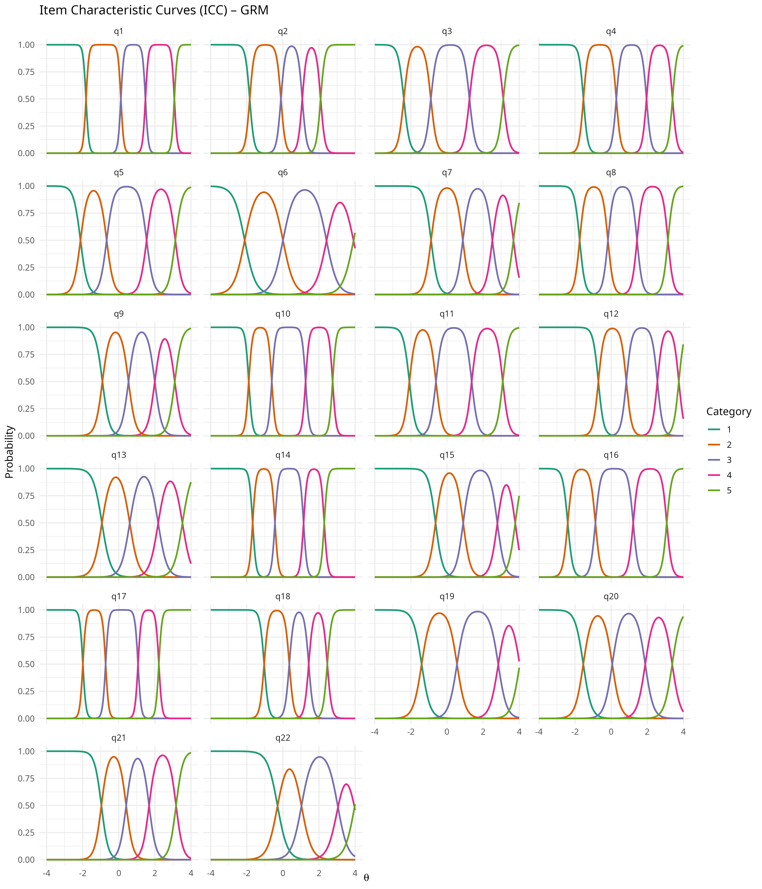

8. Decision on Item Retention
Based on the integrated psychometric evidence, including internal consistency, dimensional modeling, residual diagnostics and item-level IRT performance, the decision is to retain all 22 items in the operational form of MMAB-NCAS.
Justification:
- All items display adequate to excellent discrimination.
- No item exhibits collapsed categories or erratic response behavior.
- Multidimensional structure is consistent with theoretical expectations.
- ICCs are well ordered and response thresholds are interpretable.
Flagged items for future review:
- q13, q14, q18, q19: present cross-loadings in EFA.
- q6, q15, q22: slightly lower discrimination or high modification indices.
Recommendation:
- Maintain all 22 items in the scale for initial deployment.
- Apply longitudinal monitoring to reassess flagged items.
- In future revisions, consider semantic refinement of flagged items rather than elimination.

Final Recommendations
- Retain all 22 items for initial operationalization, given high reliability, clear dimensional structure and excellent information.
- Flag items q13–q14 and q18–q19 for revision in future versions due to cross-loadings.
- Consider allowing residual correlations in CFA models if theoretical justifications are available (e.g., q15 ~~ q22).
- The ICC curves validate the ordinal structure of the response model and confirm that each item operates across the full spectrum of the latent trait with high precision.

References (ABNT style)
BROWN, T. A. Confirmatory Factor Analysis for Applied Research. 2. ed. New York: Guilford Press, 2015.
COSTELLO, A. B.; OSBORNE, J. W. Best practices in exploratory factor analysis: Four recommendations for getting the most from your analysis. Practical Assessment, Research & Evaluation, v. 10, n. 7, p. 1–9, 2005.
EMBRETSON, S. E.; REISE, S. P. Item Response Theory for Psychologists. Mahwah: Lawrence Erlbaum Associates, 2000.
FABRIGAR, L. R.; WEGENER, D. T.; MACCALLUM, R. C.; STRAHAN, E. J. Evaluating the use of exploratory factor analysis in psychological research. Psychological Methods, v. 4, n. 3, p. 272–299, 1999.
HORN, J. L. A rationale and test for the number of factors in factor analysis. Psychometrika, v. 30, n. 2, p. 179–185, 1965.
KLINE, R. B. Principles and Practice of Structural Equation Modeling. 4. ed. New York: Guilford Press, 2016.
MCDONALD, R. P. Test Theory: A Unified Treatment. Mahwah: Lawrence Erlbaum, 1999.
OSBORNE, J. W.; COSTELLO, A. B. Best practices in exploratory factor analysis: Four recommendations for getting the most from your analysis. Pan-Pacific Management Review, v. 12, n. 2, p. 131–146, 2009.
RAYKOV, T.; MARCOULIDES, G. A. Introduction to Psychometric Theory. New York: Routledge, 2011.
REISE, S. P.; MOORE, T. M.; HAVEL, T. F. Bifactor models and rotations: Exploring the extent to which multidimensional data yield univocal scale scores. Journal of Personality Assessment, v. 88, n. 2, p. 145–158, 2007.
RODRIGUEZ, A.; REISE, S. P.; HAVEL, T. F. Evaluating bifactor models: Calculating and interpreting statistical indices. Psychological Methods, v. 21, n. 2, p. 137–150, 2016.
SAMEJIMA, F. Estimation of latent ability using a response pattern of graded scores. Psychometrika Monograph Supplement, v. 34, n. 4, p. 1–100, 1969.

