**JK_RTC_Module Porting**

Step 1: Coping source code from old BSP to new BSP

azalea_r1760/bsp/kernel/drivers/char/jk_rtc

* dolphin_plus_bsp/bsp/kernel_4.4/drivers/char/jk_rtc

**Step 2:** Add build condition in Makefile:

Opening the Makefile azalea_r1760/bsp/kernel/drivers/char/ Makefile

Coping obj-$(CONFIG_RTC_DRV_FOR_APP) += jk_rtc/

* Pasting into the Makefile:

dolphin_plus_bsp/bsp/kernel_4.4/ drivers/char/ Makefile

**Step 3:** Update Kconfig file for creating a menu configuration:

Opening Kconfig in old source location and copy contents of “**RTC_DRV_FOR_APP**” into the Kconfig file of new BSP as following samle.

Old munuconfig on Kernel 3.18.82

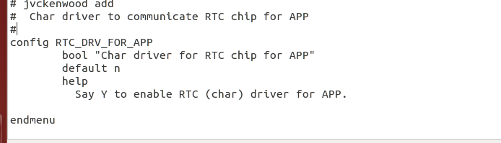

New menuconfig on Kernel 4.4.120:

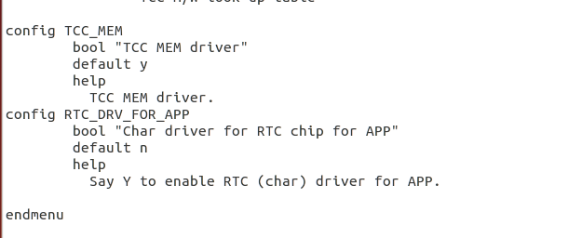

**Step 4: Check menuconfig on new BSP:**

$ make ARCH=arm64 menuconfig

Selecting as path:

**Device Drivers --->**

Input device support --->

[*] Char driver for RTC chip for APP

And slide down cursor to **select** Char driver for RTC chip for APP and save this configuration

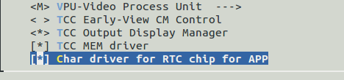

**Step 5:** Check configuration have selected into .config file

**$ gedit .config**

see CONFIG_RTC_DRV_FOR_APP=y in .config file

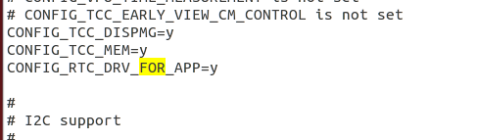

Save the defconfig to use in the next time.

$ make ARCH=arm64 savedefconfig

Copy to /arch/arm*/xxx_defconfig

$ cp defconfig arch/arm64/configs/my_defconfig

**Step 6**: Build driver module

* Navigate to source code kernel:

*$ cd dolphin_plus_bsp/bsp/kernel_4.4/*

* Export arm toolchain

*$ export PATH=/opt/gcc-linaro-7.3.1-2018.05-i686_aarch64-linux-gnu/bin:$PATH*

* Make config

*$ sudo make ARCH=* arm64 my_defconfig

* Export Environment

$ export *ARCH=arm64 CROSS_COMPILE=/opt/gcc-linaro-7.3.1-2018.05-i686_aarch64-linux-gnu/bin/aarch64-linux-gnu-*

* Build*:*

*$ make M=drivers/char/jk_rtc*

*$ make M=drivers/char/jk_rtc*

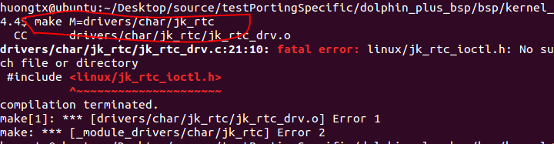

* Thiếu file **linux/jk_rtc_ioctl.h**
* Copy **jk_rtc_ioctl.h** từ azalea

*cp azalea_r1760/bsp/kernel/include/linux/jk_rtc_ioctl.h dolphin_plus_bsp/bsp/kernel_4.4/include/linux/*

*Error occur* :

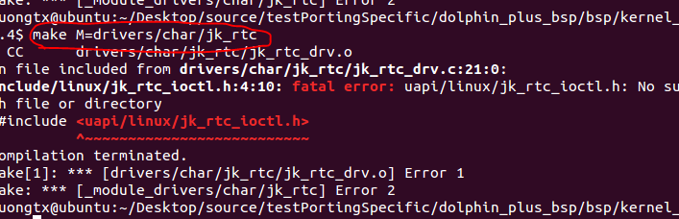

*cp azalea_r1760/bsp/kernel/include/uapi/linux/jk_rtc_ioctl.h dolphin_plus_bsp/bsp/kernel_4.4/include/uapi/linux/*

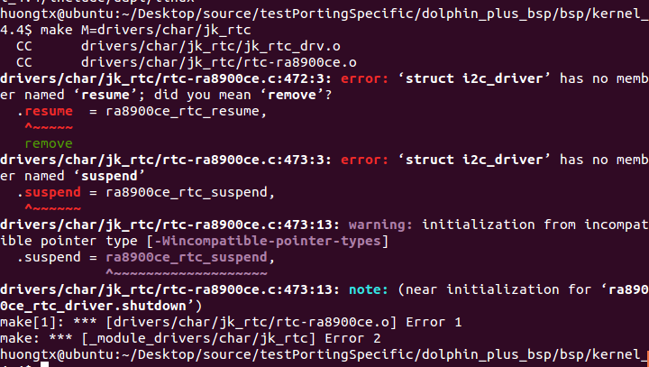

In source code kernel version 4.x, i2c_driver do not have 2 functions resume and suspend, so fixed this error by move these functions to dev_pm_ops:

* Edit file *drivers/char/jk_rtc/rtc-ra8900ce.c*

Add defined CONFIG_PM_SLEEP for two functions *suspend* and *resume*:

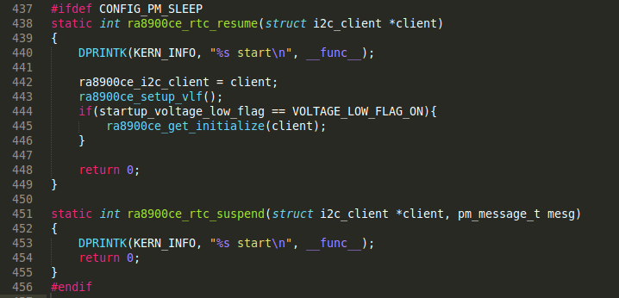

Create new struct *ra8900ce_pm_ops:*

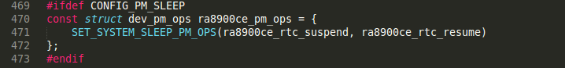

#ifdef CONFIG_PM_SLEEP

const struct dev_pm_ops ra8900ce_pm_ops= {

SET_SYSTEM_SLEEP_PM_OPS(ra8900ce_rtc_suspend,ra8900ce_rtc_resume)

};

#endif

* Add *ra8900ce_pm_ops* to *i2c_driver* and comment unused functions in this struct:

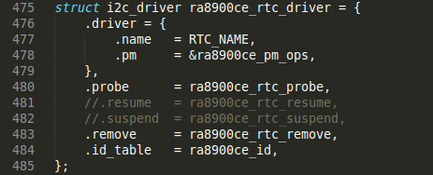

struct i2c_driver ra8900ce_rtc_driver = {

.driver = {

.name = RTC_NAME,

.pm = &ra8900ce_pm_ops

},

.probe = ra8900ce_rtc_probe,

// .resume = ra8900ce_rtc_resume,

// .suspend = ra8900ce_rtc_suspend,

.remove = ra8900ce_rtc_remove,

.id_table = ra8900ce_id,

};

* Add new defined config of CONFIG_PM_SLEEP to *arch/arm/configs/tcc803x_linux_avn_defconfig*



* Rebuild*:*

*$ make M=drivers/char/jk_rtc*

* **© Porting is successful.**