# 1 Gtest on app

Install :

Step 1 : install library gtest

* sudo apt-get install libgtest-dev

Step 2: go to home directory

* Cd~

Step 3: compile the Google test library

* g++ -I /usr/include/gtest -I /usr/src/gtest/ -c /usr/src/gtest/src/gtest-all.cc

Step 4 : move directory gtest

* cd /usr/src/gtest

Step 5 :

* **sudo** cmake CMakeLists.txt

Step 6 : run

* sudo make

Step 7 : move the (libgtest.a) static library to usr/lib directory,

* sudo cp *.a /usr/lib

Example gtest with app :

Step 1 : create file Employee_details.h

Employee_details.h

Step 2 : create file Employee_details.cpp

Employee_details.cpp

Step 3 : create google_test_example.cpp ,using test

google_test_example.cpp

Step 4 : Create makefile

Makefile

Step 5 : Run at terminal

Run :

* make
* ./google_test_example.bin

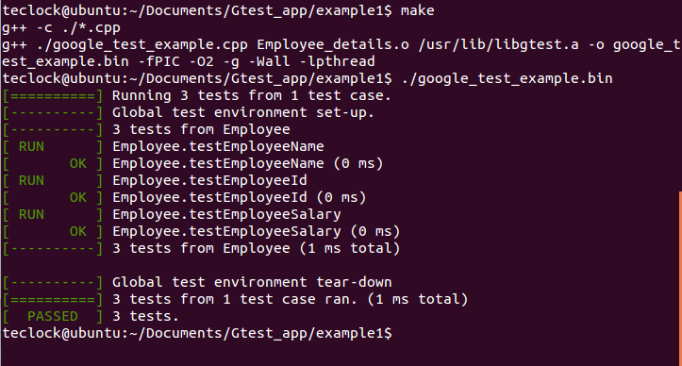

# 2 Gtest on driver

Step 1 :create file driver.c

GtestDriver/Folder/ Driver.c

Driver.c

Step 2 : Create file makefile

Makefile

Step 3 : Run makefile at terminal

Run

Step 1 : Run make create file.ko

* Make

Step 2 : load a Kernel Module

* Sudo insmod driver.ko

Step 3 : move home and move library device file

* Cd /dev

Step 4 : setup access permissions

* sudo chmod 777 etx_device

GtestDriver/

Step 4 : Create file testapp.c

testapp.c

Step 5 : Create file Gtest_example.cpp , using test

Gtest_example.cpp

Step 6 : Create file makefile

Makefile

Step 7 : Run

Run

* Make
* ./Gtest_example.bin

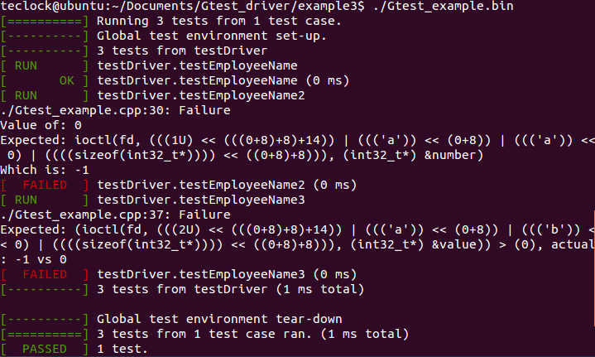

# 3 Code Coverage with app

dùng để kiểm tra các dòng lệnh và những case chưa được chạy , ...

Install

* Sudo apt-get install lcov
* Có thể không cần cài Sudo apt-get install gcovr

Step 1 : Create file main.cpp ( ../ CodeCoverage/)

Main.cpp

Step 2 : Run

Run

* g++ -fprofile-arcs -ftest-coverage -fPIC -O0 main.cpp -o program
* ./program ( dừng chay file runcov.sh nếu ko cài gcovr)
* gcovr -r .
* gcovr -r . –branches
* gcov -b main.cpp

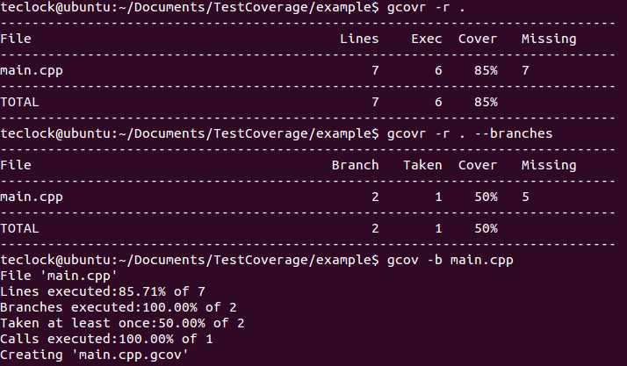

Step 3 : create file runcov.sh

runcov.sh

Step 4 : run

Run

* ./runcov.sh

( ../ CodeCoverage/ Report/index.html)

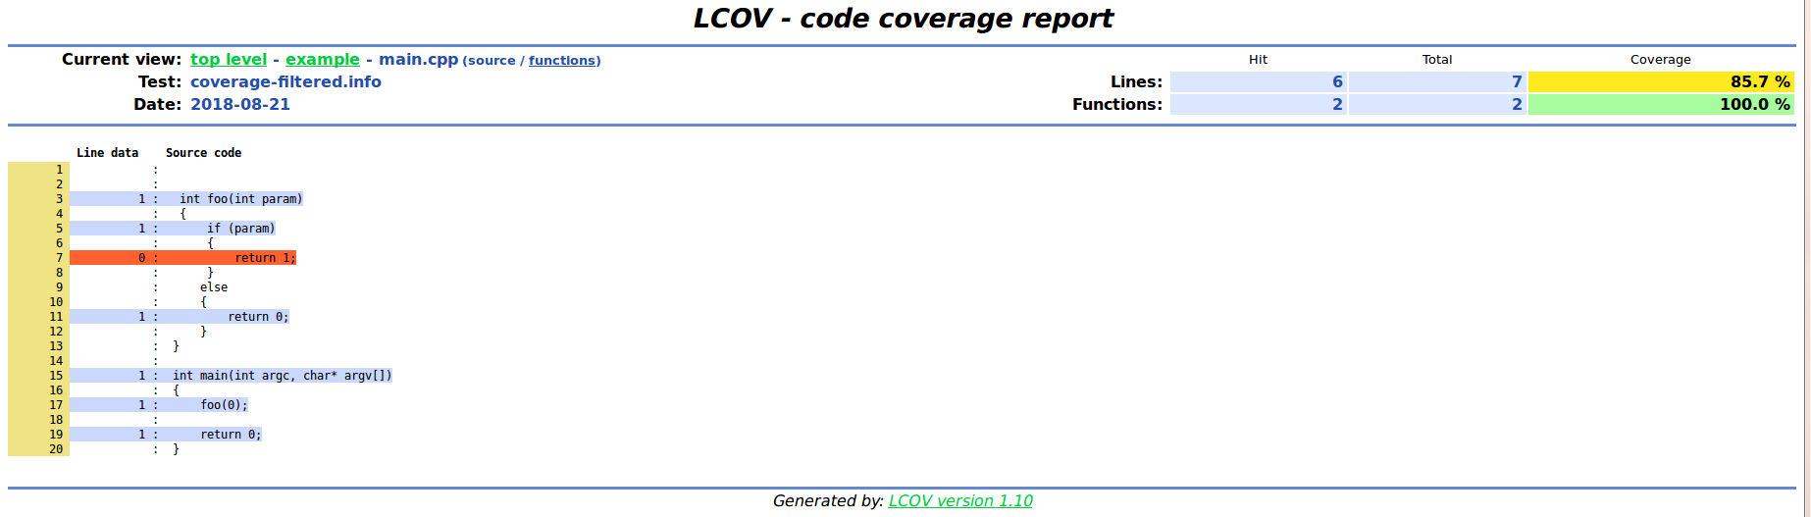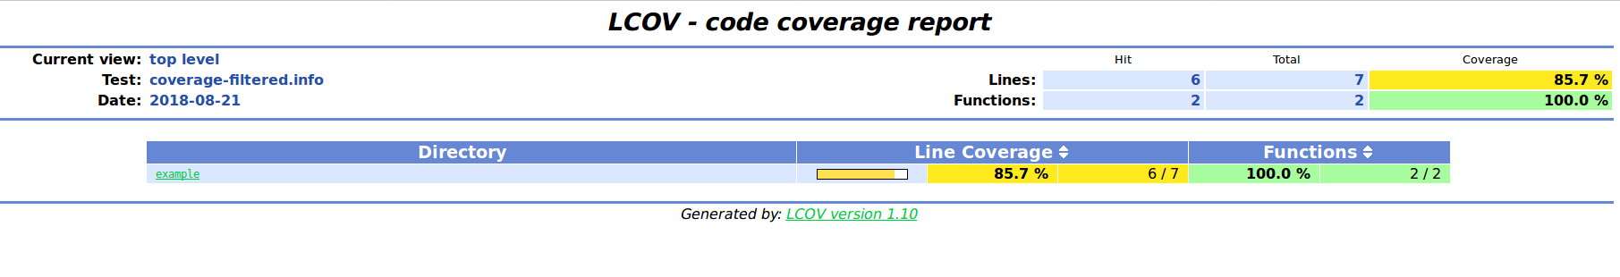

# 4 Code Coverage with driver

Folder :Example/Folder/ Sample_Pldrv

Step 1 : Create file Sample_Pldrv

Sample_Pldrv.c

Step 2 : create file makefile

Makefile

Step 3 : run

Run

* Make
* Sudo insmod driver.ko
* Cd /dev
* sudo chmod 777 etx_device

Folder :Example

Step 4 : Create file Gtest.app , using test

Gtest.cpp

Step 5 : Create file makefile

Makefile

Step 6 : Run

Run :

* Make : Create file Gtest.gcno
* ./Gest.bin : create file Gtest.gcda

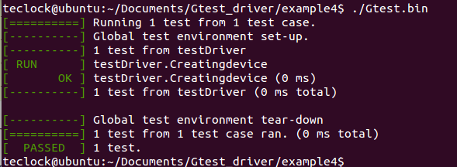

Step 7 : Create file runcov.sh (code coverage)

runcov.sh

Step 8 : Run

Run

* ./ runcov.sh

Folder :Example/report/index.html

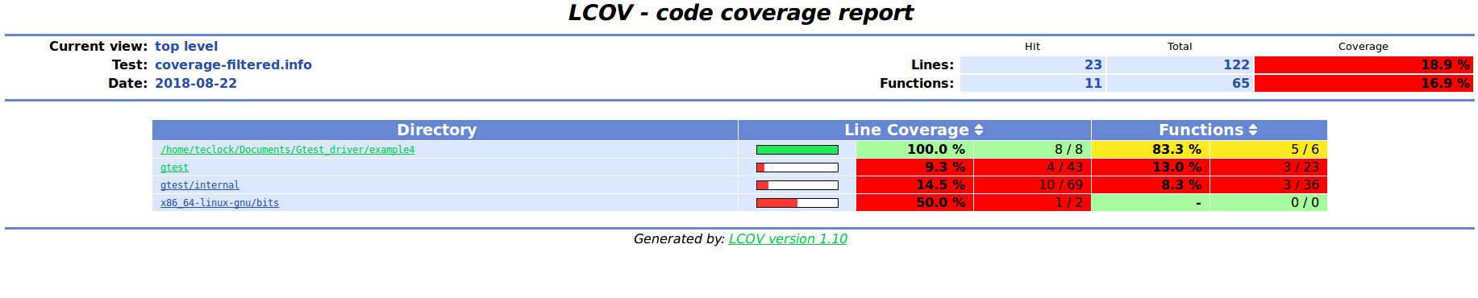

# 5 Makefile move from src to build

Step 1 : Create folder

Create : Forder Example/Src

Step 2 : Create file

Cosumer.c

Producer.c

Producer.h

Main.c

Step 3 : Create folder

Create : Example/Build

Step 4 : Create file

Example/ : create makefile

Step 5 : Run

Run makefile