Task-1. Grade Checker
Take a score as input and print the grade-

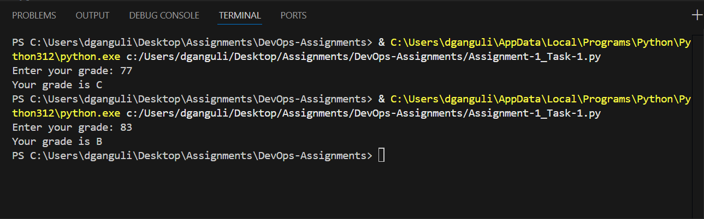

Task-2. Student Grades
Create a dictionary where the keys are student names and the values are their grades.
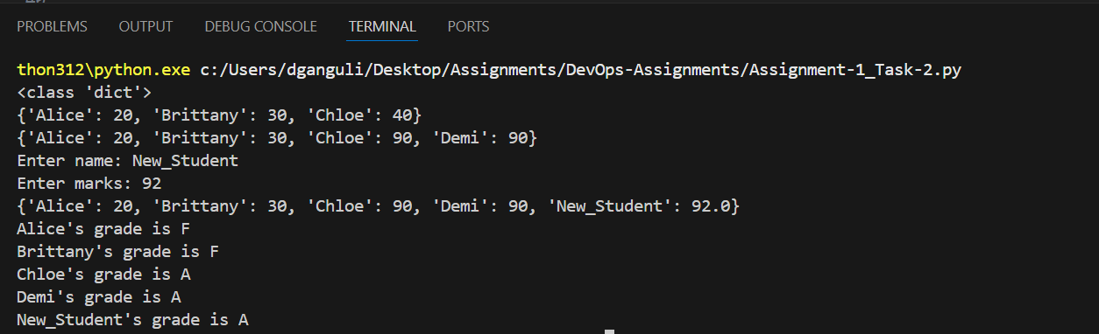

Task-3. Write to a File
Write a program to create a text file and write some content to it.
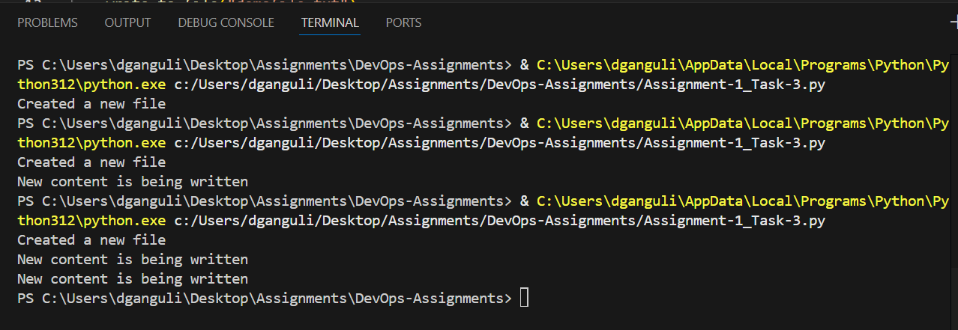
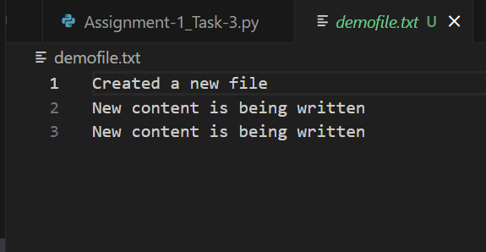

Tas-4. Read from a File
We used open in read mode and file.read to read and print to display.
