Part 1:

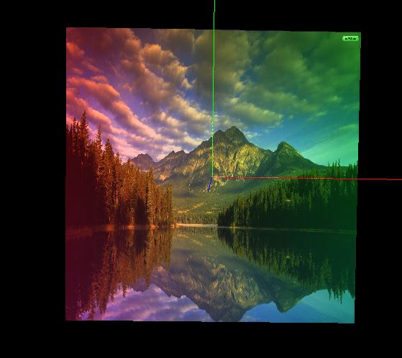

Part 2:

Mode 1:

I used a pre-defined mode.

The source scale factor I used in this is defined by GL_SRC_ALPHA and the destination scale factor I used is defined by GL_ONE_MINUS_DST_ALPHA.

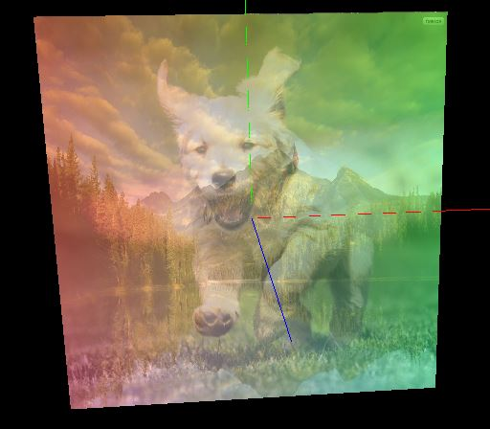

Mode 2:

The second mode I used has a source scale factor defined by GL_SRC_COLOR and a destination scale factor defined by GL_DST_COLOR.

