Eliminate Rabies Trial Analysis Report

Eliminating human rabies: impact of enhanced vaccination coverage (alternative coverage definition)
Report description:
Final Report Version 1.0
Prepared by:
Paul Johnson
Last run on:
Wed Apr 1 20:04:03 2026
Created by program:
eliminate_rabies_trial_analysis_report_v1.0.R
Created using software:
R version 4.5.1 (2025-06-13) for Unix with packages lubridate, foreign, Hmisc, gdata, lme4, glmmTMB, DHARMa, ggplot2, sjPlot, parallel, forcats, brms, bayesplot, coda, see, vioplot, sf and spdep

Table 1. Characteristics of wards, overall and by trial arm.
 |  | Total  (n=112) | Trial Arm
 |  |  | Team-based  (N=56) | Community-based  (N=56)
District | Bunda  Butiama  Musoma  Rorya  Serengeti  Tarime | 15 (13%)  14 (12%)  28 (25%)  17 (15%)  13 (12%)  25 (22%) | 7 (12%)  7 (12%)  15 (27%)  8 (14%)  7 (12%)  12 (21%) | 8 (14%)  7 (12%)  13 (23%)  9 (16%)  6 (11%)  13 (23%)
Land use | Rural  Semi-Urban  Urban | 83 (74%)  7 (6%)  22 (20%) | 37 (66%)  5 (9%)  14 (25%) | 46 (82%)  2 (4%)  8 (14%)
N dogs surveyed | Mean (SD)  Median (IQR)  [Range] | 229 (57)  226 (195, 254)  [120, 550] | 226 (51)  228 (193, 254)  [120, 395] | 232 (63)  226 (210, 254)  [120, 550]
N dogs (estimated) | Mean (SD)  Median (IQR)  [Range] | 1814 (802)  1784 (1329, 2177)  [100, 4891] | 1762 (847)  1681 (1233, 2177)  [236, 4891] | 1866 (758)  1838 (1516, 2162)  [100, 4071]
N vaccinations | Mean (SD)  Median (IQR)  [Range] | 1669 (961)  1584 (957, 2198)  [139, 5160] | 1050 (484)  1002 (676, 1305)  [167, 2096] | 2289 (920)  2217 (1756, 2684)  [139, 5160]

Table 2. Primary analysis and secondary analysis 1. Coverage and intervention odds ratio estimates (95% CI) at each survey estimated from the GLMM reported in the previous table. p-values at each survey are from likelihood ratio tests of the primary analysis null hypothesis of no intervention effect at any of the six surveys and secondary analysis 1 null hypothesis of no intervention effect at any of the three visit 2 surveys. Mean coverage (95% CI), odds ratio (95% CI) and p-value across all years were estimated from 10000 parametric bootstrap samples. Population: all dogs with primary outcome data.
Year-visit | Coverage (95% CI) |  | Odds ratio (95% CI) | p-value | p-value  (primary analysis) | p-value  (secondary analysis 1)
 | Team | Community
Y1-V1  Y1-V2  Y2-V1  Y2-V2  Y3-V1  Y3-V2 | 0.26 (0.20, 0.33)  0.17 (0.13, 0.23)  0.30 (0.23, 0.38)  0.24 (0.18, 0.31)  0.34 (0.27, 0.42)  0.23 (0.17, 0.29) | 0.37 (0.30, 0.46)  0.34 (0.26, 0.42)  0.34 (0.27, 0.42)  0.41 (0.33, 0.49)  0.42 (0.34, 0.50)  0.36 (0.28, 0.44) | 1.72 (1.32, 2.23)  2.40 (1.83, 3.16)  1.20 (0.92, 1.55)  2.14 (1.65, 2.77)  1.38 (1.07, 1.79)  1.89 (1.45, 2.46) | <0.001  <0.001  0.174  <0.001  0.013  <0.001 | <0.001 | <0.001
All years | 0.29 (0.22, 0.37) | 0.38 (0.30, 0.47) | 1.53 (1.22, 1.93) | 0.001

Table 3. Secondary analysis 2. Estimated probability (95% CI) of village-level coverage below 40% by month and averaged over the trial year, for each trial arm. The distribution of coverage among villages was estimated from 10000 parametric bootstrap samples. Population: all dogs with primary outcome data.
Trial month | P(Coverage<0.4) (95% CI)
 | Team-based | Community-based
1  2  3  4  5  6  7  8  9  10  11  12 | 0.59 (0.36, 0.80)  0.64 (0.40, 0.85)  0.68 (0.45, 0.88)  0.72 (0.49, 0.91)  0.77 (0.54, 0.94)  0.81 (0.60, 0.96)  0.85 (0.64, 0.98)  0.88 (0.68, 0.99)  0.90 (0.72, 0.99)  0.91 (0.75, 0.99)  0.92 (0.77, 1.00)  0.93 (0.79, 1.00) | 0.51 (0.27, 0.74)  0.52 (0.28, 0.76)  0.53 (0.29, 0.78)  0.54 (0.29, 0.80)  0.56 (0.29, 0.82)  0.57 (0.30, 0.83)  0.59 (0.30, 0.85)  0.60 (0.32, 0.86)  0.61 (0.33, 0.86)  0.62 (0.34, 0.86)  0.63 (0.35, 0.86)  0.63 (0.36, 0.86)
All months | 0.80 (0.62, 0.93) | 0.58 (0.32, 0.81)

Table for main text. Secondary analyses 3 and 4. Estimated median (95% CI) Community-based:Team-based temporal and spatial inter-village variance ratio. Population: all dogs with primary outcome data.
Analysis | Community-based:team-based ratio (95% CI)
Secondary 3 (variation over time)  Secondary 4 (variation over space) | 0.70 (0.59, 0.93)  1.99 (0.00, 26.75)

Table for main text. Secondary analysis 5. Estimate (95% CI) V2:V1 ratio of Community-based:Team-based odds ratios. This ratio represents the interaction between trial arm and visit; the p-value tests the null hypothesis of equal intervention effect between visit 1 and visit 2. This interaction effect did not differ between the three years (trial arm × visit × year interaction p-value = 0.405). Population: all dogs with primary outcome data.
InteractionOR | p-value
1.51 (1.27, 1.81) | <0.001

Table 4. Secondary analysis 6. Estimate (95% CI) of V2:V1 odds ratios and of minimum coverage at visit 1 required for coverage at visit 2 to exceed 40%, by trial arm. V2:V1 odds ratios differed significantly between trial arms (interaction P
Trial_Arm | Visit effect OR (95% CI) | p-value | Start-of-year coverage for end-of-year coverage ≥ threshold
Team-based  Community-based | 0.64 (0.52, 0.78)  0.96 (0.78, 1.18) | <0.001  0.701 | 0.58 (0.50, 0.66)  0.42 (0.34, 0.50)

Table S1. Estimates of fixed effects (log odds and log odds ratios) and random effects (variances) from the GLMMs fitted for the primary analysis. Number of observations, number of each random effect level, and marginal and conditional R² are also presented. The null hypothesis of no intervention effect was rejected (χ²(6), p < 0.001). Population: all dogs with primary outcome data.
 | Primary analysis null hypothesis model |  |  |  | Primary analysis alternative hypothesis model
Predictors | Log-Odds | std. Error | CI | p | Log-Odds | std. Error | CI | p
(Intercept) | -0.98 | 0.21 | -1.39, -0.58 | <0.001 | -1.32 | 0.22 | -1.76, -0.89 | <0.001
Visit [V2] | -0.39 | 0.20 | -0.77, -0.00 | 0.048 | -0.61 | 0.22 | -1.05, -0.17 | 0.007
Year [Y2] | 0.03 | 0.19 | -0.35, 0.41 | 0.872 | 0.27 | 0.22 | -0.16, 0.70 | 0.220
Year [Y3] | 0.36 | 0.19 | -0.02, 0.74 | 0.061 | 0.50 | 0.22 | 0.08, 0.93 | 0.021
Visit [V2] × Year [Y2] | 0.40 | 0.28 | -0.14, 0.94 | 0.147 | 0.24 | 0.31 | -0.38, 0.85 | 0.450
Visit [V2] × Year [Y3] | -0.12 | 0.28 | -0.66, 0.42 | 0.673 | -0.10 | 0.31 | -0.71, 0.52 | 0.756
Trial Arm  [Community-based] |  |  |  |  | 0.67 | 0.17 | 0.35, 0.99 | <0.001
Visit [V2] × Trial Arm  [Community-based] |  |  |  |  | 0.42 | 0.20 | 0.02, 0.81 | 0.038
Year [Y2] × Trial Arm  [Community-based] |  |  |  |  | -0.45 | 0.19 | -0.83, -0.07 | 0.021
Year [Y3] × Trial Arm  [Community-based] |  |  |  |  | -0.27 | 0.19 | -0.64, 0.11 | 0.165
(Visit [V2] × Year [Y2])  × Trial Arm  [Community-based] |  |  |  |  | 0.30 | 0.28 | -0.24, 0.85 | 0.277
(Visit [V2] × Year [Y3])  × Trial Arm  [Community-based] |  |  |  |  | -0.03 | 0.28 | -0.57, 0.52 | 0.917
Random Effects
σ² | 3.29 |  |  |  | 3.29
τ₀₀ | 0.55 _{sub_village.rnd} |  |  |  | 0.55 _{sub_village.rnd}
 | 0.46 _{sub_village} |  |  |  | 0.48 _{sub_village}
 | 0.15 _{ward.rnd} |  |  |  | 0.11 _{ward.rnd}
 | 0.24 _{ward} |  |  |  | 0.13 _{ward}
 | 0.12 _{district.rnd} |  |  |  | 0.13 _{district.rnd}
 | 0.18 _{district} |  |  |  | 0.18 _{district}
N | 2473 _{sub_village.rnd} |  |  |  | 2473 _{sub_village.rnd}
 | 687 _{sub_village} |  |  |  | 687 _{sub_village}
 | 663 _{ward.rnd} |  |  |  | 663 _{ward.rnd}
 | 112 _{ward} |  |  |  | 112 _{ward}
 | 54 _{district.rnd} |  |  |  | 54 _{district.rnd}
 | 9 _{district} |  |  |  | 9 _{district}
Observations | 25677 |  |  |  | 25677
Marginal R² / Conditional R² | 0.010 / 0.347 |  |  |  | 0.038 / 0.350

Table S2. Estimates of fixed effects (log odds and log odds ratios) and random effects (variances) from the primary analysis GLMM and the same model adjusted for land use category. Number of observations, number of each random effect level, and marginal and conditional R² are also presented. Adding land use category to the primary analysis model did not significantly improve fit (χ²(2), p = 0.687). Population: all dogs with primary outcome data.
 | Primary analysis full model |  |  |  | Primary analysis full model adjusted for land use
Predictors | Log-Odds | std. Error | CI | p | Log-Odds | std. Error | CI | p
(Intercept) | -1.32 | 0.22 | -1.76, -0.89 | <0.001 | -1.40 | 0.24 | -1.88, -0.92 | <0.001
Visit [V2] | -0.61 | 0.22 | -1.05, -0.17 | 0.007 | -0.61 | 0.22 | -1.05, -0.17 | 0.007
Year [Y2] | 0.27 | 0.22 | -0.16, 0.70 | 0.220 | 0.27 | 0.22 | -0.16, 0.70 | 0.220
Year [Y3] | 0.50 | 0.22 | 0.08, 0.93 | 0.021 | 0.50 | 0.22 | 0.08, 0.93 | 0.021
Trial Arm  [Community-based] | 0.67 | 0.17 | 0.35, 0.99 | <0.001 | 0.67 | 0.17 | 0.35, 1.00 | <0.001
Visit [V2] × Year [Y2] | 0.24 | 0.31 | -0.38, 0.85 | 0.450 | 0.24 | 0.31 | -0.38, 0.85 | 0.449
Visit [V2] × Year [Y3] | -0.10 | 0.31 | -0.71, 0.52 | 0.756 | -0.10 | 0.31 | -0.71, 0.52 | 0.758
Visit [V2] × Trial Arm  [Community-based] | 0.42 | 0.20 | 0.02, 0.81 | 0.038 | 0.42 | 0.20 | 0.02, 0.81 | 0.038
Year [Y2] × Trial Arm  [Community-based] | -0.45 | 0.19 | -0.83, -0.07 | 0.021 | -0.45 | 0.19 | -0.83, -0.07 | 0.021
Year [Y3] × Trial Arm  [Community-based] | -0.27 | 0.19 | -0.64, 0.11 | 0.165 | -0.27 | 0.19 | -0.64, 0.11 | 0.164
(Visit [V2] × Year [Y2])  × Trial Arm  [Community-based] | 0.30 | 0.28 | -0.24, 0.85 | 0.277 | 0.30 | 0.28 | -0.24, 0.85 | 0.277
(Visit [V2] × Year [Y3])  × Trial Arm  [Community-based] | -0.03 | 0.28 | -0.57, 0.52 | 0.917 | -0.03 | 0.28 | -0.58, 0.52 | 0.916
LandUse [Semi-Urban] |  |  |  |  | -0.07 | 0.24 | -0.54, 0.40 | 0.775
LandUse [Urban] |  |  |  |  | 0.27 | 0.34 | -0.39, 0.93 | 0.416
Random Effects
σ² | 3.29 |  |  |  | 3.29
τ₀₀ | 0.55 _{sub_village.rnd} |  |  |  | 0.55 _{sub_village.rnd}
 | 0.48 _{sub_village} |  |  |  | 0.48 _{sub_village}
 | 0.11 _{ward.rnd} |  |  |  | 0.11 _{ward.rnd}
 | 0.13 _{ward} |  |  |  | 0.13 _{ward}
 | 0.13 _{district.rnd} |  |  |  | 0.13 _{district.rnd}
 | 0.18 _{district} |  |  |  | 0.17 _{district}
N | 2473 _{sub_village.rnd} |  |  |  | 2473 _{sub_village.rnd}
 | 687 _{sub_village} |  |  |  | 687 _{sub_village}
 | 663 _{ward.rnd} |  |  |  | 663 _{ward.rnd}
 | 112 _{ward} |  |  |  | 112 _{ward}
 | 54 _{district.rnd} |  |  |  | 54 _{district.rnd}
 | 9 _{district} |  |  |  | 9 _{district}
Observations | 25677 |  |  |  | 25677
Marginal R² / Conditional R² | 0.038 / 0.350 |  |  |  | 0.039 / 0.348

Table S3. Characteristics of surveyed dogs, overall and by trial arm. Population: all dogs.
 |  | Total  (n=25677) | Trial Arm
 |  |  | Team-based  (N=12670) | Community-based  (N=13007)
Age (years) | N_{OBS} (N_{MISSING})  Mean (SD)  Median (IQR)  [Range] | 25677 (0)  3.1 (2.1)  3.0 (1.0, 4.0)  [0.5, 16.0] | 12670 (0)  3.1 (2.2)  3.0 (1.0, 4.0)  [0.5, 16.0] | 13007 (0)  3.0 (2.1)  3.0 (1.0, 4.0)  [0.5, 16.0]
Sex | N_{OBS} (N_{MISSING})  Female  Male | 25677 (0)  8527 (33%)  17150 (67%) | 12670 (0)  4003 (32%)  8667 (68%) | 13007 (0)  4524 (35%)  8483 (65%)
Year-visit | N_{OBS} (N_{MISSING})  Y1-V1  Y1-V2  Y2-V1  Y2-V2  Y3-V1  Y3-V2 | 25677 (0)  4423 (17%)  4060 (16%)  4297 (17%)  4503 (18%)  4222 (16%)  4172 (16%) | 12670 (0)  2227 (18%)  1988 (16%)  2078 (16%)  2224 (18%)  2091 (17%)  2062 (16%) | 13007 (0)  2196 (17%)  2072 (16%)  2219 (17%)  2279 (18%)  2131 (16%)  2110 (16%)
Primary coverage outcome | N_{OBS} (N_{MISSING})  Not vaccinated  Vaccinated | 25677 (0)  16644 (65%)  9033 (35%) | 12670 (0)  8633 (68%)  4037 (32%) | 13007 (0)  8011 (62%)  4996 (38%)
Secondary coverage outcome | N_{OBS} (N_{MISSING})  Not vaccinated  Vaccinated | 25677 (0)  16644 (65%)  9033 (35%) | 12670 (0)  8633 (68%)  4037 (32%) | 13007 (0)  8011 (62%)  4996 (38%)

Table S4. Moran's test for spatial autocorrelation in the residuals of the primary analysis full model, applied at a range of spatial scales defined by the number of nearest neighbours (kNN).
kNN | Moran's I | p-value
1  2  3  4  5  6  7  8  9  10 | 0.47  0.67  0.4  0  -0.78  -1.06  -0.94  -0.48  0.15  0.3 | 0.318  0.251  0.345  0.499  0.783  0.855  0.827  0.686  0.439  0.380

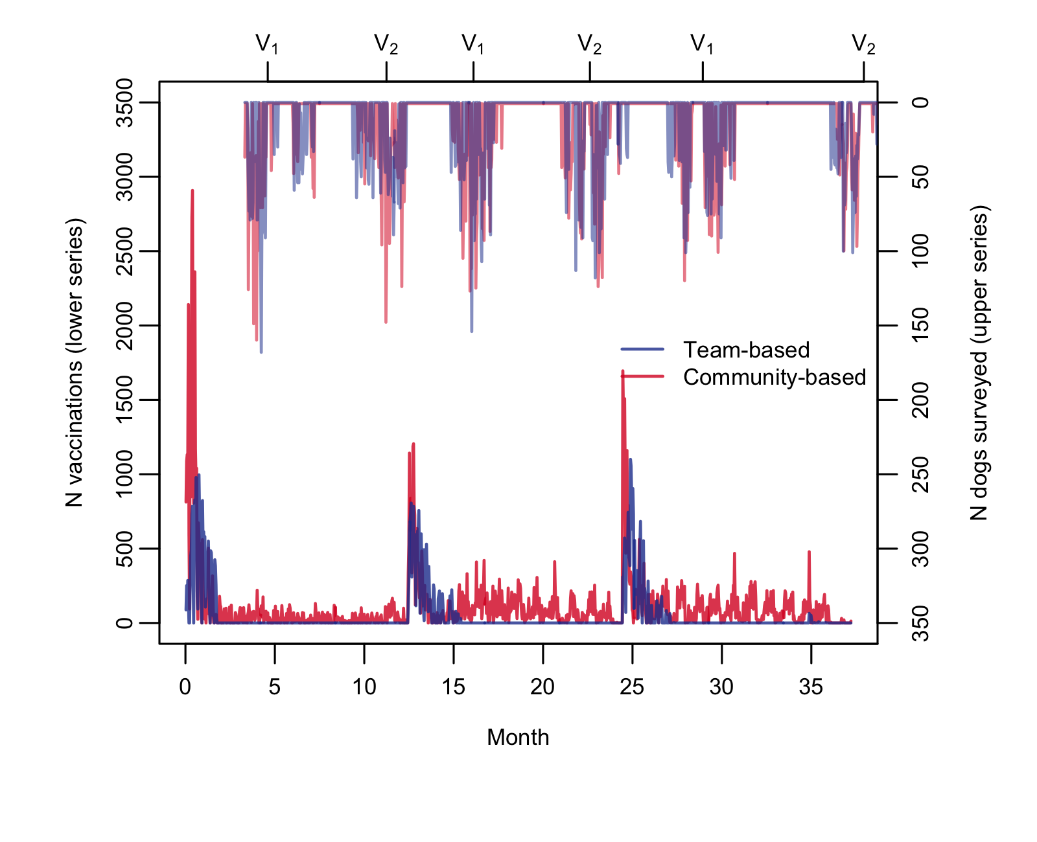
Figure 2. Number of rabies vaccinations performed (lower series; total = 186931) and number of dogs surveyed (upper series; total = 25677) per day, by trial arm.

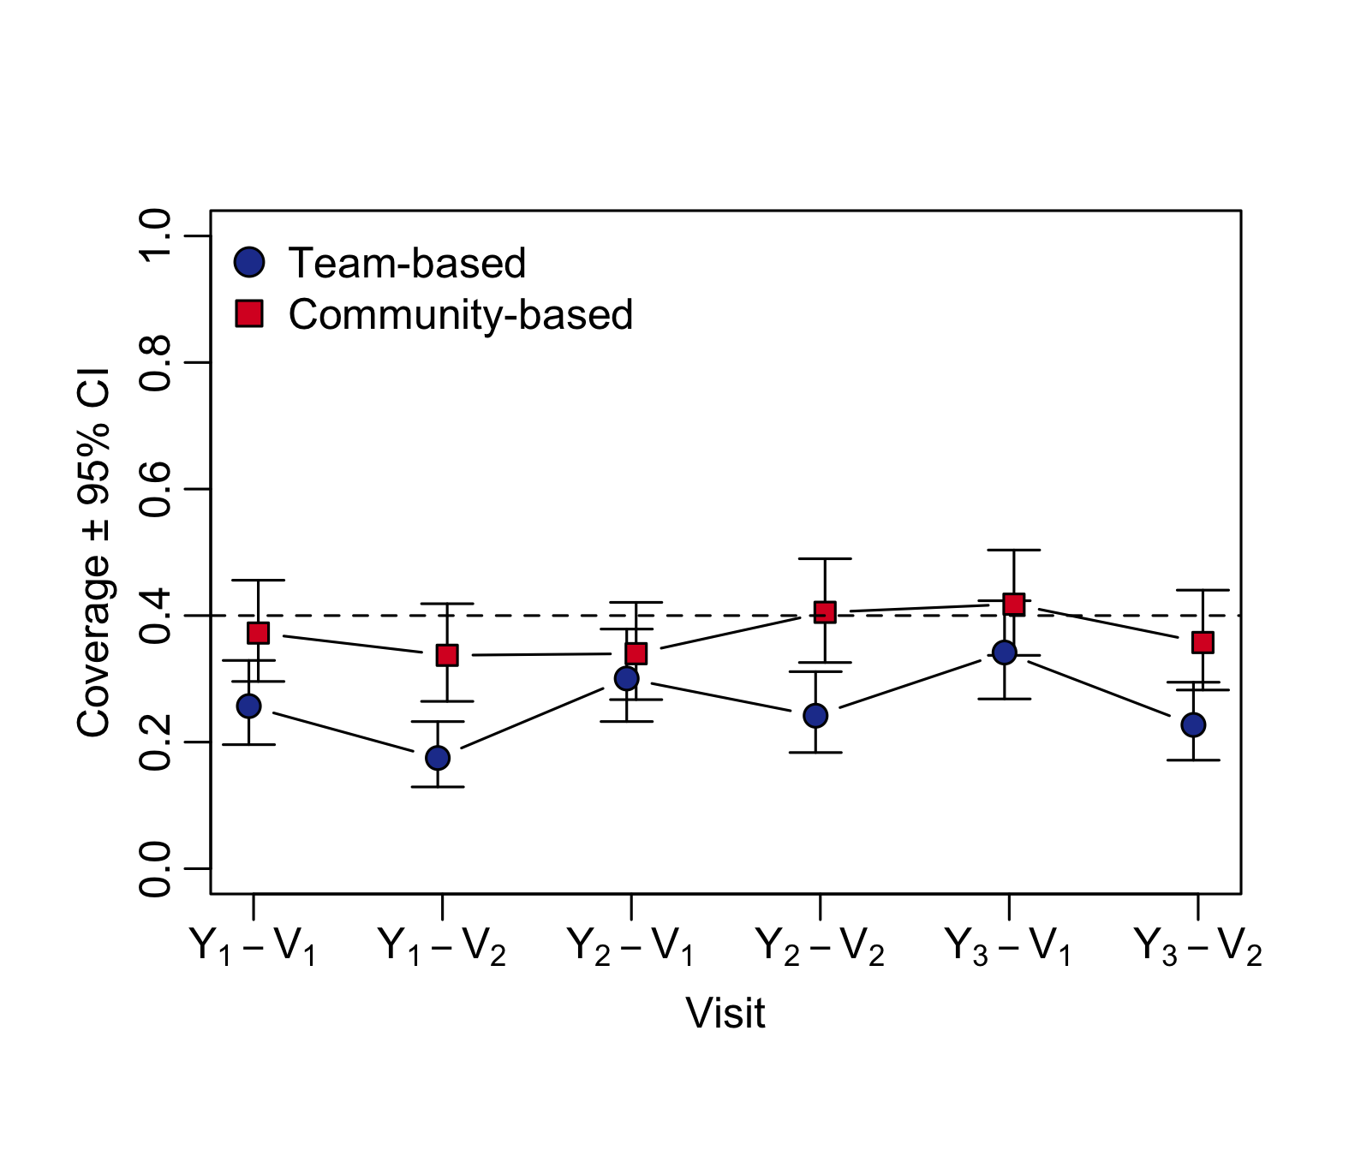
Figure 3. Estimated coverage ± 95% confidence limits at each survey time point, by trial arm. Population: all dogs with primary outcome data.

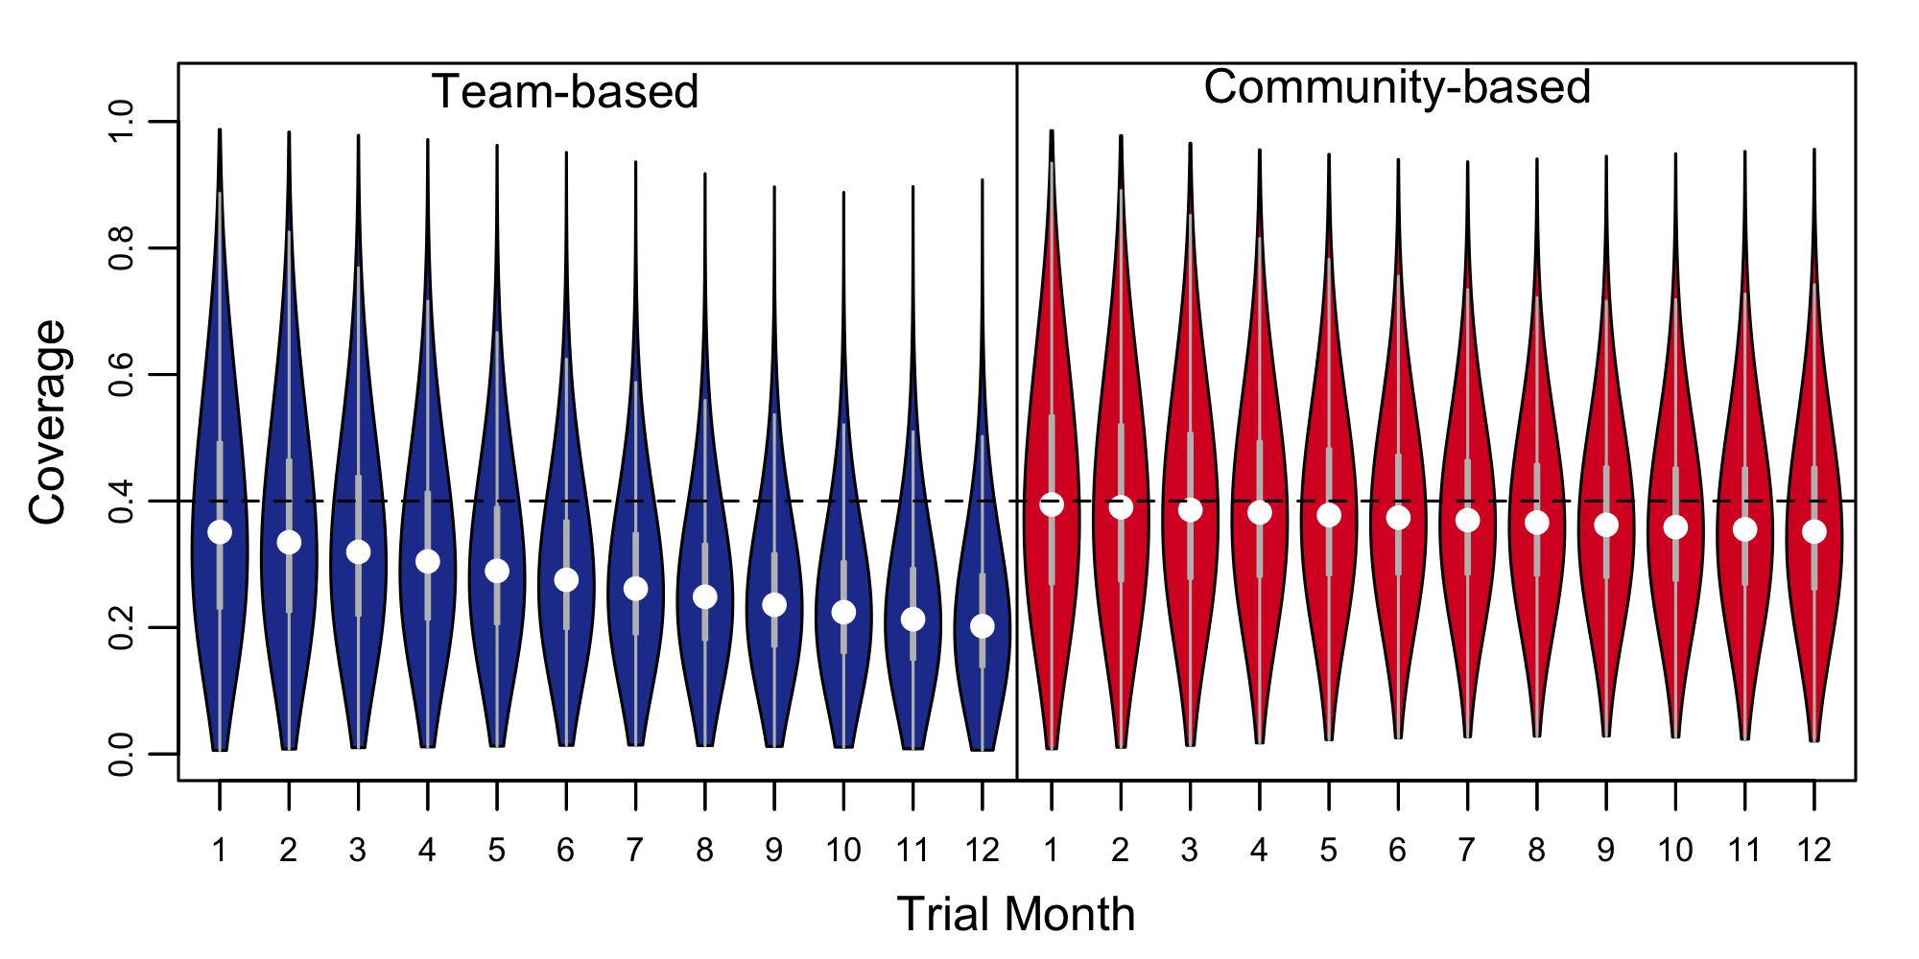
Figure 4. Estimated probability distribution of coverage by trial month for each arm. The coverage target of 40% is shown by a dashed line. White circles indicate medians and quartiles and range are shown by box-and-whisker plots.

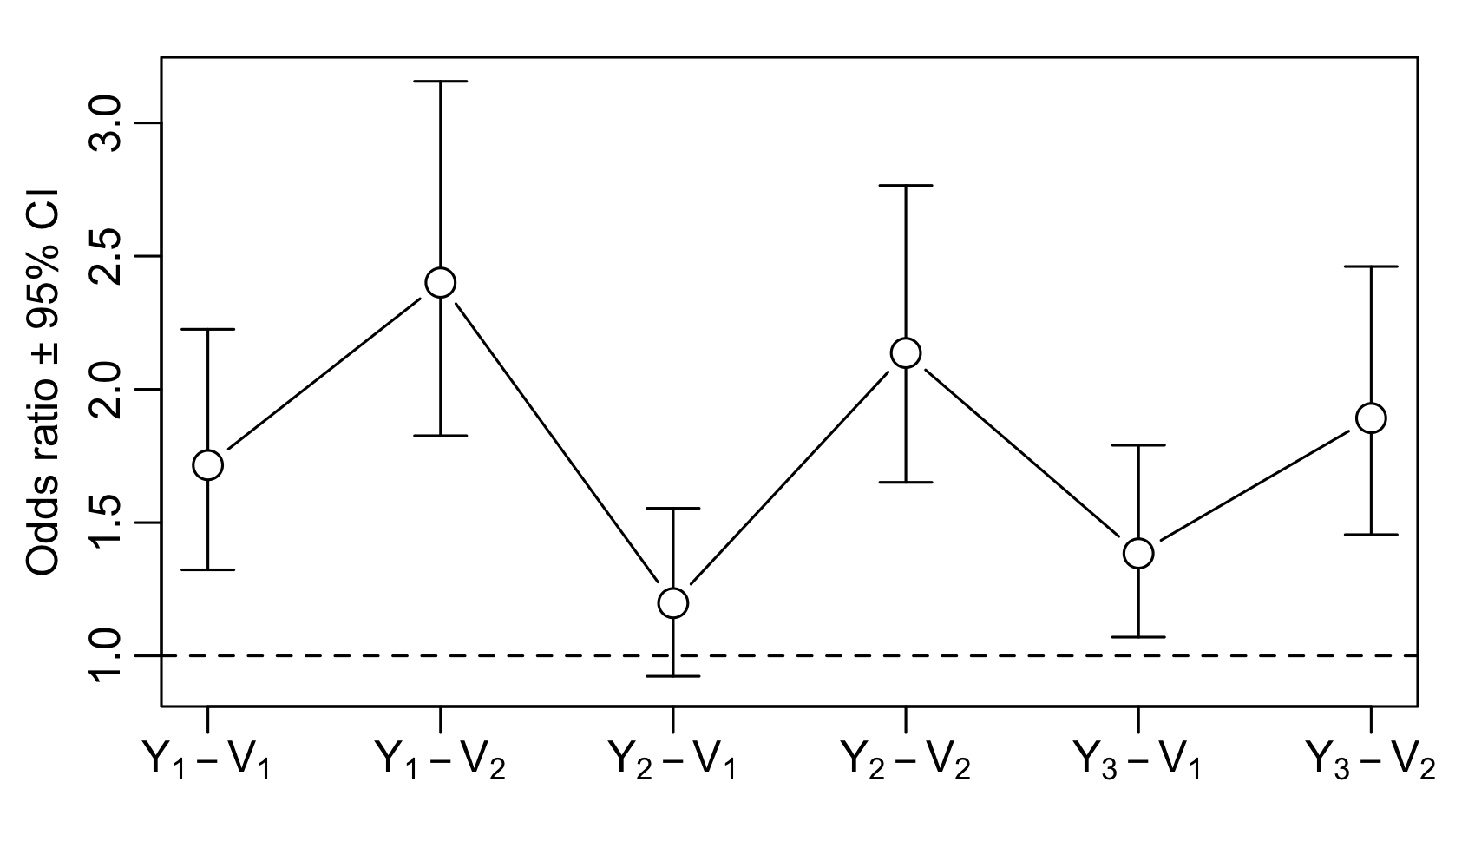
Figure 5. Estimated intervention effect (Community-based:Team-based) odds ratios ± 95% confidence limits at each survey time point. Population: all dogs with primary outcome data.

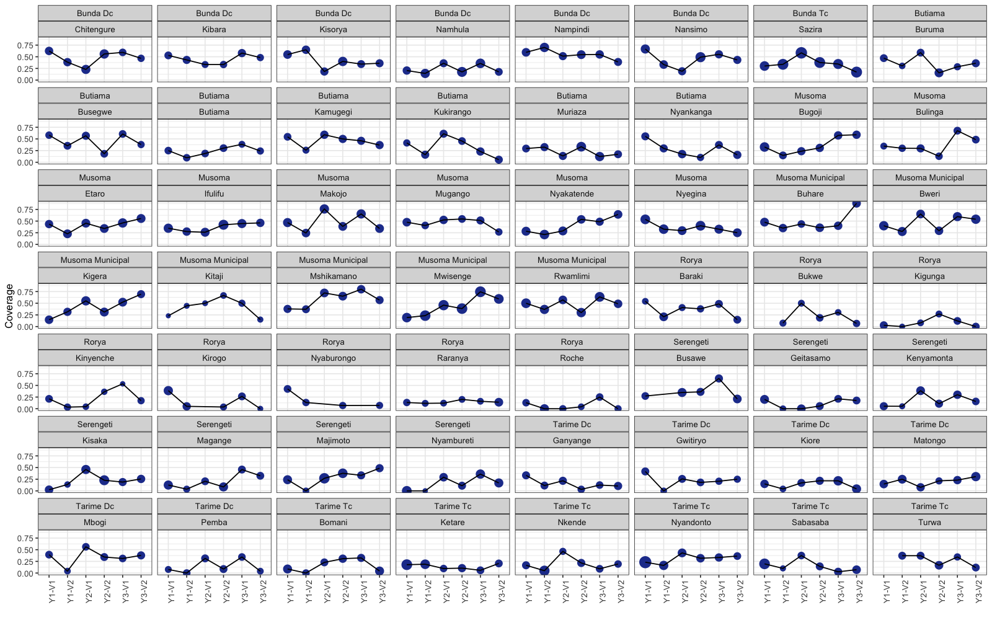
Figure S1. Coverage by ward and survey time point in the Team-based arm.

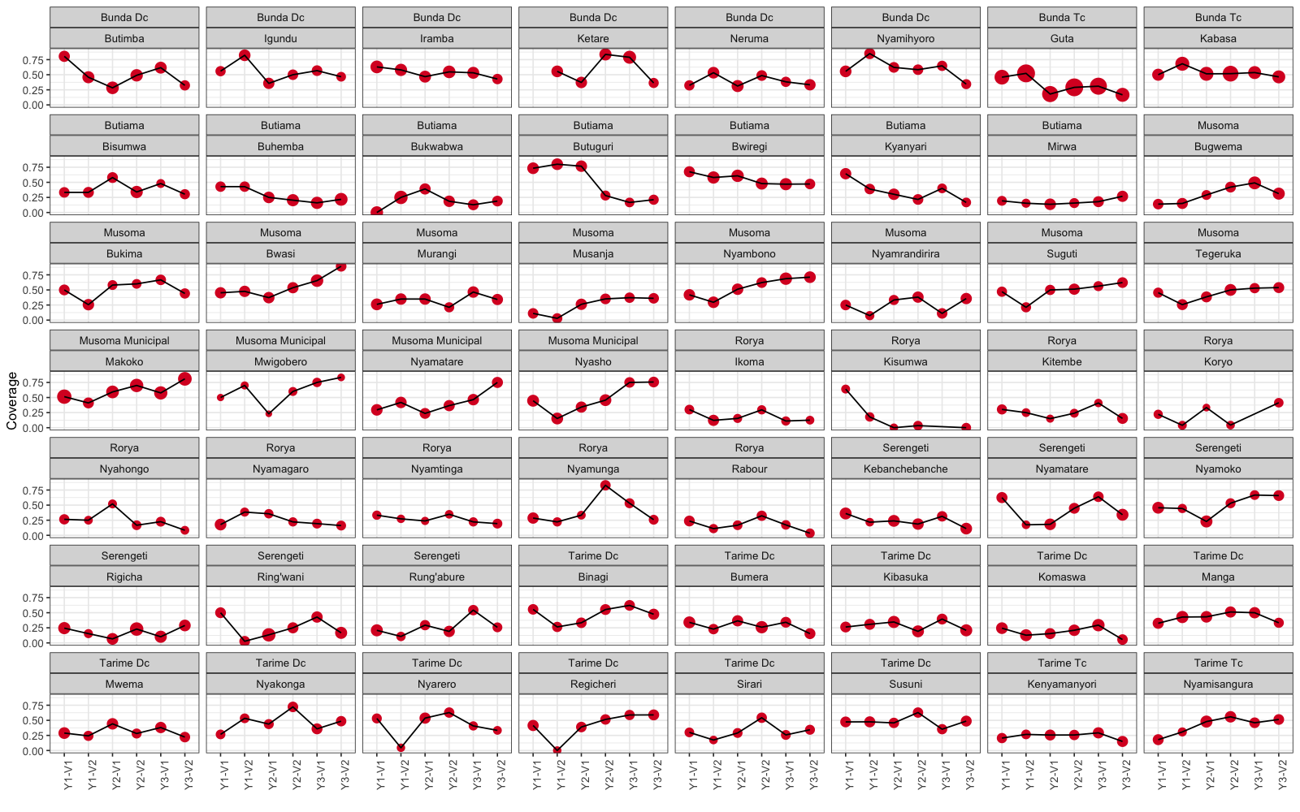
Figure S2. Coverage by ward and survey time point in the Community-based arm.

