pcDuuino3C carrier board PCB spec
1. Material: FR4

2. USB data traces: highlighted 3 pairs, differential impedance needs to be 90 ohm.

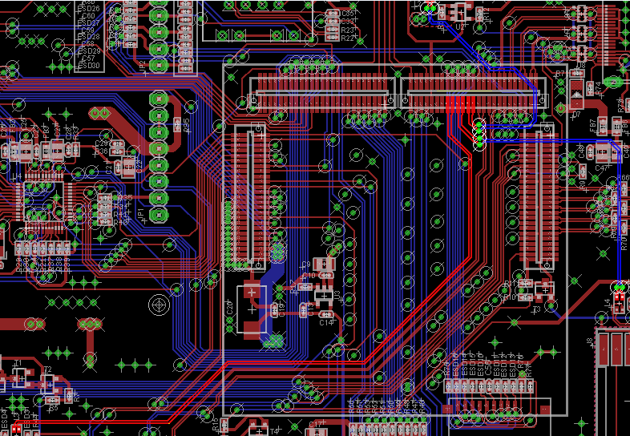

3. HDMI traces: highlighted 4 pairs. Each pair needs to have a differential impedance to be 100 ohm. 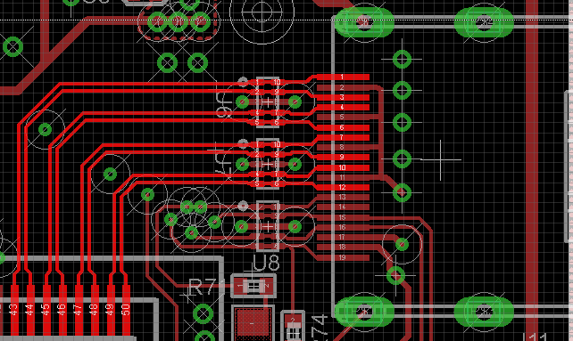

4. LVDS: Highlighted 4 pairs. Differential impedance needs to be 100 ohms.
