Initial prompt:

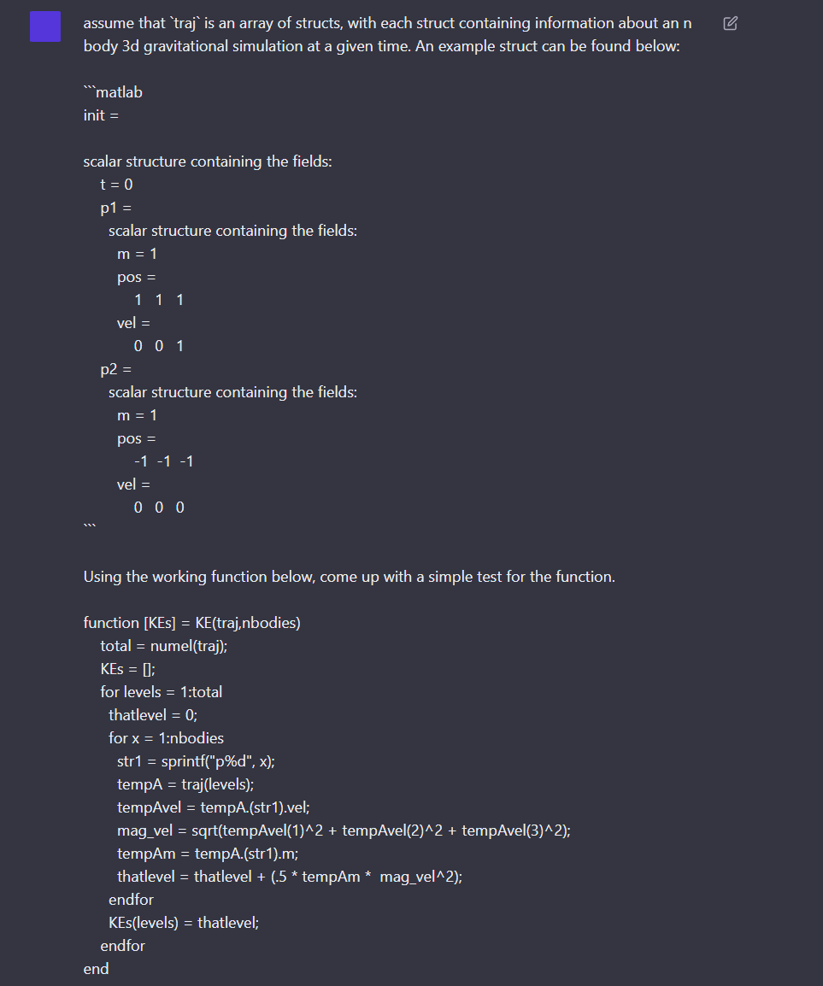

The response:  
  
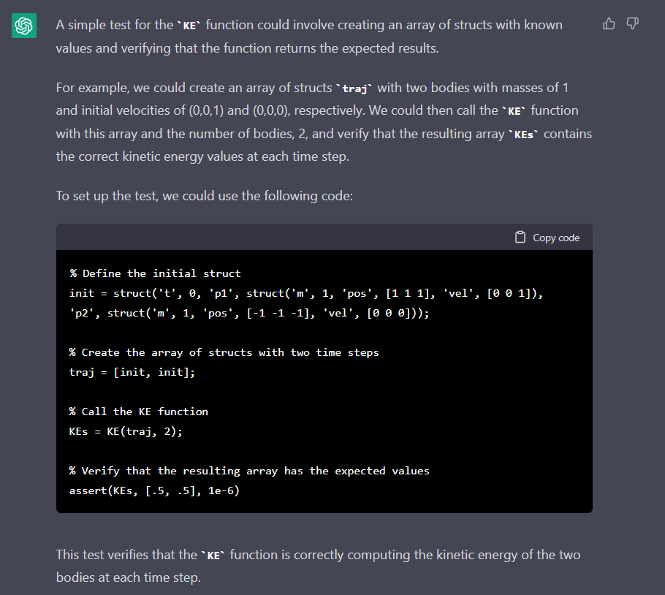

Impressively, the test passes right off the bat. I am extremely impressed that ChatGPT was able to not only determine the exact data structure I was using. Unfortunately, it doesn’t quite know about the next function, since I conveniently forgot to let it know that it exists, and it just set the second state of traj equal to init as well. It did however correctly calculate the kinetic energy of the two states it made:  
  
KE = .5mv^2  
KE = .5 \* 1 \* 1^2 = .5  
  
  
  
  
  
  
  
  
  
I let it know about the next function, and a 2% tolerance, then I get this. Note that the value of g is incorrect, it should not be equal to 9.81 m/s . After letting ChatGPT know it used the wrong gravitational constant, it was able to correct it easily. Graphical user interface, text

The expected value of the kinetic energy of the second state is wrong now that the value of g changed:

Uhh… That doesn’t look right, what is XXXXXX supposed to be?

Where is the rest of the test?

And there we have a perfectly passing test.

It is incredible that an AI chatbot has the ability to create working code for something so complex.