In a previous chat thread with ChatGPT, I managed to ‘teach’ it what my structure was for my trajectory array, traj. I attempted to continue that thread to create some tests for the min_approach_distance function.  
  
This is a very difficult task, and I don’t expect the code to work immediately.

Sure enough, the test fails, but ChatGPT did make a very solid foundation to start off on.  
  
It creates the following two states manually, without using my next function:

Note that it doesn’t even add in a velocity for each body, as it knows that min_approach_distance doesn’t use a velocity.

The reason the test fails is simple, it has the incorrect expected values. Note that the interptime is correct, the expected distance is close to accurate (sqrt(12) is correct, not sqrt(2)), and the noninterp index is entirely incorrect.

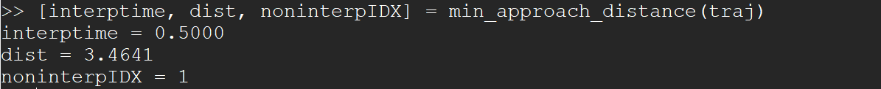

Fixing the code results in a passing test.

As seen in previous examples, I can ask ChatGPT to add the expected and actual values to the error messages:

The test still passes after changing just the following lines:

Asking ChatGPT to use assert instead of fprintf:

The test remains passing after changing the correct lines.

Overall, although ChatGPT made mistakes with the expected values and inaccuracies in the error messages and its usage of fprintf instead of assert, it is still extremely impressive that it was able to create such a useful amount of text. Overall, I would say 90-95% of the code it provided was correct, which is an extremely impressive figure given the difficulty of the problem I presented it with.