Fleet Telemetry Platform
Technical Architecture Document

Version Draft
Client Mobily Fleet Operations
Date March 2026
Prepared By Mohamed Ilyes Arfaoui

Role | Name | Responsibility
Systems Architect | — | Technical lead, architecture design, API contracts
Software Engineer | — | Ingestion library, pipeline, Odoo module
Security Engineer (Red) | — | Penetration testing, threat modeling, audit, vulnerability research
Security Engineer (Blue) | — | Transport controls, network segmentation, cert rotation, remediation, incident response
Embedded Systems Engineer | — | Firmware, device config, hardware eval
Cloud Engineer | — | Infrastructure, deployment, scaling

Full System Architecture

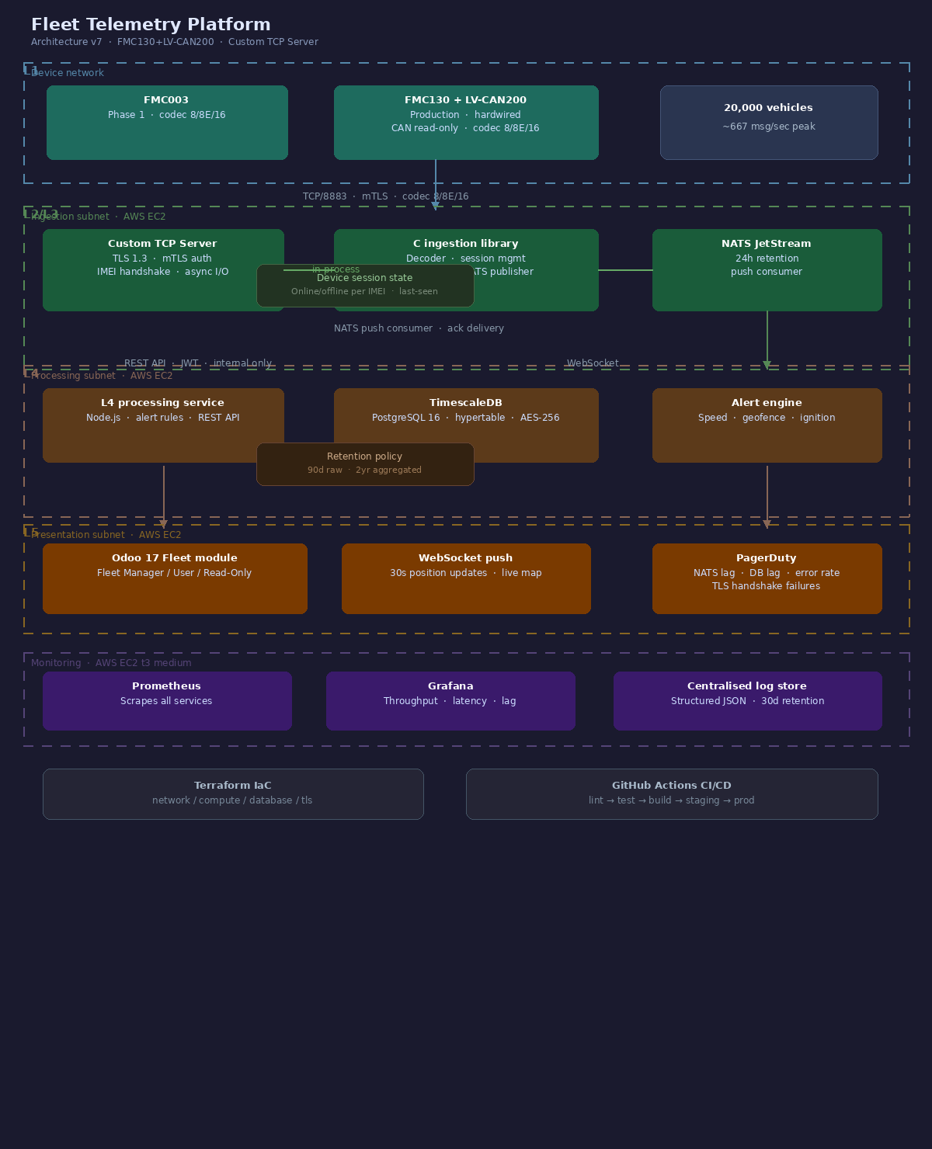

1. System Overview
The platform is a closed-network, five-layer telemetry system connecting Teltonika vehicle devices to a native Odoo Fleet module. Each layer has a single owner, a defined interface, and no knowledge of the layers above or below its own interface contract. Phase 1 (prototype) uses the FMC003. Production deployment will use the FMC650 with the All-CAN300 CAN data adapter.

Layer | Name | Responsibility | Owner
L1 | Device | FMC003 firmware, telemetry capture, offline buffer (Phase 1); FMC650 + All-CAN300 (production) | Embedded Engineer
L2 | Transport | Custom TCP server + TLS 1.3, mTLS device auth, internal network | Security Engineer (Blue)
L3 | Ingestion | Custom C ingestion library, codec 8/8E/16 decoder, device session management, NATS JetStream, event normalization | Software Engineer + Systems Architect
L4 | Processing | Business logic, alerting, TimescaleDB, REST API | Software Engineer + Systems Architect
L5 | Presentation | Odoo Fleet module, WebSocket push, read-only views | Software Engineer + Cloud

Fleet size: 20,000 vehicles. Estimated message volume at 30-second reporting interval: 40,000 messages/minute at steady state, ~667 msg/sec peak.

2. Stack & Technology Choices

2.1 Device — Teltonika FMC003 (Phase 1) / FMC650 + All-CAN300 (Production)
The FMC003 is a GNSS/GSM tracker supporting the Teltonika codec 8/8E/16 protocol over TCP. It is used for the Phase 1 prototype deployment. Key capabilities used in this platform:
- GNSS positioning GPS, GLONASS, BEIDOU — lat/lng, altitude, accuracy radius
- CAN bus reader speed, RPM, fuel level, engine load, odometer via OBD-II/CAN
- I/O events ignition on/off, door sensors, driver ID via iButton
- Records on Stop (RoS) onboard flash buffer — stores records during signal loss, flushes on reconnect. Configured via Teltonika Configurator, no custom firmware required.

Production device (Phase 2+): Teltonika FMC650 + All-CAN300
The FMC650 replaces the FMC003 for production. It supports CAN-FD and provides a dedicated CANbus interface, removing the dependency on OBD-II adapters for deep vehicle data. The All-CAN300 CAN data adapter connects inline on the vehicle CANbus, exposing full FMS/CAN-FD telemetry — fuel consumption, engine hours, axle load, and driver behaviour events — beyond the OBD-II subset available on the FMC003. Codec compatibility (8/8E/16) and the Teltonika Configurator provisioning workflow are preserved across both devices; no changes to the L2–L5 stack are required for the transition.

2.2 Transport — Custom TCP Server + TLS
The transport layer is a purpose-built TCP server with TLS 1.3 termination and mTLS device authentication. The FMC003 and FMC650 connect directly over raw TCP using the Teltonika binary codec — no MQTT broker is involved. The server is implemented as an async I/O daemon capable of maintaining 20,000 persistent connections on a single EC2 instance.
- Protocol Raw binary TCP over port 8883, TLS-wrapped
- TLS version 1.3 minimum enforced at server level. No TLS 1.2 fallback.
- Device auth Mutual TLS (mTLS) — unique client certificate per device (FMC003 or FMC650) provisioned at device configuration time
- Connection handling Per-connection IMEI handshake on connect. Persistent TCP session for the device lifetime. Heartbeat timeout and dead-connection reaping handled by the server.

2.3 Ingestion — Custom C Library + NATS JetStream
We will be implementing a custom, single purpose-built C library. The library accepts decoded payloads directly from the TCP ingestion server, decodes the Teltonika binary payload in-process, manages device session state, normalizes to the event schema, and publishes to NATS JetStream — all in one process with no intermediate hop.
The library is structured as four modules: TCP connection handler (raw socket ingestion, TLS handshake, IMEI session binding), codec 8/8E/16 decoder (pure bit manipulation, covers AVL IDs, extended IO, buffered record framing), device session manager (online/offline state per IMEI, last-seen timestamp, reconnect handling), and NATS publisher (nats.c client). Total estimated size: 1,500–2,500 lines. Deployed as a single statically-linked binary in a minimal container.

NATS JetStream is chosen over heavier brokers (Kafka, RabbitMQ) based on fleet scale. At 667 msg/sec, a single NATS server handles the load with significant headroom. JetStream persistence provides durable delivery without a cluster.
- Subject structure
- telemetry.raw.{device_id} — one subject per device
- telemetry.events.{type} — typed event streams (ignition, geofence, alert)
- Retention 24-hour sliding window on raw stream. Processed data persists in TimescaleDB.
- Consumer L4 processing service subscribes as a push consumer with ack-based delivery

2.4 Processing — PostgreSQL + TimescaleDB
L4 is a Node.js service that consumes from NATS, applies business logic, writes to the database, and exposes a REST API to L5.
- Database PostgreSQL 16 with TimescaleDB extension — telemetry data stored as a hypertable partitioned by time and device_id
- Retention policy Raw telemetry: 90 days. Aggregated hourly summaries: 2 years.
- Alerting Rule engine evaluated per-event — speed threshold, geofence breach, ignition anomaly. Alerts written to a separate table and pushed via WebSocket.
- REST API Internal only. Consumed by Odoo module. JSON over HTTP/HTTPS. No public endpoint.

2.5 Presentation — Odoo Fleet Module
A native Odoo 17 module extending the Fleet app. No separate frontend. Data is pulled via REST API from L4 and pushed in real time via WebSocket for live map updates.
- Views Fleet list with last-known position, speed, fuel. Per-vehicle telemetry timeline. Alert inbox.
- Real-time WebSocket connection from Odoo client to L4 — pushes position updates every 30 seconds per active vehicle on screen.
- Access control Odoo native groups — Fleet Manager, Fleet User, Read-Only. No telemetry data exposed outside Odoo roles.

3. Data Flow & Event Schema

3.1 End-to-End Flow
1. The vehicle device (FMC003 in Phase 1; FMC650 + All-CAN300 in production) captures a telemetry record every 30 seconds (configurable) and transmits over TCP to the ingestion server using the Teltonika binary codec.
2. The TCP ingestion server authenticates the device via mTLS, validates the IMEI on the initial handshake, and passes the raw binary payload directly to the C ingestion library in-process.
3. The C ingestion library receives the raw payload, decodes the Teltonika binary codec 8/8E/16 in-process, and updates device session state.
4. The library normalizes the decoded fields to the event schema and publishes directly to NATS JetStream on the device subject.
5. The L4 processing service consumes the NATS message, evaluates alert rules, writes to TimescaleDB, and acknowledges the message.
6. Odoo polls the REST API on page load and maintains a WebSocket connection for live updates.

3.2 Normalized Event Schema
All events entering NATS conform to this schema. This is the contract between L3 and L4 — C library internals do not leak past this boundary.

{
"event_id": "uuid-v4",
"device_id": "string — Teltonika IMEI",
"timestamp": "ISO 8601 UTC",
"received_at": "ISO 8601 UTC — broker ingestion time",
"position": {
"lat": "float",
"lng": "float",
"altitude": "float — metres",
"accuracy": "float — metres",
"bearing": "float — degrees",
"speed": "float — km/h"
},
"telemetry": {
"ignition": "boolean",
"fuel_level": "float — percentage, null if not available",
"odometer": "float — km",
"rpm": "integer, null if not available",
"engine_load":"float — percentage, null if not available"
},
"io_events": "array — raw I/O channel changes",
"buffered": "boolean — true if record was stored offline"
}

3.3 Offline Buffer Behaviour
buffered: true flags any record that was stored on the device during a connectivity gap and flushed after reconnect. L4 processes these records in order by timestamp, not received_at, so historical gaps are backfilled correctly in TimescaleDB.

3.4 TimescaleDB Schema
Core hypertable — partitioned by timestamp, indexed on device_id.

CREATE TABLE telemetry (
event_id UUID PRIMARY KEY,
device_id TEXT NOT NULL,
timestamp TIMESTAMPTZ NOT NULL,
lat DOUBLE PRECISION,
lng DOUBLE PRECISION,
speed FLOAT,
fuel_level FLOAT,
odometer FLOAT,
ignition BOOLEAN,
buffered BOOLEAN DEFAULT FALSE,
payload JSONB
);
SELECT create_hypertable('telemetry', 'timestamp');
CREATE INDEX ON telemetry (device_id, timestamp DESC);

4. Security Specification

4.1 Threat Model
The system operates entirely on an internal network. There are no public-facing endpoints. The threat surface is:
- Compromised device A stolen or cloned device (FMC003 or FMC650) attempting to inject false telemetry
- Internal network breach Lateral movement from a compromised host reaching broker or database
- Privilege escalation An Odoo user accessing telemetry outside their role scope
- Data exfiltration Bulk extraction of historical telemetry records

4.2 Controls by Layer

Layer | Control | Implementation
L1 — Device | Device identity | Unique mTLS certificate per IMEI. Certificates provisioned at configuration time via Teltonika Configurator. No shared credentials.
L2 — Transport | Encryption in transit | TLS 1.3 enforced at server level. Cipher suite: TLS_AES_256_GCM_SHA384 minimum. No TLS 1.2 fallback.
L2 — Transport | Certificate rotation | 12-month cert lifetime. Rotation via server-initiated disconnect — device reconnects with new cert.
L3 — Ingestion | Network isolation | The C ingestion library and NATS run on an isolated subnet. The TCP ingestion server is the only host with inbound connectivity from devices.
L4 — Processing | Encryption at rest | TimescaleDB volume encrypted with AES-256. Managed at infrastructure level.
L4 — Processing | API auth | Internal REST API uses short-lived JWT tokens issued to Odoo module only. No external token issuance.
L4 — Processing | Audit log | Immutable append-only table logs all data reads, writes, and admin actions with actor, timestamp, and payload hash.
L5 — Presentation | Access control | Odoo native groups enforce role-scoped access. Fleet Manager: full read. Fleet User: own-vehicle only. Read-Only: no alert data.
L5 — Presentation | Session security | Odoo session tokens, standard timeout policy. No telemetry data cached client-side.

4.3 Network Segmentation
Four network segments, no cross-segment communication except where explicitly listed:
- Device network FMC003/FMC650 devices — outbound TCP/8883 to ingestion server only
- Ingestion subnet TCP ingestion server, C ingestion library, NATS — isolated, no public routes
- Processing subnet L4 service, TimescaleDB — reachable from ingestion subnet (NATS consumer) and presentation subnet (REST API)
- Presentation subnet Odoo server — outbound to L4 REST API and WebSocket only

4.4 Penetration Testing
Scheduled at the end of Phase 3. Scope: TCP server TLS/mTLS bypass, NATS subject enumeration, L4 API token forgery, Odoo privilege escalation. Report delivered before Phase 4 handoff.

5. Infrastructure & Deployment

5.1 Topology
All components run on private infrastructure. The cloud provider is AWS. All compute runs on EC2 within a private VPC. No managed services with external data residency are used.

Component | Spec (Phase 1) | Scaling trigger
TCP ingestion server | 2 vCPU / 4 GB RAM — single node | > 50k concurrent connections
C ingestion library | 1 vCPU / 2 GB RAM — EC2 t3.small | CPU > 60% sustained or decode lag > 100ms p99
NATS JetStream | 2 vCPU / 4 GB RAM — single node | > 5k msg/sec sustained
L4 processing | 4 vCPU / 8 GB RAM — single instance | Latency p99 > 500ms
TimescaleDB | 8 vCPU / 32 GB RAM — single node | Disk > 70% or query p99 > 2st
Odoo server | 4 vCPU / 16 GB RAM | Worker saturation
Monitoring (Prometheus + Grafana) | 2 vCPU / 4 GB RAM — EC2 t3.medium | Scrape interval > 60s or Grafana OOM

5.2 Infrastructure as Code
All infrastructure defined in Terraform. No manual provisioning. Modules:
- network/ VPC, subnets, security groups, routing tables
- compute/ VM instances, autoscaling groups
- database/ TimescaleDB instance, backup schedule, encryption config
- messaging/ NATS JetStream config, stream definitions, retention policies
- tls/ Certificate authority config, device cert templates

5.3 CI/CD
GitHub Actions pipeline per service. Stages: lint → unit test → build container → push to private registry → deploy to staging → integration test → promote to production. No manual deploy steps after Phase 1.

5.4 Backup & Recovery
Component | Backup method | RPO | RTO
TimescaleDB | Daily snapshot + WAL streaming to object storage | 1 hour | 2 hours
NATS JetStream | JetStream mirror stream on secondary node | 0 | < 1 min
Odoo | Daily database snapshot | 24 hours | 4 hours
Config / IaC | Git — all config in version control | 0 | < 30 min

5.5 Observability
- Metrics Prometheus scraping all services. Grafana dashboards: message throughput, processing latency, DB query time, NATS consumer lag.
- Logs Structured JSON logs from all services. Aggregated to a central log store. Retention: 30 days.
- Alerts PagerDuty integration for: NATS consumer lag > 10k messages, TimescaleDB replication lag > 60s, L4 error rate > 1%, TLS handshake failures > 50/min.

Appendix A — Open Decisions

Decision | Options | Owner | Due
Cloud provider | Resolved: AWS | Cloud Engineer | Phase 1
MQTT broker selection | Resolved: Custom TCP server | Security Engineer (Blue) | Phase 1
Device cert CA | Self-hosted CA vs managed PKI | Security Engineer (Blue) | Phase 1
Odoo version | 17 Community vs Enterprise | Systems Architect | Phase 1
Phase 4 device | Resolved: FMC650 + All-CAN300 | Embedded Engineer | Phase 3

Appendix B — Glossary

Term | Definition
CAN bus | Controller Area Network — vehicle diagnostic protocol providing speed, fuel, RPM from ECU
FMC003 | Teltonika GNSS tracker used in Phase 1 prototype deployment. Supports codec 8/8E/16 over TCP, OBD-II/CAN via iButton, and Records on Stop offline buffering.
FMC650 | Teltonika GNSS tracker used in production deployment. Supports CAN-FD and a dedicated CANbus interface. Codec-compatible with FMC003; no changes to L2–L5 stack required.
All-CAN300 | Teltonika CAN data adapter used with the FMC650 in production. Connects inline on the vehicle CANbus to expose FMS/CAN-FD telemetry including fuel consumption, engine hours, axle load, and driver behaviour events.
Hypertable | TimescaleDB table partitioned automatically by time for efficient time-series queries
JetStream | NATS persistence layer providing durable, ordered message delivery with ack semantics
mTLS | Mutual TLS — both client and server authenticate with certificates
NATS | Lightweight open-source messaging system; JetStream is its persistence/streaming layer
RoS | Records on Stop — Teltonika firmware feature that buffers telemetry during connectivity loss
C ingestion library | Purpose-built C library handling L3 ingestion. Accepts raw payloads from the TCP ingestion server in-process, decodes Teltonika codec 8/8E/16 binary, manages device session state (online/offline per IMEI), normalizes to the event schema, and publishes to NATS JetStream via nats.c.

