**Axomate – User Guide**

v1.0

*Author: Harpreet Chahal*

Date: August 26, 2025

# Index

# UI Overview (Screenshot)

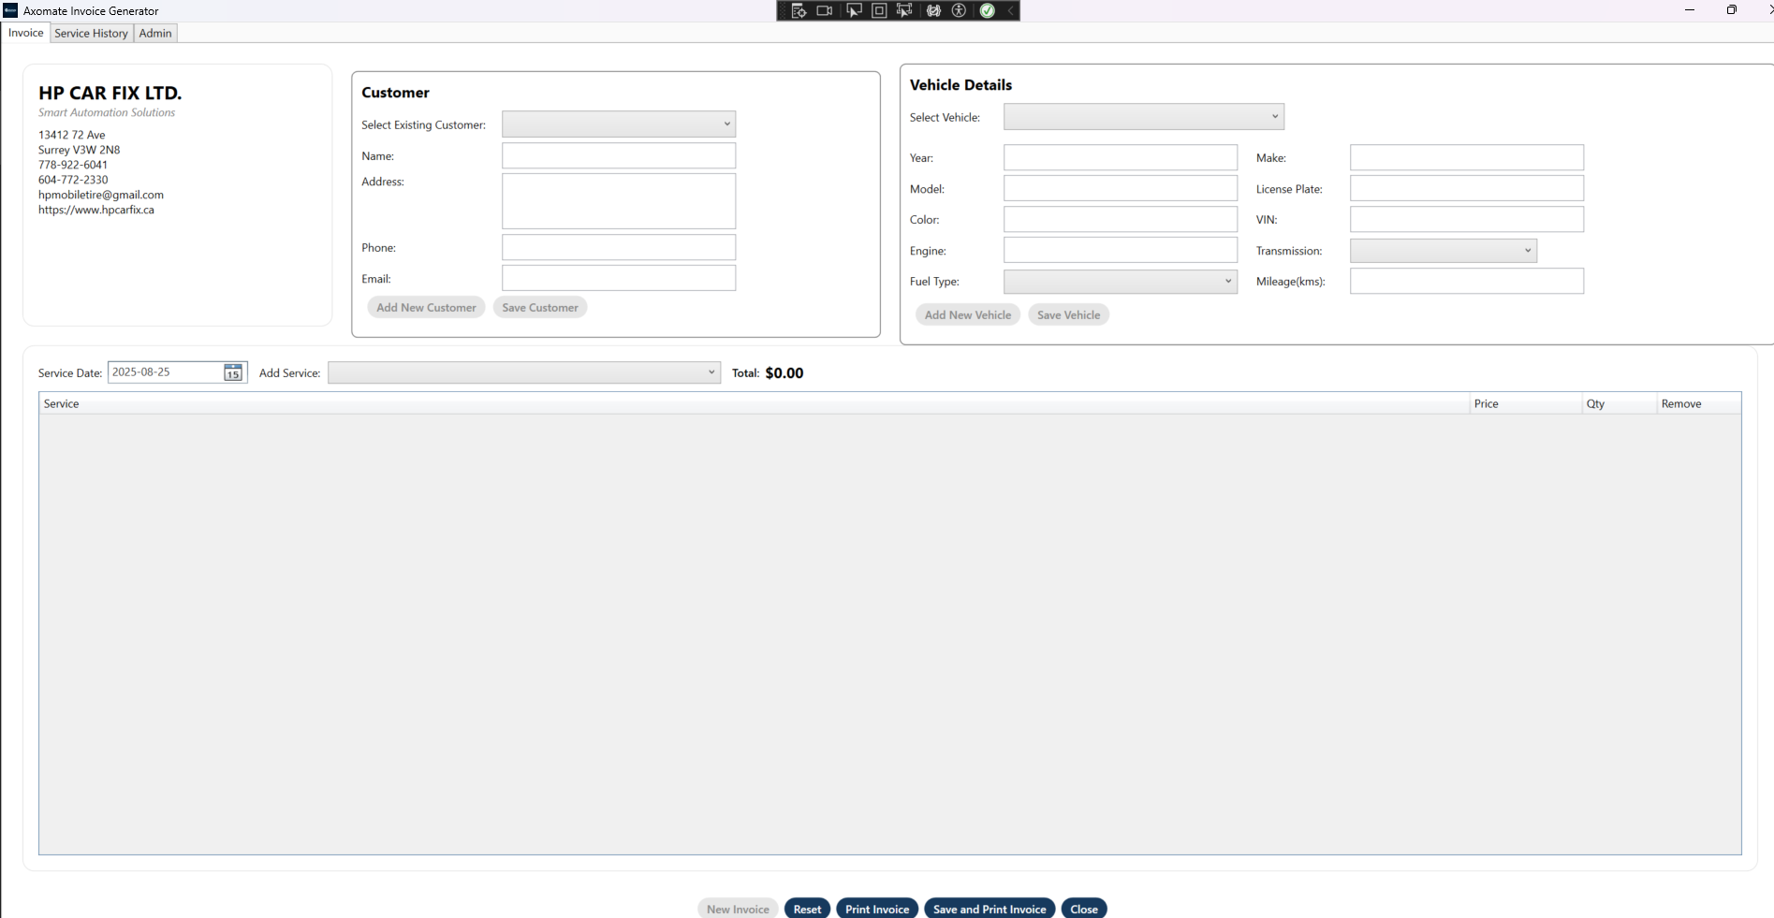

Figure 1 — Main Invoice screen.

# 1. Introduction

* This guide explains how to use Axomate to manage customers, vehicles, mileage, and invoices.

# 2. Key Concepts

* Selected vs New modes for Customer/Vehicle.
* 5‑hour mileage lock and prefill from history.
* New Invoice mode gates 'Save & Print Invoice'.

# 3. UI Overview

* Customer panel, Vehicle panel, Service Date, Add Service, Totals, Service grid, Bottom action bar.

# 4. Quick Start

* Add New Customer → Save New Customer → Add New Vehicle → Save New Vehicle → New Invoice → Add Services → Save & Print Invoice.

# 5. Managing Customers

* Select existing or create a new one; Name is required to save.

# 6. Managing Vehicles

* Requires a selected customer; need VIN or License Plate or Make+Model; optional Mileage recorded if allowed.

# 7. Services & Totals

* Add from catalog; 'Other' allows custom lines; totals auto‑update.

# 8. Mileage Behavior

* Prefill on select/date; immediate record on edit (subject to 5‑hour lock); save‑time insert if stale.

# 9. New Invoice, Save/Print & Print

* New Invoice enables save; Save & Print creates invoice + PDF; Print makes PDF only (no DB save).

# 10. Reset & Close

* Reset clears the form; Close exits the app.

# 11. Service History & Admin

* History shows past invoices per vehicle; Admin unlocks protected settings and password change.

# 12. Troubleshooting

* Disabled buttons usually mean a mode/validation step is missing; mileage may be blocked by 5‑hour rule.

Tip: In Word, press F9 (References → Update Table) to refresh the Index.