workshop 4.1 solution

Veerasak Kritsanapraphan

1/22/2020

library(ggplot2)  
library(tidyr)  
library(dplyr)

##   
## Attaching package: 'dplyr'

## The following objects are masked from 'package:stats':  
##   
## filter, lag

## The following objects are masked from 'package:base':  
##   
## intersect, setdiff, setequal, union

library(purrr)  
library(PerformanceAnalytics)

## Loading required package: xts

## Loading required package: zoo

##   
## Attaching package: 'zoo'

## The following objects are masked from 'package:base':  
##   
## as.Date, as.Date.numeric

##   
## Attaching package: 'xts'

## The following objects are masked from 'package:dplyr':  
##   
## first, last

##   
## Attaching package: 'PerformanceAnalytics'

## The following object is masked from 'package:graphics':  
##   
## legend

telco <- read.csv("WA_Fn-UseC_-Telco-Customer-Churn.csv", header=TRUE)

str(telco)

## 'data.frame': 7043 obs. of 21 variables:  
## $ customerID : Factor w/ 7043 levels "0002-ORFBO","0003-MKNFE",..: 5376 3963 2565 5536 6512 6552 1003 4771 5605 4535 ...  
## $ gender : Factor w/ 2 levels "Female","Male": 1 2 2 2 1 1 2 1 1 2 ...  
## $ SeniorCitizen : int 0 0 0 0 0 0 0 0 0 0 ...  
## $ Partner : Factor w/ 2 levels "No","Yes": 2 1 1 1 1 1 1 1 2 1 ...  
## $ Dependents : Factor w/ 2 levels "No","Yes": 1 1 1 1 1 1 2 1 1 2 ...  
## $ tenure : int 1 34 2 45 2 8 22 10 28 62 ...  
## $ PhoneService : Factor w/ 2 levels "No","Yes": 1 2 2 1 2 2 2 1 2 2 ...  
## $ MultipleLines : Factor w/ 3 levels "No","No phone service",..: 2 1 1 2 1 3 3 2 3 1 ...  
## $ InternetService : Factor w/ 3 levels "DSL","Fiber optic",..: 1 1 1 1 2 2 2 1 2 1 ...  
## $ OnlineSecurity : Factor w/ 3 levels "No","No internet service",..: 1 3 3 3 1 1 1 3 1 3 ...  
## $ OnlineBackup : Factor w/ 3 levels "No","No internet service",..: 3 1 3 1 1 1 3 1 1 3 ...  
## $ DeviceProtection: Factor w/ 3 levels "No","No internet service",..: 1 3 1 3 1 3 1 1 3 1 ...  
## $ TechSupport : Factor w/ 3 levels "No","No internet service",..: 1 1 1 3 1 1 1 1 3 1 ...  
## $ StreamingTV : Factor w/ 3 levels "No","No internet service",..: 1 1 1 1 1 3 3 1 3 1 ...  
## $ StreamingMovies : Factor w/ 3 levels "No","No internet service",..: 1 1 1 1 1 3 1 1 3 1 ...  
## $ Contract : Factor w/ 3 levels "Month-to-month",..: 1 2 1 2 1 1 1 1 1 2 ...  
## $ PaperlessBilling: Factor w/ 2 levels "No","Yes": 2 1 2 1 2 2 2 1 2 1 ...  
## $ PaymentMethod : Factor w/ 4 levels "Bank transfer (automatic)",..: 3 4 4 1 3 3 2 4 3 1 ...  
## $ MonthlyCharges : num 29.9 57 53.9 42.3 70.7 ...  
## $ TotalCharges : num 29.9 1889.5 108.2 1840.8 151.7 ...  
## $ Churn : Factor w/ 2 levels "No","Yes": 1 1 2 1 2 2 1 1 2 1 ...

### Exploratory Data Analysis

### Plot Single Variable - Histogram

# telco %>%  
# keep(is.numeric) %>% # Keep only numeric columns  
# gather() %>% # Convert to key-value pairs  
# ggplot(aes(value)) + # Plot the values  
# facet_wrap(~ key, scales = "free") + # In separate panels  
# geom_histogram(binwidth = 10)

### Plot Single Variable - Density Curve

telco %>%  
 keep(is.numeric) %>% # Keep only numeric columns  
 gather() %>% # Convert to key-value pairs  
 ggplot(aes(value)) + # Plot the values  
 facet_wrap(~ key, scales = "free") + # In separate panels  
 geom_density()

## Warning: Removed 11 rows containing non-finite values (stat_density).

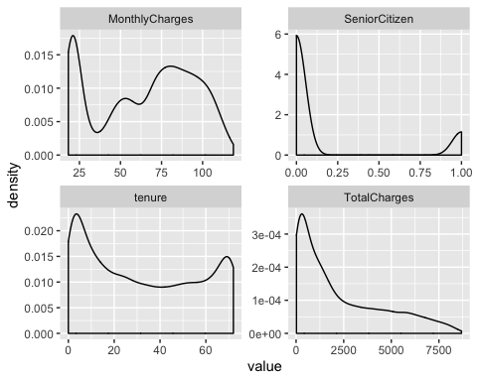 ## Bar Plot

telco %>%  
 keep(is.factor) %>% # Keep only numeric columns  
 gather() %>% # Convert to key-value pairs  
 ggplot(aes(value)) + # Plot the values  
 facet_wrap(~ key, scales = "free") + # In separate panels  
 geom_bar()

## Warning: attributes are not identical across measure variables;  
## they will be dropped

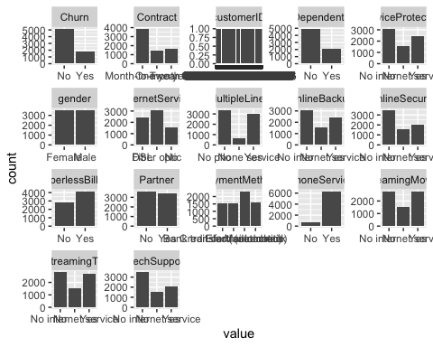

## Covariation

boxplot(MonthlyCharges ~ Churn, data=telco)

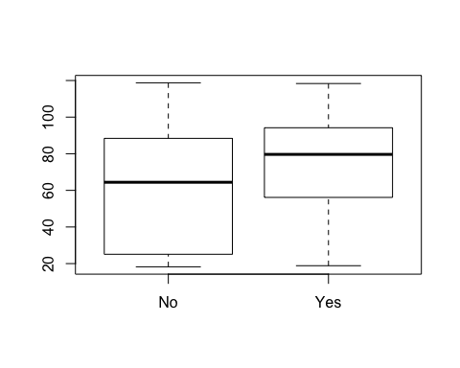

boxplot(tenure ~ Churn, data=telco)

