# —

title: “ggplot2” author: “Veerasak Kritsanapraphan” date: “January 28, 2016” output: html_document: fig_height: 5 fig_width: 5 toc: yes toc_depth: 5 pdf_document: toc: yes word_document: default —

###Exploratory Data Analysis

Let’s begin by loading the packages we’ll use this class

library(ggplot2)  
library(MASS) # Useful for data sets  
library(plyr) # We'll need mapvalues

### Introduction to ggplot2

ggplot2 has a slightly steeper learning curve than the base graphics functions, but it also generally produces far better and more easily customizable graphics.

There are two basic calls in ggplot:

* qplot(x, y, ..., data): a “quick-plot” routine, which essentially replaces the base plot()
* ggplot(data, aes(x, y, ...), ...): defines a graphics object from which plots can be generated, along with *aesthetic mappings* that specify how variables are mapped to visual properties.

#### plot vs qplot

Here’s how the default scatterplots look in ggplot compared to the base graphics. We’ll illustrate things using the Cars93 data from the MASS library.

with(Cars93, plot(EngineSize, MPG.city)) # Base graphics

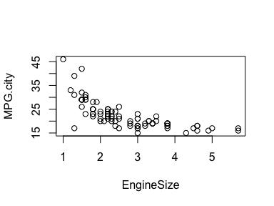

qplot(x=EngineSize, y=MPG.city, data=Cars93) # using qplot from ggplot2

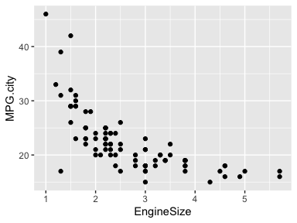

Remember how it took us some effort last time to add color coding, use different plotting characters, and add a legend? Here’s the qplot call that does it all in one simple line.

qplot(x=EngineSize, y=MPG.city, data=Cars93,   
 colour=Cylinders,   
 shape=Cylinders,  
 xlab = "Engine size (litres)",  
 ylab = "Fuel economy (MPG city)"  
 )

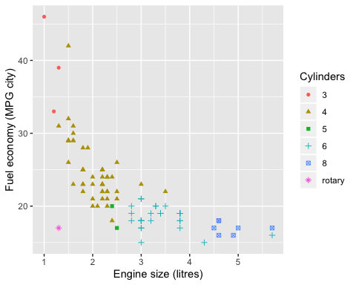

This way you won’t run into problems of accidentally producing the wrong legend. The legend is produced based on the colour and shape argument that you pass in. (Note: color and colour have the same effect. )

#### ggplot function

The ggplot2 library comes with a dataset called diamonds. Let’s look at it

dim(diamonds)

## [1] 53940 10

head(diamonds)

## # A tibble: 6 x 10  
## carat cut color clarity depth table price x y z  
## <dbl> <ord> <ord> <ord> <dbl> <dbl> <int> <dbl> <dbl> <dbl>  
## 1 0.23 Ideal E SI2 61.5 55 326 3.95 3.98 2.43  
## 2 0.21 Premium E SI1 59.8 61 326 3.89 3.84 2.31  
## 3 0.23 Good E VS1 56.9 65 327 4.05 4.07 2.31  
## 4 0.290 Premium I VS2 62.4 58 334 4.2 4.23 2.63  
## 5 0.31 Good J SI2 63.3 58 335 4.34 4.35 2.75  
## 6 0.24 Very Good J VVS2 62.8 57 336 3.94 3.96 2.48

It is a data frame of 53,940 diamonds, recording their attributes such as carat, cut, color, clarity, and price.

We will make a scatterplot showing the price as a function of the carat (size). (The data set is large so the plot may take a few moments to generate.)

diamond.plot <- ggplot(data=diamonds, aes(x=carat, y=price))  
diamond.plot + geom_point()

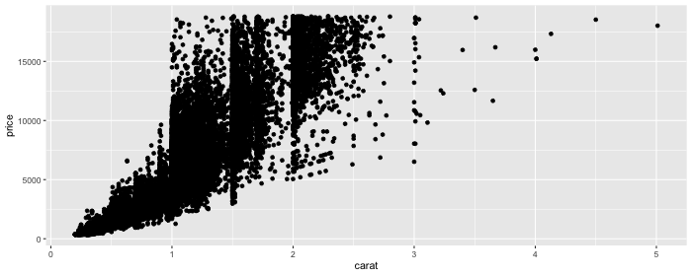

The data set looks a little weird because a lot of diamonds are concentrated on the 1, 1.5 and 2 carat mark.

Let’s take a step back and try to understand the ggplot syntax.

1. The first thing we did was to define a graphics object, diamond.plot. This definition told R that we’re using the diamonds data, and that we want to display carat on the x-axis, and price on the y-axis.
2. We then called diamond.plot + geom_point() to get a scatterplot.

The arguments passed to aes() are called **mappings**. Mappings specify what variables are used for what purpose. When you use geom_point() in the second line, it pulls x, y, colour, size, etc., from the **mappings** specified in the ggplot() command.

You can also specify some arguments to geom_point directly if you want to specify them for each plot separately instead of pre-specifying a default.

Here we shrink the points to a smaller size, and use the alpha argument to make the points transparent.

diamond.plot + geom_point(size = 0.7, alpha = 0.3)

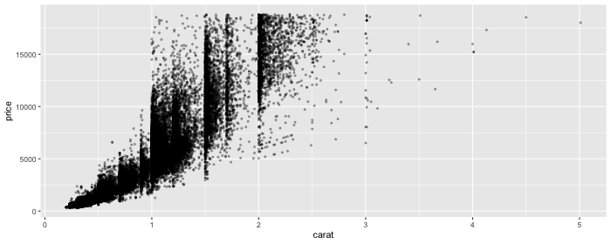

If we wanted to let point color depend on the color indicator of the diamond, we could do so in the following way.

diamond.plot <- ggplot(data=diamonds, aes(x=carat, y=price, colour = color))  
diamond.plot + geom_point()

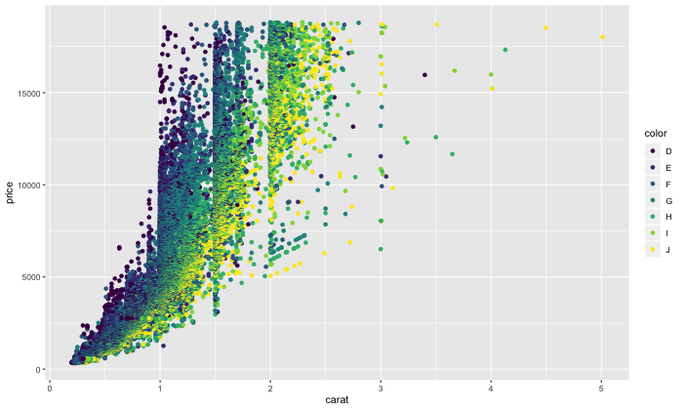

If we didn’t know anything about diamonds going in, this plot would indicate to us that **D** is likely the highest diamond grade, while **J** is the lowest grade.

We can change colors by specifying a different color palette. Here’s how we can switch to the cbPalette we saw last class.

cbPalette <- c("#999999", "#E69F00", "#56B4E9", "#009E73", "#F0E442", "#0072B2", "#D55E00", "#CC79A7")  
diamond.plot <- ggplot(data=diamonds, aes(x=carat, y=price, colour = color))  
diamond.plot + geom_point() + scale_colour_manual(values=cbPalette)

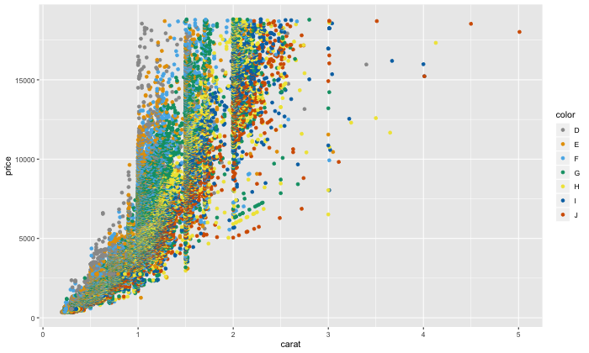

Just like in lattice, we can create plots showing the relationship between variables across different values of a factor. For instance, here’s a scatterplot showing how diamond price varies with carat size, conditioned on color. It’s created using the facet_wrap(~ factor1 + factor2 + ... + factorn) command.

diamond.plot <- ggplot(data=diamonds, aes(x=carat, y=price, colour = color))  
  
diamond.plot + geom_point() + facet_wrap(~ cut)

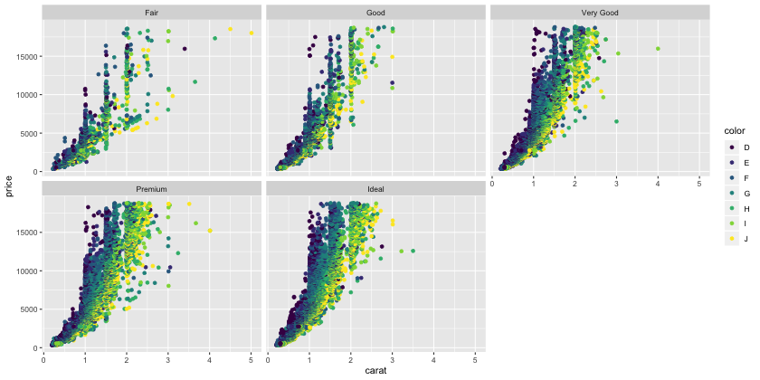

You can also use facet_grid() to produce this type of output.

diamond.plot + geom_point() + facet_grid(. ~ cut)

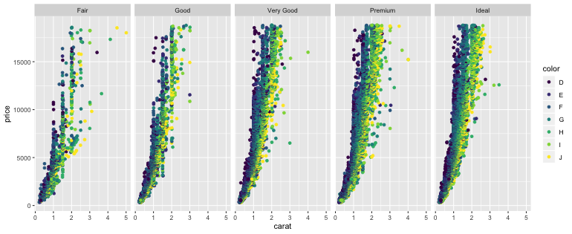

diamond.plot + geom_point() + facet_grid(cut ~ .)

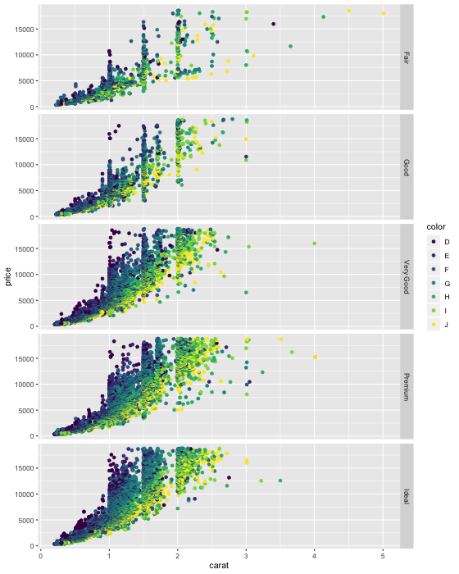

ggplot can create a lot of different kinds of plots, just like lattice. Here are some examples.

|  |  |
| --- | --- |
| Function | Description |
| geom_point(...) | Points, i.e., scatterplot |
| geom_bar(...) | Bar chart |
| geom_line(...) | Line chart |
| geom_boxplot(...) | Boxplot |
| geom_violin(...) | Violin plot |
| geom_density(...) | Density plot with one variable |
| geom_density2d(...) | Density plot with two variables |
| geom_histogram(...) | Histogram |

#### A barchart example

We’ll use the birthwt data for this example, so let’s start by loading an cleaning it. All of this code is borrowed from Lecture 5.

# Assign better variable names  
colnames(birthwt) <- c("birthwt.below.2500", "mother.age", "mother.weight",   
 "race", "mother.smokes", "previous.prem.labor", "hypertension", "uterine.irr",   
 "physician.visits", "birthwt.grams")  
  
# Assign better labels to categorical variables  
birthwt <- transform(birthwt,   
 race = as.factor(mapvalues(race, c(1, 2, 3),   
 c("white","black", "other"))),  
 mother.smokes = as.factor(mapvalues(mother.smokes,   
 c(0,1), c("no", "yes"))),  
 hypertension = as.factor(mapvalues(hypertension,   
 c(0,1), c("no", "yes"))),  
 uterine.irr = as.factor(mapvalues(uterine.irr,   
 c(0,1), c("no", "yes"))),  
 birthwt.below.2500 = as.factor(mapvalues(birthwt.below.2500,  
 c(0,1), c("no", "yes")))  
 )

geom_bar() constructs bar charts. Bar charts are useful for visualizing one-number summaries of data. E.g., counts, means, or totals, broken down by levels of a factor. Bar charts are a nice graphical accompaniment to summary tables as generated by tapply() or aggregate().

#### Simple example: Bar chart of diamonds broken down by color

p.color <- ggplot(data = diamonds, aes(x = color))  
p.color + geom_bar()

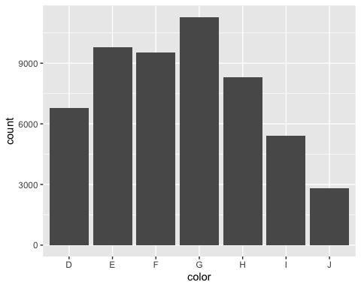

#### More complex example: Average birthweight broken down by race and smoking status

We’ll start by using the aggregate function to produce a summary of the data in a form that’s amenable to plotting with the ggplot2 functions.

# Use aggregate to get a table of values  
bwt.summary <- aggregate(birthwt.grams ~ race + mother.smokes, data = birthwt, FUN = mean)   
# Note that this returns a data frame  
class(bwt.summary)

## [1] "data.frame"

Here’s what that summary table looks like.

bwt.summary

## race mother.smokes birthwt.grams  
## 1 black no 2854.500  
## 2 other no 2815.782  
## 3 white no 3428.750  
## 4 black yes 2504.000  
## 5 other yes 2757.167  
## 6 white yes 2826.846

While the table is informative, it takes a fair bit of effort to glean insight from it. Here’s one graphical representation of the same information.

# Define basic aesthetic parameters  
p.bwt <- ggplot(data = bwt.summary, aes(y = birthwt.grams, x = race, fill = mother.smokes))  
  
# Pick colors for the bars  
bwt.colors <- c("#009E73", "#999999")  
  
# Display barchart  
p.bwt + geom_bar(stat = "identity", position = "dodge") +  
 ylab("Average birthweight") +   
 xlab("Mother's race") +  
 guides(fill = guide_legend(title = "Mother's smoking status")) +   
 scale_fill_manual(values=bwt.colors)

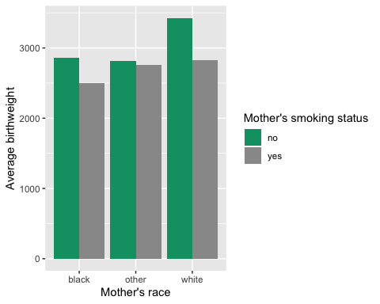

#### Statistical overlays in ggplot

One of the main advantages of ggplot is that it makes it really easy to overlay model fits, confidence bars, etc. We’ll get more practice with this next week, when we talk more about how to do statistical inference in R.

For the time being, let’s just display a scatterplot smoother.

diamond.plot + stat_smooth()

## `geom_smooth()` using method = 'gam' and formula 'y ~ s(x, bs = "cs")'

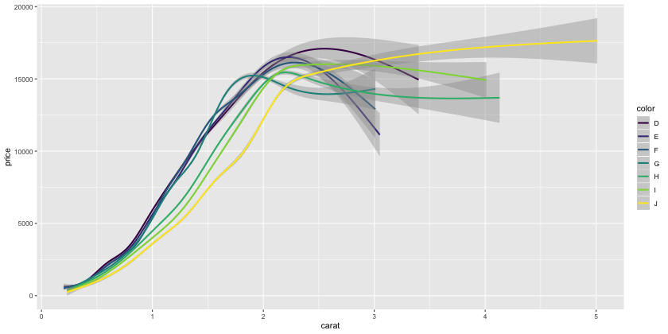

This shows curves modelling the relationship between diamond size in carats and price for the different diamond colours.

We could use the geom_point() command to also display the underlying points, but that would make the curves difficult to see. Let’s try it anyway.

diamond.plot + geom_point() + stat_smooth()

## `geom_smooth()` using method = 'gam' and formula 'y ~ s(x, bs = "cs")'

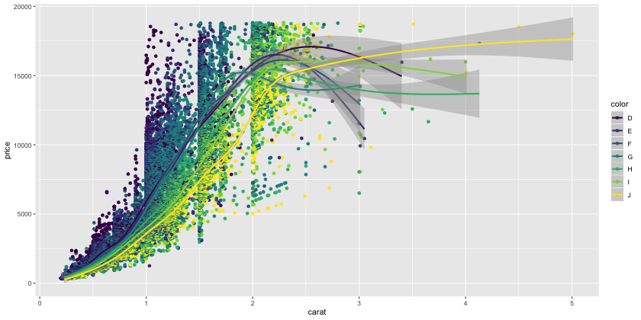

We can make this look better by decreasing the point opacity so that the trend curves aren’t so obscured.

diamond.plot + geom_point(size = 1.5, alpha = 0.25) + stat_smooth()

## `geom_smooth()` using method = 'gam' and formula 'y ~ s(x, bs = "cs")'

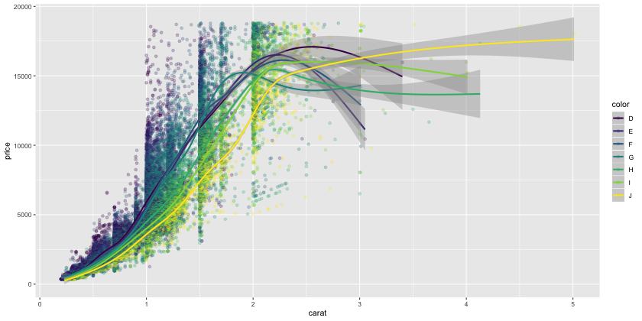

#### Birthweight regression overlay

In addition to the more flexible smoother in the example above, we can also overlay more structured summaries such as regression curves.

Here’s the plot that we saw at the end of Lecture 5, which makes good use of regression line overlays.

ggplot(birthwt, aes(x=mother.age, y=birthwt.grams, shape=mother.smokes, color=mother.smokes)) +   
 geom_point() + # Adds points (scatterplot)  
 geom_smooth(method = "lm") + # Adds regression lines  
 ylab("Birth Weight (grams)") + # Changes y-axis label  
 xlab("Mother's Age (years)") + # Changes x-axis label  
 ggtitle("Birth Weight by Mother's Age") # Changes plot title

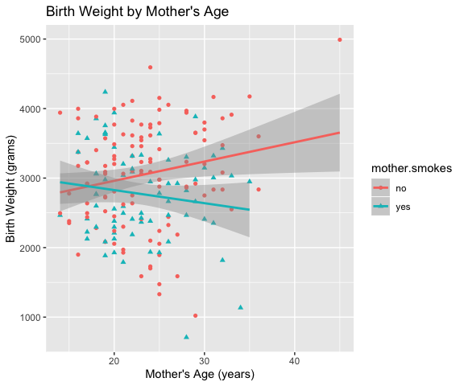

Recall that when we calculated correlations between birth weight and mother’s age, we got the following results.

by(data = birthwt[c("birthwt.grams", "mother.age")],   
 INDICES = birthwt["mother.smokes"],   
 FUN = function(x) {cor(x[,1], x[,2])})

## mother.smokes: no  
## [1] 0.2014558  
## --------------------------------------------------------   
## mother.smokes: yes  
## [1] -0.1441649

This tells us that the association between mother’s age and the baby’s birthweight seems to depend on the mother’s smoking status. Among mothers that smoke, this association is negative (older mothers tend to give birth to lower weight babies), while among mothers that don’t smoke, the association is positive.

We can read off the same conclusions more simply from the plot. The regression lines capture the association between birthweight and mother’s age. The fact that the observed points are very spread out around the regression lines visually conveys the fact that the correlation between birthweight and mother’s age is not very large.

##### Is that an outlier?

The plot shows us something that the correlation calculation cannot: there’s a non-smoking mother who was 45 years old when she gave birth, and the combination of her age and the baby’s weight (around 5000g) are well outside the range of all other data points. Let’s see what happens when we remove this observation and re-plot.

# Get new data set that no longer contains the outlier  
birthwt.sub <- subset(birthwt, subset = mother.age < 40)  
  
ggplot(birthwt.sub, aes(x=mother.age, y=birthwt.grams, shape=mother.smokes, color=mother.smokes)) +   
 geom_point() + # Adds points (scatterplot)  
 geom_smooth(method = "lm") + # Adds regression lines  
 ylab("Birth Weight (grams)") + # Changes y-axis label  
 xlab("Mother's Age (years)") + # Changes x-axis label  
 ggtitle("Birth Weight by Mother's Age") # Changes plot title

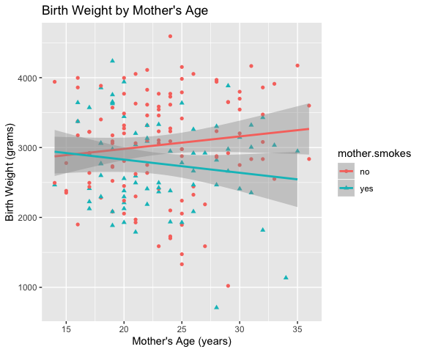

The general trends appear to be qualitatively the same, but the association in the non-smoking group appears to be far less strong than we were led to believe when we still had the outlying point in our data.

#### A dot plot/bar chart example.

For this example we’re going to use some data based on the 2011 Consumer Expenditure (CE) Survey. This data is stored in a tab-delimited file called mtbi.txt.

expenses <- read.table("mtbi.txt", sep="\t", header=TRUE)  
dim(expenses)

## [1] 579 4

head(expenses, 20)

## ucc count avg.cost descr  
## 480 790240 14418 335.99369 AVG FOOD/NONALC BEV EXPENSES  
## 479 790210 11865 470.72061 REGULAR GROC SHOPPING INCL GOODS  
## 291 470111 10779 221.60729 GASOLINE  
## 482 790410 9309 192.62423 DINING OUT AT REST., ETC EXCL ALC  
## 93 270310 8739 72.29626 CABLE/SATELLITE/COM ANTENNA SERV  
## 86 270102 8575 95.50787 CELLULAR PHONE SERVICE  
## 460 690114 7903 38.72745 COMPUTER INFORMATION SERVICES  
## 28 220211 7740 229.23689 PROPERTY TAXES OWND  
## 571 910050 7725 108.06803 RENTAL EQUIVALENCE OF OWNED HOME  
## 575 910104 7680 1281.71706 CPI ADJ RENT EQUIV OF OWNED HOME  
## 501 800721 7677 19309.76019 MARKET VALUE OF OWNED HOME  
## 78 260112 7528 136.53892 ELECTRICITY OWND  
## 85 270101 7180 53.18663 RESIDENTIAL TELEPHONES/PAY PHONES  
## 434 650310 7008 39.88927 PERS. CARE SERV.  
## 90 270212 6735 44.15650 WATER AND SEWERAGE MAINT OWND  
## 30 220311 4916 612.51098 MORTGAGE INTEREST OWND  
## 520 830201 4835 -325.53485 REDUCTION MORTGAGE PRINC OWND  
## 348 540000 4485 78.87893 PRESCRIPTION DRUGS  
## 82 260212 4308 81.45265 UTILITY--NATURAL GAS OWND  
## 528 850100 4212 -331.67379 REDUCTION PRINC VEH LOAN

The data is ordered from highest to lowest count (the count is then number of times that an item in the given ucc category was purchased). From head() we can see that the 20 most common expenses are things like food/drink, gas, cell phone bills, mortgage payments, etc. This is what we’d expect.

Now, let’s create a dot plot showing the counts for each of the top 20 expenses.

expense.plot <- ggplot(data = expenses[1:20, ], mapping = aes(y = descr, x = count))  
expense.plot + geom_point()

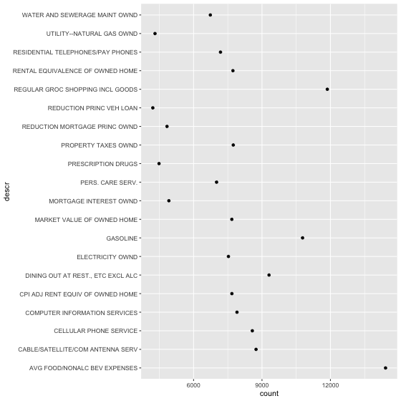

This doesn’t look very good… What happened?

Well, R doesn’t know that the count variable is important for the purpose of ordering. The default behaviour is to show the plot with factor levels ordered alphabetically. This makes sense in many cases, but not in ours.

To re-order the levels of a factor, we use the reorder() function. Here’s how we re-order the levels of descr based on the value of count.

expenses <- transform(expenses, descr = reorder(descr, count))

Now let’s try that plotting function again…

expense.plot <- ggplot(data = expenses[1:20, ], mapping = aes(y = descr, x = count))  
expense.plot + geom_point()

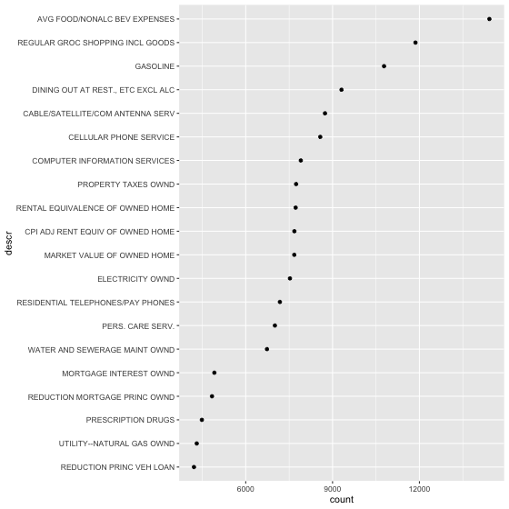

This kind of data is typically represented with bar charts instead of dot plots. Let’s create a bar chart to capture the same information.

barchart.fig = ggplot(data = expenses[1:20, ], mapping = aes(x = descr, y = count))  
barchart.fig + geom_bar(stat = "identity", fill = cbPalette[3])

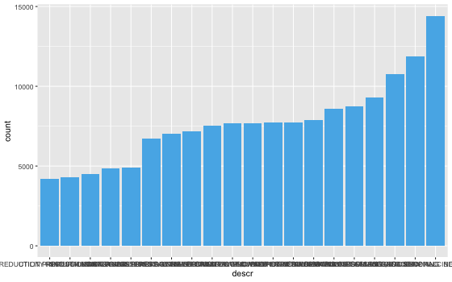

There’s an issue with this plot: the labels along the x-axis have all blended together and are incomprehensible.

To adjust the text, we can use the theme command.

barchart.fig + geom_bar(stat = "identity", fill = cbPalette[3]) +  
 theme(axis.text.x = element_text(angle = 60, vjust = 1, hjust = 1))

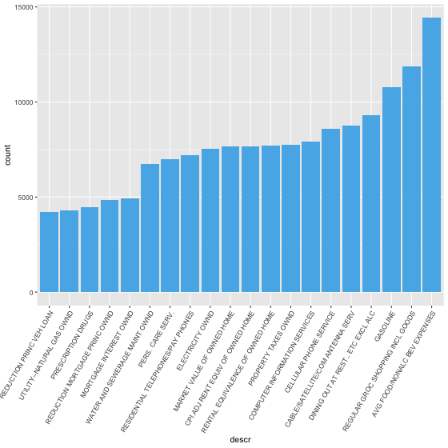

We should probably also change the axis labels and title to something more meaningful

barchart.fig + geom_bar(stat = "identity", fill = cbPalette[3]) +  
 theme(axis.text.x = element_text(angle = 60, vjust = 1, hjust = 1)) +   
 labs(x = "", y = "Times reported", title = "Most Commonly Reported Purchases")

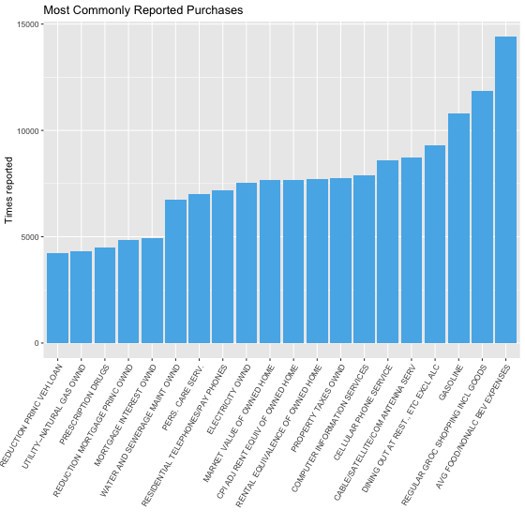

### ggplot2 also does maps

We’ll need the maps library for this example.

library(maps)

##   
## Attaching package: 'maps'

## The following object is masked from 'package:plyr':  
##   
## ozone

One of the data sets that comes with R is the USArrests data

head(USArrests)

## Murder Assault UrbanPop Rape  
## Alabama 13.2 236 58 21.2  
## Alaska 10.0 263 48 44.5  
## Arizona 8.1 294 80 31.0  
## Arkansas 8.8 190 50 19.5  
## California 9.0 276 91 40.6  
## Colorado 7.9 204 78 38.7

Here’s how we can get a headmap of Murder rates (per 100,000 population) on a map of the US.

# Create data frame for map data (US states)  
states <- map_data("state")  
  
# Here's what the states data frame looks like  
str(states)

## 'data.frame': 15537 obs. of 6 variables:  
## $ long : num -87.5 -87.5 -87.5 -87.5 -87.6 ...  
## $ lat : num 30.4 30.4 30.4 30.3 30.3 ...  
## $ group : num 1 1 1 1 1 1 1 1 1 1 ...  
## $ order : int 1 2 3 4 5 6 7 8 9 10 ...  
## $ region : chr "alabama" "alabama" "alabama" "alabama" ...  
## $ subregion: chr NA NA NA NA ...

# Make a copy of the data frame to manipulate  
arrests <- USArrests  
  
# Convert everything to lower case  
names(arrests) <- tolower(names(arrests))  
arrests$region <- tolower(rownames(USArrests))  
  
# Merge the map data with the arrests data based on region  
choro <- merge(states, arrests, sort = FALSE, by = "region")  
choro <- choro[order(choro$order), ]  
  
# Plot a map, filling in the states based on murder rate  
qplot(long, lat, data = choro, group = group, fill = murder,  
 geom = "polygon")

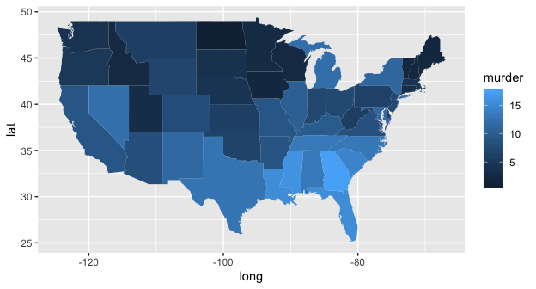

Essentially what’s happening here is that the map data (here called states) includes the latitute and longitude coordinates for the boundaries of each state. Specifying geom = "polygon" in the qplot function results in the states being traced out based on the lat/long coordinates. The arrests data provides crime rates for all the states, which allows us to color each polygon (state) based on the murder rate.

It may be counter-intuitive that light blue indicates areas with high murder rates while dark blue indicates areas with low murder rates. We can fix this by specifying a different gradient using the scale_colour_gradient() command. Here’s an example.

qplot(long, lat, data = choro, group = group, fill = murder,  
 geom = "polygon") + scale_fill_gradient(low = "#56B1F7", high = "#132B43")

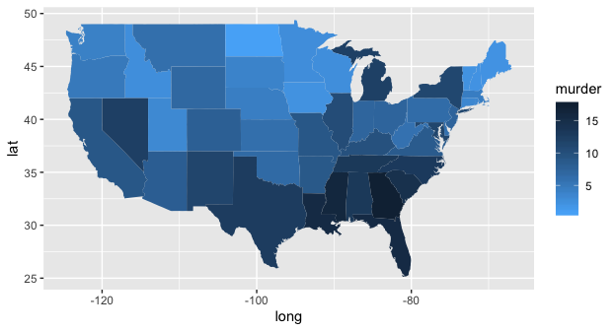

All we’ve done here is swapped the defaults for low and high.