Hello World

Veerasak Kritsanapraphan

11/13/2018

## Report for Management

This is an R Markdown document. Markdown is a simple formatting syntax for authoring HTML, PDF, and MS Word documents. For more details on using R Markdown see

### Report for performance

thhhlhjklhllllhkjhkffjgk

print("Hello World!")

## [1] "Hello World!"

## Including Plots

You can also embed plots, for example:

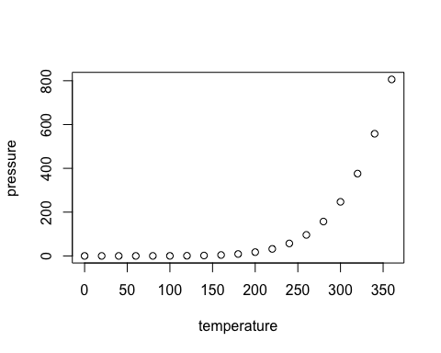

Note that the echo = FALSE parameter was added to the code chunk to prevent printing of the R code that generated the plot.