Workshop 6

Veerasak Kritsanapraphan

We’ll begin by loading all the required packages.

library(MASS)  
library(lattice)  
library(ggplot2)

#### Plotting the Cars93 data

This problem uses the Cars93 dataset from the MASS package.

**(a)** Use qplot to create a scatterplot with Price on the y-axis and EngineSize on the x-axis.

qplot(x = EngineSize, y = Price, data = Cars93)

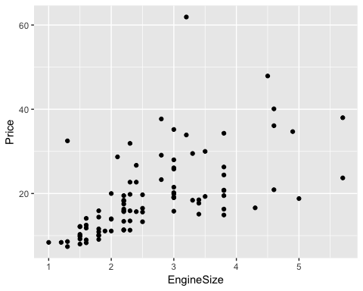

**(b)** Repeat part (a) using the ggplot function and geom_point() layer.

ggplot(Cars93, aes(x = EngineSize, y = Price)) + geom_point()



**(c)** Repeat part (b), but this time specifying that the color mapping should depend on Type and the shape mapping should depend on DriveTrain.

ggplot(Cars93, aes(x = EngineSize, y = Price, colour = Type, shape = DriveTrain)) + geom_point()

