CourseSmart Code Design
Last Revised: 2004-12-02
P. Chapin, S. Chu, A. Foco, D. Guay, G. Mopa, D. Van Horn

Introduction
This document describes the code design of the CourseSmart server and client. The server design follows the structure of the repository. The client design follows the structure of the user interface. This organization is natural and it leads to a system where the various high level components can be maintained with a high degree of independence.

Design Goals
The goals of the code design are intended to forward the system design goals articulated in the document CourseSmart System Design.

- Java Client. The client supports a variety of different student operating systems.
- Integrated Client. The client is entirely self-contained.
- Lightweight C++ Server. The server program has low impact on the server host.
- Separation of Concerns. The server makes no user interface decisions. The client makes no data storage assumptions.

Server Design
The server initializes the network, and creates various supporting objects that represent the course data repository. It then enters a main loop where it accepts client connections and forks a child process for each client. The child reads requests from the client and executes those requests by making use of the course data repository components. The main loop is procedural in nature and not implemented as a specific class. When the client closes the connection (or the connection times out), the child process destroys its copy of the various objects representing the data repository and then terminates.

The application specific classes used in the server are organized as show in Figure 1.

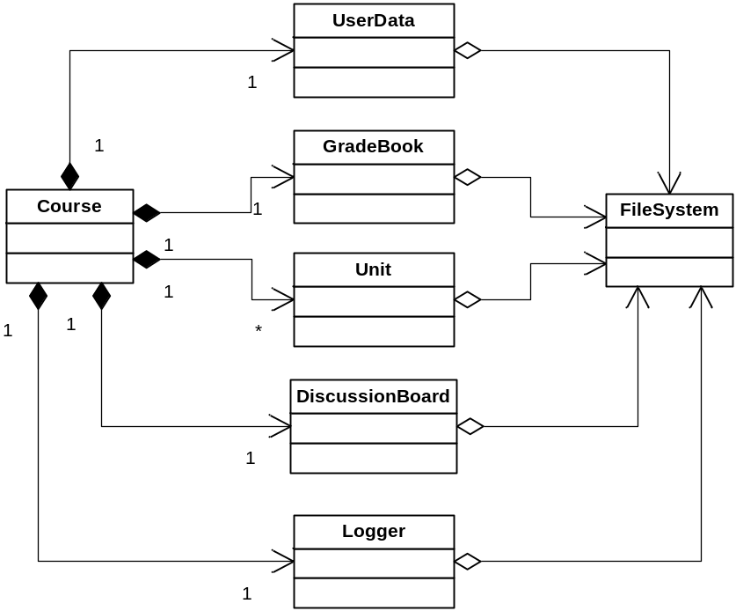

Figure 1

With the exception of the Unit class, all the classes shown in Figure 1 are singletons.

The Course object provides a way for each server child process to access course data. It is primarily a shell, containing the objects that represent the various top-level course data structures. The Course object coordinates the construction and destruction of its components and provides methods for accessing the components. When each component is constructed it receives a pointer to the Logger object (explained below) so that it can write messages to the course’s log file.

The order in which course components is constructed is important. First the Course object constructs the FileSystem object so that the other objects have access to the storage area. Next the Logger object is constructed so that the other objects have a way to output log messages. Since the server has no user interface, detailed logging is important to allow the server administrator to track problems and gather usage statistics. Finally the Course object constructs the other helper objects in no particular order. Unit objects, however, are only created on demand from the main loop.

The Course object takes the responsibility to destroy all of the course’s components in an appropriate order. The main loop need not delete any of the pointers it gets from the Course object. When the main loop terminates, the Course object itself is deleted, causing the other objects in the program to be destroyed.

What follows is a brief description of the other classes displayed in Figure 1.
- The UserData class represents the CourseSmart user database. It provides methods for accessing and modifying the user list, role memberships, and other user-specific state information.
- The GradeBook class represents the grade book and provides methods for accessing and modifying grades. It also provides methods for calculating averages and doing similar manipulations.
- The Unit class provides access to information about a particular course unit. Its structure is detailed in Figure 2 and will be discussed more below.
- The Discussion class represents the CourseSmart discussion board. It provides methods for accessing and posting messages.
- The Logger class is the only repository component without a direct representation on disk. It provides a common point where log messages are time stamped and formatted for saving to the log file.
- The FileSystem class is the back end used by all the other classes for access to the repository file system. None of the course repository components, including the Logger, do any file I/O directly. This provides a single synchronization point to help simplify file locking issues.

More information about the precise methods each of these classes support can be found on the detailed class diagram attached to this report.

The current version of CourseSmart does not provide much flexibility in how the classes described above could be implemented. This was done in the interest of simplicity. However, there are a number of possible future enhancements that could be provided relatively easily by making use of inheritance.

For example, in the current version of CourseSmart there is support for only one discussion board type. Additional types could be supported by making DiscussionBoard abstract and providing suitable concrete classes for each type. This might be useful, for example, if the CourseSmart server wished to provide a gateway to NNTP newsgroups as an alternative to (or in addition to) its own internal discussion areas. The Logger class could use a similar approach to support logging messages to different locations. The FileSystem class could be redefined as well to support new ways of storing the raw data.

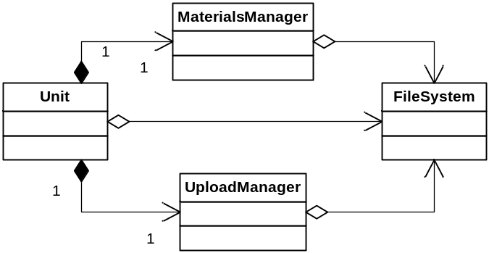

Figure 2

Figure 2 shows more detail on the structure of the Unit class. Unit objects are created by the course object on demand and cached by the course object until the child server terminates. Each Unit object provides all the methods necessary for managing a single unit of course information, however many of those methods simply forward to one of two major internal objects. The first internal object, a MaterialsManager deals with the course materials. The second internal object, an UploadManager deals with the unit’s upload area. Access to both the underlying file system and the repository is passed to these internal objects from the Unit object.

In the current version of CourseSmart, the MaterialsManager manages a collection of files and provides a URL that represents the web location of those files. Future versions of CourseSmart might use multiple MaterialsManager classes for dealing with different ways of accessing course materials.

Client Design
The client’s primary user interface is a collection of tabs using a Java Swing JTabbedPanel. Each tab requires an application specific panel. Accordingly the CourseSmart client inherits a panel type from JPanel for each of the tabs to be supported. In this document we refer to these panel types as “tab classes”. In addition the client uses a singleton class named CSGateway to encapsulate the network interface and provide the rest of the client with high level access to the CourseSmart protocol.

The application specific classes used by the client are shown in Figure 3.

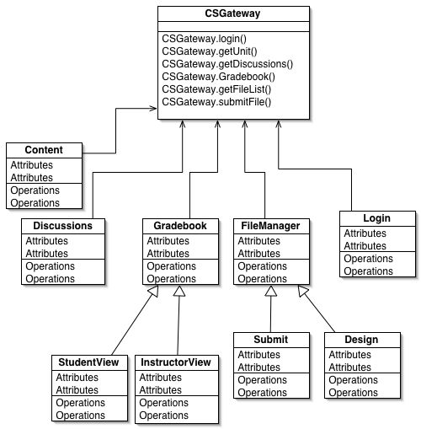

Figure 3

At construction time the various tab classes create the necessary user interface elements and add them to the JPanel super class object. These user interface elements contain event listeners that are inner classes of the corresponding tab class. The business logic of the client program is implemented in these event listener classes. What follows is a brief description of the various tab classes.

- The Content class displays HTML formatted course content. It is our intention to use a third party HTML rendering library to provide a majority of this functionality.
- The Discussions class allows the user to interact with the course’s discussion board. It provides user interface elements for viewing the list of messages, viewing a message, and posting new messages.
- The Gradebook class allows the user to interact with the grade book. Because the instructor will have very different capabilities in the grade book than the student, the client uses two subclasses to differentiate between these cases. The super class contains elements that are in common with both views; the subclasses contain specialized elements in each view.
- The FileManager class is an abstract super class that provides a general facility for managing a list of files. The client creates two subclasses from this general facility to handle the two cases where such lists are used: when the student uploads an assignment and when the instructor uploads course materials.
- The Login class defines a JPane that lets the user log into the system. Once the login is successful the Login class takes responsibility to create the appropriate tab objects and populate the JTabbedPane.

The CSGateway class provides a long list of methods that map to the CourseSmart protocol messages.

CourseSmart Protocol
Although not code in the usual sense, the CourseSmart protocol is an integral part of the system’s design and thus an overview of it is described here. The details of the protocol are described in the document CourseSmart Protocol that can be found with the other CourseSmart design documents.

The protocol provides message types that largely correspond to the methods on the course component classes in the server. For example, a method such as addUser in the UserData class will have a corresponding add-user protocol message and, for that matter, a corresponding addUser method in the client’s CSGateway class. The mapping from CSGateway method to CourseSmart protocol message, to server repository class method is not always one-to-one, but in many cases it is. Access control is always enforced on the server; an attempt by the client to issue protocol messages that are illegal will result in a failure response. The client attempts to remove inaccessible features from the user interface (according to the access granted to the logged in user), but the security of the system does not depend on this.

The actual messages are XML fragments. The client sends a <request> element containing the arguments of the request as child elements. The server responds with a <response> element that either indicates a failure or that contains child elements that hold the value of the response.

The only parts of the system where the XML messages are handled are in the server’s main loop and the client’s CSGateway object. The rest of the system is completely insulated from the details of the protocol making it relatively easy to change or adjust the protocol later.

Supporting multiple discussion boards would require creating one of these objects for each board supported and adding methods to the Course class to allow the discussion boards to be enumerated.
Logging to multiple locations could be supported using a hypothetical MultiLogger class that acts like a container of other Logger objects.
This suggests that an alternative design based on some RPC technology would be a relatively natural modification. For example, CourseSmart might be implementable as a web service.

