Mission:
This document gives direction on how to re-install the Bitcraze firmware onto the Crazyflie 2.1 in a reliable way.
Steps:
The first step that we took was to find appropriate resources online. We found a link to “Recovery firmware flashing” which explains how to recover the firmware:
https://www.bitcraze.io/documentation/repository/crazyflie-clients-python/master/userguides/recovery-mode/
However, the page instructs to only follow the steps if the Crazyflie is not booting up properly. This link is not very useful now, but may be useful in the future, so it is included in this document.

Next, we found a page for “programming the Crazyflie.”
https://www.bitcraze.io/documentation/tutorials/getting-started-with-development/
Here, they have you clone a repository on github. We cloned the repository and built it using the instructions they provide.
The page then explains how to flash the Crazyflie. We put the drone in bootloader mode, plugged in the Crazy Radio, and followed the rest of the instructions. After this, we verified that the drone was still working correctly by flying it from the mobile app.
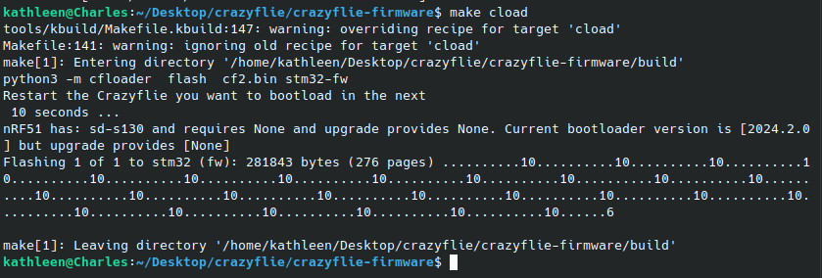
The following page is about building and flashing. It gives similar instructions to the previous page. https://www.bitcraze.io/documentation/repository/crazyflie-firmware/master/building-and-flashing/build/

