CrazyCube
Application Requirements 2.0
Christian Lukengu
Kathleen Niekrewicz
Nicholas Slocik
Introduction
A popular thing that people like to do is to fly drones or remote helicopters in the air. NASA has their spacecraft that use communication systems to control their ships. Each component of the spacecraft is talking back and forth with messages. In a similar light, this project involves using our own software in a Crazyflie 2.1 drone (CF) to control it in the way that is desired.
This project has a controller in which commands can be given to the Crazyflie over the Crazy Radio. This document describes the details of this application and how it relates to the drone itself.

Key Concepts
- The CF will have a controller, which will receive a desired list of commands to change the drone’s state of positioning.
- The controller will have the ability to connect to the CrazyFlie using the Crazy Radio
- There will be a user-friendly interface to communicate with the CF from the command line of the controller. These commands must be given in a sequence and will take place one at a time, one after the other.
- The CF will have the ability to make smooth movements left, right, straight, back, up, and down when prompted.
Setup
- This project includes the Crazyflie, a wired charger for the Crazyflie, the Crazy Radio, and the controller.
- The Crazyflie, charger, and Crazy Radio are shown below.
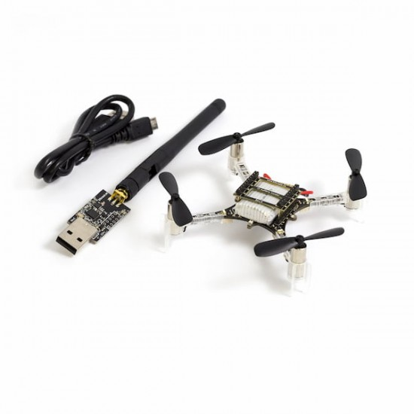
- The power button for the CF is found on the front right hand side. The CF must be turned on, and have a battery life of at least 20%. The controller for the Crazyflie is made available through a command prompt.
- To run this controller application, the user needs at least 4GB of RAM on his/her computer.
- The operating system must be of the Linux variety.
- The user’s computer must have up-to-date Ada/SPARK compilers installed (CubeSat).

Features
To start the application, the user must run the main file of the software from the command prompt.
There are 10 main commands that the user can give to the Crazyflie to control it.
The user can give any number of commands in a list (with the exception of CANCEL, which is reserved for emergencies and SCAN, which must be run before anything else). The list must start with LAUNCH and end with LAND, however.
If any of these commands fail to execute as the drone is flying, the controller will send an error message to the user and cancel the command process.
It is possible to give a second list of commands while the first list is being carried out.
These 10 main commands are as follows:
- SCAN
  - This command scans for interfaces to connect to the application.
  - When scanning, the application disconnects anything already connected
  - If the user types in alternative commands before there is a connected device, the application says “there must be an interface connected to run those commands!”
  - If the user types this command while a connected CF is in the air already, it sends a message to the user saying “please land your current connection.”
  - If all is successful, a message is displayed saying “scanning.” It then goes through the interface results, asking if the user would like to connect.
  - When the user says yes to an option, it shows a message saying “connected to <info>.”
- LAUNCH
  - This command launches the CF off the ground
  - If the user tries to place this command in the list where the CF is in the air already, the application displays a message saying it can not run the list for that reason.
  - Likewise, if any of the following commands are run before the LAUNCH command is run, a message saying “LAUNCH must be your first command!” will display.
  - When in this mode, the command LAUNCH cannot be used again until after a LAND command is placed in the list.
- LAND
  - This command lands the CF on the ground, from wherever it is flying.
  - The only command that can be placed after the LAND command is LAUNCH.
- CANCEL
  - This command lands the CF from wherever it is currently in the air.
  - It gradually slows the motors until it hits a surface.
  - It then shows a message saying an emergency landing took place.
  - If the CF fails to stabilize itself after any given command, this command will be invoked and the CF will make an emergency landing.
  - When the emergency land takes place, the current list of commands gets canceled and must be re-given.
The following six commands each require that the user specifies how many feet they would like the Crazyflie to move. Furthermore (as previously stated), the drone must be launched for the commands to be accepted. If it is placed in the LAND state, an error message will display saying the list could not be carried out for that reason.
- UP
  - This command tells the CF to move up in the air.
- DOWN
  - This command tells the CF to move down in the air.
  - If the ground is too close, it will engage the LAND command. A message will then display to the user saying “the ground was detected.” It will then cancel all further commands in the list.
- LEFT
  - This command tells the CF to move left in the air.
- RIGHT
  - This command tells the CF to move right in the air.
- FORWARD
  - This command tells the CF to move forwards in the air.
- BACKWARDS
  - This command tells the CF to move backwards in the air.
The text for these commands are not case sensitive.
If an unknown command is given, it will display a message to the user saying it can not carry out the list of commands for that reason.
The command line will display the commands as they are being carried out. That way, the user can confirm that everything is running correctly.
If the battery life drops below 10%, it sends a message to the user. If it drops below 5%, autopilot takes over and it lands.
Use Cases
Connecting the CrazyFlie
Goal:
connect the Crazyflie to the controller application
User actions:
The user runs the main file of the application for controlling the Crazyflie.
The user plugs in the Crazy Radio.
The user turns on the CF.
The user confirms that the CF is operational by observing the drone lights.
The user types SCAN into the prompt to scan for connections.
The user types Y when asked if they want to connect to the found interface of the CF.
The user confirms that the Crazyflie is connected.
App Actions:
The application starts running when prompted.
The application displays a message saying that it does not detect the Crazy Radio, and to please plug it in.
The application detects that the Crazy Radio is plugged in.
The application shows a message asking the user to scan for interfaces.
The application scans for connections.
The application displays the first connect option and asks the user if they want to connect [Y/N].
The application connects to the CF.
The application shows that the Crazyflie is connected.
Crazyflie Actions:
The CF runs routine tests after being turned on, reflecting this in its lights.
The CF uses the Crazy Radio to connect to the controller.

Flying the Crazyflie
Goal:
Give a list of commands to have the CF complete
User Actions:
The user confirms that the CF is connected to the controller software.
The user types in “LAUNCH, UP 0.5, LEFT 2, UP 1, RIGHT 4, LAND” to the command prompt.
The user confirms that the list can run.
The user confirms that the CF is flying correctly.
The user confirms that the CF has landed.
App Actions:
The application sends the command prompt message to the drone.
The application confirms that the list is within the requirements for a successful flight.
The application shows that the CF is carrying out each command.
Crazyflie Actions:
The CF receives command prompt messages about the desired state.
The CF gets the current state from the sensors.
The CF sends messages to the motor to obtain the correct state.
This repeats until all commands are completed.

Canceling Actions to the Crazyflie
Goal:
Canceling the previous commands being carried out to the CF while it is mid-flight.
User Actions:
The user types in CANCEL to cancel the CF’s previous command.
The user confirms that the drone successfully canceled the previous command and is making an emergency landing.
App Actions:
The app sends controller messages to the CF to halt flight.
Crazyflie Actions:
The CF receives the controller messages to cancel the command.
The CF stops at the place that it’s currently at. It is put back to a hover state at the point after the cancel command was given.
The CF hovers in its current position until it is given its next command from the prompt.

Functional Requirements
The Crazyflie will be able to fly: Up, Down, Left, Right, Forwards, and Backwards.
The CF will not be able to rotate in the air, or move diagonally.
The CrazyFlie will be controlled with a command prompt that gives instructions to the drone.
If a command fails to carry out, the CF will send an error message to the user and cancel all commands and land.
There are several things that the controller will check for when a list of commands is given. These include the following:
- The drone and its sensors must be functioning correctly.
- The list must start with LAUNCH and must end with LAND.
- If the drone is in a launched state, the LAUNCH command can not be given.
- If the drone is in a landed state, the LAND command can not be given.
- There must be no illegal commands in the list. This means it must recognize each command.
- The accumulated state of the drone at any point must not go further than 8 feet from where it starts.
If any of these requirements are not met, then the drone will refuse to launch and a message will be sent to the interface.
The message will display all errors in order of occurrence. It is up to the user to address all of them before the drone can be successfully launched.

Non Functional Requirements
The Crazyflie will respond in under 4 seconds to any LAUNCH command sent to it by the controller. This command is sent after verifying that each command in the list is legal.
If there is an issue in carrying out the command, the CF will send an error message to the user in under 4 seconds.
There will be little to no delay time between the end of one command and the beginning of the second command. The end of a command is marked by the desired state of the drone being obtained.
The CF will move in the direction issued using feet as the units of measure.

Glossary
CF : Crazyflie

