The Crazyflie application is designed to give the user the means to fly the drone in a simple and straightforward way. There are several commands that can be given to the drone. These include up, down, left, right, and more.
Ideally, the user will give the drone a string of multiple commands and the Crazyflie will carry them out one by one. For more details, see the requirements document.

The following is a diagram of the design of the Crazyflie application. It is intended to represent the software in the most efficient way possible.
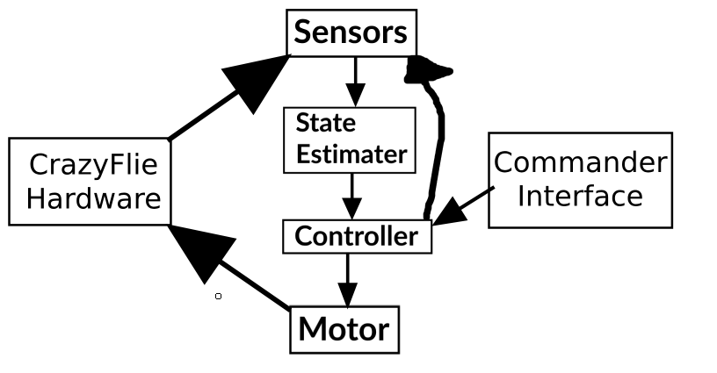
For starters, there is a Commander interface. This is the means by which the user can command the drone. This interface will appear as a command line when the program is launched. From there, the user can type in commands and send them to the Crazyflie as desired. This interface communicates to the Controller.
The Controller is what serves as a main module to keep everything throughout the system in the correct place. When a message is given from the commander interface to the controller, the controller breaks down what each command is and calculates what the desired state of the drone is at any given time. It then sends a message to the Sensors module.
The Sensors module gets the output from the Crazyflie hardware. This output comes from the accelerometer and gyroscope sensors. It then sends this data to the State estimator.
The State estimator calculates the current state of the drone. From the accelerometer and gyroscope values, it calculates altitude and attitude. It then sends that back to the controller. From there, the controller calculates what commands need to be sent to the motors in order to obtain the desired state. These commands are then sent to the Motor module.
The Motor module communicates to the hardware, to identify how much thrust and directional commands to give. From there, the loop is started over. Information is sent to the sensors again and the loop continues until the drone is in the desired state. When this state is obtained, a message is sent back to the controller module reflecting the success and the next command is carried out. Once all given commands have been completed, a message is sent back to the commander interface reflecting that.

