NetWeather

User’s Manual
Section 2: Hardware

By: Josh Bouffard


Table of Contents

Intoduction……………………………………………………………...….3
Setting up the HCS12 Microcontroller……………………………………3
Code Section 1……………………………………………………………………………6
Code Section 2……………………………………………………………………………7
Code Section 3……………………………………………………………………………8
Bill of Materials…………………………………………………………….9
Introduction

In Section 1 we developed a web site and stored it onto a special server which has a serial connection that is used to connect to the hardware end of out weather station.

Attached to NetWeather’s Hardware Manual is another User’s Manual for the Anemometer and wind direction sensor. Also, if you wish to include other sensors such as temperature, pressure, sun, rain, relative humidity, soil saturation, etc. Use the Installation Manuals given and simply follow his Hardware Manual to see how they’re attached.

Setting up the HCS12 Microcontroller

Once the weather station and all other sensors are installed it is now time to hook up the HCS12 microcontroller.

- The first thing to do is look up what ports you want to use if your using a different setup than what’s shown or if you have more sensors than what’s shown.

We will be using:

  - Pin 1 (Serial Transmit)
  - Pin 8 (Power)
  - Pin 4 (Ground)
  - Pin 9 (ANO0)
  - Pin 11 (ANO1)
  - Pin 13 (ANO2)
  - Pin 14 (PT7)

- Next you need to find the ‘Holes’ on the board and Double Check that you do in fact have the right holes. Then solder in as many GREEN wires needed to the microcontroller board. Make sure at this point you do not solder in the other sides of the GREEN wires.

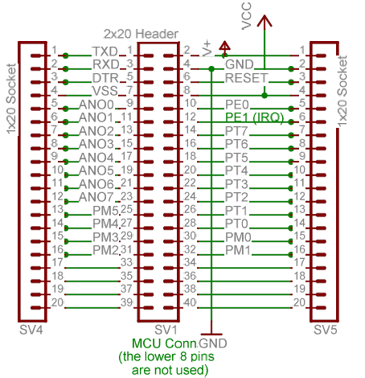

Note: You have all the Pins shown to work with!

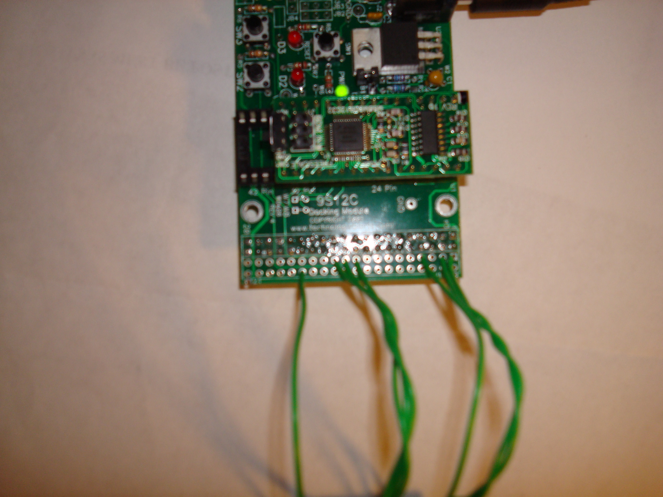
2x20 Header
Double Check to make sure you have the right Holes!!

Microcontroller Board 2x20 Header

- Now identify the 2x20 header layout on the ‘Terminal Board’ and solder in the corresponding wires.

Serial Communication Port / Program code download Port
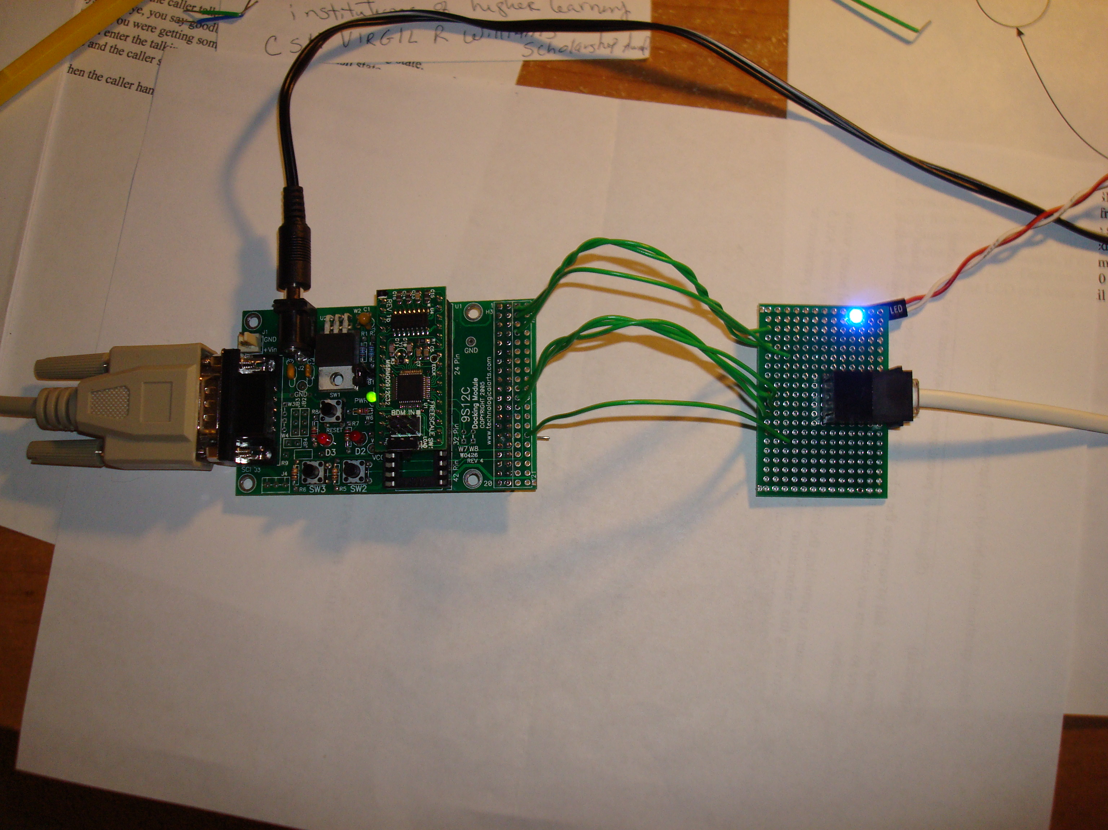
2x20 ‘Terminal Board’ Header
‘Via’ expansion 2x20 Header
Anemometer Data Cable
Additional Sensors

- Now that the wires are connected, it is time to plug in the outside Anemometer and any sensors added.

  - Take note that if they’re more sensors than what can fit on the Anemometer data cable (white telephone wire), then the additional sensors will have to be soldered in the back on the ‘Via’ pad which is another 2x20 Header identical to the one next to it.

- With the hardware set up, it’s time to download the project code shown below. If you decide to make modifications to the code below, it is recommended that you safe the original and create another project so that there will always be a working code to fall back on.

- Fist we will begin by entering the following code which will provide the main portion of the project (Code Section 1).

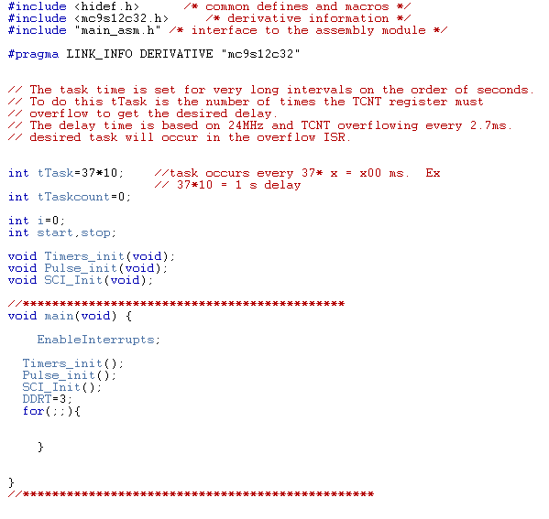
Code Section 1

- Next we will initialize the timer and the pulse accumulator and enter in the ‘Task’ function shown below (Code Section 2).

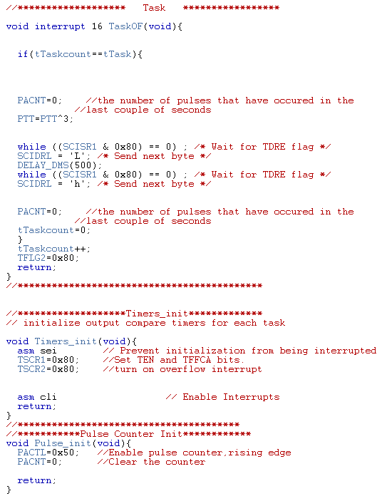
Code Section 2

- Last we will enter in the Serial Interface function what will output data onto the Serial Communication Interface which is where the server will get its data (Code Section 3).

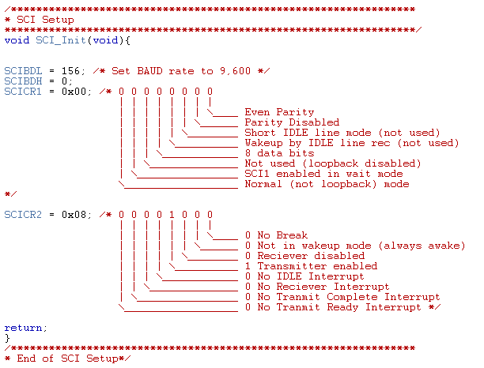
Code Section 3

- Additional functions for the various sensors are left up to you as an exercise. Also, other functions can be added to improve the sample startup code above. Help with HCS12 programming can be found in the user’s manual for the HCS12 provided with the microcontroller.

Now that the hardware has been soldered and is working fine and the project code is receiving data, it is time to attach the Serial cable to the HCS12 board.

Congratulations, you’re now recording real time weather data which appears directly on your very own weather web page!!!

Bill of Materials

When ordered as a kit, everything is included. Otherwise, what you need is listed below.

Qty. Description
1 | 68HSC12 Microcontroller by Feescale (Motorola) or equivalent
1 | 9SC12 Docking Module
1 | Code Warrior (included with Microcontroller)
1 | 68HCS12 User’s Manual (included with Microcontroller)
1 | Anemometer kit by David Labs
1 | Terminal Board (included with this kit)
1 | Computer Server
1 | Section 1 of this kit (for web development)

- Note that almost everything listed above can be found at www.technologicalarts.com with the only exception of the
Terminal Board and computer server.

