**CS 498 AML HW 1 REPORT**

**Pengyu Cheng**

**pcheng11**

**673359146**

* Part 1 A accuracy: 0.7584415584415585
* Part 1 B accuracy: 0.7441558441558442
* Part 1 D accuracy: 0.7714285714285715

Accuracy subject to change as I used random split for dataset.

* Screenshot of my code:

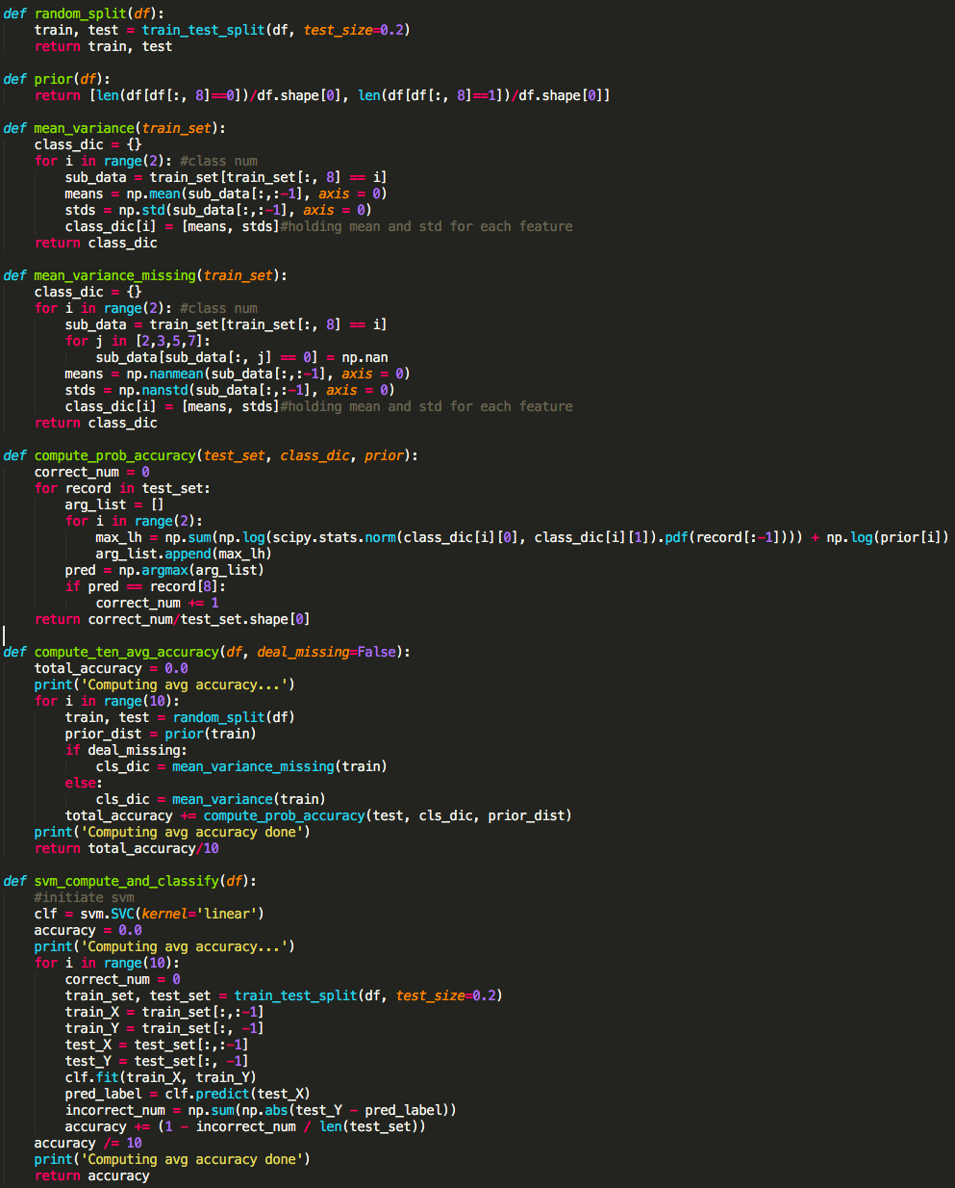

1: Gaussian + untouched: 0.55560

2: Gaussian + stretched: 0.81230

3: Bernoulli + untouched: 0.83650

4: Bernoulli + stretched: 0.82360

5: 10 trees + 4 depth + untouched: 0.74905

6: 10 trees + 4 depth + stretched: 0.75580

7: 10 trees + 16 depth + untouched: 0.95915

8: 10 trees + 16 depth + stretched: 0.95935

9: 30 trees + 4 depth + untouched: 0.78615

10: 30 trees + 4 depth + stretched: 0.79320

11: 30 trees + 16 depth + untouched: 0.97075

12: 30 trees + 16 depth + stretched: 0.97405

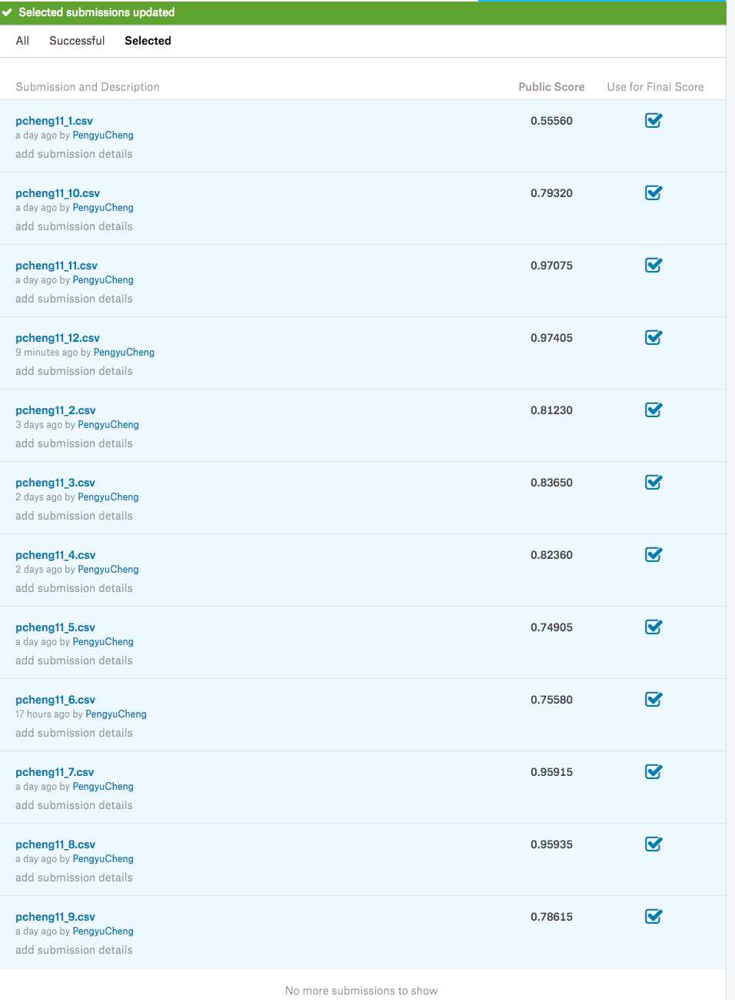

* Gaussian + Untouched



* Gaussian + Stretched



* Bernoulli + Untouched



* Bernoulli + Stretched



