* My leaderboard screenshot

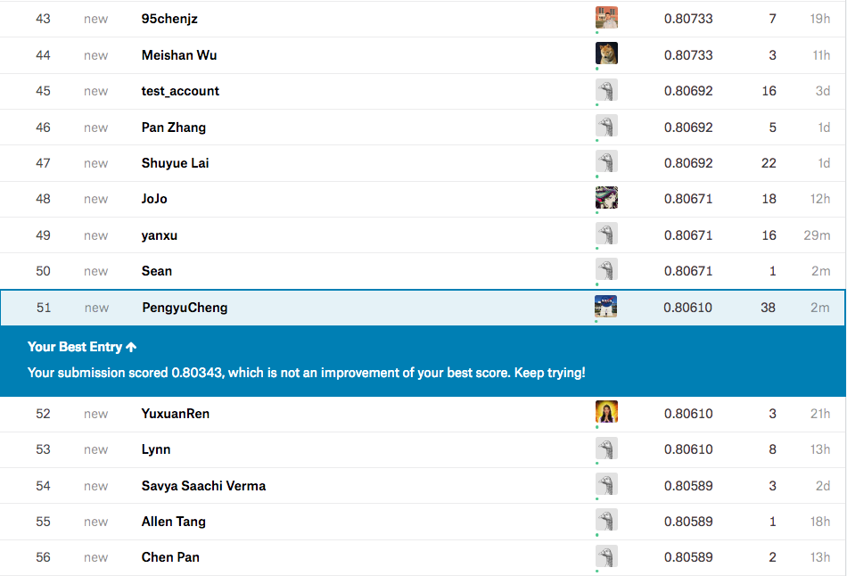

* My best test dataset accuracy obtained on kaggle is 0.80610
* A plot of the accuracy every 30 steps, for each value of the regularization constant.

(epochs = 50, steps = 300, batch size = 131)

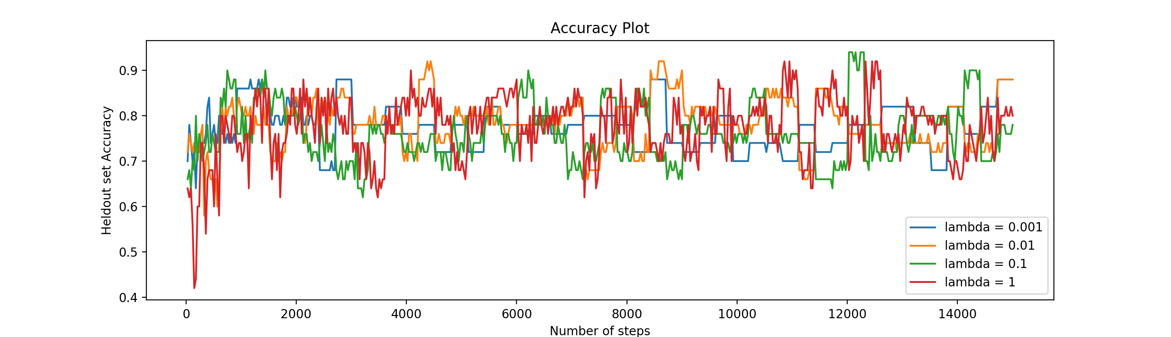

* A plot of the magnitude of the coefficient vector every 30 steps, for each value of the regularization constant.

(epochs = 50, steps = 300, batch size = 131)

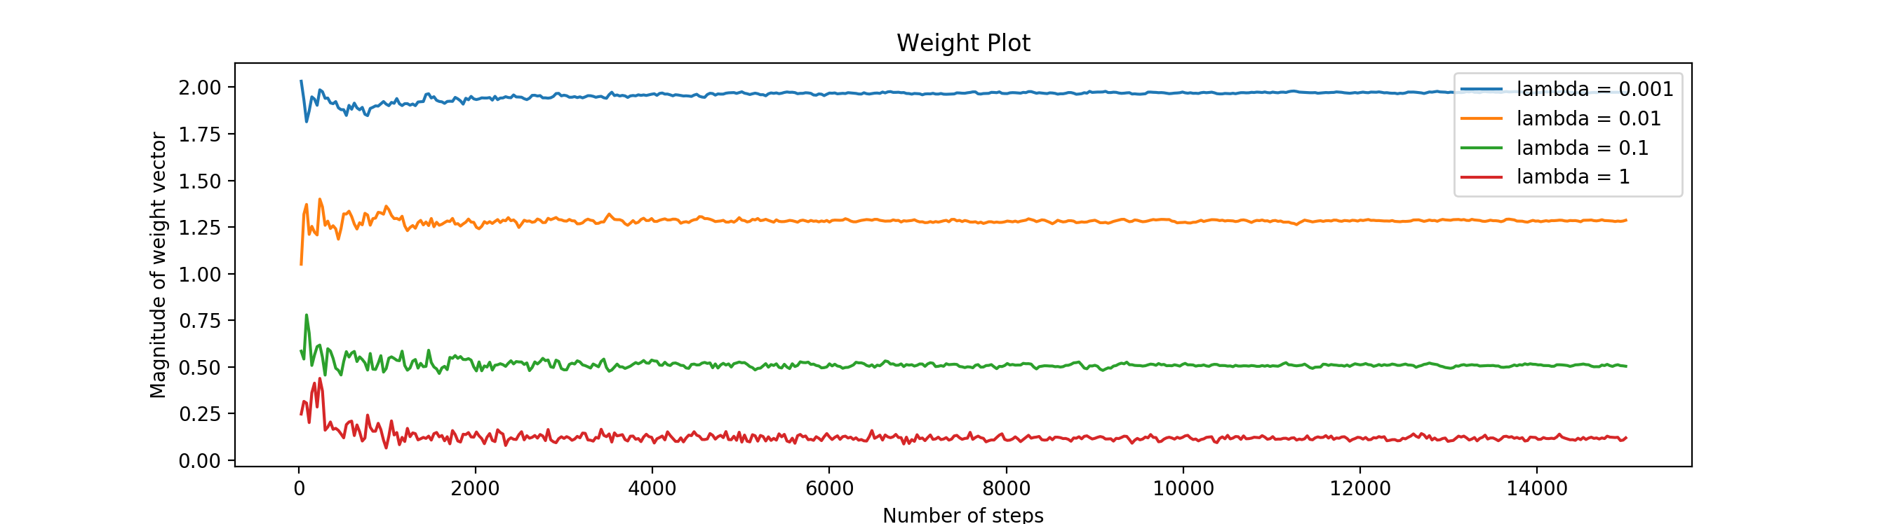

My estimate of the best regularization constant is 0.01.

* We can see from the accuracy graph that the accuracy is not particularly sensitive to the regularization constant but tend to give a good result when lambda is 0.01.
* The graph below also testifies the choice of my lambda.

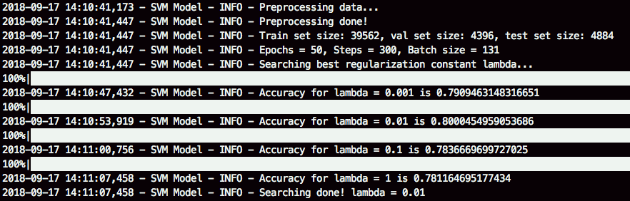

We see that when the lambda = 0.01, the accuracy of the validation set is around 80% which is the largest value.

My choice of learning rate is 1/ (number of epochs).

* I have tried a several of learning rates either constant = 0.01 or diminishing learning rate such as 1/(number of epochs + 50) as given in the book but my chosen learning rate of this specific lambda and batch size tends to give a good result. From another point of view, just as the books says: “that the method can explore large changes in the values of the classifier parameters — and small steps later — so that it settles down”.