* 50 MSE fitted in a table

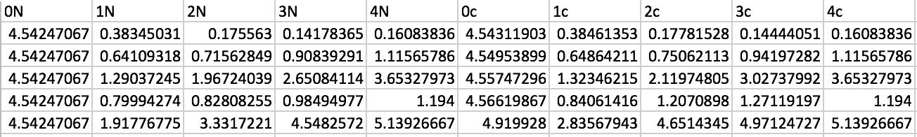

* Code (Used PCA library from scikit-learn)

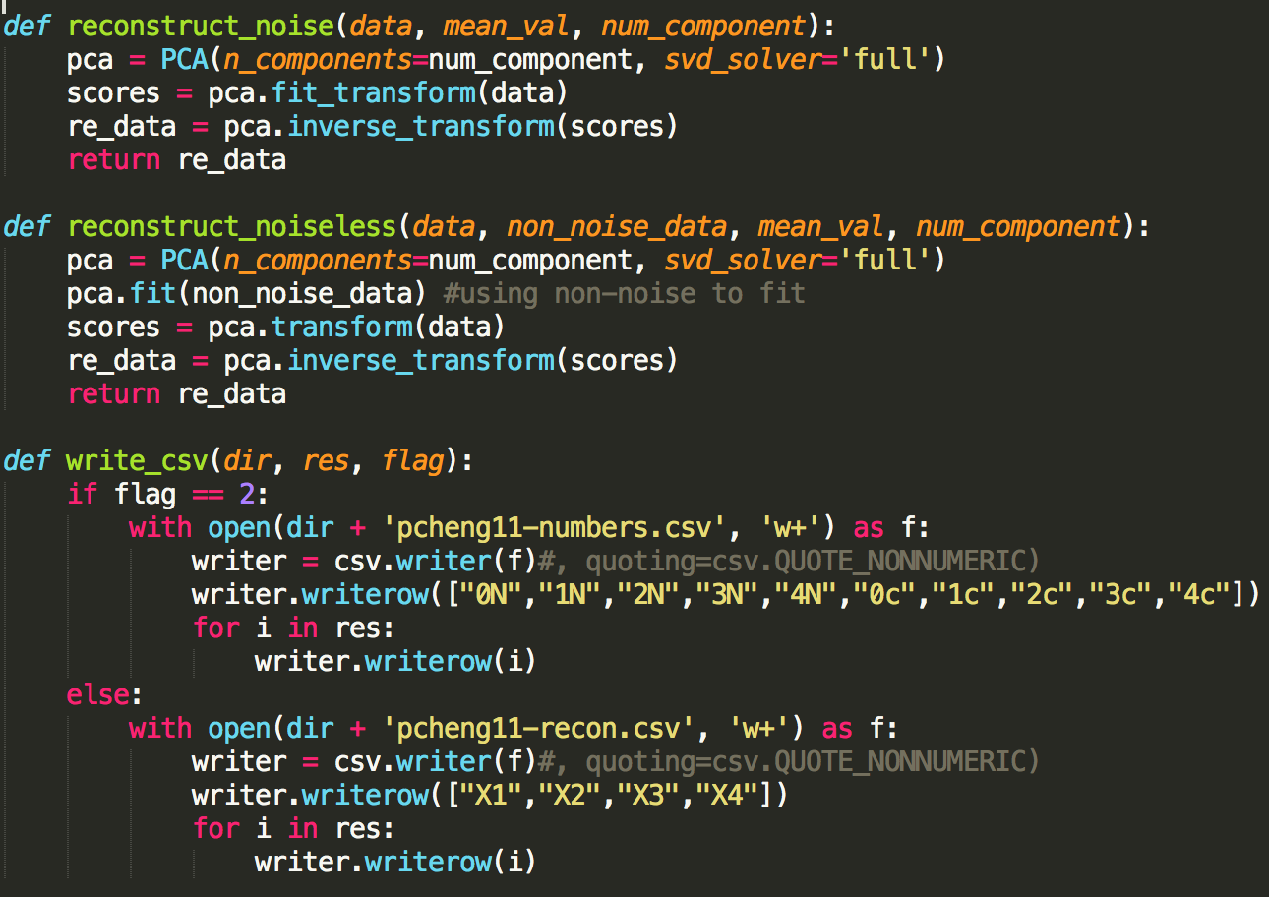

* Main function:

