**The Intelligence Studies Department presents…**

**Jeffery Luce and Nick Regelman, from Erie Insurance!**

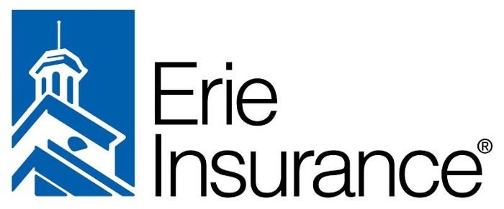

**When:**

Thursday, 20 April at 7:00 pm

**Where:**

CAE 300  
 **What:**

Jeffery Luce and Nick Regelman will be speaking about their professions as information security professionals, specifically as penetration testers. They will be giving ethical hacking demonstrations and talking about what it takes to test all of the various systems at Erie Insurance. **Pizza and drinks will be provided!**