Overall structure of the code
Index.html – loads everything in the webpage
Main.js – launches the initial routines to read the latex input
Parser.js, grammar.peg – parses the input string into the master tree using the grammar file
Tree.js, node.js – classes for the master tree and its nodes with all the functions
Equation.js – class for the displayed equation (containing both master tree and Raphael tree)
(Includes animation routines)
Gui.js – GUI for interacting with the equation
Simpl.js – classes for the transformations of the tree
Store.js – classes to store the previous operations and make them accessible.
---------------------------
Note that the master tree is organized according to the logical structure of the equation, while the Raphael tree has a slightly different structure for displaying the elements – s.t. when dragging, always move the whole parent set of the element:
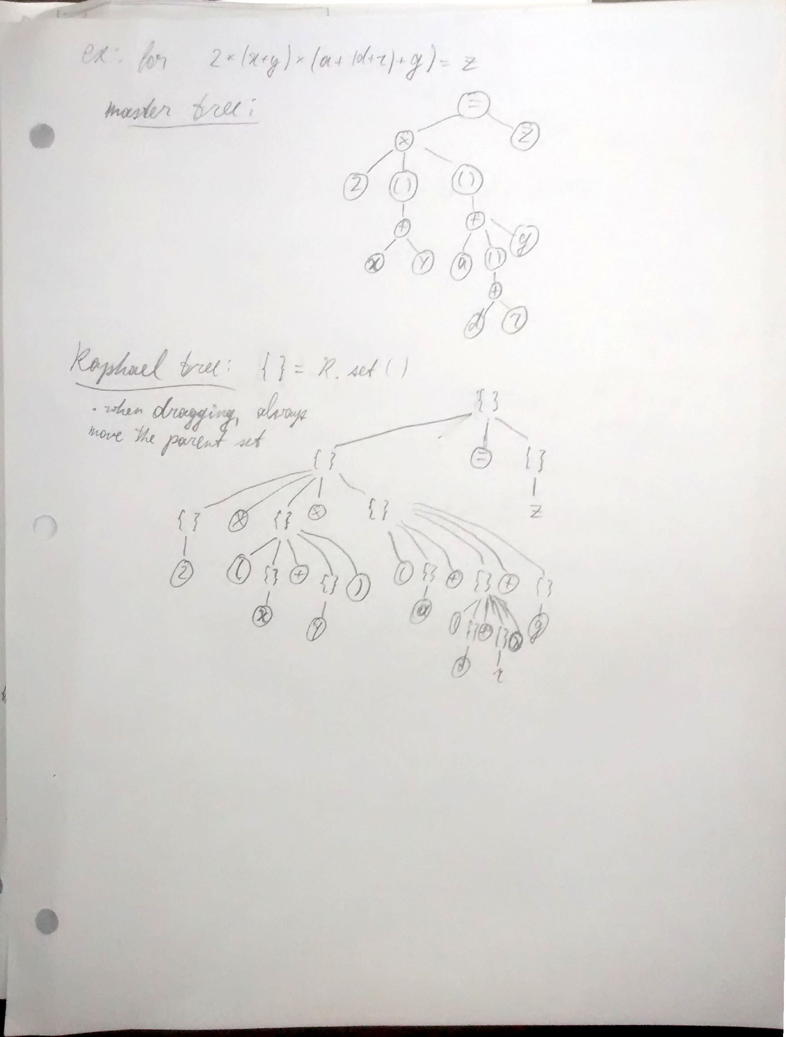
To Do
- Add hand-writing recognition support!!
- Adjust grammar to handle – and /
  - currently these are handles just like + and *
  - we want the + and * to be fundamental nodes, with ability to have many children, while – and / should be just modified single-child nodes (i.e. organize as f –h = f + (-h) )
- add display support for fractions
- restructure simpl.js slightly to make adding new transformations easier
  - have a simply grammar for how transformations should be encoded, and make the code capable of parsing it (e.g., for distribution something like { . * ( . + . )} => (.*. + .*.) should be enough input to define this transformation
  - eventually, we want to allow for user-defined transformations..
- add more algebraic operations – both transformation and gui user interaction
  - multiplicative and additive “take element to the other side of equation”
  - finish constant expression (or subexpression) evaluation
  - inverse of distribution (factor out a common term)
- tweak the distribute operation
  - should only work if you drag the entire expression to be distributed in – not just any child of it
- Prettier GUI
  - Visual appeal is incredibly important in prototypes to get people’s attention!
- Fix usability bugs in GUI
  - There are some details now that are not super convenient in the usability of the GUI and should be worked out
- Better display of stored operations
  - Allow to branch off a derivation path, and show all such branches
- Propagating changes through manipulations
  - Allow to make a small adjustment (e.g., change variable name) in the early stages of derivation and automatically propagate it through all the later stages

To Do – later steps:
- Plotting support
  - Allow to double click an equation to show its plot
  - This is a good illustration that out platform can also be extended beyond just equation manipulation
- Integration with Mathematica in backend
  - For integral / derivative evaluation, equation solving, automatic simplification etc.

