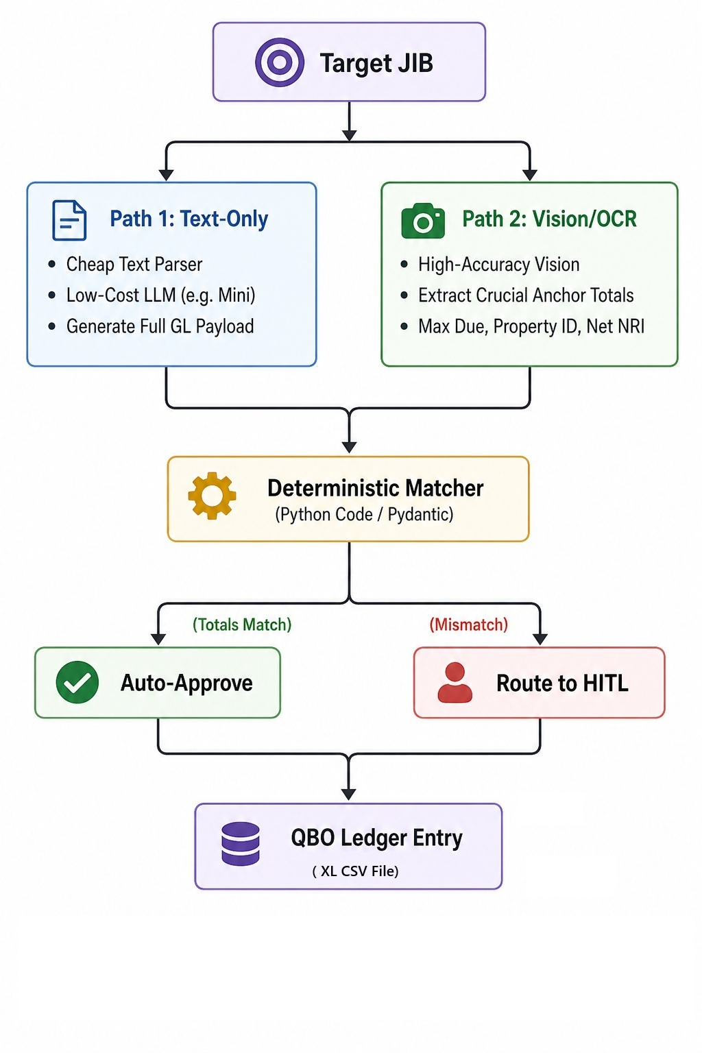
Create an agentic harness in python using the attached flowchart document.
The harness shall ingest oil and gas lease JIB (Joint Interest Billing) pdf files.
In addition to the JIB, the harness shall also ingest oil and gas lease Run Statement pdf files.
The harness shall use the OpenAI Agents SDK.
The harness shall loop executing these steps:
Step 1
Retrieve a JIB pdf file from the user, if not available go to Step 5.
Step 2
Description of fields to parse in the JIB pdf file:
JIB Master Fields (the JIB summary)
• The check number of the payment made to the operator, if available
• The date the vendor was paid, if available
• The vendor name
• The vendor information
• The date of the JIB
JIB Detail Fields (the JIB line items)
• Each line item is a lease, and contains the following values:
- The account name = one of the following: Lease Operating Expense, Lease Equipment, Taxes, Admin Fees, Office Rent, Postage, Office Supplies.
- The total amount for the lease for that account.
- A memo for the lease = the month for the operating cost charge.
- The class = the lease name.
Parse the JIB in two parallel stages:
Stage-2a (text extraction):
• Read the JIB pdf file.
• Parse JIB pdf text into JIB Master Fields and JIB Detail Fields described above.
Stage-2b (vision extraction):
• Convert the JIB pdf file to an image file, using pdf2image.
• Parse the JIB image/OCR input into JIB Master Fields and JIB Detail Fields described above.
Note: Use a frontier LLM model if needed to parse image/OCR.
Step 3
Compare Stage-2a fields to Stage-2b fields, to verify all parsed fields agree.
Step 4
If all fields in GLPayload1 and GLPayload2 match, create the excel csv.
This excel csv shall not allow macros.
Otherwise, route to Human-In-The-Loop, and flag the discrepancies.
Step 5
Retrieve a Run Statement pdf file from the user.
Step 6
Description of fields to parse in the Run Statement pdf file:
Run Master Fields (the Run Statement summary)
• The check number of the check deposited
• The date of the check deposited
• The amount of the check deposited
• The net amount of the run statement
• The gross amount of the run statement
• The total taxes of the run statement
• The owner name
• The owner information
• The date of the Run Statement
Run Detail Fields (the Run Statement line items)
• Each line item is a lease, and contains the following values:
- The account name = one of the following: Lease Net WI, Lease Gross WI, Taxes, Deductions.
- The total amount for the lease for that account.
- A memo for the lease = the barrels of oil, or cubic feet of gas.
- The class = the lease name.
Parse in two parallel stages:
Stage-6a (text extraction):
• Read the Run Statement pdf file.
• Parse Run Statement pdf text Run Master Fields and Run Detail Fields described above.
Stage-6b (vision extraction):
• Convert the Run Statement pdf file to an image file, using pdf2image.
• Parse the Run Statement image/OCR input into Run Master Fields and Run Detail Fields described above.
Note: Use a frontier LLM model if needed to parse image/OCR.
Step 7
Compare Stage-7a fields to Stage-7b fields, to verify all parsed fields agree.
Step 8
If all fields in GLPayload1 and GLPayload2 match, create the excel csv.
This excel csv shall not allow macros.
Otherwise, route to Human-In-The-Loop, and flag the discrepancies.
Design Choices
Validation is intentionally strict: malformed data or invalid numbers raise errors instead of silently passing.
The matching layers (Step 3 and Step 7) are deterministic, and compare exact values rather than fuzzy tolerances.
Manual review is favored any time a mismatch validation signal appears.
Show more
3:17 PM
Worked for 7m 39s
I’m using the OpenAI documentation skill because this implementation depends on the current Agents SDK APIs. I’ll first inspect the workspace and the skill guidance, then build and verify the harness against the flowchart’s dual-path, deterministic-review design.
Ran a command, searched the web
The flowchart confirms the key control boundary: text and vision paths converge only at a deterministic matcher; exact agreement auto-approves, while any discrepancy goes to human review. I’ll preserve that behavior for both document types and ensure CSV generation occurs only after approval.
Edited files
The core harness is now implemented: strict Pydantic schemas, concurrent text/vision agents, exact field-by-field matching, mismatch review artifacts, and macro-free/formula-safe CSV output. I’m validating the package now, including the matcher and CSV safety behavior.
Ran commands
Syntax compilation passed. The base environment lacked the project dependencies, so I’m completing an isolated .venv installation before running the full tests; no source PDFs or external accounting systems are being touched.
Ran commands
Implemented the Python agentic harness based on the attached flowchart.
Key components:
- [README.md](/home/azureuser/source/README.md) — setup and operating instructions
- [workflow.py](/home/azureuser/source/lease_gl/workflow.py) — orchestration and approval routing
- [extractors.py](/home/azureuser/source/lease_gl/extractors.py) — parallel text and vision Agents SDK extraction
- [models.py](/home/azureuser/source/lease_gl/models.py) — strict JIB and Run Statement schemas
- [matcher.py](/home/azureuser/source/lease_gl/matcher.py) — deterministic exact comparison
- [output.py](/home/azureuser/source/lease_gl/output.py) — CSV and human-review output
- [cli.py](/home/azureuser/source/lease_gl/cli.py) — repeating interactive workflow
- [pyproject.toml](/home/azureuser/source/pyproject.toml) — dependencies and CLI packaging
Behavior:
- Processes JIBs and Run Statements.
- Runs text and rendered-image extraction concurrently.
- Uses pypdf, pdf2image, Pydantic, and the OpenAI Agents SDK.
- Rejects malformed or missing required data.
- Compares every canonical field exactly.
- Generates CSV only when both payloads match.
- Routes mismatches to a detailed .review.json.
- Escapes spreadsheet-formula cells; CSV cannot contain VBA macros.
- Supports interactive looping and one-shot automation.
Validation completed:
- 3 tests passed.
- Python compilation passed.
- CLI help smoke test passed.
- Both schemas passed the installed Agents SDK structured-output schema generator.
Run it with:
cd /home/azureuser/source
source .venv/bin/activate
cp .env.example .env
# Add OPENAI_API_KEY to .env
lease-gl
A live extraction was not run because no actual JIB/Run Statement PDFs or API credentials were supplied.
Edited 14 files+589-0Review changes
UndoReview
.env.example.env.example+5-0
.gitignore.gitignore+7-0
README.mdREADME.md+60-0
Show 11 more files
3:25 PM

Want fewer approval prompts?
ChatGPT can automatically approve eligible actions while it works. This may use more credits. Learn more.
Keep manual approvalsApprove for me⏎

Work locallyLocal

