A Report  
on

**Spots Nutrition Tracking**

by  
**Piyush Chanduka 2021A4PS1554P**

of  
Study-Oriented Project



BIRLA INSTITUTE OF TECHNOLOGY AND SCIENCE  
PILANI, PILANI CAMPUS

ACKNOWLEDGMENT

I express profound gratitude to my project guide and supervisor, Professor M.S. Dasgupta, for introducing me to this rewarding endeavor. His unwavering guidance and support motivated me to exceed expectations throughout the project, cultivating a deep interest in the subject. I am incredibly thankful for his invaluable inputs, which were crucial to the project's success.

I would also like to extend my sincere thanks to Prof. Srikanta Routroy, Head of the Department of Mechanical Engineering at BITS Pilani – Pilani Campus, and Prof. Sachin Belgamwar, Associate Dean of Academic Undergraduate Studies Division at BITS Pilani – Pilani Campus. Their provision of project courses for undergraduate students as part of the academic curriculum has exposed students to research early on, enriching their academic experience.

**Introduction -**

Athletes and health-conscious individuals prioritize maintaining a healthy lifestyle to optimize their performance and overall well-being. A key aspect of this lifestyle involves managing body weight and nutrition. Body Mass Index (BMI) remains a relevant metric is often considered indicative of obesity, which can impact an athlete's performance and increase the risk of various health issues.

To address the challenges associated with maintaining a healthy weight, athletes often focus on a balanced approach to diet and exercise. The primary cause of weight-related issues is still the imbalance between calorie intake and energy expenditure. In the context of sports and fitness, maintaining an appropriate body weight is crucial for optimal performance and injury prevention.

For athletes and health-conscious individuals, effective weight management involves strategic dietary choices and precise calorie monitoring. Computer vision-based measurement methods have gained popularity in recent years, providing innovative solutions to estimate calorie intake. These methods leverage deep learning, an emerging approach in machine learning that explores multiple levels of representation.

In this project, the focus shifts to the application of deep learning for food classification and recognition within the context of sports nutrition. The primary goals include:

1. Proposing the first recognition system for food.

2. Proposing a complete and effective calorie estimation method.

By tailoring the focus to sports nutrition, this project seeks to contribute valuable insights and tools that empower athletes and health-conscious individuals to make informed dietary choices, ultimately supporting their journey towards peak performance and well-being.

**Problem –**

Given a set of food images with desired specifications, estimate the calories and provide a personalized analysis.

**Objectives:**

1. To detect food type by using Convolutional Neural Network (CNN)

2. To estimate food weight and calories of food

3. To provide a personalized application for each user

4. To estimate the calories of the leftovers (overlapping food items).

**Dataset –**

For training of the model, I used the FOODD dataset. The dataset contains images taken with different cameras, illuminations, and angles. Having a wide variety of food and foods gives a better and more reliable dataset in order to increase the accuracy of calorie food measurement systems. In the dataset, the images are divided into 6 categories considering the capturing device, background, and lighting condition:

Samsung-S4 Light Environment

Samsung-S4 Dark Environment

IOS-4 Light Environment

IOS-4 Dark Environment

CanonSD1400 Light Environment

CanonSD1400 Dark Environment

In this project I used 7 food items:

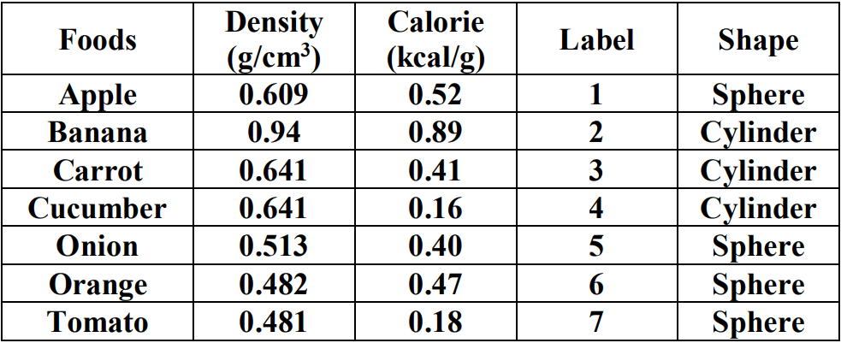

**Food Recognition Model –**

Food Recognition deals with recognition of food item when given an image. For this problem I used Convolutional Neural Network (CNN). The Architecture of CNN given

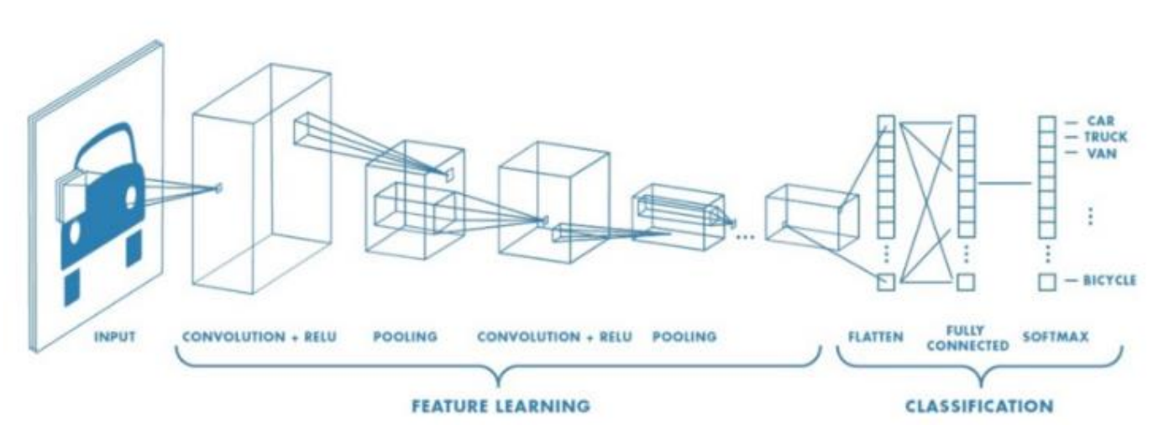

In this study, I implemented a neural network architecture comprising 5 convolutional layers with ReLU activations, dropout functionality, and SoftMax layers. The process of refining the model on the dataset was completed within approximately 2 hours, with a single Windows 10 Pro CPU equipped with 8GB of memory. The training phase involved a dataset containing 100 images for each food category, each image sized at 300*300 pixels. The optimization process employed the Adam optimizer and a categorical cross-entropy loss function, with a learning rate set at 0.0001. This approach facilitated the calculation and minimization of loss while enhancing the overall accuracy of the model.

The model summary:

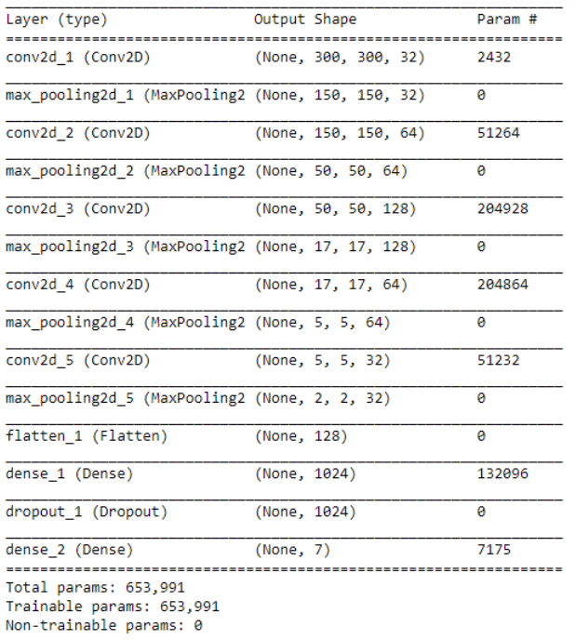

The training of the model -

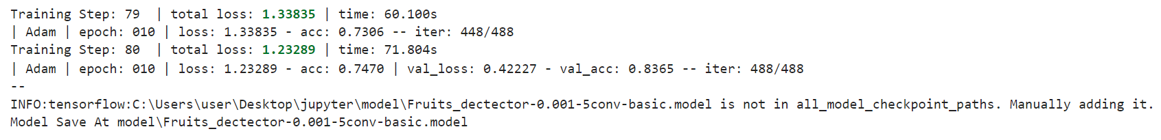

Accuracy of this model is **86.06%** with total loss **1.11.**

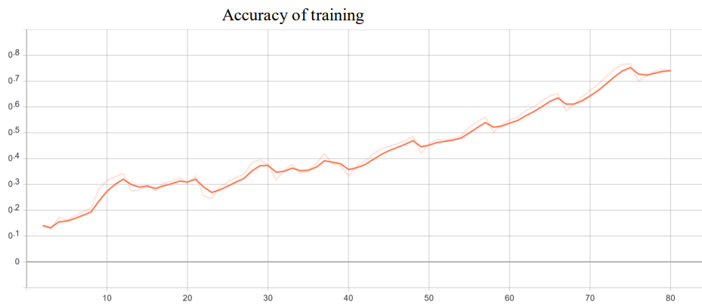

We know that, our thumb size is approximately 5*2.3cm is a skin multiplier (say). We calculate pixel to cm multiplier by using Maximum pixel height.

*pix_to_cm_multiplier* =

We have 3 factors from image segmentation

1. Foods pixel area

2. Skin pixel area

3. Actual skin area (skin multiplier)

From this factors food estimated area is given below:

*Estimated Food Area* =

We have two types of shape of foods

1. Sphere - like apple, orange, tomato, onion

2. Cylinder – like banana, cucumber, carrot

Volume estimation for Sphere:

Volume Estimation for Cylinder:

Weight And Calories Estimation of Food:

**Code –**

Previous code has much errors as it was running only for one time, showing warnings and import error.

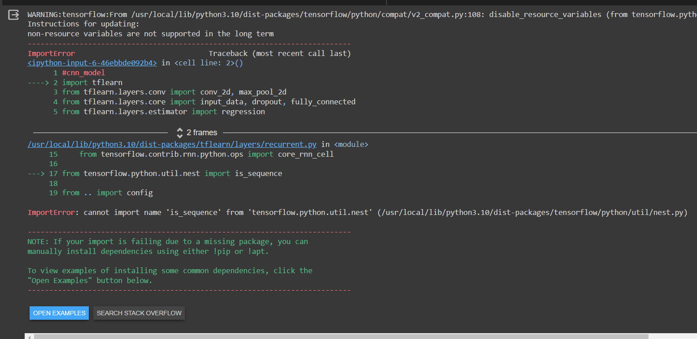

The updated code is free from errors and can be run multiple times. The code link can be found here –

<https://colab.research.google.com/drive/1ypUrp91iyDbqOO7hNWUMzvKzBieJ4Fm4>

The first and second objectives are completed. For fourth objective there are no much research papers about the overlapping problems. The third objective’s code is given in the code link but it needs more dataset with labelled sample names.

Limitations –

The personalized user interface is not fully implemented as it needs labelled dataset.

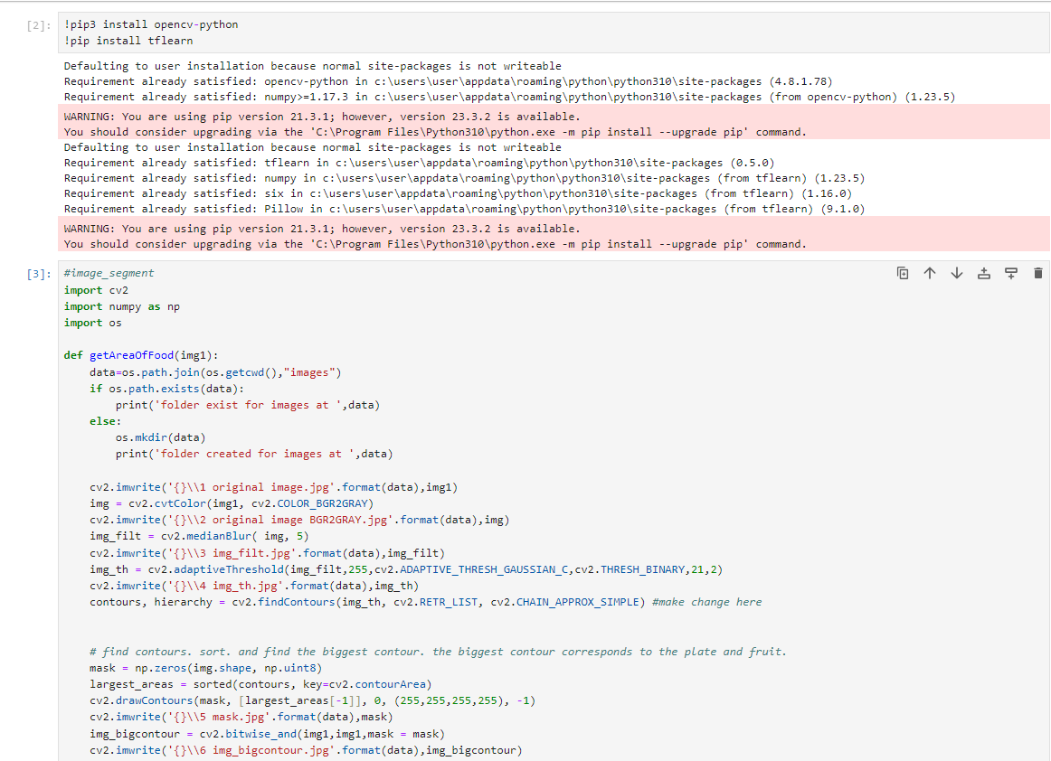

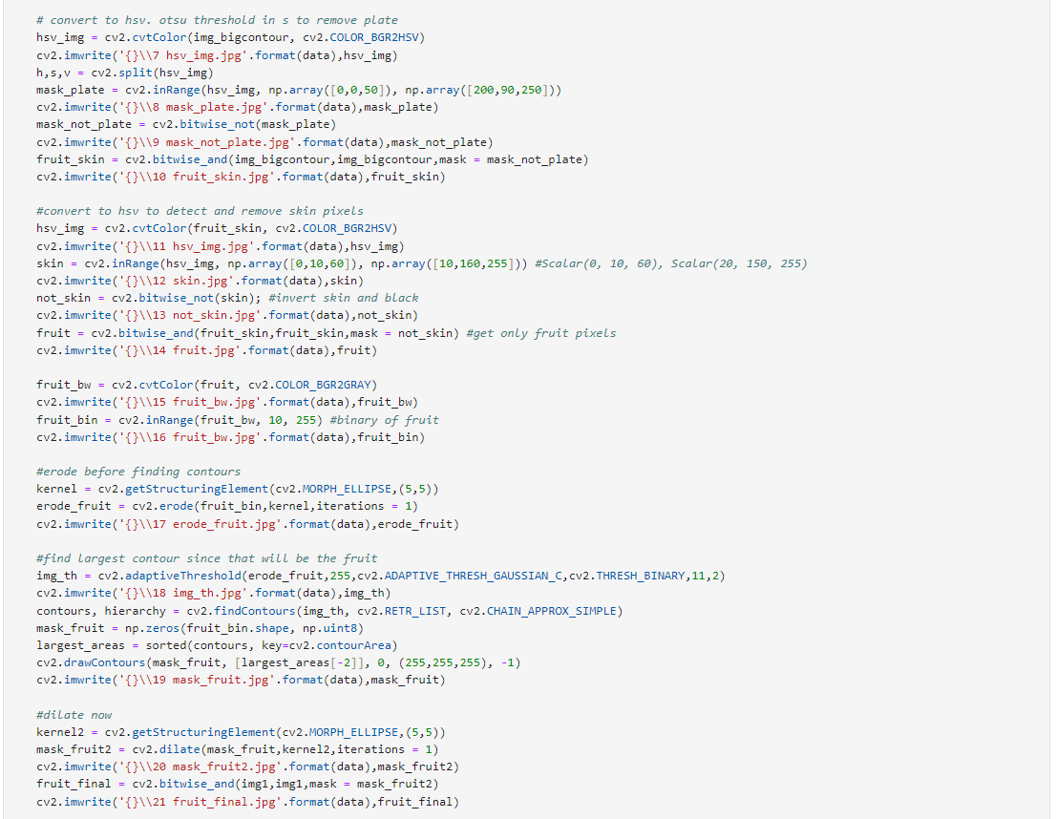 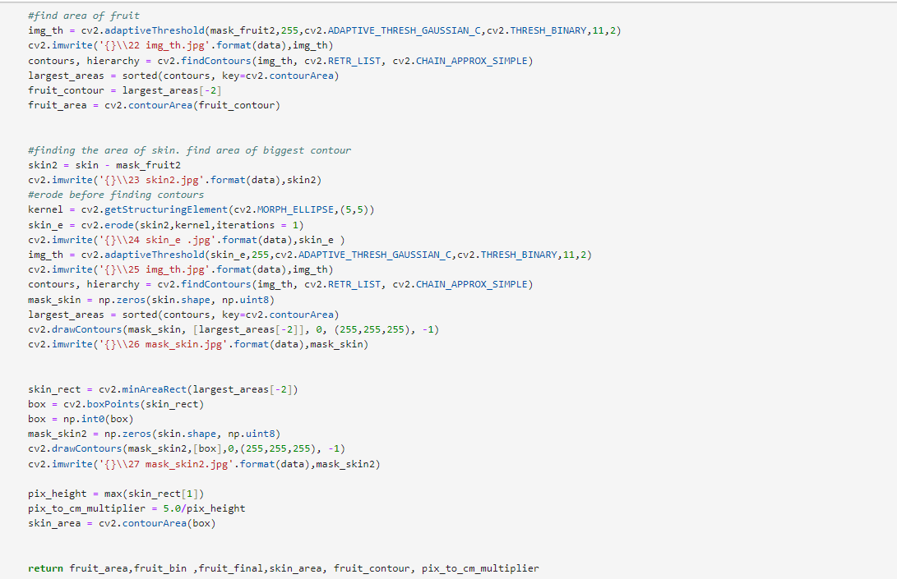

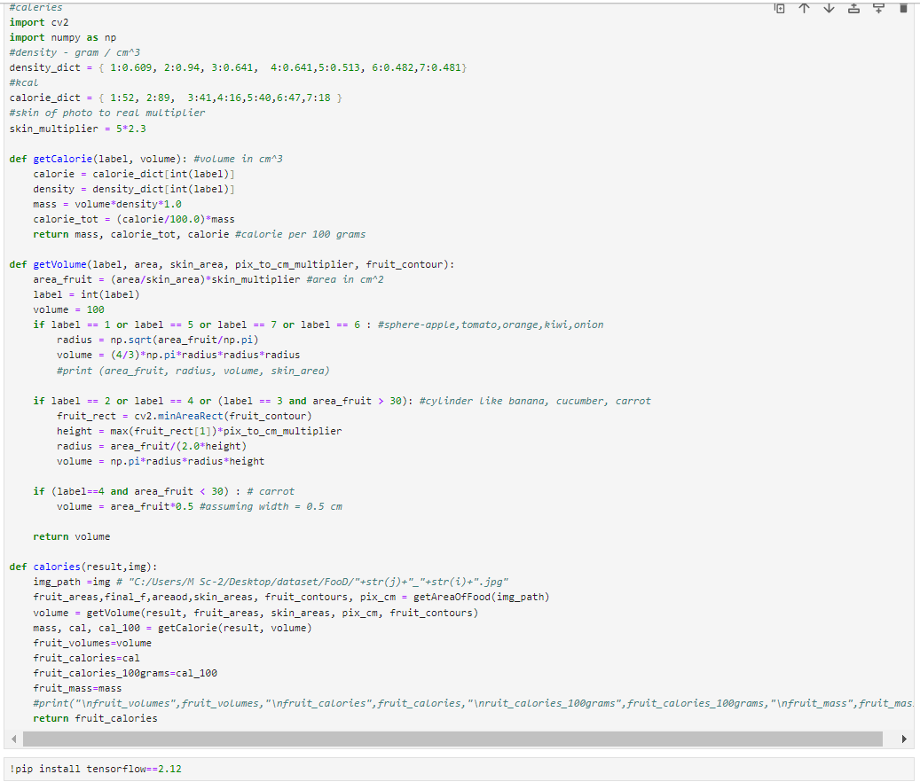

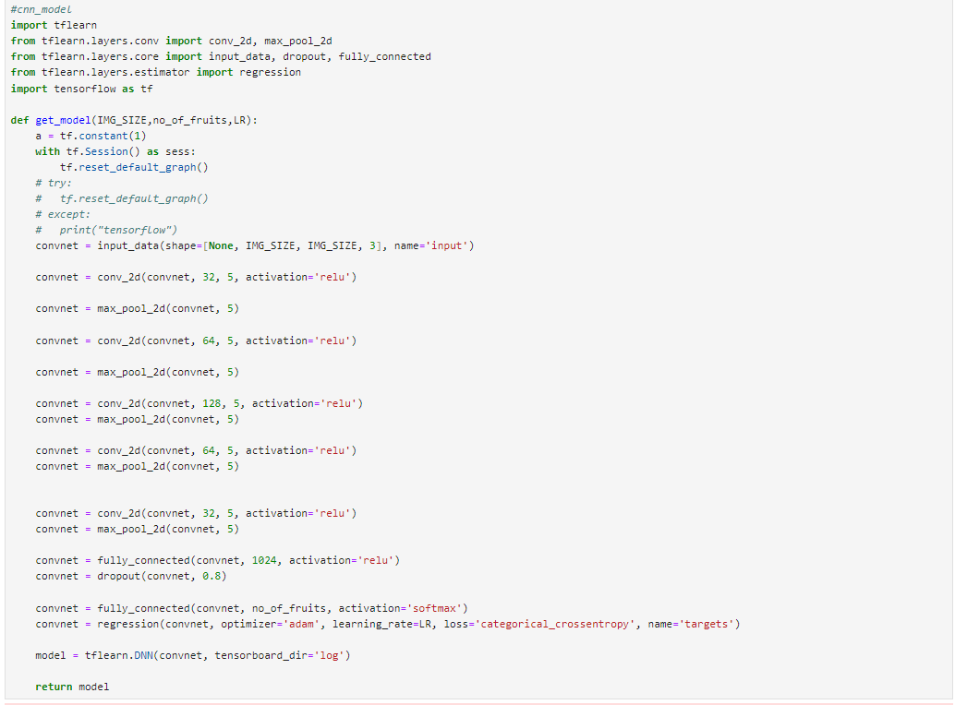 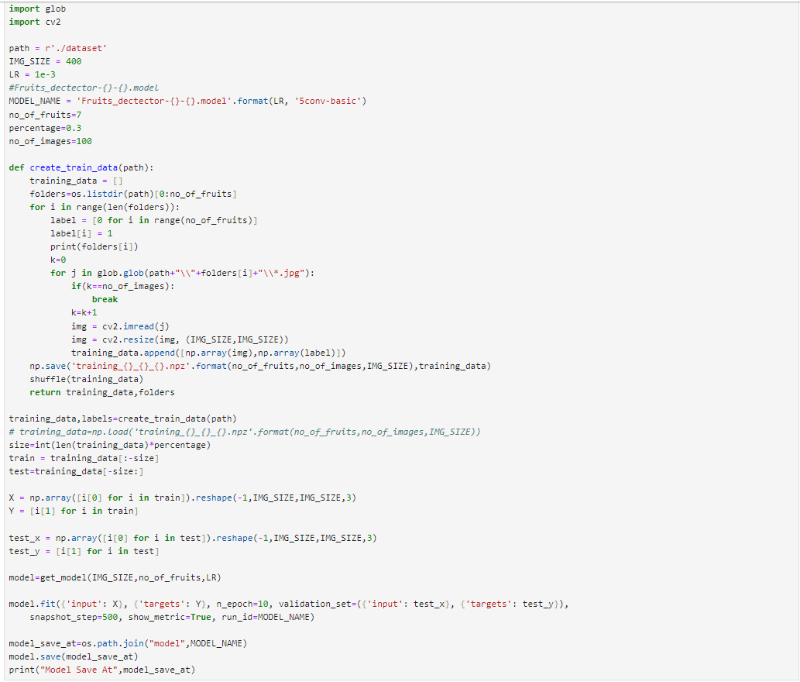

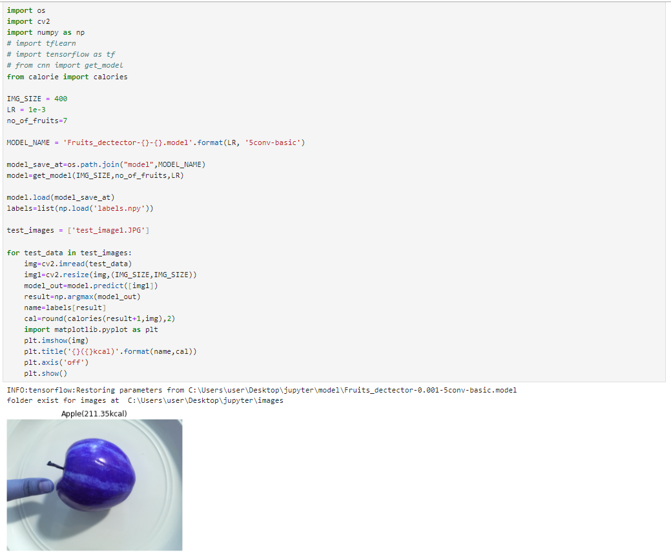

The following pictures are analyzed for calculating the calories of the sample apple -

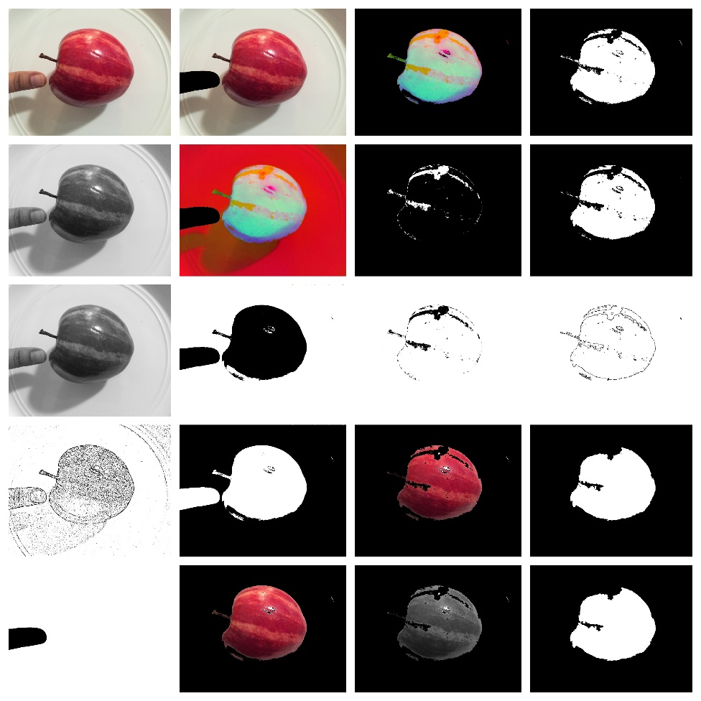

**References –**

1. https://viso.ai/deep-learning/mask-r-cnn/

2. https://github.com/vinayaksable2399/Food-Calories-Estimation-Using-Image-Processing

3. P.Pouladzadeh, S.Shirmohammadi, and R.Almaghrabi, “Measuring Calorie and Nutrition

from Food Image”, IEEE Transactions on Instrumentation & Measurement, Vol.63, No.8,

p.p. 1947 – 1956, August 2014.

4. Parisa Pouladzadeh, Abdulsalam Yassine, and Shervin Shirmohammadi, “Foodd: An

image-based food detection dataset for calorie measurement,” in

InternationalConferenceonMultimediaAssistedDietaryManagement, 2015

5. Meghana M Reddy, “Calorie-estimation-from-food-images-opencv”, Git repo , May

2016