**This Outlook Macro code auto triggers every time when new email is received from particular email id (eg:** [**abc@abc.com**](mailto:abc@abc.com)**) and downloads the attachment and body of email at the specified local path of your machine.**

Follow the following steps to successfully run the code.

# Step 1:

Open outlook and press Alt + F11 to open developer mode.

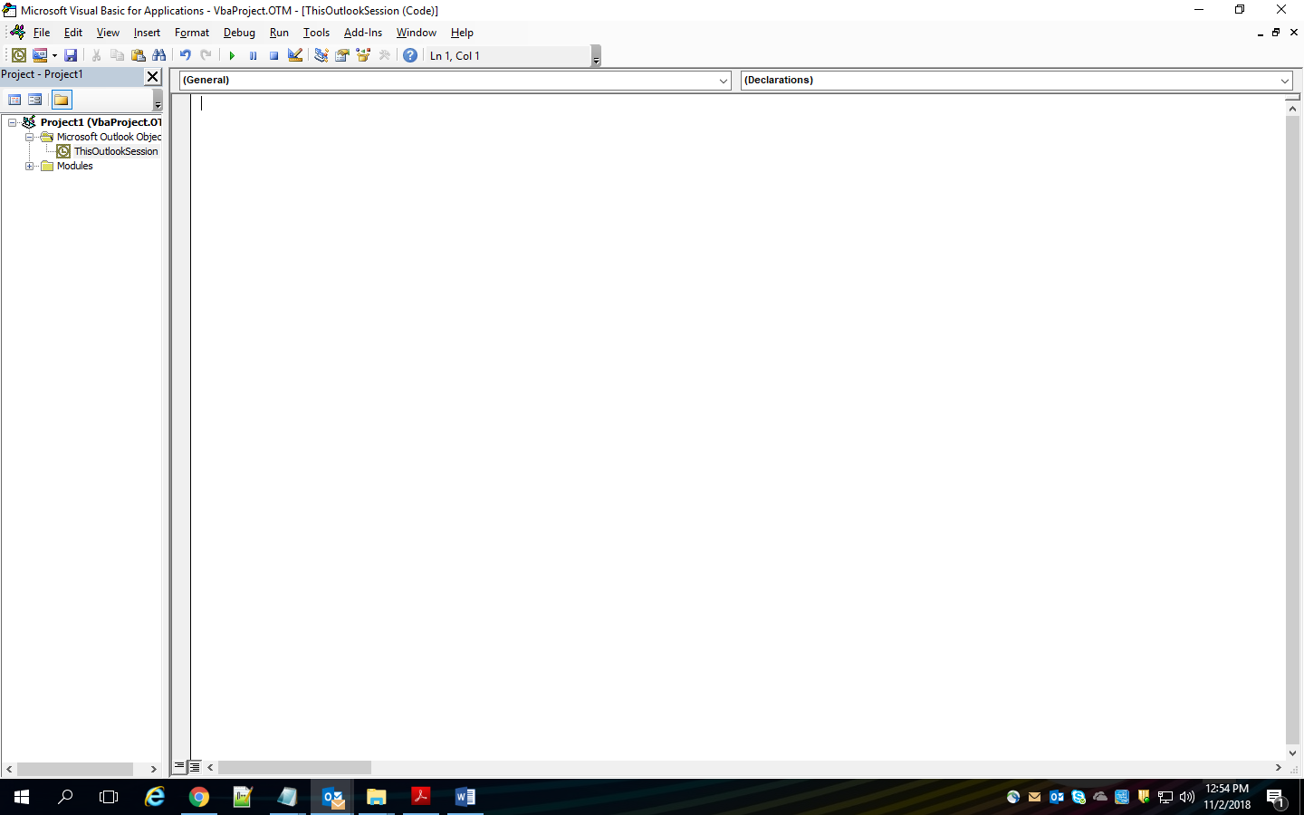

# Step 2:

Browse Project, goto Microsoft Outlook Object, goto ThisOutlookSession

Copy the code in file ThisOutlookSession.txt and paste it in ThisOutlookSession

Note: Press Ctrl + R to open Project window if not already open

# Step 3:

Save the project and restart the outlook.

# Code:

Option Explicit

Private WithEvents inboxItems As Outlook.Items

Private Sub Application_Startup()

Dim outlookApp As Outlook.Application

Dim objectNS As Outlook.NameSpace

Set outlookApp = Outlook.Application

Set objectNS = outlookApp.GetNamespace("MAPI")

Set inboxItems = objectNS.GetDefaultFolder(olFolderInbox).Items

End Sub

Private Sub inboxItems_ItemAdd(ByVal Item As Object)

On Error GoTo ErrorHandler

Dim objAtt As Outlook.Attachment

Dim saveFolder As String

Dim dateFormat

Dim MessageInfo

Dim Result

Const OLTXT = 0

Dim sPath As String

Dim dtDate As Date

Dim sName As String

dateFormat = Format(Now, "yyyy-mm-dd H-mm")

‘********** Path to local machine (change to your path) ************************************

saveFolder = "c:\outlook backup\"

If TypeName(Item) = "MailItem" Then

MessageInfo = "" & _

"Sender : " & Item.SenderEmailAddress & vbCrLf & _

"Sent : " & Item.SentOn & vbCrLf & _

"Received : " & Item.ReceivedTime & vbCrLf & _

"Subject : " & Item.Subject & vbCrLf & _

"Size : " & Item.Size & vbCrLf & _

"Message Body : " & vbCrLf & Item.Body

Result = MsgBox(MessageInfo, vbOKOnly, "New Message Received")

'**************************************************************************************************************

'downloads attachment sent from particular email

'check particular email address

‘********************* email id of the person ***************************************

If Item.Sender.GetExchangeUser.PrimarySmtpAddress = "pooja.chaudhary@capgemini.com" Then

For Each objAtt In Item.Attachments

' If InStr(objAtt.DisplayName, ".jpg") Then

objAtt.SaveAsFile saveFolder & "\" & objAtt.DisplayName

' End If

Next

'**************************************************************************************************************

'downloads body as txt file

sName = Item.Subject

ReplaceCharsForFileName sName, "_"

dtDate = Item.ReceivedTime

sName = Format(dtDate, "yyyymmdd", vbUseSystemDayOfWeek, _

vbUseSystem) & Format(dtDate, "-hhnnss", _

vbUseSystemDayOfWeek, vbUseSystem) & "-" & sName & ".txt"

‘********** Path to local machine (change to your path) ************************************

Item.SaveAs "C:\outlook backup\" & sName, OLTXT

'*****************************************************************************************************

End If

End If

ExitNewItem:

Exit Sub

ErrorHandler:

MsgBox Err.Number & " - " & Err.Description

Resume ExitNewItem

End Sub

Private Sub ReplaceCharsForFileName(sName As String, _

sChr As String _

)

sName = Replace(sName, "/", sChr)

sName = Replace(sName, "\", sChr)

sName = Replace(sName, ":", sChr)

sName = Replace(sName, "?", sChr)

sName = Replace(sName, Chr(34), sChr)

sName = Replace(sName, "<", sChr)

sName = Replace(sName, ">", sChr)

sName = Replace(sName, "|", sChr)

End Sub

**---- Pooja Chaudhary**