Module ParticleSizeDistribution

The module ParticleSizeDistribution provides the following features:
- it allows to choose different methods of representation (PSD_style) of the particle size distribution (currently only fully stationary is available)
- it allows to choose a size range for diameter (dp_range) and the number of sizes/bins (nr_bins) considered (subroutine GeneratePSDarrays)
- it allows to generate PSDs for modelling by fitting it to input PSD (PSD_in) (subroutine GeneratePSDfromInput). Note that the fitting subroutine can be used to fit anything with respect to particle diameter.
- it allows to set a composition for the read-in particles (derived from input → XTRAS)
- it allows to apply changes to the particle size distribution due to various processes (subroutine Mass_Number_Change). This includes change in concentration, diameter, composition

An overview of the structure is given in the figure below.

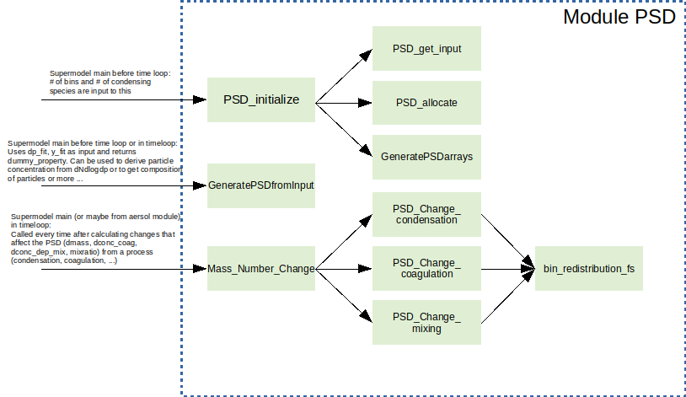

A main feature of the module is the type PSD. It includes all information needed to describe the particle phase for the different representation types. Currently only full stationary method is available.

Changes to the particle size distribution will determined in the aerosol dynamics subroutines and provided to the module:
condensation → dmass (nr_bins, nr_species_P)
coagulation → dconc_coag (nr_bins, nr_bins)
mixing → dconc_dep_mix (nr_bins), dmass and mix_ratio(1)
deposition → dconc_dep_mix

Description of vectors providing the changes:
dmass: for condensation: change (!not new composition!) in particle mass for each bin and each species. Unit is kg / m³. For mixing, it is the composition of the mixing aerosol.
dconc_coag: Collision number matrix (i.e. all collisions for 1 timestep; Unit is 1/m³). In the first row there is 1 entry at (1,1): concentration loss of smallest particles due to collision with each other. In line n there are n entries(n,1:n): concentration loss of smallest particles due to collision with particle of size n, second smallest,... last entry: collisions of n with n.
dconc_dep_mix: The change in particle number concentration within 1 timestep due to deposition or the number concentration of particles that are added due to mixing.

