Suberbox manual and developer guidelines

Date: 13 November 2019

Table of Contents
1.1 Precision 2
1.2 Time 2
1.3 Derived types 2
1.3.1.1 type timetype (in constants.f90) 2
1.3.1.2 type input_mod (in constants.f90) 3
1.3.1.3 Other derived types (in constants.f90) 4
1.4 Useful functions 4
1.4.1.1 real(dp) function NORMALD(MODS[, timein]) 4
1.4.1.2 real(dp) function PERIODICAL(MODS [, timein]) 5
1.4.1.3 real(dp) function INTERP(conctime, conc [, row, unit, timein]) 5
1.4.1.4 integer function ROWCOUNT(file_id [, ‘comment_char’]) 6
1.4.1.5 integer function COLCOUNT(file_id [, separator]) 6
1.4.2 Other functions 6
1.4.2.1 real(dp) function C_AIR_cc(T, P) 6
1.4.2.2 real(dp) function C_AIR_m3(T, P) 6
1.4.2.3 real(dp) function hrs_to_s(h) and sec_to_d(s) 7
1.4.2.4 boolean function EVENMIN(t, check [, zero]) 7
1.5 Input 7
1.6 Output 7
1.6.1 Screen output 7
1.6.2 File output 8

Precision
All reals are double precision, use real(dp); dp is declared in second_precision and should be used globally. Always USE SECOND_PRECISION (the module comes later from KPP and will always be present).

Time
There is a Global Model Time (GMT) MODELTIME, which gets initialized in constants.f90. It should always be available for functions.

Derived types

type timetype (in constants.f90)
For all time-related variables, a single variable of TYPE(timetype) is used. The type definition is currently in constants.f90. It currently holds the following information, and more will be added:

Component name | Component type | Default value | automatically updated? | Description
SIM_TIME_H | real(dp) | 1d0 | no | Total simulation time in hours; input from user in INIT_FILE
SIM_TIME_S | real(dp) | 3600d0 | only upon declaration | Total simulation time in hours; calculated from above
dt | real(dp) | 10.0d0 | no | Time step of main model in seconds
sec | real(dp) | 0 | yes [via ADD()] | Current time in seconds
min | real(dp) | 0 | yes | model time in minutes (and decimal fractions)
hrs | real(dp) | 0 | yes | model time in hours (and decimal fractions)
day | real(dp) | 0 | yes | model time in days (and decimal fractions)
dt_chem | real(dp) | 10.0d0 | no | Time step of chemical model in seconds
dt_aero | real(dp) | 10.0d0 | no | Time step of aerosol model in seconds
JD | integer | 0 | no | Julian day of year at the start of the run
PRINT_INTERVAL | integer | 900 | no | interval of screen output in model seconds
FSAVE_INTERVAL | integer | 300 | no | interval for saving all values in model seconds
ind_netcdf | integer | 1 | yes | index of netcdf-file row (in effect the row number)
JD | integer | 0 | no (currently) | Julian day
hms | character(8) | "00:00:00" | yes | Character string for showing time (e.g. error messages)
printnow | logical | .true. | yes | TRUE if time to print screen output (automatic)
savenow | logical | .true. | yes | TRUE if time to saving values
PRINTACDC | logical | .false. | no | TRUE if cluster/monomer fractions are printed

Function ADD(time, sec), also in constants.f90, will forward the time%sec by sec seconds. Alternatively, ADD(time) will forward the time%sec by time%dt. Also, operator + (“plus”) is assigned to timetype, so that time+sec will have same effect than ADD(time, sec).
Every module working with time should USE CONSTANTS.

type input_mod (in constants.f90)
The purpose of this type is to modify the value of any input. It wraps the necessary parameters for the function NORMALD, and additionally it has two operators assigned to it, + for adding (or subtracting) a constant in input_mod%shift, and * for multiplying the value by input_mod%multi. When input_mod is used with + or *, only the respective variables are used, and none of the others have any influence.
Effect of different operators and input_mod:
real(dp) * input_mod returns real(dp) * input_mod%multi
real(dp) + input_mod returns real(dp) + input_mod%shift

The input_mod type holds the following variables:

 | Component name | Component type | Default value | Description
General use | MODE | integer | 0 | 0 = use values that are read in from column "col", possibly modifying by a factor or a constant  1 = Use NORMALD to create function in LINEAR mode  2 = Use NORMALD to create function in LOGARITMIC mode
General use | col | integer | -1 | Column used for reading input if MODE is 0
General use | NAME | character(16) | empty | Name of the compound, variable etc.
Modify some existing values | multi | real(dp) | 1d0 | Used as multiplication factor if input_mod is used with operator * or .mod.
Modify some existing values | shift | real(dp) | 0d0 | Used as offset if input_mod is used with operator + or .mod.
Pure Gaussian parameters | min | real(dp) | 0d0 | Minimum value for the function; background level.
Pure Gaussian parameters | max | real(dp) | 1d5 | Maximum of the peak.
Pure Gaussian parameters | sig | real(dp) | 1d0 | Width of the bell curve; sigma of the gaussian function
Pure Gaussian parameters | mju | real(dp) | 12d0 | Time of the peak in hours; exact if modulation is not used, otherwise approximate.
Periodic function parameters | fv | real(dp) | 0d0 | Angular frequency of the modulation
Periodic function parameters | ph | real(dp) | 0d0 | Phase shift of the modulation
Periodic function parameters | am | real(dp) | 1d0 | Amplitude of the modulation function.
General use | UNIT | character(5) | ‘#’ | Unit for the given number. Case insensitive.  ‘#’ number contentration in 1/cm3.  'ppm' parts per million (1/1e6)  'ppb' parts per billion (1/1e9)  'ppt' parts per trillion (1/1e12)  'ppq' parts per quadrillion (1/1e15)  'Pa' Pascals  'hPa' Hectopascals  'kPa' Kilopascals  'mbar' millibars  'atm' Atmosphere (101325 Pascals)  'K' Kelvin  'C' Celsius  note: the user is responsible to provide units that make sense, e.g. ‘C’ in pressure will result in garbage.
General use | NAME | character(16) | ‘NONAME’ | Name of the compound, variable etc. Filled from NAMES.DAT

The functions that are assigned to + and * operators are PLUS(c, MODS) and MULTIPLICATION(c, MODS), respectively, found in constants.f90.
For consecutive operation real * input_mod + input_mod can be used (but only in this order), also for convenience an operator .mod. has been assigned to such operation, so real .mod. input_mod has the same effect; first multiplying with multi, then adding shift.

real(dp) :: a = 4.0d0
type(input_mod) :: b
b%multi = 3d0
b%shift = 4.2d0
a = a .mod. b
print*, a

>>> 16.199999999999999

input_mod (or an element of a vector of them) can be used to modify any variable in the program, including multiplying values, or setting them to zero or some other constant, using just one variable. Naturally, if input_mod%min_c == 0 and input_mod%amplitude == 1, such operation keeps the original value intact. These are the default values of a declared input_mod variable.
Currently all input variables are stored in MODS vector, which gets allocated with the length of the NAMES.DAT file. From this vector, current concentrations at each time step are read in (interpolated with interp), and stored in TSTEP_CONC, which has the same length than MODS.

Other derived types (in constants.f90)
These include the types that are directly imported from old UHMA, and are most certainly going to see many changes.

Useful functions
All the functions under chapter 1.4 are in auxillaries.f90, except NORMALD(), which is in constants.f90

real(dp) function NORMALD(MODS[, timein])
timein: current type(timetype), optional
MODS: type(input_mod)

The function is useful if one wants to create artificial concentrations, rates or whatever value is needed, which has a peaked form. It creates a Gaussian bell curve, and also optionally modifies it with sine function (see code for details). NORMALD uses MODS to return a value at GMT, or if TIME is provided, on that time. Assumed time unit is hours, so basically it is possible to create a function just by estimating the correct numbers. In practice, it is best to use the helper program ParameterTweaker.py to create parameters for artificial functions. Also see above for description of input_mod.

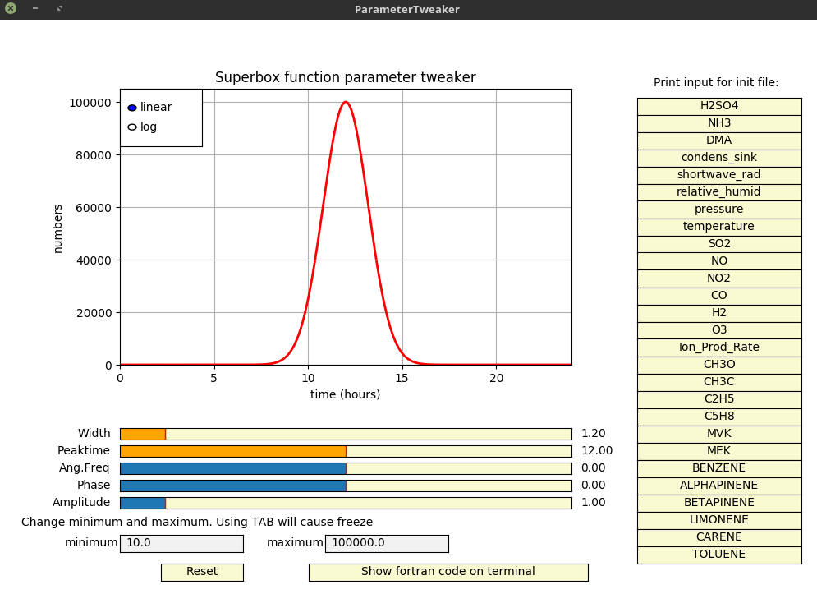
Figure 1: Screenshot of ParameterTweaker.py in action. A function is created here using pure Gaussian function. The parameters are visible in the widget, but clicking on the Show fortran code on terminal will output the Fortran code snippet that is needed to define new variable of input_mod, which will produce identical output in Suberbox when used in NORMALD() function. The code snippet is the full variable definition line, user needs to change the name in [variable-name]. On the right individual rows for INIT_FILE with correct index and name can be printed.

real(dp) function PERIODICAL(MODS [, timein])
timein: type(timetype), optional
MODS: type(input_mod)

A simple sine function that uses timetype and input_mod. The function returns a value at GMT (or timein if provided) from a sine curve that has minimum in MODS%min, maximum at MODS%max, has exactly MODS%fv periods (e.g. MODS%fv == 1.5d0 means one and half period) and is shifted forward by MODS%ph hours. Might or might not be useful for simulating temperature, humidity and other periodic values.

real(dp) function INTERP(conctime, conc [, row, unit, timein])
conctime: real(dp), dimension(n)
conc: real(dp), dimension(n)
row: integer, optional
unit: character(len=3), optional
timein: type(timetype), optional

Function that linearly interpolates any value at GMT (or timein if provided) using a vector of timepoints and respective concentration time series. If row is provided, function will use that row as starting point for interpolation, or search for correct row if this fails (and issues a warning in that case).
By default, INTERP() assumes that conctime is in days (decimal), and uses [time]%day to search for the correct point of interpolation. If conctime is in some other units, optional value unit must be sent. Possible options for unit are: ’sec’, ’min’, ’hrs’, ’day’. Later we might want to define a global default time unit but the possibility to define unit for each case provides additional flexibility.
The conctime does not have to be spaced equally, but the dimensions must match the conc vector. It must not contain NaNs or infinities. Also, in order to successfully run the whole simulation, the conctime must include the start and end time of the simulation.

integer function ROWCOUNT(file_id [, ‘comment_char’])
file_id: integer
comment_char: character(1)

Given the UNIT (file_id) that points to opened file, calculates the rows in file (including empty lines), returns INTEGER, number of rows. ROWCOUNT() and COLCOUNT() rewind to the beginning of the file and return the pointer back where it was when the function was called, so it is (or should be) safe to use it at any time, even while cycling through a file. If comment_char is sent in, if first row begins with it, it will be omitted from the count. Example ROWCOUNT(51,’#’)

integer function COLCOUNT(file_id [, separator])
file_id: integer

Given the opened file_id, calculates the columns in file (including empty lines), returns INTEGER, number of columns. By default, assumes columns are space-separated, and multiple spaces are counted as one. If optional character separator is send, it will be used as separator, in which case consecutive separators are counted as different columns. COLCOUNT() and ROWCOUNT() rewind to the beginning of the file and return the pointer back where it was when the unit was sent in the function, so it is (or should be) safe to use it at any time, even while cycling through the file.

integer function IndexFromName(name)
name: Character
Finds out the index number used in MODS and TIMECONC using the proper name. E.g. IndexFromName(‘APINENE’) would return 150 (in current NAMES.DAT). Name name must match the name in NAMES.DAT exactly.

Other functions

real(dp) function C_AIR_cc(T, P)
T: real(dp)
P: real(dp)

Given temperature T (Kelvins) and pressure P (Pascals) returns air concentration in cubic centimetre [#/cm³] using ideal gas law PV = NkbT.

real(dp) function C_AIR_m3(T, P)
T: real(dp)
P: real(dp)

Given temperature T (Kelvins) and pressure P (Pascals) returns air concentration in cubic meter [#/m³] using ideal gas law PV = NkbT.

real(dp) function hrs_to_s(h) and sec_to_d(s)
h: real(dp)
s: real(dp)

These take in hours and seconds and return seconds and hours. The purpose of such trivial functions is to lessen the probability of errors in conversion. These functions have already become obsolete because we are using type(timetype).

boolean function EVENMIN(t, check [, zero])
t: real(dp)
check: integer
zero: integer

Checks whether time t (in seconds) coincides evenly with some time interval check (in minutes). As any time coincides with time 0, .false. is returned at t == 0. If for some reason one would want to get .true. at time zero, send optional integer zero in (can be any integer). While mostly obsoleted by type(timetype), which carries booleans for different events, this function can be used to trigger one-time events etc, therefore in order to be as universal as possible, also the time is sent in as seconds instead of timetype.

Input
Input handling is done in module input.f90. The main input method for SUPERBOX is the INITFILE, and in fact this is the only compulsory input if only parametrized and constant values are used.

Variable declarations
In practice all of the variables that are user-configurable, are declared in input.f90.

Output

Screen output
Simulations might take a long time, and it is good to see what the model is producing even while running. Different FORMATs have been made in order to have a clear and uniform layout for output. As development of Supermodel progresses, we will have different levels of screen output (as well as file output) that the user can choose from. The formats in next table are in auxillaries.f90.

Format name  (example row below) | What it is for | Example of usage
FMT_TIME  (1) | Printing a time (hh:mm:ss) with horizontal bar; starts new “box” | print FMT_TIME, time%hms
FMT10_CVU  (9) | Print a triplet of  – Comment (10 characters max)  – Value (REAL, will print scientific format)  – unit (for example) , CHARACTER string | print FMT10_CVU, 'C-sink:', CS_H2SO4 , ' [1/s]'
FMT30_CVU  (11) | Same than previous, but Comment is 30 characters long | print FMT30_CVU, TRIM(buf), c(n)/c(1), '[]'
FMT10_2CVU  (5),(6),(7), | Same than FMT10_CVU, but has 2 triplets | print FMT10_2CVU,'ACID C: ', c_acid*1d-6, ' [1/cm3]', 'Temp:', TempK, 'Kelvin'
FMT10_3CVU  (8) | Same than FMT10_CVU, but has 3 triplets | print FMT10_3CVU, 'Jion1:', J_NH3_BY_IONS(1)*1d-6 , ' [1/s/cm3]','Jion1:', J_NH3_BY_IONS(2)*1d-6 , ' [1/s/cm3]','Jion1:', J_NH3_BY_IONS(3)*1d-6 , ' [1/s/cm3]'
FMT_LEND  (10) | prints endline of the “box”. Accepts no input | print FMT_LEND,
FMT_SUB (4) | print small messages. Acceps a string | if (time%printnow) print FMT_SUB, 'NH3 IGNORED'
FMT_WARN0  (12) | Print warning, with text WARNING and the string message | print FMT_WARN0, 'UNKNOWN TIME UNIT, can not interpolate, trying with days'
FMT_WARN1  (2),(3) | Same that previous, but accepts a REAL after the message | print FMT_WARN1,'real row is: ', REAL(rw)

Example of output:

+.Time: 11:15:00 ..................................................................................+ (1)
| WARNING: Wrong row number is sent in to INTERP, searching for the real row now.9.0000~~~~~~~~~~~~+ (2)
| WARNING: real row is: 68.0000~~~~~~~~~~~~~~~~~~~~~~~~~~~~~~~~~~~~~~~~~~~~~~~~~~~~~~~~~~~~~~~~~~~~+ (3)
| :........NH3 IGNORED | (4)
| ACID C: 5.058E+00 [1/cm3] Temp: 3.008E+02Kelvin | (5)
| NH3 C: 1.735E-04 [1/cm3] J_NH3: 6.907-316 [1/cm3] | (6)
| DMA C: 1.132E+00 [1/cm3] J_DMA: 1.199E-65 [1/cm3] | (7)
| Jion1: 6.953-316 [1/s/cm3] Jion1: 6.907-316 [1/s/cm3] Jion1: 0.000E+00 [1/s/cm3] | (8)
| C-sink: 2.860E-02 [1/s] | (9)
+..................................................................................................+ (10)
| 1A3N1P/1A from NH3: 2.430E-04[] | (11)
| WARNING: UNKNOWN TIME UNIT, can not interpolate, trying with days~~~~~~~~~~~~~~~~~~~~~~~~~~~~~~~~+ (12)

Using these (or some similar) formats will lead to more uniform and pleasing output. If they are widely used, it is easy to modify the visualisation of output.

File output
Currently all output is done only in NetCDF files. They can be read with many command line programs, Matlab, Python (with netCDF4 module). For more information on NetCDF: https://www.unidata.ucar.edu/software/netcdf/
This part is still under constant change, so far a file called OutputGas.nc is created, and it stores information about some gases and nucleation from ACDC.
For example how this works, see OPEN_GASFILE(), SAVE_GASES() and CLOSE_FILES() in output.f90. A header of the .nc file is below, to show what gets saved now.

~/supermodel-phase-1/output $ ncdump -h OutputGas.nc
netcdf OutputGas {
dimensions:
time = 1442 ;
Compound = 5 ;
Constant = 1 ;
StringL = 16 ;
variables:
double time_in_sec(time) ;
char gas_names(Compound, StringL) ;
gas_names:units = "[]" ;
double gas_concentrations(time, Compound) ;
gas_concentrations:units = "1/m^3" ;
double temperature(time) ;
temperature:units = "K" ;
double pressure(time) ;
pressure:units = "Pa" ;
double J_out_NH3(time) ;
J_out_NH3:units = "1/s/m3" ;
double J_out_DMA(time) ;
J_out_DMA:units = "1/s/m3" ;
double c_sink(time) ;
c_sink:units = "1/s" ;
double Temperature_Multipl(time) ;
double Temperature_Shifter(time) ;
double H2SO4_Multipl(time) ;
double H2SO4_Shifter(time) ;
double Base_NH3_Multipl(time) ;
double Base_NH3_Shifter(time) ;
double DMA_Multipl(time) ;
double DMA_Shifter(time) ;
double C_sink_Multipl(time) ;
double C_sink_Shifter(time) ;

// global attributes:
:Information = "(c) Atmospheric modelling group 2019 and (c) Simugroup 2019 (ACDC)" ;
:Contact = "michael.boy@helsinki.fi (Superbox), tinja.olenius@alumni.helsinki.fi (ACDC)" ;
:Software = "Superbox 0.1" ;
:Package_Name\: = "superbox.exe" ;
:Notes = "e.g. Sulfuric acid concentration multiplied by 0.1" ;
:experiment = "Experiment set here" ;
}

