ContentMine pipeline for cell migration literature – paola masuzzo (@pcmasuzzo)

getpapers

I am interested in cell migration at large, which can be broadly classified as collective (i.e. cells maintain their contacts and move all together), or single (i.e. cells move as individual entities).

So let's first run two queries, one for each cell migration phenotype, and see how many open access publications we can retrieve with the two search terms in their title. We run these queries in a no-execute mode, just to get a first idea – nothing is downloaded yet. Furthermore, we do not specify the API, so the Europe PMC is used (by default).

getpapers -q TITLE:collective cell migration -o ccm -n
getpapers -q TITLE:single-cell migration -o scm -n

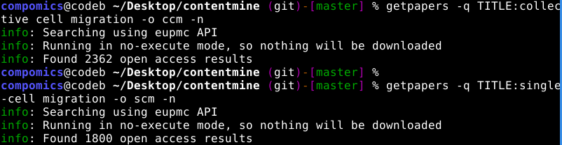

We find:
Search term | Number of OA papers
collective cell migration | 2362
Single-cell migration | 1800

I decided to narrow down the search space, and only look for papers that contained exactly the two search terms in their title (basically, using the quotation marks ' '). This time we will save the results in the two folders ccm and scm.

getpapers -q TITLE:'collective cell migration' -o ccm
getpapers -q TITLE:'single-cell migration' -o scm

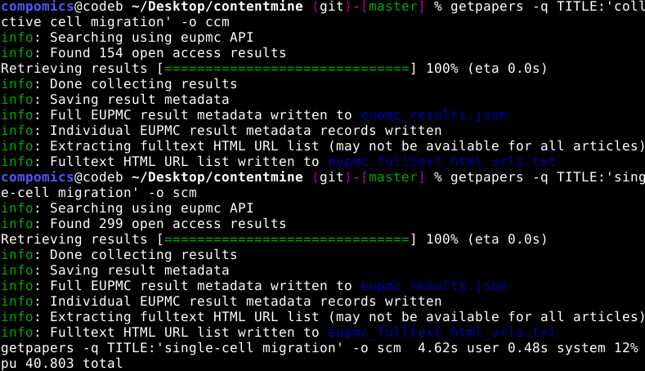

We now find:
Search term | Number of OA papers
collective cell migration | 154
Single-cell migration | 299

These numbers seem more reasonable at least to start getting acquainted with the tools without having to wait too much.

I have run the same queries with the -x option as well, to download machine-readable full texts; for example, for the 'collective cell migration' query, I got XML URLs for 152 out of 154 results (only paper PMC4085699 and paper PMC2064460 were not OA – therefore no XML was available).

The execution of the getpapers command creates a CProject folder, containing subfolders with each paper and associated files; here I show this for the 'collective cell migration' query:
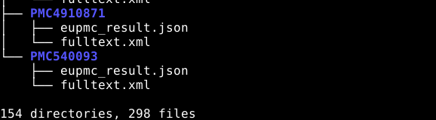

As you can see, XML full texts and json files are there, as I have not downloaded PDF full texts, nor supplementary files.

One of the major role of collective cell migration is in cancer invasion, so I decided to restrict a bit more my search space looking for disease-annotated papers, like this:

getpapers -q 'TITLE:”collective cell migration” AND DISEASE:cancer' -o cancer -n

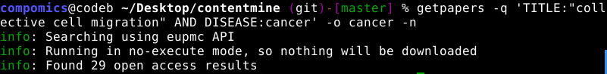
I was surprised to get only 29 OA results, but most likely annotations on papers are not perfect.
For these publications I also downloaded full PDF texts and supplementary files, obtaining the following structure at the end:
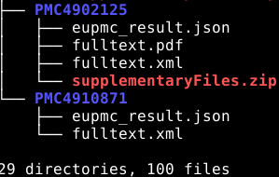

norma

I have then used norma on the results obtained from the previous step (my 'cancer' folder). First I have created the scholartly.html files:

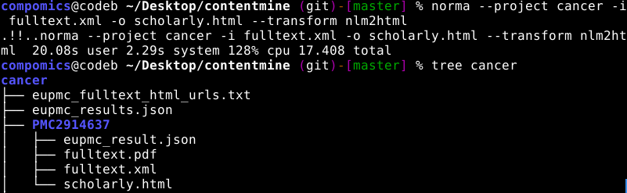
And then I have transformed the PDF into text files (first creating an appropriate structure, as explained in the tutorial):

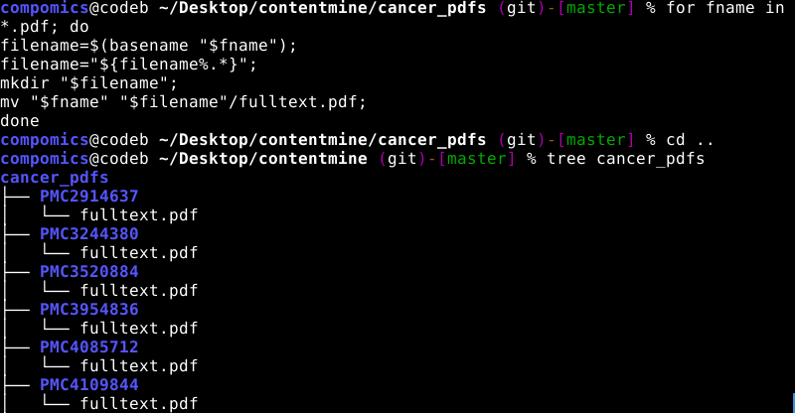

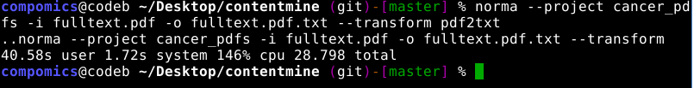
ami

I then used the ami plugins on the normalized papers. I executed the ami2-species extraction in a loop, like this:

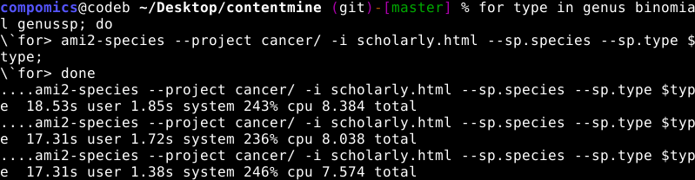

The structure of my folder then became like this:

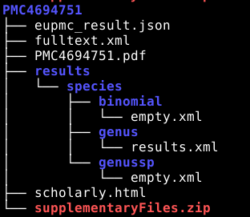

with some empty XML files (no results) and some results XML files.

An example of a results XML file is given here:

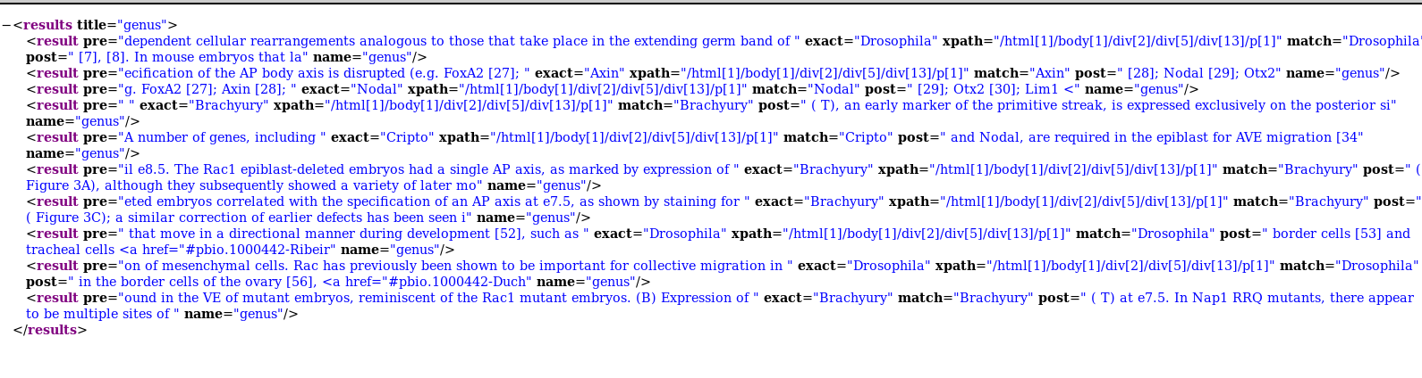
These results surprised me a bit, as I can explain the Drosophila matches, but I do not understand why the plugin is also returning Axin and Brachyury matches (these are proteins...). Or maybe I am missing something...

I also used the ami2-word plugin, looking at the frequencies of used words both in the XML and HTML format. It is interesting to me to see that words like 'adhesion' and 'proliferation' are almost always present, and in a considerable amount of recurrences.
What I would like to do next is to scan across these results, looking for 'similar' words (given a certain similarity score), and check for nomenclature consistency.
I would especially like to perform this task mining the Materials and Methods section of the papers (I am not sure this is a functionality of the tools yet).

quickscrape

I chose the article 10.1371/journal.pone.0027950; this is a PLOS paper, so I used the plos.json scraper, like this (I needed to resolve the DOI to an appropriate URL first):

quickscrape -u http://journals.plos.org/plosone/article?id=10.1371/journal.pone.0027950 -s journal-scrapers/scrapers/plos.json -o plos_scraper

quickscrape created the correspondent folder with the full text in PDF and XML, and the results of the scraping in a json format.

I then repeated the scraping for other papers as well, looking specifically for a BMC or a PeerJ publication, but it seems my research led only to PLOS papers (and a few NPG ones).

CONCLUSIONS:
I think I am now pretty familiar on how the ContentMine pipeline works, and I have in mind a few things that I'd like to test out with it.

