Data Archive for

Optimal Financial Knowledge and Wealth Inequality

Journal of Political Economy

Annamaria Lusardi, Pierre-Carl Michaud and Olivia Mitchell

October 2015

The directory structure for the data archive is reproduced below. The **build** directory allows to produce the executable program out of Fortran source code. The source code is in the directory **src**. Raw data and simulated data can be found in the directory **data**. The directory **dcdflib.f** is a fortran library used for statistical distribution. It can be compiled under any system (see dcdflib.f/compile_dcdflib.sh).

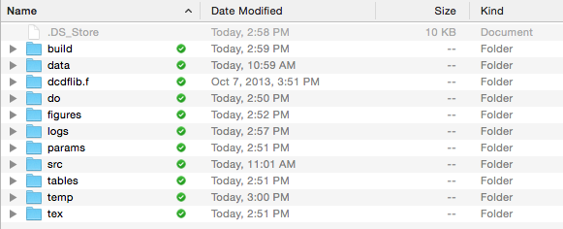

The **do** directory contains stata code used to construct the data and generate tables and figures out of the simulated data. Results reported in the paper can be reproduced running the do-file **do/master.do** in Stata. There is a switch called *irun* that if set to one, will also execute the fortran code. In order to run the fortran code, one needs to be on a system with parallel computing capacity using MPI. We are using *mpif90* to compile the source code for the simulation models. The code could be adapted to run on a single processor, but would likely result is extremely slow computations. The computations produced in the paper were produced out of a server running RedHat Linux with 64 cores. The source code needs also to be modified if run on a different server by changing the paths to your location.

Inputs for the simulations produced by **master.do** are stored in the **params** directory. Output from the do-files is sent to either **tables** or **figures** which contain the numbers used in the paper. Some formatting is done manually ex post. Therefore the labelling of the tables may not be exactly like in the paper. The do-files use a number of contributed ado programs. These can be downloaded using “**net install** …”.

Please contact Pierre-Carl Michaud ([pcmichaud@gmail.com](mailto:pcmichaud@gmail.com)) if anything is unclear, so that we can improve the documentation and make it clearer for everyone.