Data Science and AI for Systems Engineering: APIs, Apps, and Analytics for Cloud Systems
Name: Puchun Niu
Email: pn287@cornell.edu
Homework 1: AI-Powered Reporter Software
Writing Component:
What the software does
The app is a methane emissions reporter for C-Lock GreenFeed data. It pulls visit data from the C-Lock API, lets you filter by animal and date, and shows tables and charts. There’s also a button that sends the full dataset to OpenAI and displays a summary report in a separate tab. So it’s basically: fetch data → explore it →generate an AI summary.
How the pieces fit together
The API part logs in with credentials from a .env file and fetches CSV. That raw CSV is parsed into a pandas DataFrame and kept in memory, so nothing is written to disk. The Shiny UI uses reactive values for the data and the AI report. When you click “Fetch from API,” it updates those values and refreshes the dropdowns. The AI report button takes the raw CSV, sends it to OpenAI, and stores the returned HTML in another reactive value. The app then switches to the AI Report tab so you see the summary right away, sometimes it can take 1-2 minuts. Plotly charts and tables are driven by the same reactive data, so everything stays in sync.
Design choices and challenges
I put everything in one main_app.py so the API, UI, and AI logic are in one place. One issue was that Shiny’s Python API uses nav_panel instead of nav, which caused an error until I switched to the right function. Another problem was contrast: the AI-generated HTML used light text on light green backgrounds, so I added CSS overrides to force dark text on light backgrounds. Credentials are loaded from .env in the project root or the lab submission folder, so the same code works in different setups.
Git Repository Links:
Link to API query
Link to Shiny app code
Link to AI reporting script
Link to the main app integrating API query and AI reporting in shiny app
Screenshots/Outputs:
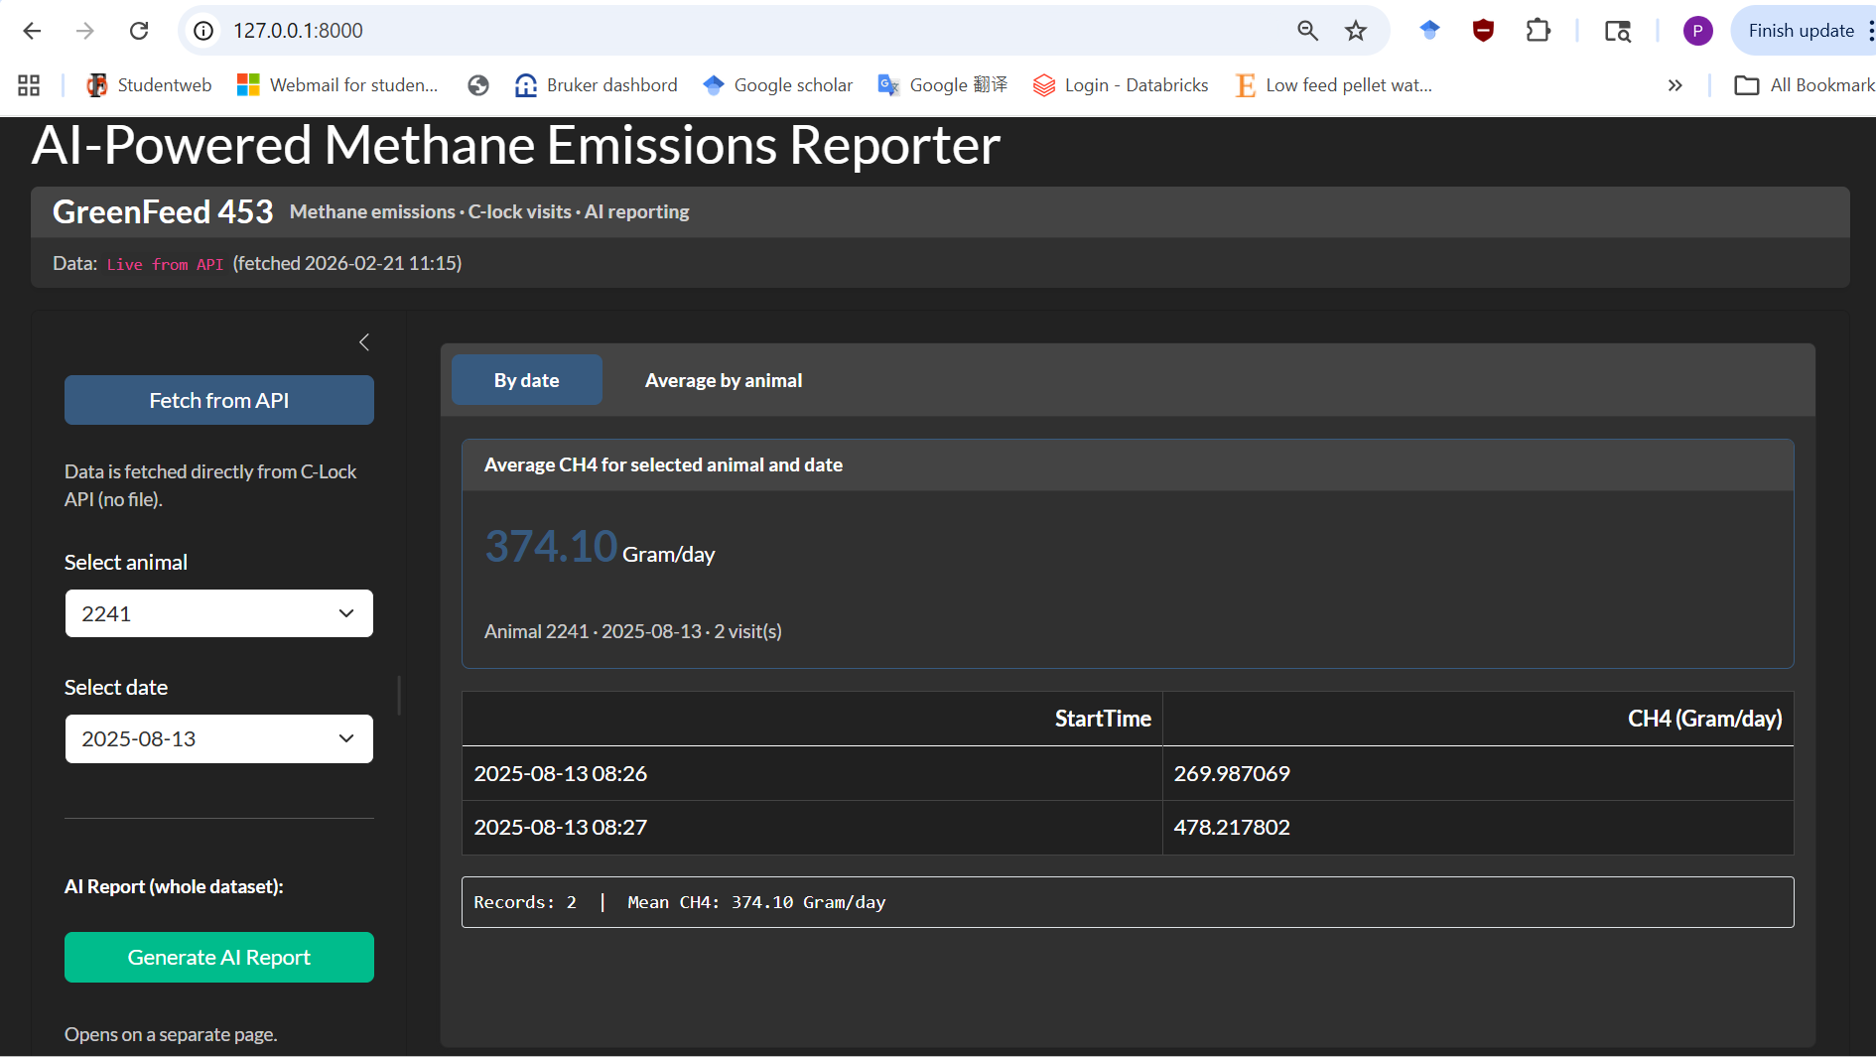
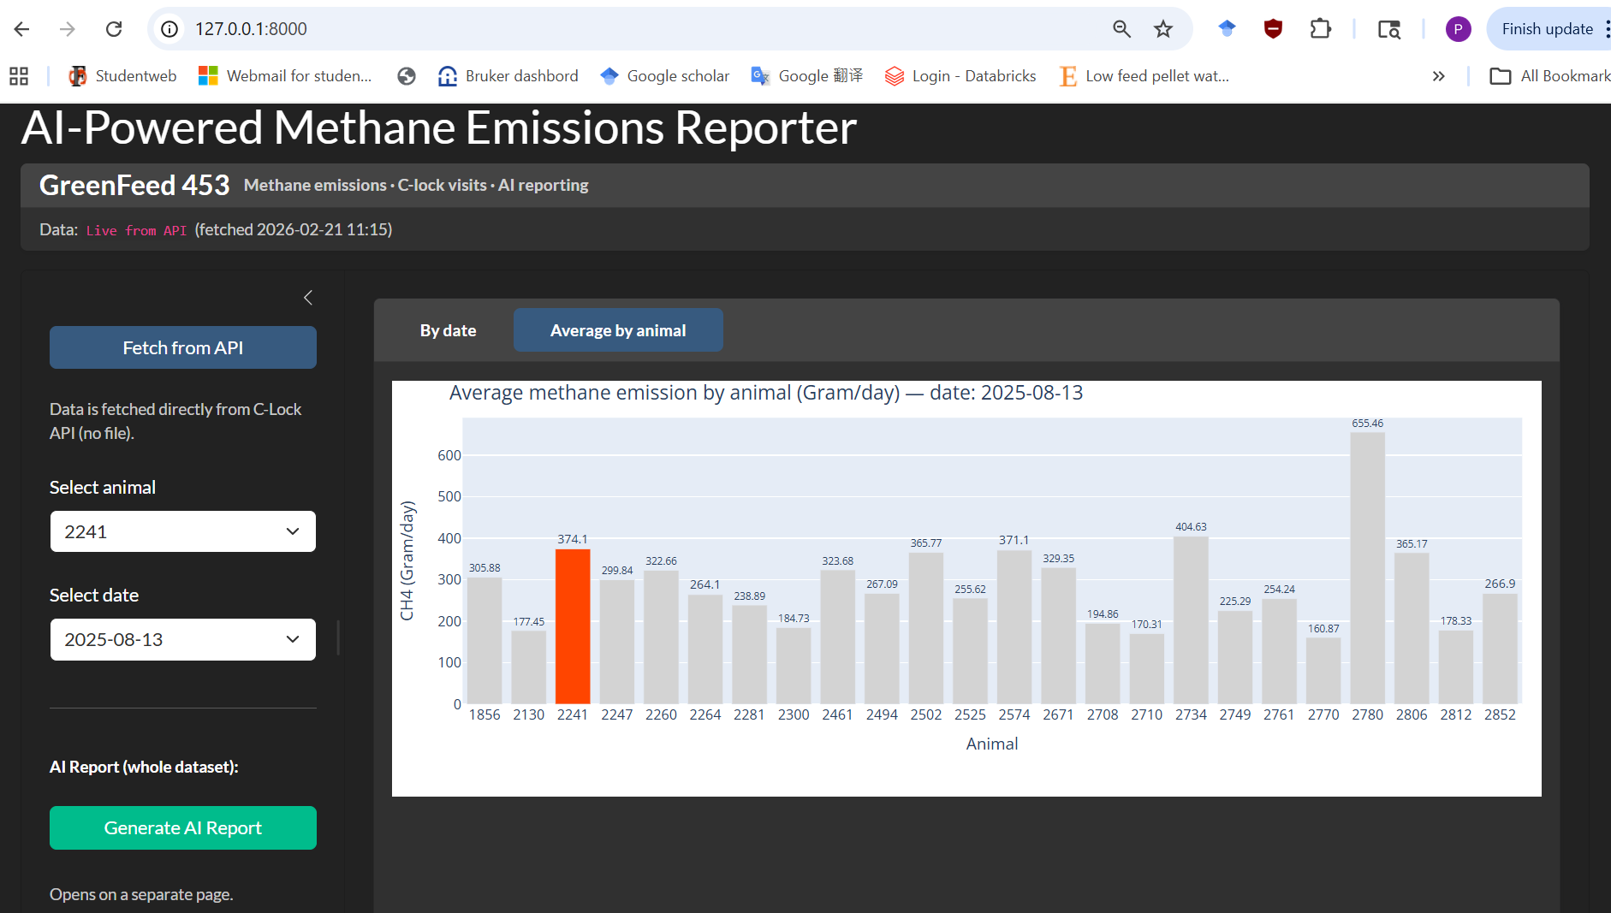
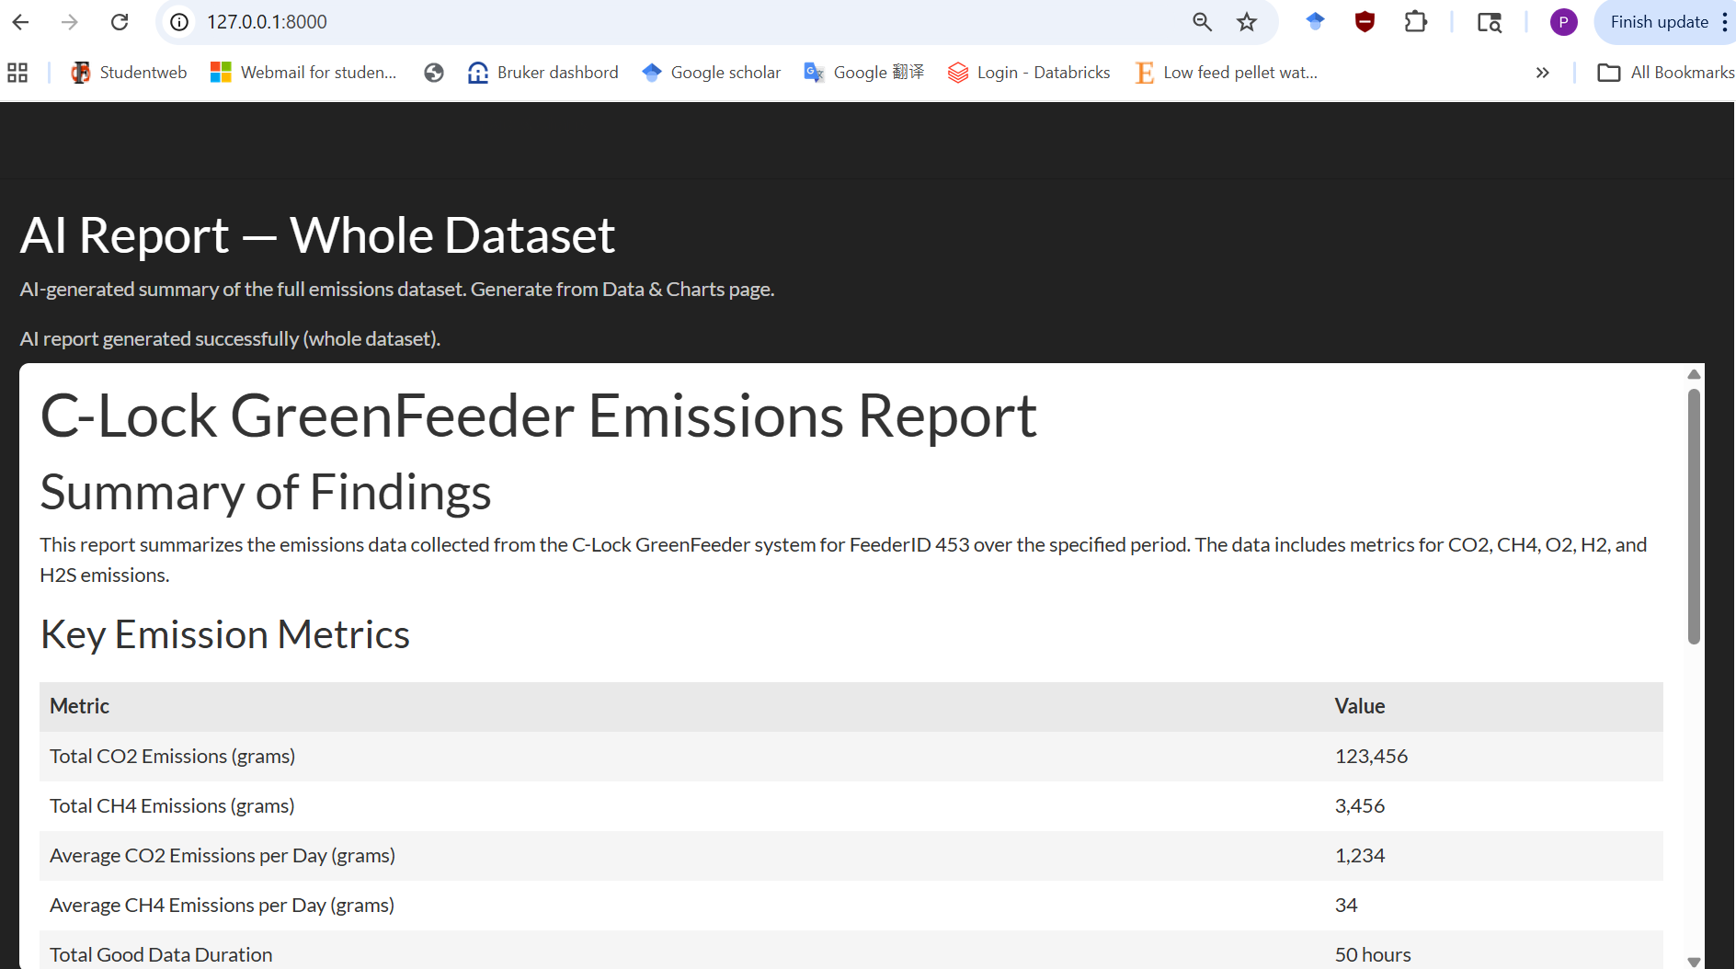
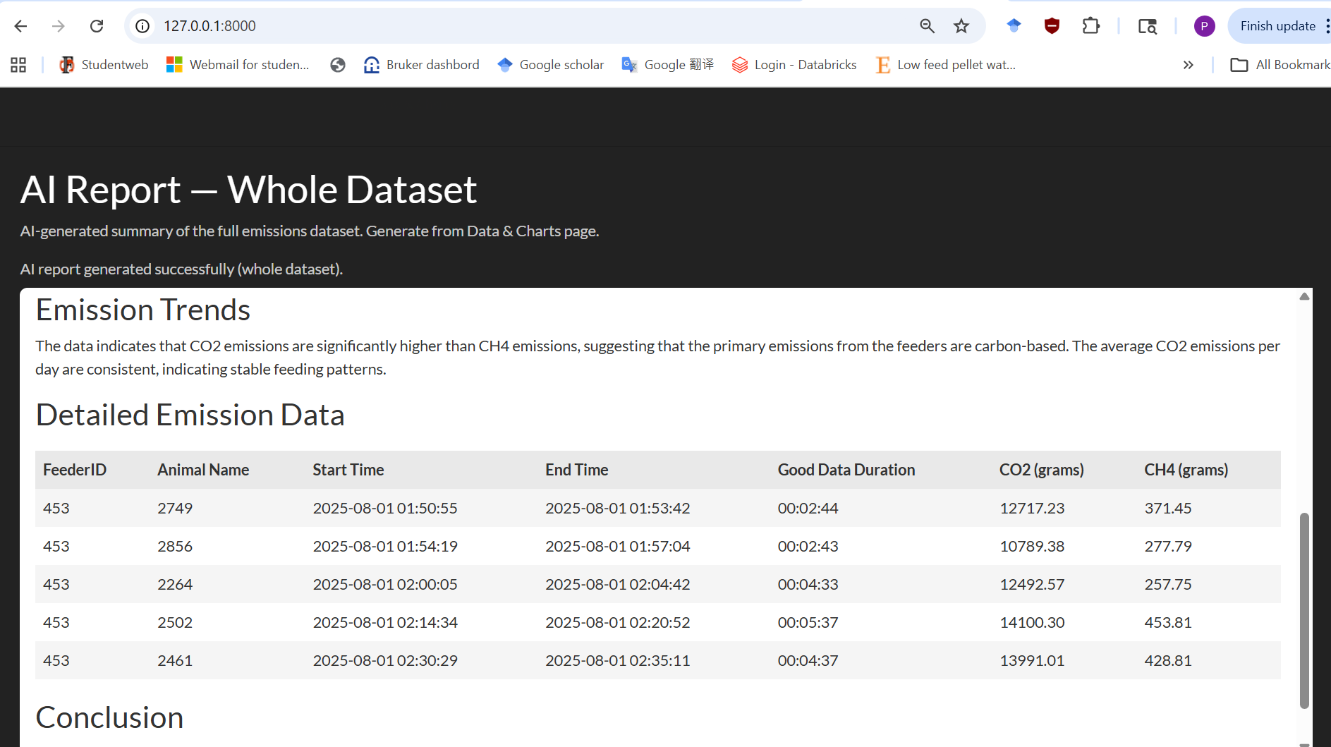
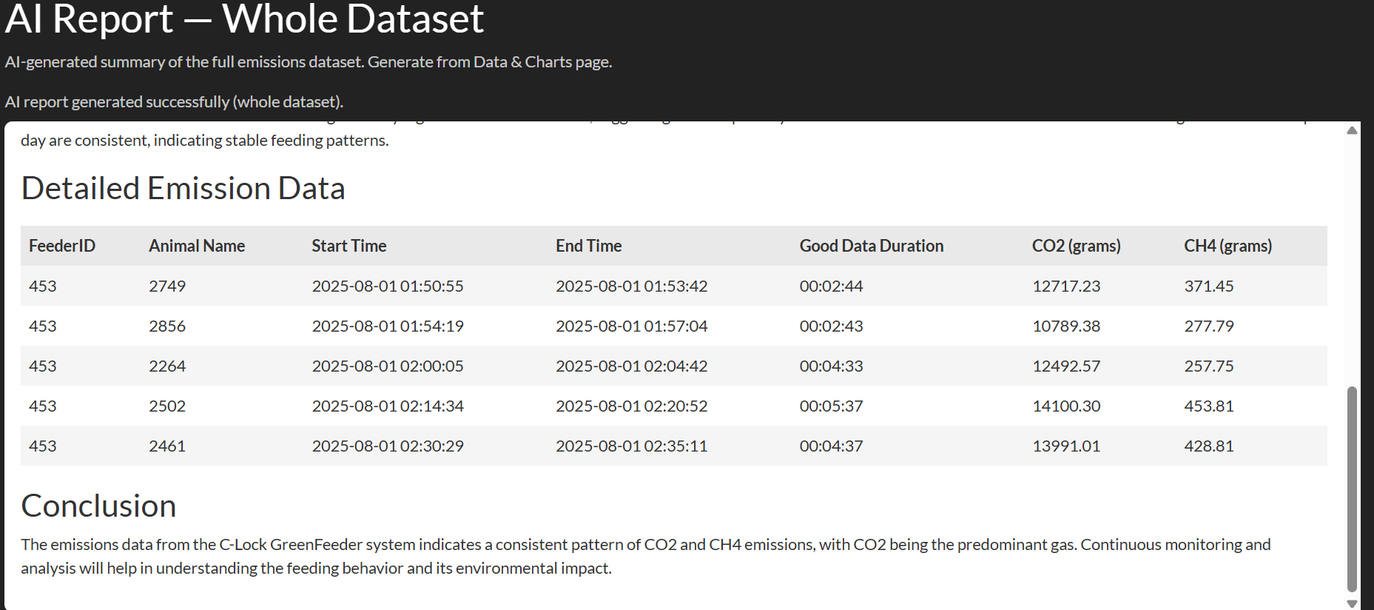
Documentation:
Please find data summary, technical details and usage instructions in ReadMe on github.

